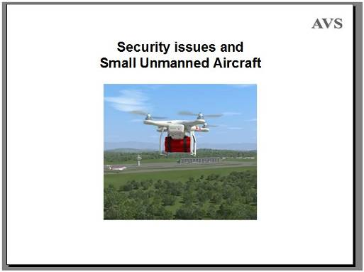
Security Issues and Small Unmanned Aircraft
[Text in square brackets [ ] need not be translated. The <Click> is only a prompt for a mouse-click so can be ignored.]
The small unmanned aircraft in this presentation are mostly under 7 kg maximum take-off weight. That is the weight of the aircraft plus anything it is carrying. I call them SUA, Small Unmanned aircraft. I call larger and heavier aircraft either Unmanned Aerial Vehicles (UAVs), or Drones.
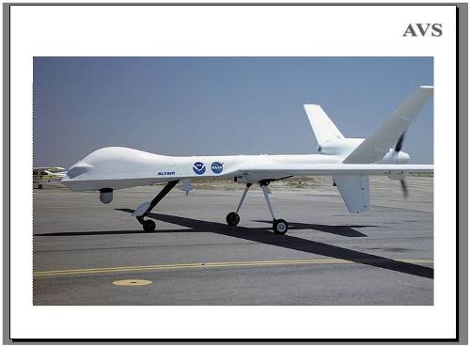
So this is not about the military hardware that is much larger, like this Class III “Predator” Drone that is around 600 kilos in weight and can have an effectively “unlimited” operational range. The SUA in this presentation rarely have an effective range greater than a kilometre or two.
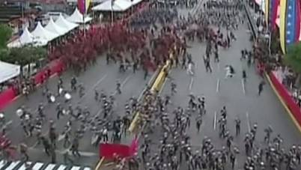
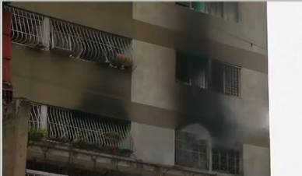
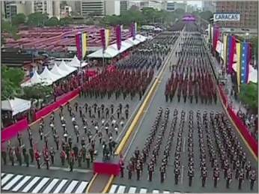
At the start of last month (4th August), the president of Venezuela claimed to have been attacked using two drones…
The government claimed that two small aircraft, each carrying a kilogramme of C-4 plastic explosive, were flown toward the President. <Click> Apparently, one of the aircraft was to explode above the president while the other was to detonate directly in front of him. The event was being filmed from several vantage points but there was no indication of an aircraft or an explosion anywhere in the footage that was immediately available. Later a picture of an SUA exploding was shown, <Click> but it is not certain where it was.
An alternative truth was offered by the fire-fighters responding to the blast – who said that there had been a gas tank explosion inside an apartment building around the corner from the president’s event. <Click> Video of the building taken when the fire-fighters arrived showed no point of impact, no window frames destroyed, and evidence of smoke coming from several windows. This evidence indicated an internal blast that had nothing to do with unmanned aircraft. While I am not convinced, it could have happened.
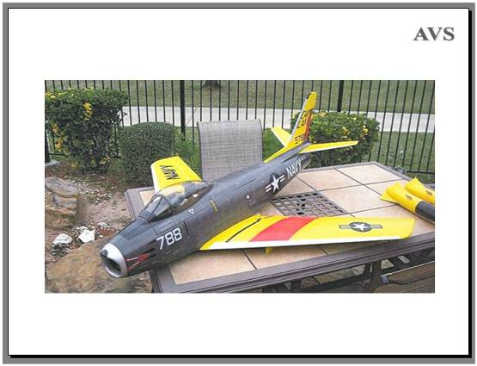
This threat is not new. In 2011, the FBI arrested a man for plotting an attack with remotely controlled fixed wing model aircraft. The pilot, a US university graduate, was planning to fill the bodies of three toy aeroplanes with plastic explosive and fly them into government buildings in Washington.
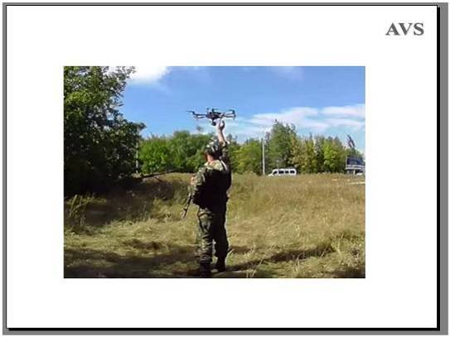
Most small unmanned aircraft today have a camera system attached and can stream video back to the person controlling the aircraft.
The camera can be used to gather intelligence, to find and track targets, and as a security guard’s ‘eye in the sky’.
The picture shows a pro-Russian separatist launching a small unmanned aircraft near Donetsk Airport in Ukraine in 2014 – gathering intelligence.
[This is sometimes abbreviated to ISTAR - Intelligence, surveillance, target acquisition and reconnaissance (ISTAR)].
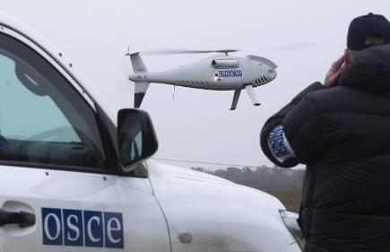
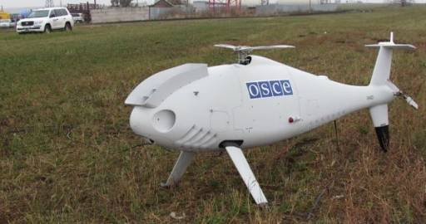
The OSCE’s special monitoring Mission in Ukraine uses larger helicopter drones to monitor activities along the frontline and so monitor the ceasefire. <Click>
This camera carrying helicopter is more than 3 metres long. It can carry up to 200 kg and can fly for hours without refuelling.
The cameras on SUA were widely used by ISIS separatists to overfly combat areas, and also by the security forces in Iraq.
[Schiebel Camcopter S-100, length 311 cms, ]
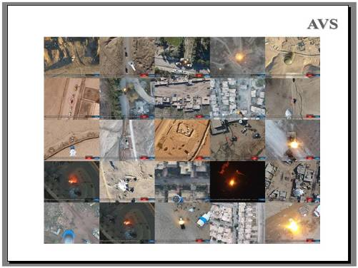
This shows 25 separate ISIS attacks in 2017.
By 2014 ISIS were using small unmanned aircraft to overfly vehicle carried IEDs and direct them so that they could avoid roadblocks.
They also turned their small aircraft into bombers on a large scale. There is evidence that ISIS conducted nearly 200 attacks in Syria with armed small unmanned aircraft in February 2017 alone.
ISIS publicised many of those that were successful themselves, so using the attacks for propaganda purposes.
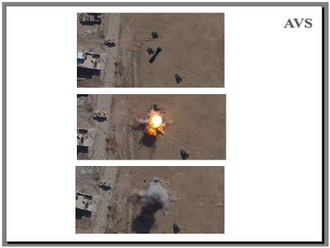
Although the aiming is not precise, the aircraft were often able to strike accurately from a considerable height.
However, their improvised release systems and improvised munitions were both prone to failure.
Typically, propaganda videos showed successful attacks but reports from the field indicate that many attacks failed.
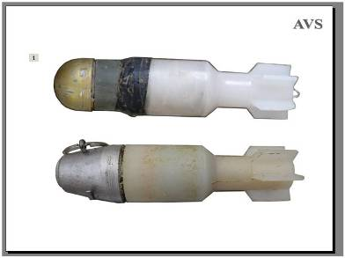
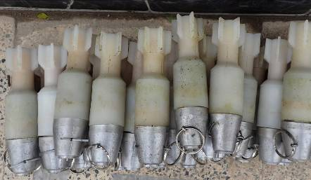
These are improvised bombs dropped from small unmanned aircraft that were recovered in Mosul Iraq in 2016 (used in both Iraq and Syria). <Click> The total length of each improvised bomb is about 20cms. Different warheads were taken from different munitions. The goal was to have an armour piercing capacity despite the small size.
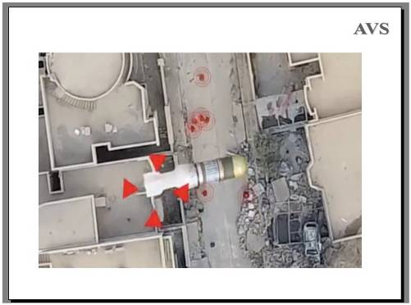
This was filmed at Deir Ez-Zour, Syria, in February 2017.
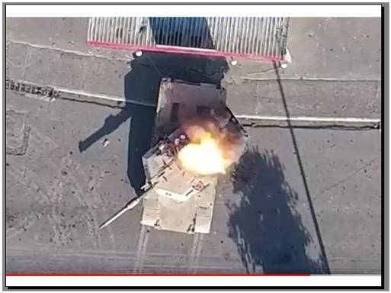
And there is evidence that they had some success.
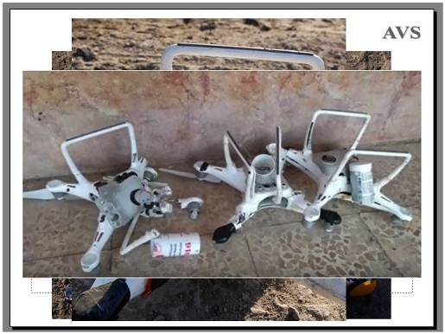
The bombs were dropped from small aircraft like these – DJI Phantom quad-copters with an improvised release mechanism <Click> added to the camera pivot. <Click> These pictures were taken in 2016 and 2017.
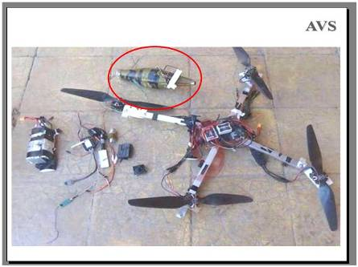
They also took standard munitions such as hand grenades and fitted fins. And modified [M383] high explosive projectiles. <Click>
This improvised aircraft made out of spare parts was adapted to deliver a PG7 <Click> shaped charge warhead.
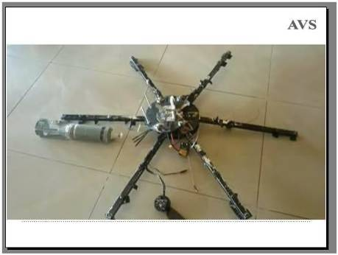
This hexacopter was captured from ISIS in Mosul, Iraq, in May 2017. It is designed to drop a PTAB-2.5M submunition. The aircraft itself appears to be largely improvised.
[HEAT – High Explosive Anti Tank, containing 450g TNT/RDX].
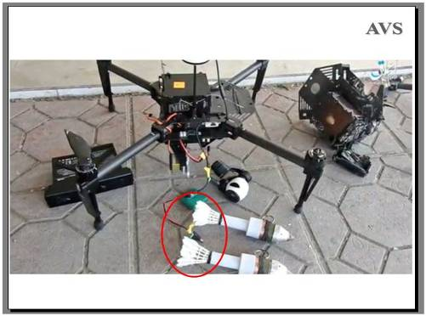
ISIS were not the only ones to use small unmanned aircraft. This quad-copter belonged to the Iraqi Federal Police and was captured by ISIS in 2017, then captured back later. These modified munitions appear to use <Click> Badminton shuttlecocks as fins.
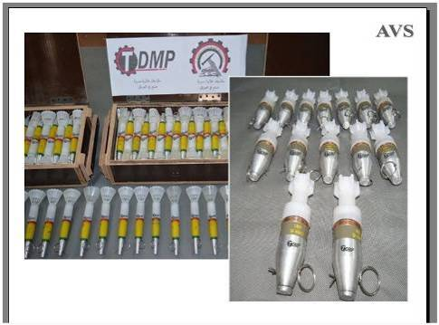
The Iraqi arms industry produced modified bombs for their small unmanned aircraft in large numbers. These were produced in Iraq by the Technical Directorate for Military Production (TDMP).
[These are modified 30mm HEIT projectiles and modified M383 40mm HE projectiles.]
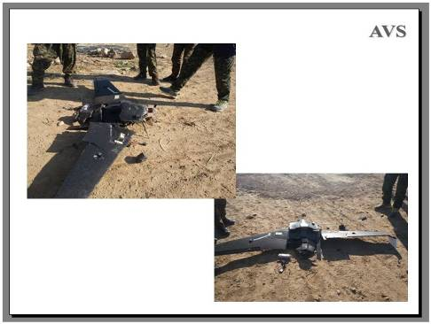
ISIS also used fixed wing aircraft which could fly for longer and so allow them to attack from a greater distance. This appears to be the commercially available Skywalker X8 with no obvious signs of modification. Kurdish forces shot it down and said they found a 500g explosive charge connected to a point detonating nose fuze.
[December 2015.]
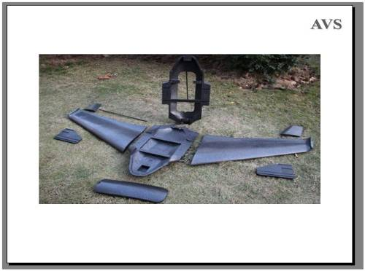
Even if 500g is a little hard to believe, the X8 has enough space inside and the ability to carry a 3kg cargo, so can easily be converted to a flying bomb with a greater range than the smaller aircraft with multiple rotors.
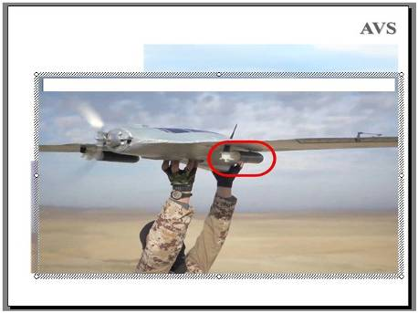
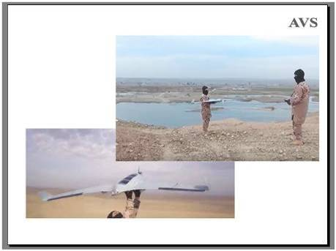
These pictures are taken from an ISIS promotional video made in Mosul, Iraq, in early 2017 – showing off their air-force. <Click>
That aircraft was expensive so it was intended to be able to drop its bombs and fly back and be used again.
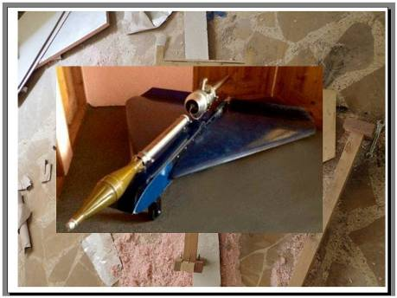
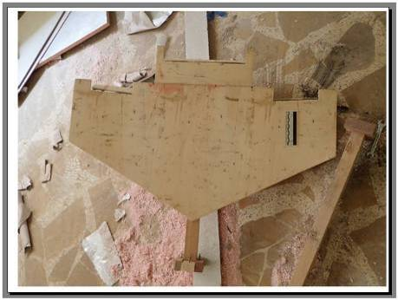
ISIS made their own aircraft for single use, <Click> <Click> perhaps adapted to deliver PG7 warheads like this.
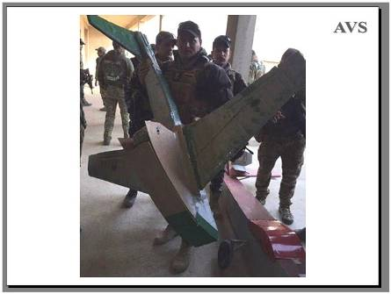
These large improvised fixed wing drones were captured from ISIS in Mosul, Iraq in January 2017.
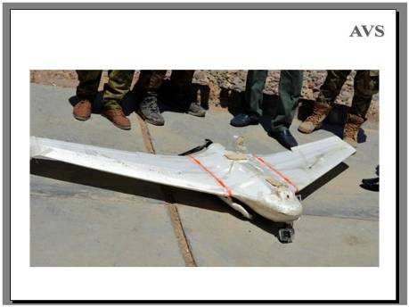
They even used their aircraft as attractive booby-traps. The French newspaper 'Le Monde‘ reported that this abandoned fixed wing aircraft exploded on the ground killing two Kurdish Peshmerga fighters and wounding two French Special Forces troops in October 2016.
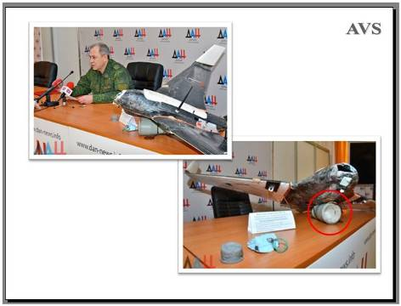
It is not only in Syria and Afghanistan where small unmanned aircraft are used as weapons. For example, pro-Russian separatists reported that they had shot down a Ukrainian volunteers’ aircraft in December 2016. Under the fuselage was a <Click> Russian KZ-6, a 1kg demolition shaped charge. The report may be unreliable, but the armed aircraft existed.
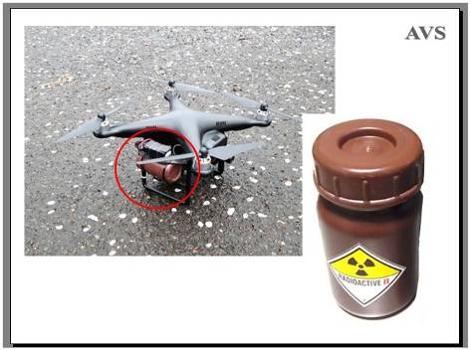
And in non-conflict countries, the threat may be greater because it is not expected. In April 2015 an SUA was discovered on the roof of the official residence of the Japanese Prime Minister. Attached was a cell-phone <Click> and some electrical wiring on top of a small brown bottle <Click> with a radiation hazard label. The quad-copter may have been there for several weeks before it was discovered.
The aircraft had been flown onto the roof as a protest against the Japanese Government's nuclear energy policies at a time when the Prime Minister was known to be absent. Low-level gamma radiation was found, but it was not a bomb and no harm was done, but it very easily could have been.
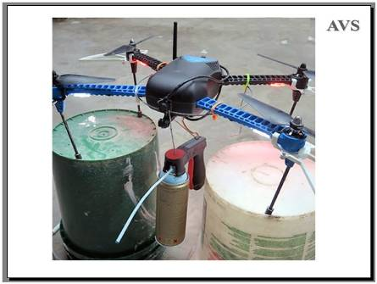
This SUA is sold with additional servos to allow it to be used for spray painting high on walls. Imagine if the spray-can contained a chemical, biological or radiological hazard.
[3DR IRIS+ has a flight time of 16-22 minutes and a payload capability of 400g with a range of approximately a kilometre.]
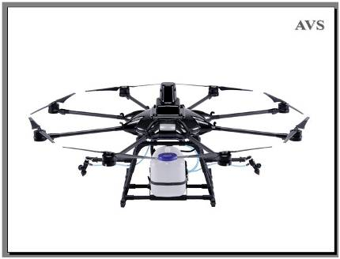
This “ProDrone” SUA is designed for selective crop spraying high in trees, so has a large capacity tank and wide spray nozzles.
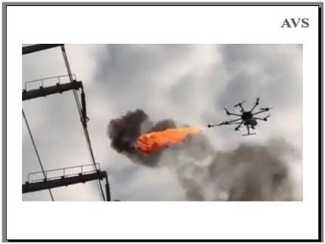
This aircraft in China is being used to fly alongside overhead cable and burn off garbage such as plastic bags with a flame thrower.
[Xiangyang, China.]
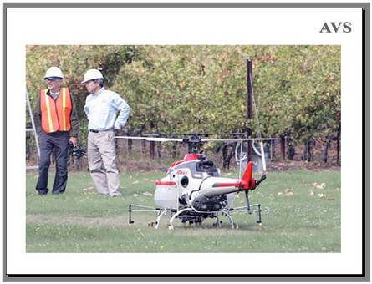
And the larger unmanned aircraft tend to have a longer flying time and larger load carrying capacity. This is a Yamaha RMAX agricultural crop duster put on sale in 2018. It is 3 metres long, has an 8 litre spray tank, and can fly for almost an hour.
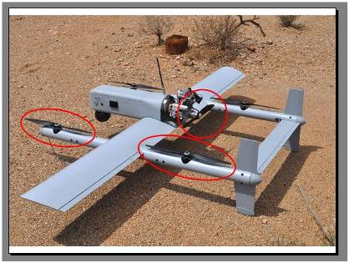
Longer flight times are achieved with fixed wing or hybrid aircraft like this one that can carry a 2 kilogramme payload and fly for 5 hours. It has helicopter rotors <Click> and a forward propeller <Click> with an internal combustion engine. It can take off and land vertically. And of course, with a longer flight time the attacker can be a greater distance away.
[Acturus HQ-40].
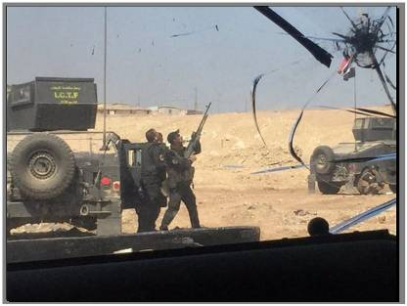
So how do we defend ourselves? The most popular method which can be surprisingly effective against low flying aircraft is to shoot them down. For this to have any effect, they first have to be seen or heard. Constantly scanning the sky for very small aircraft is not really practical. Also, they can be invisible at night and although some are surprisingly noisy when flying fast, others are not.
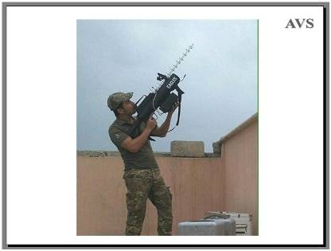
Electronic countermeasures intended to disrupt the radio control signal have been developed and some may work some of the time. With this one, the threat has to have been identified before the device is used. [It is the Raysun MD1 Multicopter Defender.]
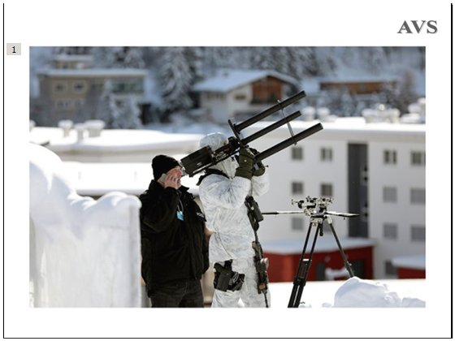
This is the HP_47 jamming system widely used in Europe. <Click> Again, the aircraft has to be spotted by eye before an attempt can be made to disrupt its control systems..
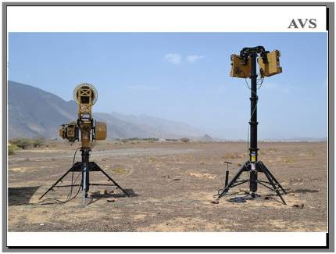
The Blighter system includes a radar to spot the aircraft. It can detect, track and identify the aircraft before disrupting its controls. <Click>
With all of these systems, disrupting the radio control signal may be of no use if the aircraft is pre-programmed and not controlled from the ground while it is flying. Disrupting its GPS positioning system may make it unable to complete its flight, but when the target area is large or the flight has been made before, the GPS system may not be used. A directed magnetic pulse that stops the electric motors may be the only way to stop them, but if the aircraft is carrying hazardous material, that will cause a problem when it crash lands.
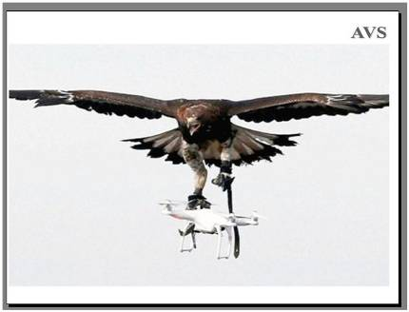
The best way to deal with the aircraft is probably to bring it down gently. Firing guns at an aircraft above an urban area would make it crash, and the bullets would create their own hazard, so the French security forces have been training birds of prey to attack the aircraft. This has worked, but is reported to be unreliable because the birds are easily distracted.
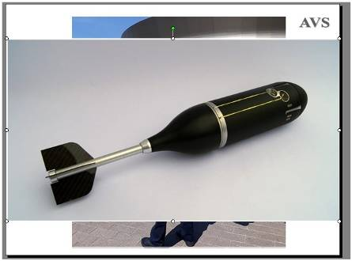
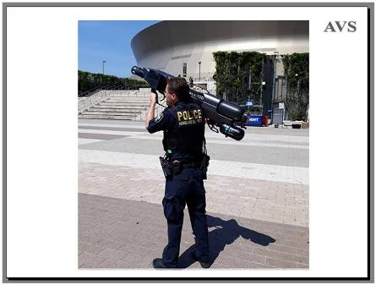
This Sky Wall 100 was in use by police in Los Angeles in 2017.
With a sophisticated aiming system, it fires a projectile <Click> containing a net and a parachute at the aircraft, so bringing it down gently to allow it to be forensically examined.
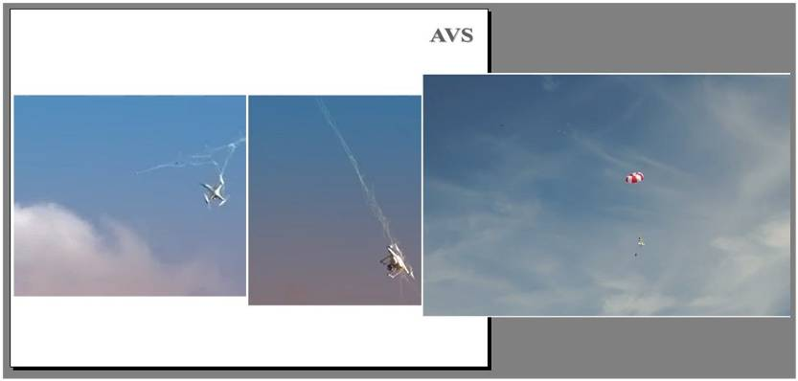
The projectile separates at a distance from the target and deploys a net.<Click> The net entangles the rotors of the aircraft, which falls. <Click>
But the net is attached to a parachute <Click>
so the aircraft falls to the ground gently. This can be very effective when the target is hovering, but less so if it is flying fast and its effective range is limited.
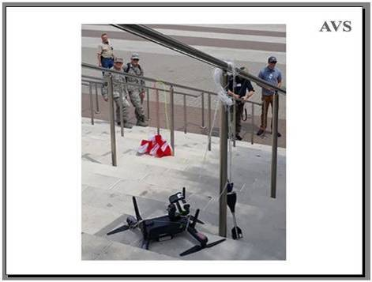
Bringing the aircraft down so that it can be examined is valuable because it may lead to the identification of the pilot. In many cases, as with this example, the aircraft will be only carrying a camera. The camera may be being used for innocent purposes or to gather information in advance of making an attack.
Laws making it illegal to overfly urban areas and high profile events can be required to make it legal to disable someone’s aircraft.
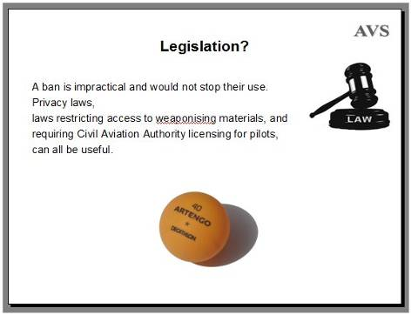
A ban on these aircraft would not stop their use because the people wanting to use them for illegal purposes would simply ignore the ban. As ISIS showed, anyone could buy the parts and make one themselves.
<Click> Laws protecting people’s privacy that can be used to prosecute people using the aircraft’s camera inappropriately are useful, <Click> as are laws restricting the ownership of weapons, munitions or bomb making materials. These have been tightened up in Britain because of general security concerns. For example, the purchase of tradition table-tennis balls made from cellulose is no longer allowed, <Click> because cellulose can be used in improvised detonators and pyrotechnics. Sometimes restricting a material can be counter-productive because the ban tells the bomb makers that this is a material they could use.
<Click> Laws requiring pilots to be trained and licensed can give the security forces a record of who is legitimately flying them and what they are used for.
Manufacturers are also concerned and some of the aircraft have built in software restrictions that prevent them being used in some geographic regions, such as the popular DJI Phantom aircraft that simply will not fly in Syria and Afghanistan. But of course, it did not take long for a software crack to be made available on the internet, so those who want to use them in those countries still can.
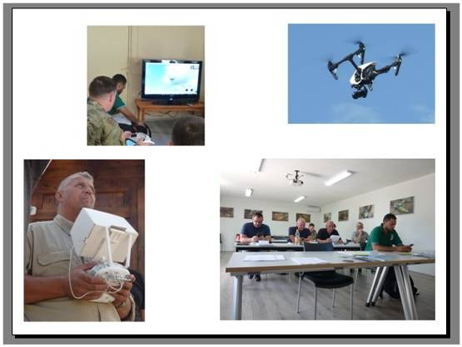
These pictures were taken during a small unmanned aircraft pilot training course held last year. The training was similar to the training of pilots who will fly manned aircraft.
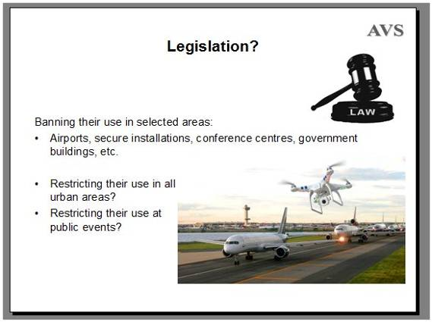
People who buy small unmanned aircraft and fly them for fun without any training also present a threat – especially when they think it would be interesting to film passenger airports or secure areas. The aircraft are difficult to detect and to reliably stop, so their use near any sensitive area should always be banned.
Small unmanned aircraft have very limited flight times, so, from a security perspective, <Click> restricting the unlicensed use of any unmanned aircraft in urban areas may make sense - partly because it would make it unquestionably legal for the security forces to bring them down.
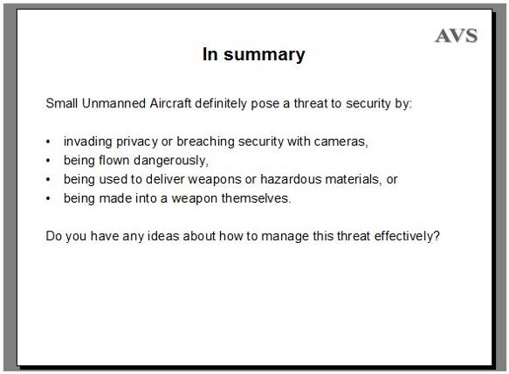
Small Unmanned Aircraft definitely pose a threat to security by:
<Click> invading privacy or breaching security with cameras,
<Click> being flown dangerously,
<Click> being used to deliver weapons or hazardous materials, or
<Click> being made into a weapon themselves.
<Click> Do you have any ideas about how to manage this threat effectively?

[2,412 words]

