IEDS and Humanitarian Mine action
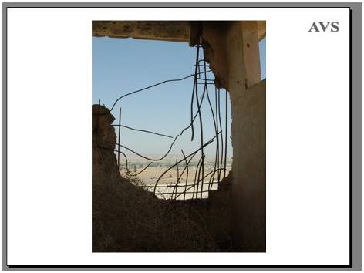
<Click>
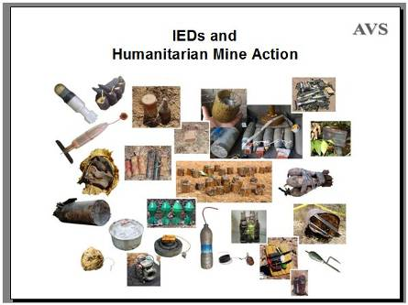

Improvised Explosive Devices and Humanitarian Mine Action
All Improvised Explosive Devices (IEDs) are made using some parts that were either designed for another purpose or have been made informally (outside conventional munitions factories). The term IED is used to describe so many different explosive hazards that it is useful to subdivide the definition of Improvised Explosive Devices.
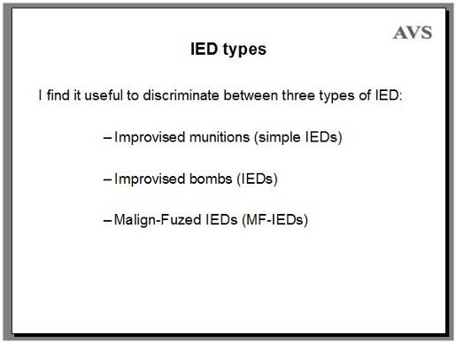
IED Types
I find it useful to discriminate between three types of IED: <Click>
- Improvised munitions (simple IEDs) <Click>
- Improvised bombs (IED bombs) <Click>
- Malign-Fuzed IEDs (MF-IEDs)
This distinction between types of IED was made to help determine both the appropriate political and the appropriate hands-on response to the device.
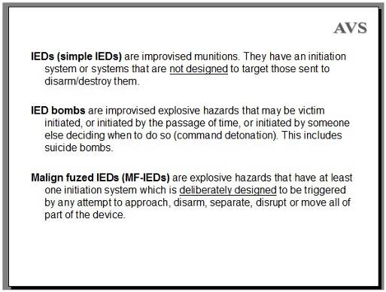
Simple IEDs are improvised munitions. They have an initiation system or systems that are not deliberately designed to target those sent to disarm/destroy them. <Click>
IED bombs are improvised explosive hazards that may be victim initiated, or initiated by the passage of time, or initiated by someone else deciding when to do so (command detonation). This includes suicide bombs. <Click>
Malign fuzed IEDs (MF-IEDs) are explosive hazards that have at least one initiation system which is deliberately designed to be triggered by any attempt to approach, disarm, separate, disrupt or move all or part of the device.
Simple IEDs are improvised munitions that are used in the same scenario as the conventional munitions they replace. Typically they include grenades, mortar bombs, rockets and mines. Improvised booby-traps are also made and used in the same way as conventional booby-traps manufactured in a munitions factory.
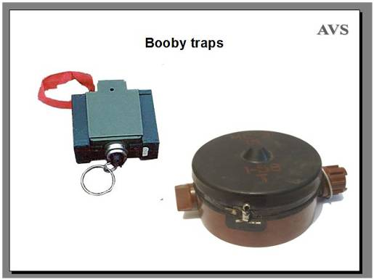
Booby-Traps
Booby-traps which are made in munitions factories and sold to armed forces as part of their arsenal are not improvised, so are not IEDs. Booby-traps are usually designed to target anyone who disturbs them, not specifically those sent to find and destroy them. <Click>
The ML-7 and <Click> MS3 anti-lift devices are good examples. They are designed to detonate when a weight is removed from on top of them.
These can be placed beneath mines to target anyone trying to lift the mines, of course, but the use of appropriate demining procedures can avoid the risk of injury.
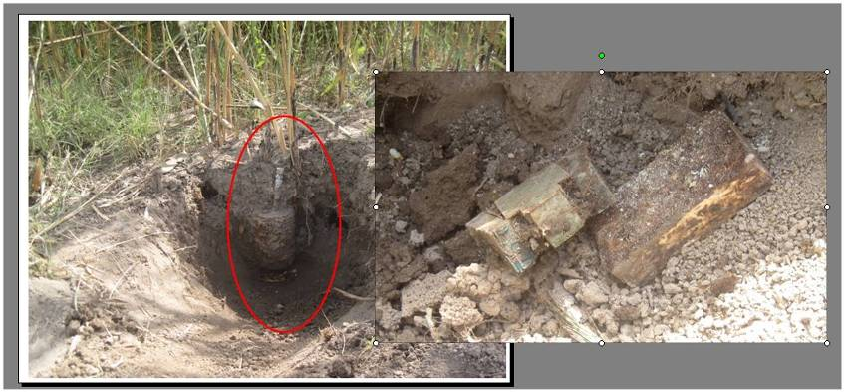
This picture shows an ML7 anti-lift device underneath an OZM-72 bounding fragmentation mine <Click> which was uncovered by soldiers from the Humanitarian Demining Unit in the army of Tajikistan.
The safe method of excavation by digging a long sloping hole in the ground to approach the device meant that the ML-7 was found before the mine was moved.
The mine was pulled from a safe distance and <Click> the ML-7 and a 200g block of TNT recovered from underneath it. It had been in place so long that it did not detonate as designed but the demining method meant that no one would have been injured if it had detonated.
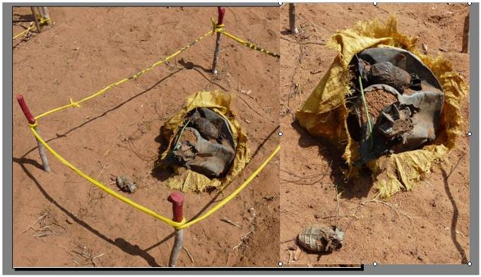
This is an improvised booby trap that as found in Sri Lanka. A grenade was left lying on the surface with a wire attached to a fuze inside a buried bag of munitions and loose explosives. <Click> Anyone who came along might pick up the hand grenade, which had its pin in place and looked safe.
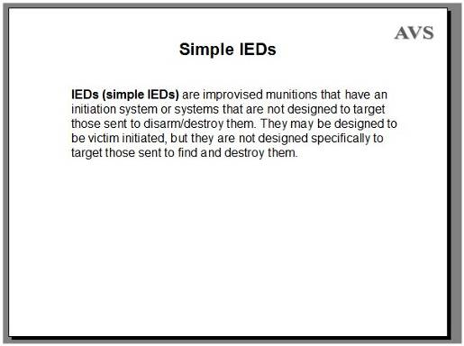
Simple IEDs
IEDs (simple IEDs) are improvised munitions that have an initiation system or systems that are not designed specifically to target those sent to disarm/destroy them. They may be designed to be victim initiated, but they are not specifically designed to target those sent to find and destroy them.
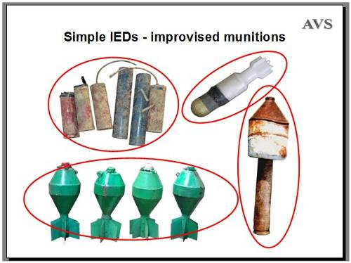
Simple IEDs - improvised munitions
This picture shows typical examples: <Click> Grenades, <Click> Mortars, <Click> rockets, <Click> and air dropped bombs. There are also improvised landmines, of course.
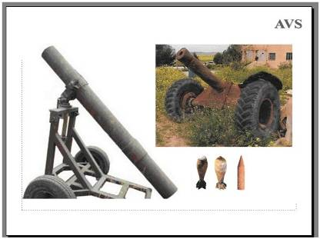
And with improvised munitions, there are often improvised weapons that are used to fire them.
The picture show a mobile mortar and a mobile field gun, both used to fire improvised munitions (both in Syria).
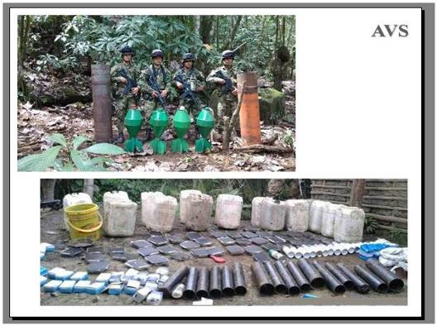
This shows <Click> improvised mortars and <Click> mortar bombs in Colombia 2017, along with the materials to manufacture other improvised munitions and mines.
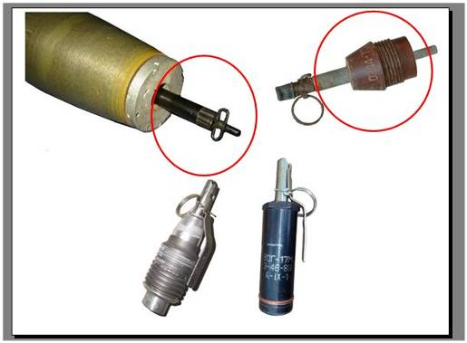
Improvised munitions have always been used and military training often includes ways of combining parts of one munition to improvise another.
The 88mm shell has been fitted with a <Click> pin-pull fuze in a German Army conversion dating from World War Two.
The mortar nose <Click> has been adapted to take a standard MUV2 fuze (found in Cambodia). <Click>
These hand grenades were improvised by combining parts of other munitions in Ukraine (2015).
It is not only rebels or terrorist groups who improvise weapons. Every professional army also does so when there is a need.
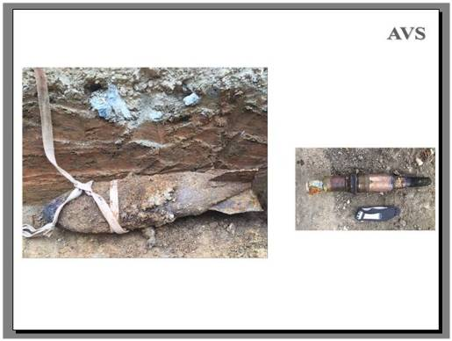
This large (500lb) Japanese aerial bomb was converted into a large landmine during WW2 battles in 1945 in Palau, which is a small group of islands in the Pacific Ocean. It was found and disarmed when excavating a new pipeline earlier this year. [NPA, Palau, 2018]
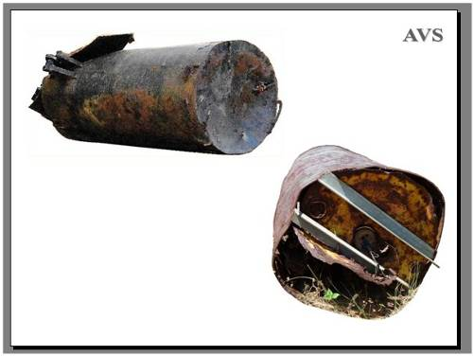
This is a barrel bomb made and used by government forces in Syria (2016). <Click>
And another kind of barrel bomb made by Tamil separatists and wired for command detonation that was found in Sri Lanka in 2009. The explosive charge in the barrel was surrounded with captured small arms ammunition that the separatists did not have the weapons to fire.
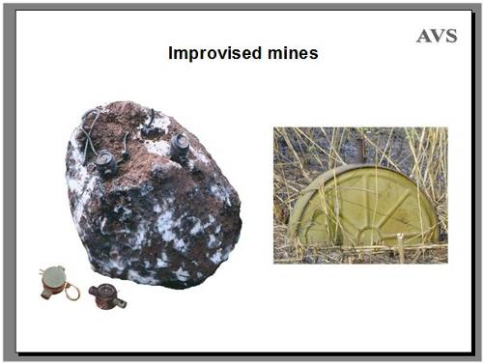
Improvised mines
Mines have been improvised in many countries.
This is an improvised rock mine found in Angola in 1998. It was probably placed by South African soldiers because the initiators <Click> were made in a South African munitions factory. [Prank booby-trap switches that are pressure sensitive.]
<Click> And this is a TM57 anti-tank mine that has been adapted to take an MUV fuze <Click> and so be initiated by a person pulling a tripwire (1997, in Angola).
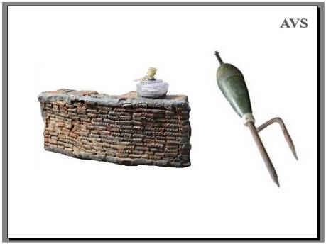
This is an improvised fragmentation mine found in Yemen (2017) and another kind of improvised fragmentation mine found <Click> used in Cambodia in 1997. The same conversion of a mortar bomb to a fragmentation mine was common in Sri Lanka ten years later.
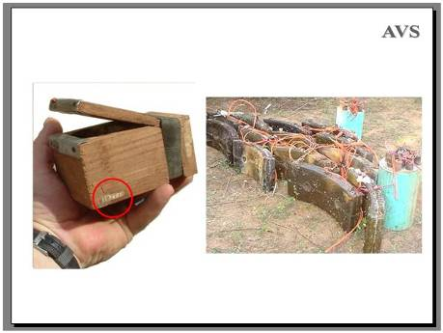
In Sri Lanka, this ‘Jonny’ mine was an improvised anti-personnel pressure mine that was battery operated. Although wrapped in plastic bags before being hidden, they were not very reliable because water quickly short-circuited the batteries. <Click> But enough were manufactured for them to be given a production number. <Click> This one was found unused. <Click> These improvised directional fragmentation mines were much bigger than usual (40cm tall) and all made to be command detonated in ambushes (photographed in 2008).
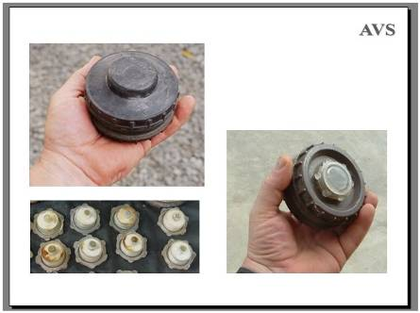
The conflict between Tamil separatists and the government in Sri Lanka went on for so long that the Tamils set up small factories to manufacture anti-personnel mines. These were known as Rangan Jonny 99s and had eleven separate parts. They proved reliable and many thousands were made.
Like many conventional mines, <Click> they were usually easy to disarm by unscrewing the detonators and boosters.
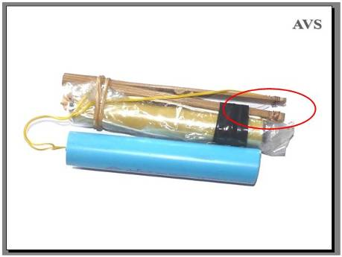
This is a common anti-personnel mine found in Myanmar (or Burma) in 2015. Wrapped in plastic bags before being placed, these are being made and used by anti-government forces today. The pressure plate is made using a piece of split bamboo <Click>. The blue plastic water pipe contains the high explosive, which is usually industrial gelignite used by companies mining for minerals. The electric detonators come from the same source and are fired by two 1.5v batteries held in the yellow pipe. The blue plastic pipe is replaced by a metal pipe to make a fragmentation mine.
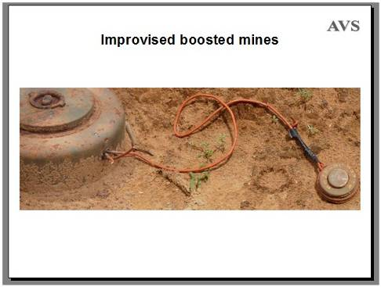
Improvised boosted mines
Sometimes factory made mines are linked together with other munitions to make an improvised hazard.
This (M15, USA) anti-tank mine in Sri Lanka was linked to four anti-personnel mines (Pakistan P4 mines) so that stepping on any one of the anti-personnel mines would detonate them all. This was found in a minefield laid by government forces.
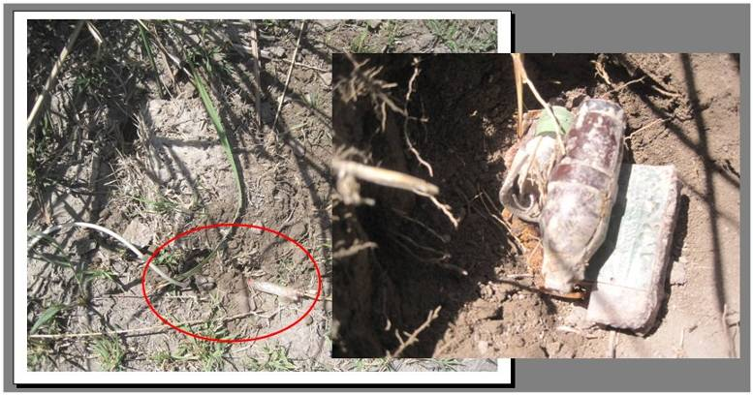
You can see some wires disappearing under the ground here… <Click> <Click>This improvised bomb was linked to a landmine in a minefield on the Tajikistan-Afghanistan border.
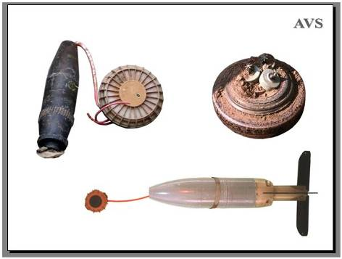
This is a boosted anti-tank mine found in Iraq – there was detonating cord attached to other munitions as well. (2006).
<Click> And a boosted anti-personnel mine photographed in Afghanistan in 1998.
<Click> Small mines can be boosted with other larger mines just by placing an anti-personnel mine on top of an anti-tank mine. Used on earth roads in Angola, this meant that even a bicycle would initiate an anti-tank mine. This terrorised local people so that they avoided the road, which was what the combatants wanted.
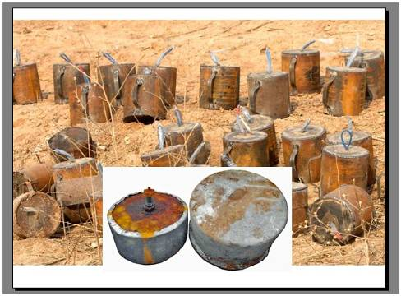
Isis made large numbers of mines for use in Syria and Iraq. They were sometimes booby trapped and were laid in defensive minefields in the same way as factory made mines are used. <Click> This shows another type of mine that is found there in large numbers. It has an improvised pressure fuze. The case of this mine was made using cooking pots.
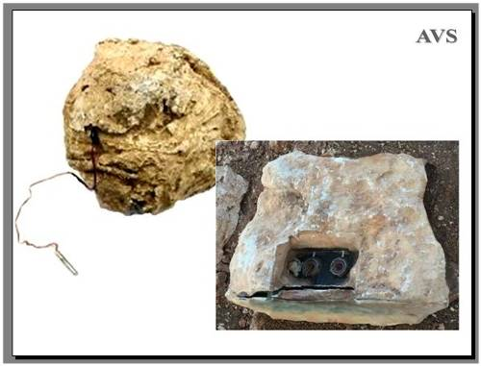
And there are rock mines in Syria too – some initiated by movement <Click> and some configured for command detonation. Anything that works in one conflict will quickly be copied in another.
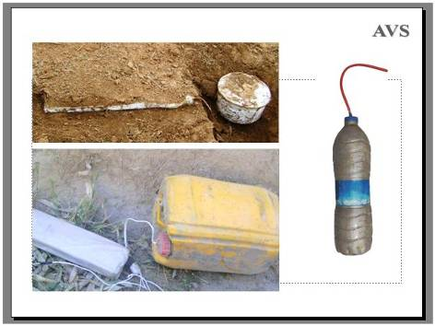
Improvising mines and other munitions is nothing new.
Some of the recently improvised mines have different initiation systems that we need to know about – such as the electrically initiated mines that have pressure plates positioned separately from the explosive charge - and may have several pressure plates wired to the same explosive charge.
Many contain explosive material that is improvised and can be unstable and hazardous to handle. Common examples are ammonium nitrate (combined with either aluminium, potassium sulphate, or diesel oil) or tri-acetone tri-peroxide and its variants. Conventional explosives such as TNT, RDX and plastic explosives may be added or used as boosters when available.
The explosive charge has been found packed into many improvised containers, from <Click> cooking pots and <Click> plastic bottles to…
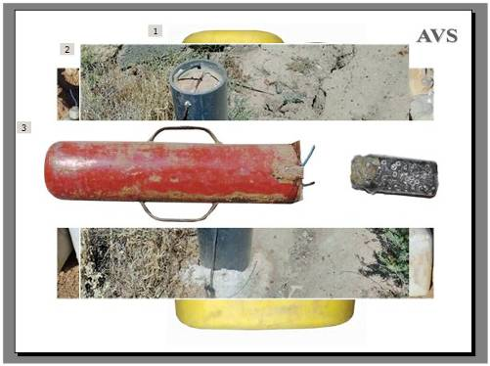
…cooking oil containers <Click> <Click> lengths of plastic sewer pipe, <Click> fire extinguishers and coffee jars.
Their failure rate can be high, so improvised munitions of all kinds are often still around when the conflict ends and the humanitarian demining teams start work.
But all this has been true for the past 25 years in Humanitarian Mine Action. With some extra specialised training designed for that conflict and those particular improvised munitions, this is just another day’s work in demining.
The initial approach to all improvised munitions must presume that they may detonate when moved because the explosive itself may do so regardless of what fuze system the munition has.
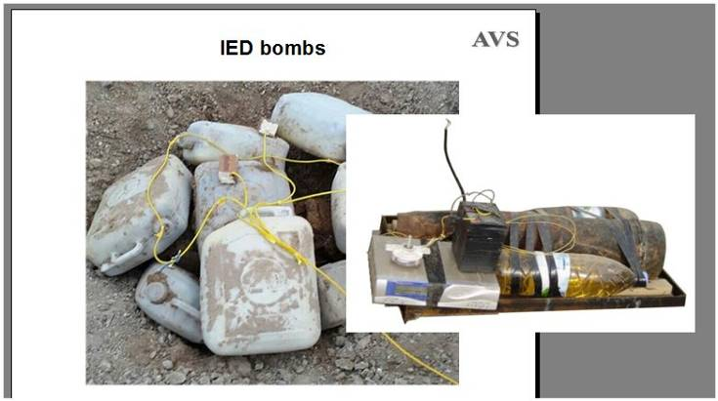
Moving on from IED munitions to IED bombs…
Typically, the fuze of IED bombs is either victim initiated, command detonated or detonated after the passage of a set time. <Click> Victim initiation may be by pressure, pull, pressure release, light, movement, seismic vibration, electromagnetic disturbance, or the completion or breaking of an electrical circuit.
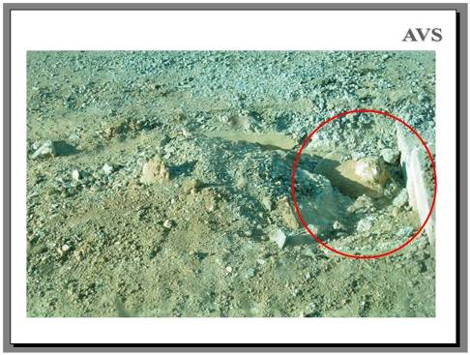
Roadside bombs may be fuzed for victim initiation or command detonation. This one had a pressure plate concealed under the road surface with the explosives <Click> concealed at the side of the road.
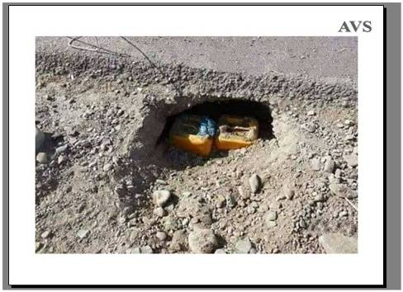
Others are wired for command detonation.
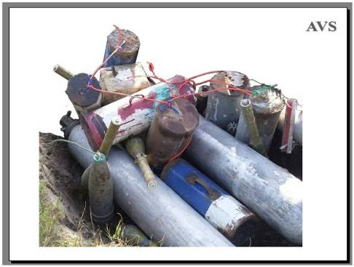
Roadside bombs are often boosted by a wide range of munitions. This is a Boko Haram bomb in Nigeria. Large gas bottles have been used to boost the explosion.
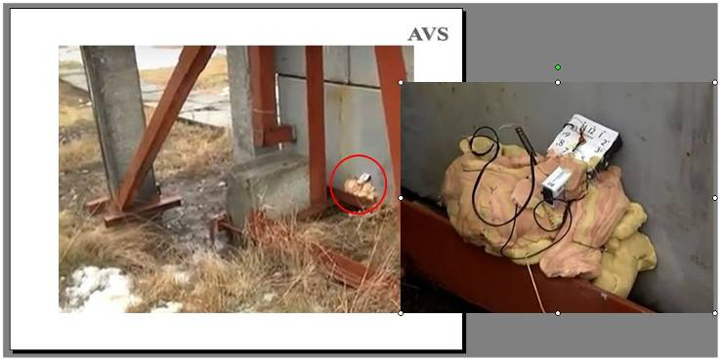
IED bombs can be placed in a way that is obvious <Click> possibly with the intention of limiting civilian casualties <Click>. This was found in an electricity sub-station in Ukraine this year. [March 2018]
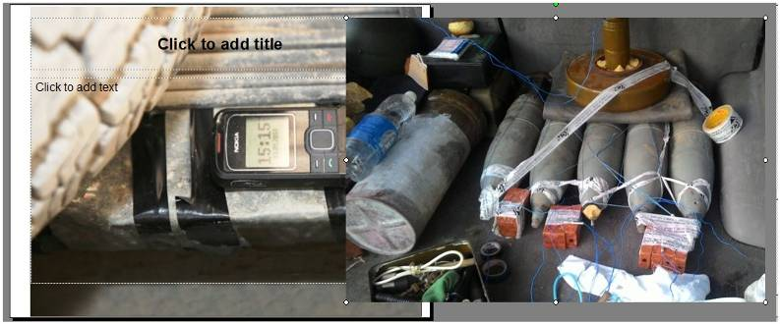
Car bombs, which may be beneath the vehicle. <Click> or inside it… [Ukraine 2016]
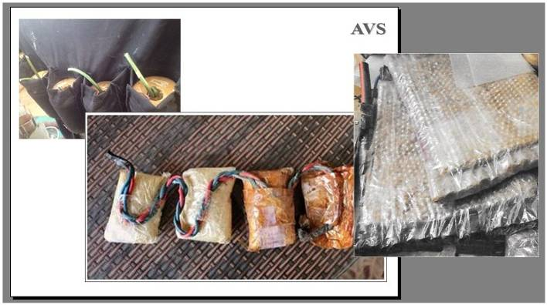
Suicide bombs worn by people…
This is a disarmed suicide vest recovered from a Boko Haram store in Nigeria.<Click>
And the content of an ISIS suicide vest from Syria <Click> where sometimes the explosive is sealed in lengths of hosepipe and the suicide vest faced with ball bearings to serve as fragmentation. The same kind of vest is used in Yemen.
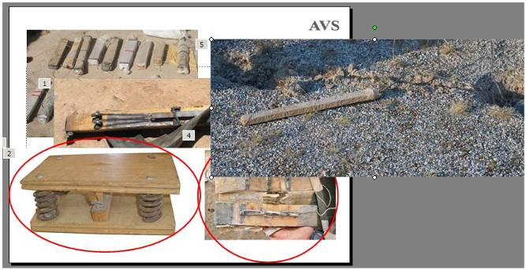
Next we have mines with pressure plates that are used to complete an electrical circuit to initiate the explosives. <Click>
This one from Afghanistan uses a recycled metal saw blade and springs to make a flexible connection. The whole thing was wrapped in a length of motorcycle tyre inner-tube to make it waterproof – but it was very easy to find with a metal-detector. <Click>
And on the left, this <Click> heavy wooden pressure plate was designed to initiate a roadside IED in Sri Lanka. The design was intended to spare civilians. The heavy springs would not be compressed by a light civilian vehicle, but would be compressed by a heavy military vehicle.
And on the lower right, <Click> this example from Afghanistan shows an ingenious way of making a pressure plate hard to detect with a metal-detector. It worked, so was copied in Iraq, Syria and Yemen. The thin electrical wires lead to carbon-rods that make the electrical connection, and do not make a metal detector signal. <Click>
As mentioned before, electrical pressure plates are often positioned some distance from the explosives.
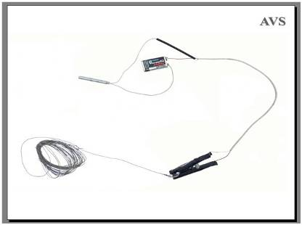
Other improvised switches for victim initiation can be very simple like this ‘clothes-peg’ switch.
This has been used in many countries (such as Afghanistan, Iraq, Syria and Sri Lanka). An electric detonator is attached to a battery. One wire is attached to a clothes-peg so that when the peg is closed, an electrical connection is made. A plastic disc attached to a wire is put between the jaws of the clothes peg holding them open. <Click> When the wire is pulled, the plastic disc is pulled out and the clothes-peg closes, making the electrical connection that fires the detonator. The wire may be stretched across a path or attached to something that someone may pick up or move.
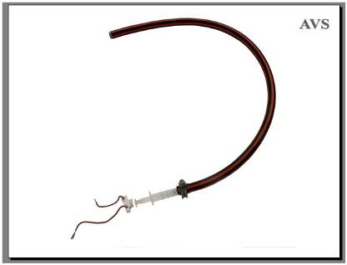
A metal free pressure plate can be made using a length of flexible hosepipe such as might be used to water a garden and a small hypodermic syringe. The hose is filled with water. When the hose is compressed, the plunger of the syringe is pushed out and presses the electric switch. <Click> This actually works more reliably if the hose is filled with oil.
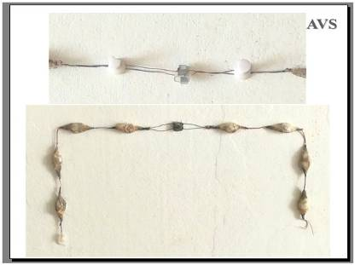
Reliable micro-electric switches which use very fine wires that are impossible to detect with a metal-detector have been made using a chain of computer keyboard switches. This can be metres long. Simply depress any one switch to complete the circuit and detonate the explosives.
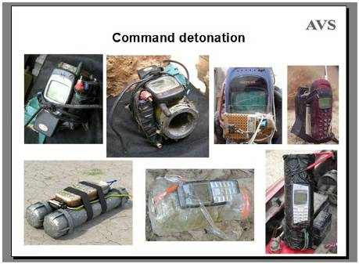
Command detonation
Command detonation is when someone deliberately detonates the bomb at a time that they choose, such as when their enemy is close to the bomb.
It is so simple to use a cell phone <Click> as a remote control switch for command detonation that it has often been done. A call to the phone may initiate a detonation or may start a timed delay. The phone can also be used as a timer switch with the detonation happening when the telephone’s alarm clock signals.
The ease with which the security forces can jam telephone signals has led to an increasing use of other ways to command detonate a device.
Using landline telephone or electrical wiring that is already in place to make a physical link is common.
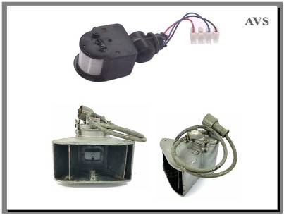
Infrared movement sensitive switches made for security lighting can be used to initiate a device when someone is close by, and the electrical power to the infrared sensor may be switched on remotely.
Also, <Click> infrared light signals can be broadcast over many kilometres with the right equipment and cannot be reliably blocked by current jammers. The picture shows a long-range infrared signal transmitter designed for secure military communications but readily converted as a means of remotely initiating IEDs.
Infrared receivers are commonly used in household devices that are remotely controlled (such as televisions), so are available for inclusion in the command detonation systems of IEDs. A direct line between the transmitter and receiver is not critical for reliable communication.
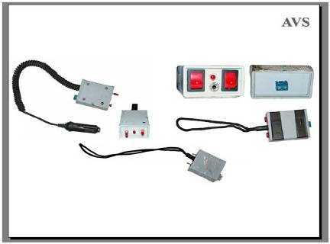
Many ordinary electrical items have been used as switches, from switches to unlock a car to the switch in a car door that turns on the light when the door is opened, and switches from household appliances.
This picture shows switches recovered from suicide bombs.
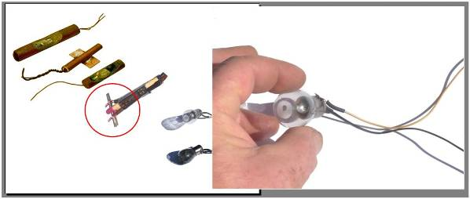
Even the detonators may be improvised. Anything that gets hot can start the detonator, from <Click> friction-strike matches and carbon from a pencil to a <Click> light-bulb filament surrounded with inflammatory chemicals. <Click> It is surprisingly easy to make a hole in the end of a light bulb.
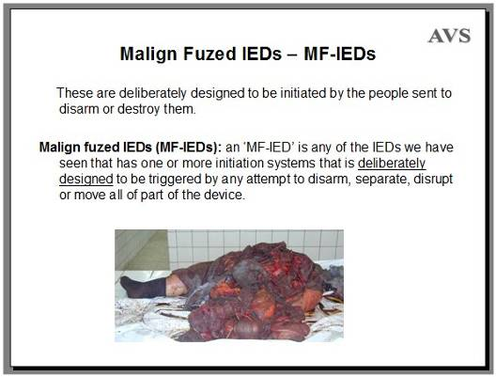
From IED munitions and IED bombs to Malign Fuzed IEDs.
These are deliberately designed to be initiated by the people sent to disarm or destroy them.
A Malign Fuzed IED is any of the IEDs we have seen that has one or more initiation systems that is deliberately designed to be triggered by any attempt to disarm, separate, disrupt or move all of part of the device.
So any explosive hazard can be turned into an MF-IED by the addition of an initiation system designed to target those sent to find and destroy it. MF-IEDs may have several initiation systems, any one of which may be followed by a delay to give the impression that the hazard is safe, so maximising injury.
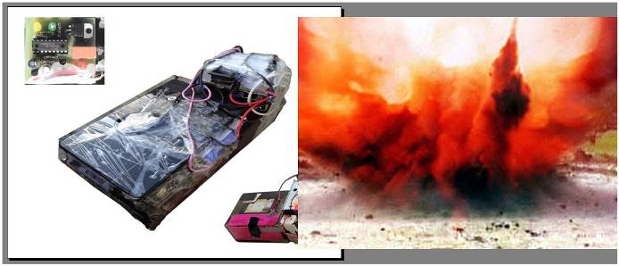
When the person making a switch knows how to build circuit boards and program computer chips, the initiation systems can be very hard to understand and so impossible to safely take apart. Approaching it, moving it, shining a light on it, cutting a wire… all can be fatal. The only safe thing to do is to disrupt it from a distance. If the disruption is well aimed and fast enough, it can often prevent the bomb exploding <Click> but not always.
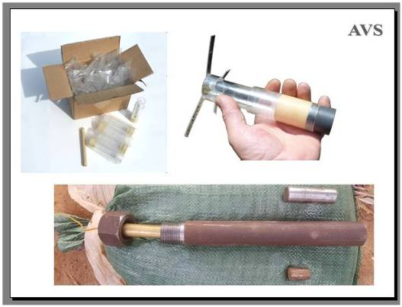
There are many ways to disrupt an IED that may be a MF-IED, and I will talk about a few of them in another presentation.
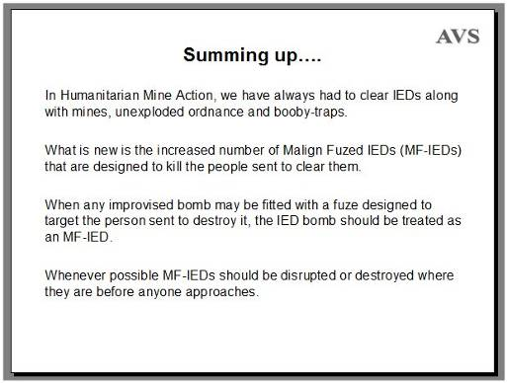
Summing up…. <Click>
In Humanitarian Mine Action, we have always had to clear IEDs along with mines, unexploded ordnance and booby-traps. <Click>
What is new is the increased number of Malign Fuzed IEDs (MF-IEDs) that are designed to kill the people sent to clear them. <Click>
When any improvised bomb may be fitted with a fuze designed to target the person sent to destroy it, the IED bomb should be treated as an MF-IED. <Click>
Whenever possible MF-IEDs should be disrupted or destroyed where they are before anyone approaches.

I would like to add that this is my personal view and that I use definitions that I have found useful. Other people with diverse and valuable experience use other definitions. Defining the words used is important for things to be clearly understood, but the definitions need not always be the same. Regardless of what we call things, I believe that true security requires co-operation and the honest information exchange that this workshop is designed to promote.

Thank you for your attention.

