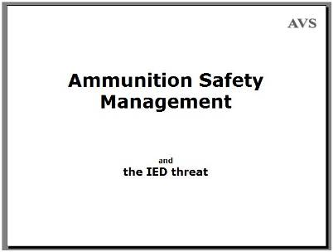
Ammunition Safety Management and the Improvised Explosives Hazard (IED) threat
[This presentation was written for delivery at a workshop in the Central Asian State of Kazakhstan in 2018. People from Ukraine were also present. Text in square brackets is not on the slides. Each <Click> is a prompt for a mouse-click.]
This presentation is about the need to store ammunition in a way that prevents it falling into the wrong hands or causing accidents.
We all know that effective risk management relies on identifying the risks and gathering as much information about the ways that others have used to avoid or reduce them as possible before deciding priorities and making decisions.
This presentation reflects my personal opinion in support of sharing experience, opinion and information about ammunition safety management. Most of it will not be new to you but sometimes it can be interesting to see things through another person’s eyes.

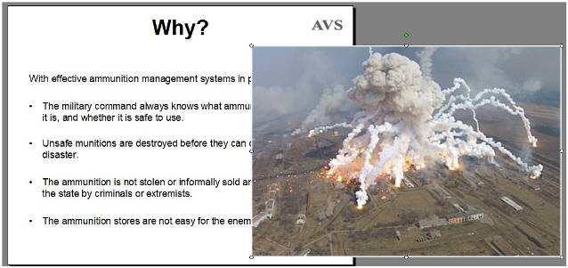
Why?
With effective ammunition management systems in place: <Click>
- The military command always knows what ammunition it has, where it is, and whether it is safe to use. <Click>
- Unsafe ammunition is destroyed before it can explode and risk a civil disaster. <Click>
- The ammunition is not stolen or informally sold and used to threaten the state by criminals or extremists. <Click>
- The ammunition stores are not easy for the enemy to attack.
By using an efficient system, the military will always know what it has, where it is and when it should be replaced, so making the forces safer and better able to do their job with reliable ammunition when needed. They will also keep their ammunition secure so that it cannot be misused in improvised explosive devices that threaten security for everyone – and so that the storage areas are not easily attacked by the enemy. <Click>
Many will remember this ammunition store blowing up in Ukraine in 2017. There were reports that the fires were started by saboteurs. [Balakliya, 600 km East of Kyiv.]
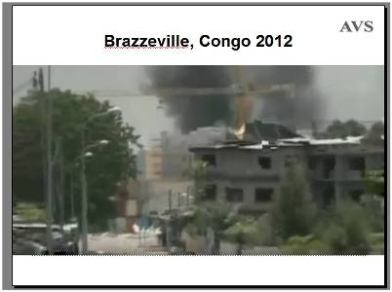
[Brazzeville, Congo, 2012.
In other well known accidents in ammunition storage areas, such as Brazzeville in Congo in 2012, the cause was found to have been a fire that spread amongst old and unstable munitions. In this case, the ammunition was stored in large quantities in a military barracks inside the city.
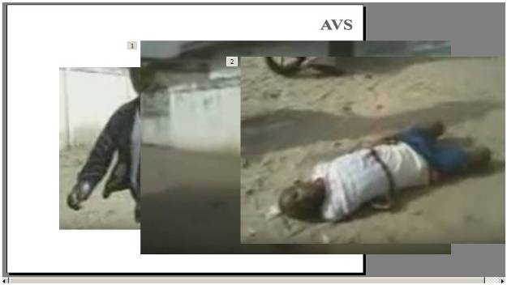
As with most ammunition storage area accidents, the event was not just one explosion. It went on for hours, with munitions being thrown great distances and cutting women and children down as they tried to run away. <Click> The final death toll was estimated to be 500. There were an additional 3,277 recorded casualties including many children. <Click> At least half of the dead were soldiers trying to extinguish the fire caused by the first big explosion. There were three large explosions in all.
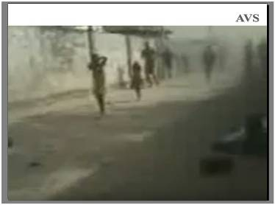
Some Grad rockets landed 5 km away inside the city – and although they had no warhead attached, they destroyed property and killed people. Smaller rockets with warheads attached were detonating in a radius of a kilometre from the centre of the blast.
This cost the government millions of US dollars in terms of compensation and far more in terms of re-building its military capacity and its stockpile of serviceable weapons.
An official inquiry found an army Corporal guilty of setting the fire and sentenced five officers to fines and prison terms for failing in their duty. One of the Colonels was so angered by the sentence that he resisted arrest and 40 of his men died before he finally surrendered. I am not saying these people were not guilty, but I am saying that finding evidence to definitively prove anyone’s guilt would be difficult after so must devastation and do many deaths in the barracks. During the cleanup afterwards, many old and unstable munitions were found. It is likely that, even if unstable ammunition did not start the fire, it probably helped it to spread.
[Small Arms Survey report.]
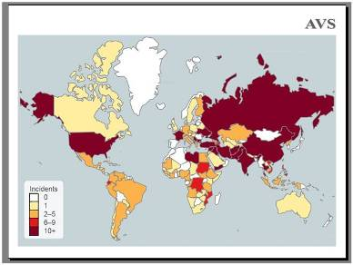
Accidents in ammunition storage areas occur in almost every country.
This slide shows the numbers of accidents that have occurred since records began in1980 up to 2018. The darker the colour shown, the more accidents there have been there. Very few countries have had none – and countries with the most munitions tend to have had most accidents.
This data comes from the Small Arms Survey Group based in Geneva, which is supported in some of its work by the US Office of Weapons Removal and Abatement.
[http://www.smallarmssurvey.org/weapons-and-markets/stockpiles/unplanned-explosions-at-munitions-sites.html
http://www.smallarmssurvey.org/publications/by-type/handbooks/uems-handbook.html
https://2001-2009.state.gov/t/pm/rls/fs/107694.htm]
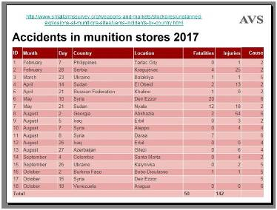
There were 18 recorded ammunition storage accidents in 2017. They occurred all around the world, from Venezuela to Ukraine and the Philippines to Burkino Faso.
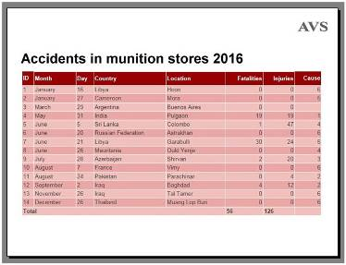
And 14 in 2016, in countries ranging from Thailand to France, Pakistan to Argentina.
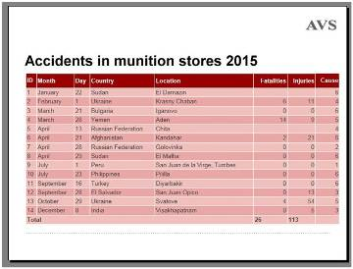
And 14 again in 2015.
The United Kingdom have had accidents, the USA has had accidents, Russia, Germany, India, China and even….
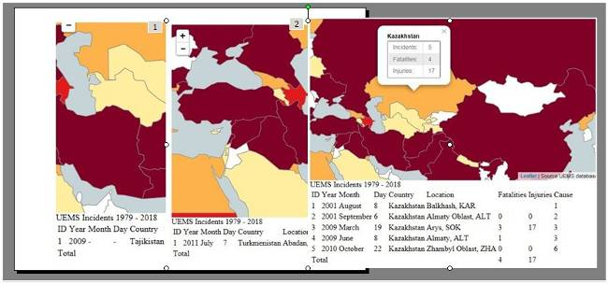
Tajikistan, <Click> Turkmenistan <Click> and Kazakhstan
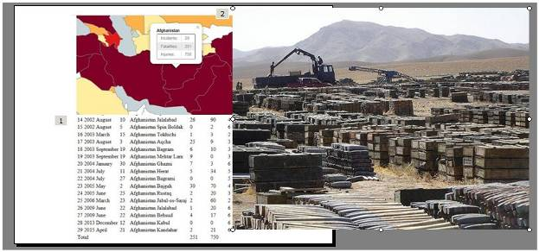
With, unsurprisingly, the most accidents in this region happening in Afghanistan, <Click> where the army inherited many unsatisfactory storage areas, <Click> and has many competing risk management priorities.
[Some more detailed information about some the accidents is at https://2009-2017.state.gov/t/pm/rls/fs/182344.htm.]
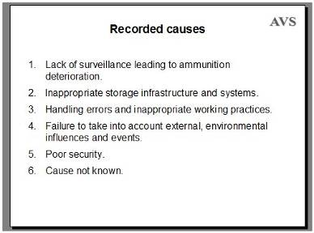
Recorded Causes - these are the causes recorded by the Small Arms Survey Group
- Lack of surveillance leading to ammunition deterioration.
- Inappropriate storage infrastructure and systems.
- Handling errors and inappropriate working practices.
- Failure to take into account external, environmental influences and events.
- Poor security.
- Cause not known
Having a record of the ammunition storage accidents is very useful, but the recorded causes may be less so. The survey uses those six main categories with a little additional detail, but the true reason for the accident is often unknown. This is inevitable when there is often no physical evidence of a cause in the aftermath of large explosions. One cause that the survey does not list but which I have seen myself in Angola and Afghanistan is the storage of recovered UXO in the same place as unused ammunition. Sometimes this is done without thinking, but sometimes it is done because the UXO may be useful in making IEDs.
There was an explosion on March 19th 1997 in Jalalabad. This is recorded as having involved 200 tons of munitions. It occurred in a munitions depot, killing 30 people and injuring approximately 200. I was worning near the city and was told that the accident was caused by unstable unexploded munitions that had been added to that store routinely.
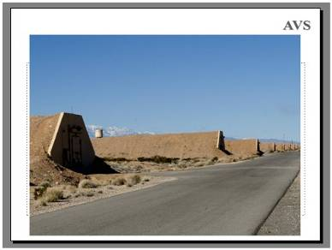
This is a fairly typical ammunition storage area in the United States.
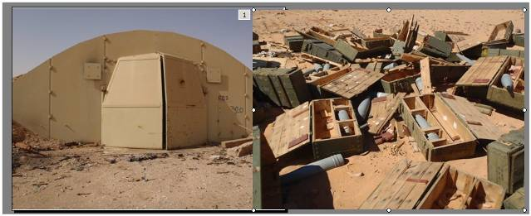
And this is an ammunition storage area in Libya. Having modern storage areas is no good if your enemy knows where they are and the place is not appropriately secured. This is a bunker at the Gharyan storage area, one of the few that was not bombed by coalition aircraft. But the door is open and <Click> the desert around it is strewn with munitions that people took away.
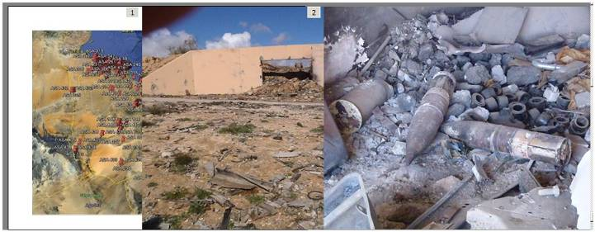
This Google Earth map shows all of the ammunition storage areas in Libya, some of which had dozens of bunkers. Each red pin is an ammunition storage area. Most of these ammunition storage areas were bombed in 2011. Some burned out and in others the contents were spread around. This is another bunker after it was bombed. Armed groups and ordinary civilians took what they wanted.<Click>
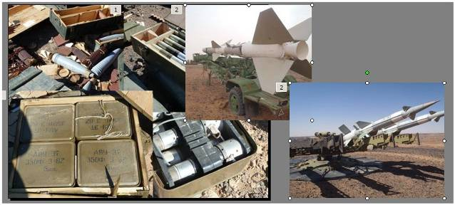
With so many weapons and so much ammunition freely available, the armed militia groups could take whatever looked useful. <Click> Even the damaged munitions were used in IEDs. There is evidence that some of these weapons and munitions found their way to Syria, Yemen, and Palestine. <Click> These SA-2 missile systems were found unguarded months after the bombing. Fortunately no one had the means to use them or to take them away. The consequences for security when ammunition and weapons storage is compromised is always severe. Those consequences are not only national, but regional and international.
[Site for SA-2 missiles in Sebha]
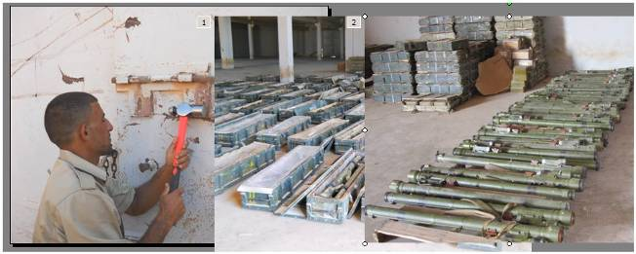
A lot of unpublicised effort went into finding and destroying Man Portable Air Defence Systems, <Click> MANPADS, that could have been used against civilian aircraft. Hundreds of MANPADS <Click> were found in Bhenghazi Artillery storage area and destroyed by coalition forces.
[Sebha Ban Arif storage area.]
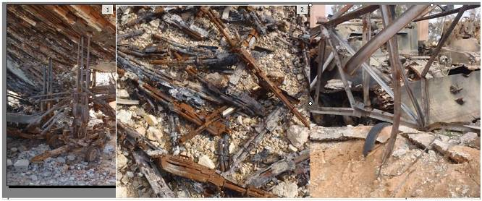
Some ammunition storage sites are also used to store weapons, the loss of which can be an additional huge expense. This is the Al Aziziyah ammunition and weapon storage area in Libya after it burned out. <Click> Everything from small arms to <Click> armoured vehicles were destroyed.
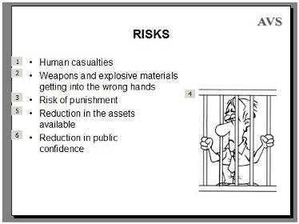
Insecure or unsafe storage areas present risks.
<Click> The most obvious risk is that there will be human casualties – often civilian, with women and children at high risk whenever a storage area is inside or close to a town. This is a humanitarian priority for all security forces.
<Click> When security is poor, enemies may steal ammunition and weapons. If there is an accident, the risk that ammunition will be spread around and may be accessed by enemies is also very real. And the cost of cleaning up can be far greater than people expect.
<Click> Less obvious perhaps is the risk of the staff responsible for an ammunition storage area being held legally liable for a security breach or an accident, which could affect their careers, cost them money and even lead to them being imprisoned. <Click>
<Click> Perhaps the most important risk is that the security forces will lose ammunition and equipment that cannot be easily replaced. There can be severe consequences for the security of the country when the armed forces do not have the equipment they need. The consequences can be even worse if the ammunition and weapons are stolen and the security forces are unaware that they are missing.
<Click> When there are accidents or security breaches in areas controlled by the military, this can erode public confidence in them - and national security relies on the people having confidence in the professionalism and reliability of their security forces.
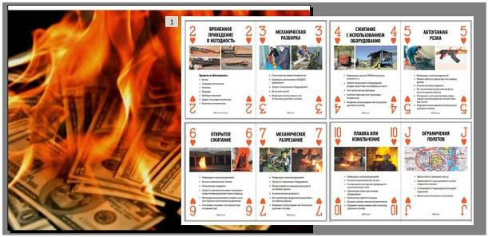
The cost of knowing what ammunition and weapons you have, where it is, and whether it is safe to use can be high when that means building secure storage areas, training staff, and keeping accurate records. The cost of destroying unserviceable ammunition can also be high, and there are many ways to do this apart from simply blowing it up. <Click> The picture shows a few of the playing cards that are part of the available teaching materials for the disposal of unwanted ammunition and weapons.
The cost of having secure and safe facilities may be high, but the cost of not having secure and safe storage areas can be far higher in terms of both money and national security.
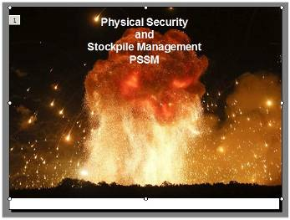
Whatever name we choose to use, this all about the physical security of ammunition stores and stockpile management. <Click> [Physical Security and Stockpile Management PSSM.]
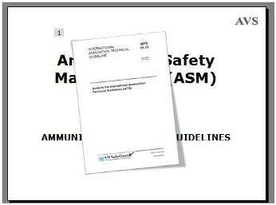
International Ammunition Technical Guidelines (IATG) are part of what the people in New York and Geneva call, Ammunition Safety Management or ASM. This covers the management of unexploded and abandoned munitions as well as stockpiles of ammunition.
In 2011 the UN’s International Ammunition Technical Guidelines (IATG) were first published. <Click> and they are now part of the UN’s Safer Guard system.
Ammunition is designed to be as safe as possible in storage but it contains hazardous compounds and was not designed to last forever. The level of risk associated with it depends on the condition of the ammunition, the competence of the people responsible for it, the management systems that are used, and the context in which it is stored.
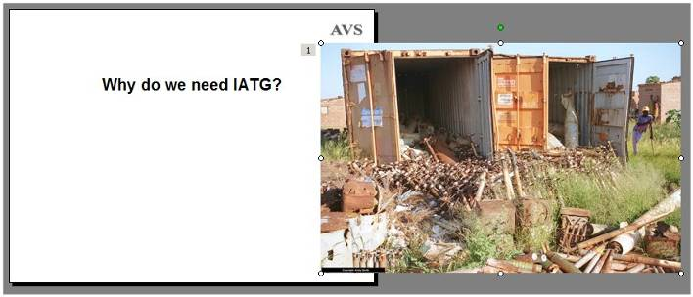
Why do we need IATG?
I think that every country can learn something from the IATG – but some places need them more than others. <Click>
In Humanitarian Mine Action we have always had to deal with ammunition stores and UXO as well as mines. These containers were in a residential part of the city of Luanda in Angola. During confused fighting in the civil war, it seems that this storage area was forgotten and local people broke into the containers looking for anything of value. Collecting and transporting these safely out of the city for destruction was a major challenge.
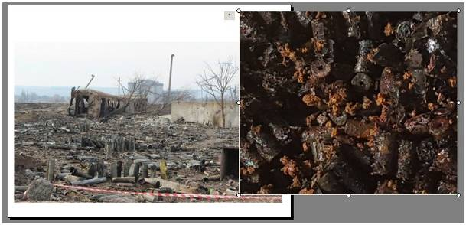
That problem in Angola may have been unusually bad, but we know that the problem of accidents occurring at ammunition stores is common.
As far as we know, the most frequent cause of these explosions is fire. This may be caused by lightning strikes, dry vegetation catching fire in the sun, electrical faults, careless handling causing sparks, spontaneous combustion, or by sabotage. Where undergrowth is allowed to grow out of control or where other flammable material is stored with the ammunition, any fire that starts can quickly get out of control.
All ammunition is affected by fire but items over 20 years old are particularly susceptible, especially ammunition containing propellant. As propellant gets older it gradually loses the stabiliser put into it when it was manufactured. <Click> This can lead to the spontaneous ignition of the nitrocellulose within the propellant, or ignition after a small impact, such as when a munition falls over. These nitro-cellulose pellets date from WW2 and have to be kept wet to avoid the risk of friction ignition.
There is no point in keeping old and unreliable ammunition. Managing the stockpile so that old ammunition is destroyed before it becomes a hazard is obviously beneficial.
[The first picture shows the aftermath of the ammunition storage area explosion in Svatove, Ukraine.]
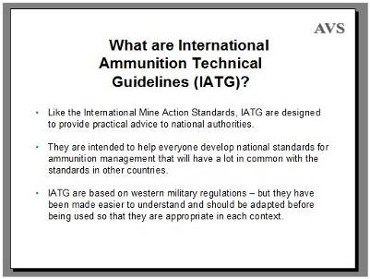
What are International Ammunition Technical Guidelines (IATG)? <Click>
- Like the International Mine Action Standards, International Ammunition Technical Guidelines are designed to provide practical advice to national authorities. <Click>
- They are intended to help everyone develop national standards for ammunition management that will have a lot in common with the standards in other countries. <Click>
- The International Ammunition Technical Guidelines are based on western military regulations – but they should be adapted before being used so that they are appropriate in each context.
The IATG contain ideas from around the world that are intended to maximise safety and help keep your ammunition secure.
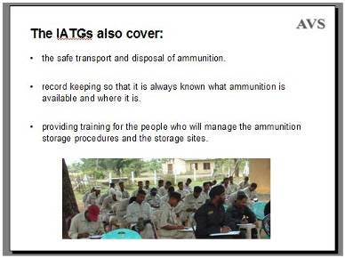
The IATGs also cover: <Click>
- the safe transport and disposal of ammunition; <Click>
- record keeping so that it is always known what ammunition is available and where it is; <Click>
- providing training for the people who will manage the ammunition storage procedures and the storage sites.
The IATG training requirement is designed to ensure that everyone is appropriately trained and that there are people able to train the next intake of staff.
As usual when things are written by committees where everyone must agree, the IATGs are not quite what I think they should be. However, the Geneva International Centre for Humanitarian Demining (GICHD) has developed an Ammunition Management Toolset that is sometimes more practical than the IATGs.
[https://www.gichd.org/resources/databases-and-tools/detail/publication/ammunition-safety-management-asm-toolset/#.W3RJzY2Wziw]
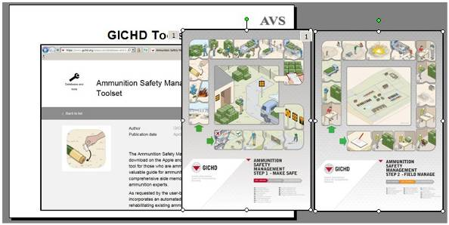
The Geneva International Centre for Humanitarian Demining’s toolset on their website gives a practical approach to the IATG and includes resources such as these posters. <Click>
[https://www.gichd.org/resources/databases-and-tools/detail/publication/ammunition-safety-management-asm-toolset/#.W3RJzY2Wziw]
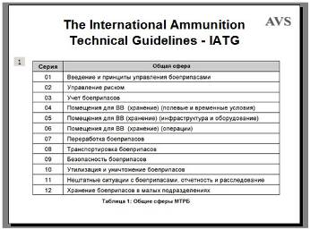
There are 45 separate documents in the International Ammunition Technical Guidelines. More than 1200 pages – but the good news is that there is a lot of repetition than can be skipped and they are available <Click> translated into the Russian language.
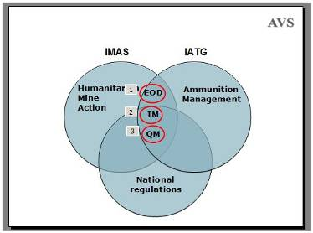
There is an overlap between the International Mine Action Standards (IMAS) and International Ammunition Technical Guidelines. There will also be an overlap between both of them and the national ammunition management standards or operating procedures that are used in each country.
What is shown in the overlap here is <Click> Explosive Ordnance Disposal, <Click> Information Management and <Click> Quality Management.
Each of those is a discipline we already have, but which we can improve by sharing ideas and learning from others. We do not have to do things in the same way, but if we use a similar system, we can share successes and problems more easily. But the International Ammunition Technical Guidelines should be examined and adapted for each context.
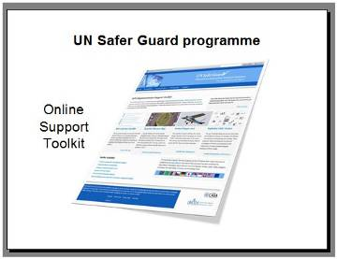
The International Ammunition Technical Guidelines have an online support kit that is available online from the UN Safer Guard website.
I believe that there really is a need for standards. I also believe that the only way to make these standards genuinely practical is for the people who use them to make corrections and improve them. The people in New York and Geneva are doing their best but they need help from the users. Getting engaged in the standards process can be frustrating but also rewarding because end-users can help to improve them.
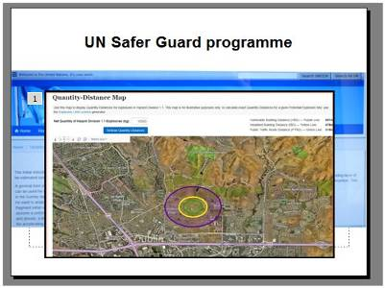
Tools on the UN’s Safer Guard website include <Click> a simple calculator for the blast over-pressure from high explosive sources at various ranges – and…
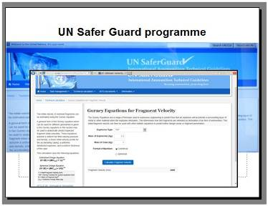
…a way of determining the likely velocity of fragments.
These tools allow you to:
- Perform an Explosion Consequence Analysis;
- Predict the noise of a detonation; and
- Calculate an Explosion Danger Area.
The IATG documents are available at the website along with some useful reference and training materials.
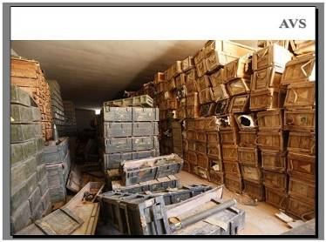
Summing up… Poor ammunition management leads to the risk of an explosion whether or not there is a fire.
Chemical and mechanical parts or munitions degrade with age and spontaneous detonations have occurred.
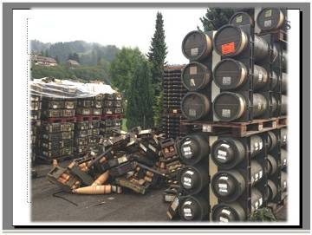
Ammunition in good condition can still be mistreated in a way that causes a catastrophe, especially in places where different kinds of munition are stored together.
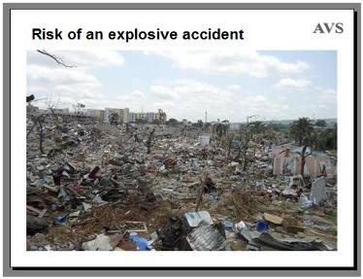
Risk of an Explosive Event
If there is an explosion – with loss of civilian life and munitions scattered over a wide area - this is a humanitarian disaster, but is can also have other consequences for those responsible for the ammunition.
The cost of clearing up and replacing ammunitions and weapons can be far higher than the cost of improving storage facilities.
It can lead to an immense amount of work clearing up scattered munitions over a very wide area.
It can make the armed forces very unpopular with the population.
For both humanitarian and practical purposes, no one wants an ammunition storage area to explode but if ammunition is not well managed and old munitions are not destroyed before they decay, there is a high risk that an accident will happen.
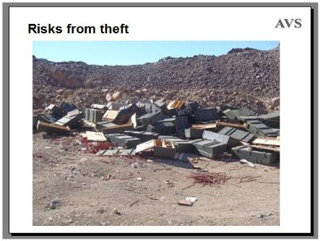
Risks from Theft
When insecure storage leads to theft, there are two main problems. First, the armed forces may not have the ammunition and weapons they need. Second, the missing ammunition will almost certainly end up in the hands of people opposing the security forces.
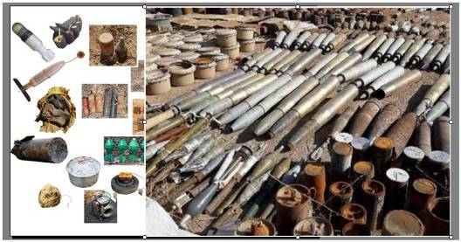
Insecure ammunition storage can provide munitions to enemies of the state.
Even when the thieves do not have the weapons to fire the ammunition they have taken, the stolen ammunition can be used to make the Improvised Explosive Devices (IEDs). <Click> this picture shows an ISIS stockpile of Improvised Explosive Devices and components in Syria. If ammunition is available on the informal market, extremists will use it.
This is not only an internal security issue because weapons and ammunition that are not state controlled have often been moved across borders to be used in attacks that take place in other countries. Regional co-operation is a logical necessity.
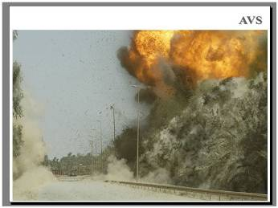
This picture shows an Improvised Explosive Device detonating in Iraq.
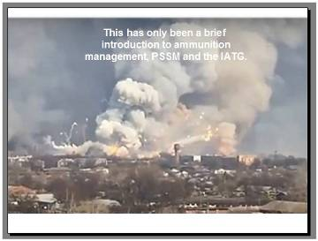
This has been a brief introduction to my views on ammunition management, Physical Security and Stockpile Management (PSSM) and the International Ammunition Technical Guidelines (IATG).
Nothing we do can guarantee that there will never be accidents or thefts in ammunition storage areas, but we can make them very rare events by sharing our knowledge about managing risks and cooperating for everyone’s benefit.
A lot of other information about what other countries have done is available and there are international programmes that can advise and assist.
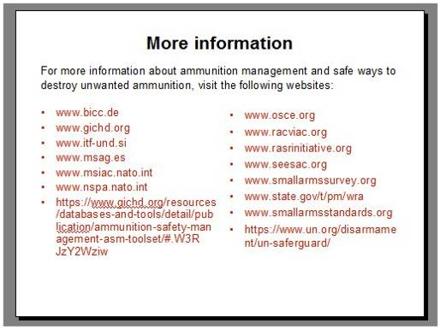
For more information about ammunition management and safe ways to destroy unwanted ammunition, you can visit the following websites, or ask for assistance from the OSCE offices.
www.bicc.de
www.gichd.org
www.itf-und.si
www.msag.es
www.msiac.nato.int
www.nspa.nato.int
https://www.gichd.org/resources/databases-and-tools/detail/publication/ammunition-safety-management-asm-toolset/#.W3RJzY2Wziw
www.osce.org
www.racviac.org
www.rasrinitiative.org
www.seesac.org
www.smallarmssurvey.org
www.state.gov/t/pm/wra
www.smallarmsstandards.org
https://www.un.org/disarmament/un-saferguard/

