HMA Global SOPs 2018
CHAPTER 7: IED Search & Clearance

Release date: December 2018
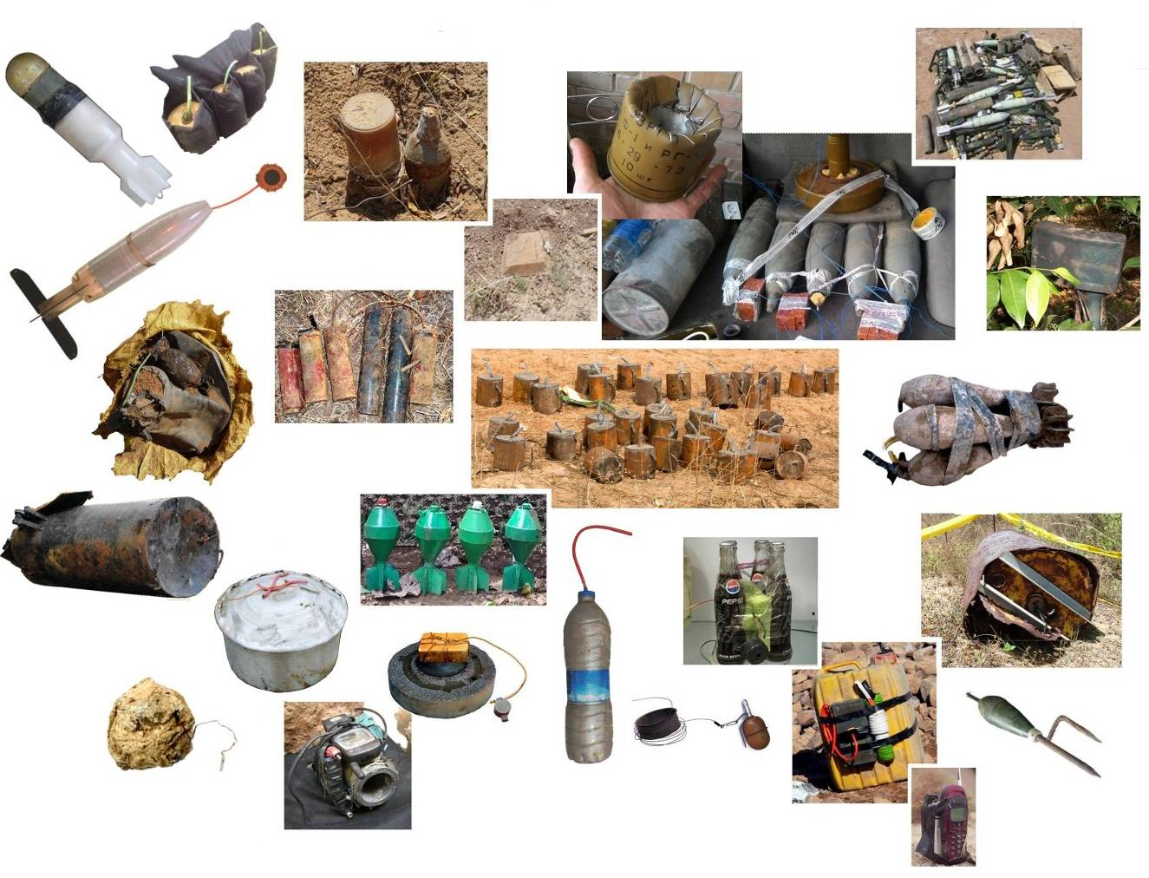

This Chapter extends the Search & Clearance procedures detailed in Chapter 6 by describing approved approaches to improvised explosive hazards in Humanitarian Mine Action. Some tasks where there are improvised hazards can be Searched & Cleared by conventional demining teams using the procedures detailed in Chapter 6. Other tasks must be conducted by specialist HIEDC teams who have had appropriate extended training and use the procedures and rules described in this Chapter.
Just as with conventional munitions after hostilities have ended, many improvised hazards remain active and may present an increased risk as they age. This Chapter should be extended to include details of the improvised hazards that may be found in the area of operations and the condition in which they may be found.
CHAPTER 7: IED SEARCH & CLEARANCE
A version of these SOPs has been available since 2007. This Chapter was included in 2015 and has been updated for this 2018 release. Definitions that are necessary to understand this SOP are included at the start of the Chapter.
Contents
1. Glossary 3
1.1 Should, Must & Shall 6
2. Introduction 7
2.1 Defining Improvised Explosive Devices (IEDs) 7
2.2 Forensic and non-forensic removal of IED bombs and MF-IEDs 10
2.3 Maintaining a low public profile 11
3. Search & Clearance in simple IED minefields 11
3.1 Unconventional features in some improvised mines 12
4. When to use a specialist HIEDC team 14
4.1 Specialist HIEDC teams 14
4.2 Working hours 16
4.3 Team member responsibilities 16
5. Safety rules 18
5.1 Safety cordon 18
5.2 Supervision from a distance 18
5.3 Electronic noise 18
5.4 Jamming wireless signals 19
5.5 Locating wireless signals 19
5.6 Magnetic influence 19
5.7 Seismic disturbance 19
5.8 Movement proximity fuzes 19
5.9 PPE variations 20
5.10 Blast trauma 20
6. Before deployment 20
6.1 Pre-deployment Task Assessment 21
6.2 Provisional Task Release Plan 23
6.3 Deployment liaison 23
7. Communications 24
8. Approaches to IED bombs and MF-IEDs 24
8.1 Manual approaches 25
8.2 Approaches using a remotely controlled machine 25
9. Spot-tasks in public places 28
10. Searching buildings 29
10.1 Preparation 30
10.2 Search team size and separation 30
10.3 Searching from outside 31
10.4 Entering the building 31
10.5 Searching corridors and opening doors 32
10.6 Searching visually 32
10.7 Complete search 32
10.8 IED parts 33
11. IED bombs and MF-IEDs in vehicles 33
12. Destroying confirmed IED bombs and MF-IEDs 35
12.1 General disarming safety guidelines 36
13. Dealing with discovered UXO, AXO or explosives 37
14. Finding human remains 38
15. Quality Assurance (QA) and Quality Control (QC) 38
15.1 Internal QA 38
15.2 Internal QC 38
15.3 External QA 38
15.4 External QC 39
16. Reporting 39
Annex A: Notes about improvised explosive hazards 40
Annex B: Sample fuzes 48
Annex C: Subjects to be covered in specialist HIEDC training 54

Glossary
The terms defined below are listed in alphabetical order. Terms not used in this SOP may be included for clarity. A full Glossary of terms used throughout the Global SOPs is included in the introductory Chapter.
Accident (Demining accident): following ordinary use of the term, an HMA ‘accident’ is any damaging or injurious event that occurs during working hours. This includes road traffic accidents and other events that give rise to injury which do not involve explosive hazards. Whenever an accident involving explosive hazards occurs (whether injurious or not), a detailed and objective accident report must be compiled and shared. Demining accident reports must be appended to the Field Risk Register and the appropriate risk mitigation strategies recorded. See also the entry for ‘Incident (demining incident)’.
Area Cleared: the area ‘Cleared’ is a defined area (or areas) that has been subjected to one or more demining Search & Clearance procedure(s) which guarantee(s) that a thorough search to the required depth has been conducted over the entire area(s). In all areas released as ‘Cleared’, the task supervisors must have full confidence that no explosive hazards remain to the specified search depth and must be prepared to demonstrate their confidence by walking or driving over the area. When no explosive hazards are located during Search & Clearance of an area, the area may still be released as ‘Cleared’ even though there were no explosive hazards to ‘Clear’.
Area Verified (Area Verification): an ‘Area Verified’ is a part of a task area for which there is no evidence of any explosive hazards being present (No Threat Evidence, NTE) and on which one or more demining procedure(s) has been carried out. What is being ‘Verified’ is the belief that there is NTE in the area. The entire area Verified must be processed in a manner that increases confidence that formal Search & Clearance is not required in that area. Because there is NTE, the demining procedures used for area Verification need not equal thorough Search & Clearance of the area. If any evidence of hazards is discovered during Area Verification, the status of the area changes and appropriate Search & Clearance procedures must be conducted. Those who make the decision that Area Verification is all that is required must be prepared to walk or drive over the land that they have decided does not need to be thoroughly searched. After the Area Verification, if No Threat Evidence has been found, the land may be released as ‘Presumed Clear’.
Booby-traps: in common with the definition of anti-personnel mines in the Ottawa Convention, ‘booby-traps’ are victim-initiated devices that are not triggered remotely by command detonation. Designed to target anyone who disturbs them, they are manufactured in volume production and sold to armed forces as part of their arsenal. An example is the MS3 which looks similar to a PMN anti-personnel mine but functions when a weight is removed from on top of the device. The ML-7 has a similar function and is frequently placed beneath anti-personnel mines to target anyone lifting the mine.
Clear (Presumed Clear): when applied to land, the word ‘Clear’ is used to describe land where there is no evidence of there being any explosive hazards (No Threat Evidence, NTE). When this is a result of the explosive hazards having been removed/destroyed during Search & Clearance, the area must be described as having been ‘Cleared’. When land has been released by area Reduction, Verification or Cancellation, it has not been ‘Cleared’ but can be ‘Presumed Clear’ because there is no evidence of it being likely to be contaminated with explosive hazards (No Threat Evidence, NTE). The distinction between the use of ‘Presumed Clear’ and ‘Cleared’ is important because it can be critical in cases of litigation.
Clearance: ‘clearance’ is the removal or destruction of explosive hazards. Most in the industry describe what they do as ‘clearance’. In fact what most field people are doing most of the time is preparing ground and searching. If there are no explosive hazards there, there is nothing to be ‘cleared’ so clearance cannot be happening. In these SOPs, the activity of searching for and removing or destroying explosive hazards is referred to as Search & Clearance despite the fact that, at some times, no hazards will be found and no ‘clearance’ will be required.
Deminer (Searcher): a ‘deminer’ is a person engaged in Search & Clearance tasks in areas that may be contaminated with explosive hazards. A deminer must always be trained and qualified to carry our procedures related to searching. A deminer may also have EOD training, but does not have to be trained to appraise and manage the explosive hazards that are found. Persons with EOD training are called ‘EOD specialists’ and must also be trained as deminers/searchers.
Device(s): the term ‘device’ is sometimes used to describe any explosive hazard.
Explosive hazard: the term ‘explosive hazard’ is used to describe mines and ordnance whether fuzed, fired or otherwise, and all explosive devices whether mass-produced or improvised. It also covers hazardous parts of these devices, including detonators, propellants and pyrotechnics. Following the usage in international treaties and conventions, the IMAS distinguish between ‘mines’, ‘submunitions’ and ‘Explosive Remnants of War’ (ERW) and treats them separately. This is confusing because, in normal language, ‘mines’ and ‘submunitions’ are also ‘ERW’. Rather than trying to reclaim the commonsense meaning of ERW, the term ‘explosive hazard’ is used in these SOPs.
HIEDC: The acronym ‘HIEDC’ (Humanitarian Improvised Explosive Device Clearance) is used to describe those IED search & Clearance activities that are conducted in HMA. HIEDC differs from the counter IED work that is conducted by active combatants or security services because it prioritises the safe destruction of the hazard without adopting a forensic approach that is intended to assist in the identification of those who made or placed it.
High Probability Area (HPA): a ‘High Probability Area’ is a part of a task where there is a high probability that explosive hazards are present. This may be called a Confirmed Hazardous Area or CHA by other agencies. The threat in a High Probability Area is the same as that in a Low Probability Area when the same explosive hazards may be present. Typical HPA include mapped and marked minefields, areas where mines are visible, defensive positions, areas where there have been multiple explosive accidents, and areas where the presence of hazards has been reliably reported.
IED (simple IED): in these SOPs, a simple ‘IED’ is an ‘improvised explosive device’ which is an improvised munition, such as a mortar bomb, rocket, grenade, or a mine. The defining feature of a simple ‘IED’ is that it is designed to function in a way that parallels the conventional munition it is intended to emulate. See also the entries for ‘IED bombs’, ‘MF-IEDs’ and ‘booby-traps’.
IED bombs: ‘IED bombs’ are improvised explosive hazards that are placed for timed or command detonation. Although placed during the conflict which should have ended before HMA activity began, improvised bombs may be encountered as legacy hazards. They may be unstable and may have MF-IED features. See also the entries for ‘IEDs’, ‘MF-IEDs’ and ‘booby-traps’.
Incident (Demining incident): avoiding the confusion between ‘accident’ and ‘incident’ apparent in the IMAS, in these SOPs a ‘demining incident’ is the discovery of one or more explosive hazard(s) on land that has been declared ‘Cleared’ or ‘Presumed Clear’ and released to the end-users as part of Land Release. The rigorous and honest investigation of demining incidents is necessary to ensure that errors are identified and corrected in pursuit of the primary goal of HMA. Demining incident reports must be appended to the Field Risk Register and the appropriate risk mitigation strategies recorded. See also the entry for ‘Accident (demining accident)’.
Low Probability Area (LPA): a ‘Low Probability Area’ is a part or parts of the task where it is possible that there are explosive hazards but there is not enough evidence of their presence to make it probable. Typically, land bordering a High Probability Area is a Low Probability Area. The threat in a Low Probability Area is the same as that in a High Probability Area when the same explosive hazards may be present.
Malign fuzed IEDs (MF-IEDs): an ‘MF-IED’ is an IED that has one or more initiation systems that is deliberately designed to be triggered by any attempt to approach, disarm, separate, disrupt or move all of part of the device. Any explosive hazard can be turned into an MF-IED by the addition of an initiation system designed to target those sent to find and destroy it. MF-IEDs may have several initiation systems, any one of which may be followed by a delay to give the impression that the hazard is safe, so maximising injury. See also the entries for ‘IEDs’, ‘IED bombs’ and ‘booby-traps’.
MDD - Mine Detection Dog: also known as EDD – Explosive Detection Dogs – an ‘MDD’ is a dog that has been trained to detect various target substances related to mines and explosive hazards. The target substances may include specific mines, certain types of explosives, surface and sub-surface ordnance, and fragments of mines and UXO/AXO.
National Mine Action Authority (NMAA): the NMAA is the national organisation mandated by the national government to control and monitor humanitarian mine action activities.
Presumed Clear: See the definition for ‘clear’.
Procedure(s), demining procedure(s): ‘demining procedures’ are activities conducted on land that may be contaminated with explosive hazards as part of preparing it for Land Release. Searching with metal-detectors or MDDs are demining procedures. Cutting undergrowth or ground processing with a demining machine are also demining procedures. One or more procedure can be applied to process the same ground to give confidence that the area can be released. Not all procedures, or combinations of procedures, constitute full Search & Clearance and so guarantee that no explosive hazards remain to the required depth in the area. This is not important when there is found to be No Threat Evidence in an area and it can be reliably ‘Presumed Clear’.
Risk Register: a ‘Risk Register’ is a record of identified risks and the strategies adopted to manage them by reducing them (risk mitigation) or by avoiding them. Derived from as broad an evidence base as possible, it informs risk management decisions and allows experience to be shared and retained when staff move on. Two registers should be kept, a ‘Programme Risk Register’ and a ‘Field Risk Register’.
Safety distance: the ‘safety distance’ is the distance at which all staff must be from a deliberate detonation in order to avoid injury. This is also the distance at which staff must be from a demining procedure that may predictably detonate some devices (such as processing the ground surface using a machine). See also the entry for ‘working distances’.
Search & Clearance (Searched & Cleared): ‘Search & Clearance’ refers to the disciplined use of demining procedures that are reliably able to locate all anticipated explosive hazards to a specified depth beneath the ground surface and the removal/destruction of those hazards over an entire recorded area. Only areas that have been Searched & Cleared can be released as ‘Cleared’.
Search depth: the ‘search depth’ is the depth beneath the ground surface to which reliable search for explosive hazards must be conducted. Unless otherwise directed by the NMAA or client, the search depth should be agreed during task planning and must be increased as soon as any evidence suggests that the hazards may be at a greater depth than was originally believed.
Searcher: See the entry for ‘Deminer’.
SUA or UAV: The term ‘Small Unmanned Aircraft ‘(SUA) is preferred by the Civil Aviation Authorities in Europe and so is used instead of Unmanned Arial Vehicle (UAV). In this context, the terms are treated as synonyms. An SUA is an aircraft with a Maximum Take Off Weight (MTOW) of 7 kg or less. It may have rotors, fixed wings or gas lift in any combination and is controlled remotely by a pilot in real time or following a pre-programmed flight path.
Suspected Hazardous Area (SHA): at the start of a demining task, the entire task area is often referred to as a ‘Suspected Hazardous Area (SHA)’. After a Technical Survey has been conducted and more becomes known as the task progresses, parts of the SHA should be designated Low Probability Areas (LPA) and High Probability Areas (HPA) where the ‘probability’ refers to the probable presence of explosive hazards. HPA and LPA designations and the Task Release Plan should be reviewed and revised as soon as more as soon as more evidence about the contamination in the SHA is gathered. As areas with No Threat Evidence are identified, they may be Reduced, Verified or Cancelled, as appropriate.
Task (demining task): a ‘task’ is a specified area of land on which a demining organisation must conduct activities detailed in a Task Release Plan in order to declare the area ‘Cleared’ or ‘Presumed Clear’ in preparation for land release.
Task Folder: the NMAA (or other authority) should provide a ‘Task Folder’ containing all relevant survey data about the task being undertaken. Information gathered during this organisation’s internal Task Assessment will be added to the Task Folder to allow an informed Task Risk Assessment to be made. The Task Folder and the Task Assessment also provide an evidence base on which to make a preliminary Task Release Plan. The Task Folder may include agreements about the demining assets and procedures that must be used at the task.
Task Release Plan: the ‘Task Release Plan’ is the schedule of all demining activities that will take place in a demining task area. It includes maps of HPA and LPA showing all areas that will be released as ‘Cleared’, Reduced, Verified or Cancelled. All Task Release Plans should be revised regularly as work progresses and more becomes known about the task area. This is essential to allow the work to be conducted efficiently, so protecting the donor/client from unnecessary costs. When the Task Release Plan must be approved by the NMAA, a provisional Task Release Plan sent to them before work starts should cover as many of the variations that may be required as can be reasonably predicted. When further revisions are required, the NMAA should appraise revised Task Release Plans without delay. When the revision is necessary to keep risk within tolerable limits, the NMAA should approve its immediate implementation pending the results of their formal appraisal.
Task Risk Assessment (TRA): a ‘Task Risk Assessment’ is a process designed to evaluate and manage risk before and during field tasks. A TRA takes account of all available information about conditions in the task area, the hazards present and the demining procedures that are available to be used. As work at the task progresses and more information becomes available, the TRA must be revised so that the work is always conducted in a manner that minimises the main risks during HMA field activities. The main risks are the risk of leaving explosive hazards in areas that will be released (demining incidents) and the risk of demining staff suffering explosive related injury (demining accidents).
Tolerable Risk: a ‘tolerable risk’ is the risk remaining after having taken all reasonable measures to avoid the risk event and/or to minimise its undesirable consequences. The International Standards Organization (ISO) (and the IMAS) define ‘tolerable risk’ as “risk which is accepted in a given context based on current values of society”. Every industry is intended to interpret that definition appropriately in their own working context. It would be inappropriate to adopt the high-risk mindset that may prevail in a post-conflict context because the current humanitarian values in peaceful and secure societies are the values of HMA and of those paying for the work. These are also the values that will be used to define what is ‘tolerable’ during any litigation that may follow accidents or incidents.
Wide-area: in these SOPs, the term ‘wide-area’ is used to describe large land areas over which Search & Clearance will be conducted. The breach lanes that are ‘Cleared’ during a Technical Survey are not conducted over wide-areas, but parallel breaches can be combined to provide wide-area Search & Clearance.
Working distance: the ‘working distance’ should make it unlikely that more than one person will be injured in a demining accident. Working distances can generally be shorter than safety distances because demining accidents are rare and injuries to a second worker rarer still. Reduced working distances can increase safety by improving the ease of supervision which ensures that procedures are conducted correctly and risks are appropriately managed. See also the entry for ‘safety distances’.
  - Should, Must & Shall
Throughout these SOPs the distinction between the terms ‘should’ and ‘shall’ that is used by the International Standards Organisation (ISO) and in the International Mine Action Standards (IMAS) is adopted.
When ‘shall’ or ‘must’ is used, everyone working to these SOPs must comply with the requirements as they are written. No variation is permitted.
When ‘should’ is used, everyone working to these SOPs must follow the requirements unless they have a reason to vary them that has been approved by the senior staff with operational responsibility. Variations must be recorded in writing in the Task Release Plan and the person(s) making the variation must be identified.
- Introduction
Improvised explosive hazards have often been located and destroyed during HMA operations over the past 25 years. Some of these devices have been designed to be victim initiated, to detonate after a time delay, or to be command detonated during a conflict. Until recently, very few of these devices were designed to specifically target the individual who is sent to find and destroy them.
Improvised mines have been widely used in Sri Lanka, Myanmar, Colombia, Iraq and Syria. Designed to be victim initiated, some are approximate copies of familiar mines and some look very different. All are designed to be activated by the application of pressure or the pulling of a retaining pin and, as with conventional mines, all may be booby-trapped to prevent them being moved.
In the same countries, improvised mortar bombs, rockets and grenades have also been widely used. Some are adapted from conventional munitions and some are entirely improvised. What they have in common is the fact that they are designed to detonate on use but the constraints of manufacture mean that they may be more likely to malfunction than the munitions they replace. The features of the original may be varied in a manner that is unexpected. A common example is when a pressure-activated mine large enough to destroy a vehicle is designed to be initiated by the weight of a person. The initial approach to all improvised munitions, whatever their fuze system(s), must presume that they may detonate when moved.
HMA should only be conducted after hostilities have ended so those engaged in HMA should not be asked to search for devices that may be command detonated to target them as they work. However, sometimes the end of hostilities is uncertain so the risk of command detonation should always be considered when working with improvised bombs or MF-IEDs (see below).
Just as with conventional munitions after hostilities have ended, many improvised hazards remain active and may present an increased risk as they age. Until staff have become familiar with the improvised explosive hazards in their working area, the precautionary measures required usually need to be more extensive than during conventional Search & Clearance or EOD Spot tasks.
The term Humanitarian Improvised Explosive Device Clearance (HIEDC) is used in these Global SOPs to discriminate between conventional HMA demining procedures and those used in specialist IED Search & Clearance tasks.
  - Defining Improvised Explosive Devices (IEDs)
All IEDs are made using some parts that were either designed for another purpose or have been made for the purpose informally (outside conventional munitions factories). Initiation systems that were manufactured for use in another munition or as booby-trap switches may be used but many have initiation systems that are not manufactured for sale on the open market so may be unfamiliar to those searching for them. However, these improvised initiation systems are often made to patterns and may be manufactured in batches in informal workshops, so close similarities frequently occur. Improvised initiation systems often have a limited reliable design life which can may make them unpredictable and unstable.
IEDs may be disguised to appear innocent and their main charge may be comprised of (or boosted by) any conventional munitions that are available to those making the device.
When the main charge in an IED is an unconventional explosive (often known as a ‘Home Made Explosive’ HME) the explosive may become unstable and be sensitive to any movement, or may detonate apparently spontaneously. Unconventional explosives often have a lower velocity of detonation than conventional explosives but are frequently used in sufficient quantity to make the consequence of a detonation at least as severe as when conventional explosives are used.
From an HMA perspective, it is useful to discriminate between different kind of improvised explosive devices. There is some overlap between the definitions, but the essential features are defined below.
- IEDs (simple IEDs) are improvised munitions that have an initiation system or systems that are not designed to target those sent to disarm/destroy them. This includes improvised mines, booby traps, and any munition that is designed to replace a conventional counterpart, such as rockets and grenades. They may be designed to be victim initiated, but are not designed specifically to target those sent to find and destroy them. However, a simple IED may be more hazardous than the conventional munition it replaces because the main charge may be an improvised explosive and the initiation system may be sensitive or unreliable, so unpredictable. A conventional munition with an improvised initiation system that allows it to be used in a way for which is was not designed is an improvised explosive device.
- IED bombs are improvised explosive hazards that can be victim initiated, initiated after the passage of time, or initiated by command detonation. Although placed during the conflict which should have ended before HMA activity began, improvised bombs may be encountered as legacy hazards. They may be unstable and may have MF-IED features. The hazardous content in all improvised bombs may include munitions that were originally designed for another purpose and/or improvised explosive/incendiary materials. Complex improvised bombs have been designed to fire conventional munitions, so greatly increasing the hazard radius. Frequently an IED bomb is not assembled until it is placed and the explosive hazards should be expected to vary even when the initiation systems are similar.
- Malign fuzed IEDs (MF-IEDs) are explosive hazards that have at least one initiation system which is deliberately designed to be triggered by any attempt to approach, disarm, separate, disrupt or move all of part of the device. Any explosive hazard (including simple IEDs and IED bombs) can be made into MF-IEDs by the addition of initiation system(s) designed to target those sent to find and destroy them. MF-IEDs may have several initiation systems that may be activated by proximity, movement, light, pressure, pressure-release, and/or the disruption of another initiation system such as breaking a circuit by cutting a wire. In some cases, the initiation is followed by a delay to give the impression that the hazard is safe, so maximising injury.
Booby-traps that are manufactured in volume production and sold to armed forces as part of their arsenal are not improvised, so are not IEDs. In common with the definition of anti-personnel mines in the Mine Ban Treaty, ‘booby-traps’ are victim-initiated devices that are not command detonated. They are usually designed to target anyone who disturbs them, not specifically those sent to find and destroy them. When a booby-trap is improvised, it is a simple IED. Factory made booby-trap devices may be used as one or more of the initiation systems in IED bombs or MF-IEDs. They may also be copied in informal factories. Some examples of factory made fuzes and booby traps are included in Annex B.
During conflict, the target of an IED bomb is the perceived ‘enemy’ and/or their supporters. When an IED bomb works, those who made it often try to repeat their success by making systems or components that work in a similar manner. When an IED bomb fails through being discovered and safely disarmed or destroyed, those making them have frequently complicated the initiation system in order to mislead the enemy into thinking that their previous knowledge of the mechanism ensures their operational safety when in fact hidden initiation systems have been added. So ironically it was the success of those clearing conventional IED bombs during conflict that inspired their makers to produce many more MF-IEDs with initiation systems that target the people sent to destroy them.

Simple IEDS
Simple IEDs are improvised munitions that are used in the same scenario as the conventional munitions they replace. In asymmetric conflict where one or more of the combatant groups had limited access to conventional munitions, improvised munitions such as grenades, mortar bombs and rockets may be found as UXO/AXO in any places where conflict took place. In the same scenario, improvised mines have been used in defensive minefields, to deny safe access to areas, or to channel the enemy’s movements, just as conventional mines made in a factory are used. Improvised booby-traps may be used to target infrastructure, enemy forces or the civil population, such as conventional booby-traps manufactured in a munitions factory are used.

IED Bombs
IED bombs are used to achieve one or more of the following goals.
- To prevent others accessing an area, as when the hazard is placed in a way that is easily seen or found so that people avoid it.
- As an act of defiance to demonstrate that the enemy does not have control of the security in an area.
- For ideological punishment designed to instil terror, as when the purpose is to terrorise the civil population for political/ideological purposes.
- As a concealed weapon targeting enemy combatants, as with command detonated suicide bombs or bombs placed to be detonated when the enemy is passing in vehicles.
Whenever an IED bomb is reported or easily seen, the specialist HIEDC team should expect that other hidden devices have been placed to be initiated as they approach. Even when a device that was not easily visible is found, the team members should expect there to be other explosive hazards (improvised or otherwise) in the vicinity because multiple devices may be placed to achieve the goals above.
In pursuit of goal 4 above, IED bombs are used in suicide attacks with the bomb carried on the person or in a bag or vehicle. Suicide bombers are the responsibility of the security forces in the area but HMA staff may have to locate and safely dispose of abandoned hazards made for use in suicide attacks. Although the primary initiation system may be a mechanism which the bomber was intended to use, many suicide IED bombs are also designed to be initiated by a wireless signal from a distance. This serves as a secondary means of initiation to be used if the bomber is apprehended and disabled, or when the carrier may be reluctant, afraid or drugged.
The fuze of IED bombs may be victim initiated, command detonated or detonated after the passage of a set time. Victim initiation may be by the application of pressure, pull, pressure release, exposure to light, movement, seismic vibration, electromagnetic disturbance, or the completion or breaking of an electrical circuit. If an IED bomb has a fuze system designed to be initiated by anyone attempting to disarm or disrupt the device, it is an MF-IED. Generally, it should be presumed that all IED bombs are MF-IEDs with multiple initiation systems until the actual systems used in an area are known.
IED bombs may also be used as booby-traps by attaching them to something that will attract attention or be moved. For example, they may be attached to an attractive item that someone will pick up, or to a door that someone will open. Corpses have often been attached to hidden devices because they will always have to be moved.
An IED bomb may be disarmed by an EOD 3+ C-IED specialist when that person considers it safe to do so but should generally be disrupted first unless it is believed to be entirely unable to function.

Malign Fuzed IEDs (MF-IEDs)
MF-IEDS may be used to achieve all of the goals of IED bombs, but are also used as a weapon directly targeting the people sent to locate and destroy them.
MF-IEDs may be designed to be victim-initiated, command detonated, set to explode after a set time, or all three. Some can only be initiated by an attempt to disarm the device. By definition, all have at least one initiation system that is intended to target the person tasked with their disarming and destruction. Fuzes used in MF-IEDs have been initiated by pressure, pull, pressure release, light, movement, seismic vibration, electromagnetic disturbance, or the completion or breaking of an electrical circuit either by physical means or remotely with a wireless communications device.
No attempt to disarm an MF-IED should be permitted unless the MF-IED has been disrupted and separated and is believed to be entirely unable to function.
  - Forensic and non-forensic removal of IED bombs and MF-IEDs
In recent years the policy of deliberately disarming and dismantling IED bombs and MF-IEDs for forensic examination that is intended to lead to the identification of those involved in their manufacture and/or placement has been adopted by some security agencies. This has led to the increased use of sophisticated MF-IEDs and as a result the risk to the people involved in conducting render-safe and forensic examination of them has increased. Unless the information gathered by taking an IED bomb or MF-IED apart is used by an organisation with sophisticated forensic and follow-up facilities, the risks involved in conducting forensic examination can never be justified.
Those engaged in Humanitarian Mine Action must be seen to be impartial and so should avoid identification with any of the (former or current) conflict factions. To comply with the International Mine Action Standards (IMAS), organisations engaged in Humanitarian Mine Action must recognise a duty of care to their employees and must minimise their risk at all times. To achieve this, the forensic examination of IEDs shall not be a part of HIEDC activities. Consequently, the need to recognise, locate and disrupt/destroy improvised explosive hazards with minimum consequences to people and property is the requirement covered in this SOP.
The distinction made between forensic and non-forensic hazard removal is described below.

Forensic explosive hazard disruption
Forensic disruption is the use of render-safe procedures and equipment that are designed to retain enough of the device to reward subsequent specialist forensic examination off-site. In this, the ideal outcome is for all of the device to be rendered safe and available for detailed inspection. The inspection of the parts may then lead to its manufacturer or user being apprehended and prevented from making or placing more devices.

Non-forensic explosive hazard disposal
Non-forensic disposal is the disruption or demolition of the hazard with minimum practical consequences to people and property compliant with the humanitarian requirement that every effort should be made to ensure zero casualties amongst civilians and HMA staff. In this, the ideal outcome is for all of the device to be destroyed where it is found or elsewhere without any casualties or significant damage to property.
To minimise the consequences of a detonation, non-forensic hazard removal may include manual or robotic disarming or disruption when the Task Risk Assessment permits this. Any recovered parts of the hazard should be destroyed as soon as possible afterwards. When it is possible to discreetly make a photographic record of the device and its initiation systems for training and staff preparation purposes without risk, that should be permitted.
  - Maintaining a low public profile
Publicising the work that is conducted in the field can be advantageous because it can please existing donors/clients and attract new donors/clients. Usually, the conflict is over and the former combatants are no longer enemies, so publicity can be entirely appropriate. When the end of hostilities is less certain and any enmity remains, publicity should be approached with more caution. If there is any chance that publicising the work of demining or specialist HIEDC Teams could lead to reprisals or the placement of MF-IEDs to target them, the work must not be made public at all.

Search & Clearance in simple IED minefields
When the results of a Task Assessment indicate that large numbers of improvised mines (simple IEDs) are anticipated at a task, the conventional demining Search & Clearance procedures in Chapter 6 should be adapted for the context and the hazard as required in a Task Risk Assessment (see Chapter 14). A Task Release Plan taking note of the results of the Task Risk Assessment must be submitted for approval by the operations manager and, when required, the NMAA.
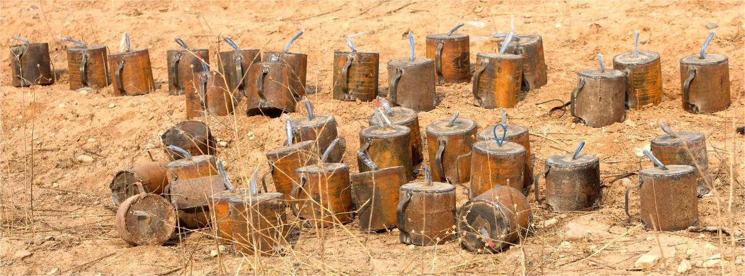
The picture shows improvised mines recovered from a minefield. The mines are large and have a metal casing, so are easy to detect with metal-detectors.
Where improvised mines are found, other improvised munitions may also be found as UXO or AXO. Although these are not designed to be victim initiated, the explosive content may be unstable and the initiation mechanisms may be in an unpredictable condition. As in conventional minefields, random improvised mines may have secondary initiation systems or be booby-trapped.
 NOTE: All improvised mines and munitions should be carefully exposed and then an EOD specialist deminer must ‘pull’ the hazard and any separate pressure-plate(s) from a distance as described in Chapter 6, Part 12.1. The underside of the hazard and the area around/beneath it must be examined before it is disarmed or destroyed.
Demining teams as described in Chapter 6 may conduct simple IED Search & Clearance tasks after the staff have received continuation/extension training covering the approved approaches to the anticipated hazards. EOD specialist deminers may destroy the discovered hazards as long as their training and experience is sufficient to render them competent to do so.
When there is sufficient information about the hazards for the Task Risk Assessment to decide that their movement and/or disarming does not involve intolerable risk, improvised mines and munitions may be moved for demolition, but should not be transported by vehicle unless rendered safe beforehand.
  - Unconventional features in some improvised mines
The main explosive charge in improvised anti-personnel mines is often far larger than in conventional mines. The main charge may be an improvised explosive, a civil explosive, a military grade high explosive harvested from conventional munitions, or any combination of these. What is nominally an ‘anti-personnel’ mine because it can be initiated by a person may be powerful enough to destroy thin-skinned vehicles or incapacitate groups of people.
A common feature of improvised electrically activated mines is that the pressure-plate need not be a part of the device so need not be above the main explosive charge. There may be several separate pressure-plates attached to the same main charge. Electrical components are generally made weatherproof by being wrapped in plastic (cling-film or plastic sheet) and sealed with adhesive tape. The whole device may be wrapped to help protect it from the sun, rain and wind. Separated electrical initiation systems have been used in improvised mines found during HMA in Sri Lanka, Syria, Iraq, Colombia and Myanmar.
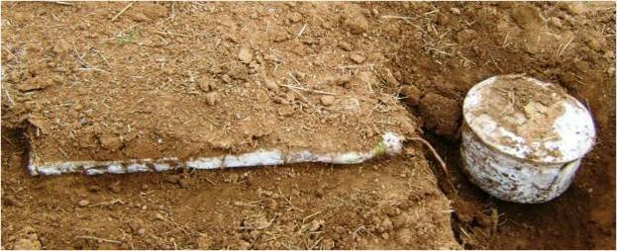
The picture shows an aluminium improvised mine made using cooking pots that has been found in large numbers in Iraq and Syria. It contains a reported 8-10kg of improvised explosive and is initiated with an electric detonator (the detonator is often ‘boosted’ by being encased in a small amount of conventional plastic explosive). The mine has a large, separated pressure-plate wrapped in plastic. Secondary fuze systems may be present and one mine may have more than one pressure-plate. In some cases, a pressure-plate can have more than one initiation circuit attached to it, so cutting one does not make the pressure-plate safe to lift.
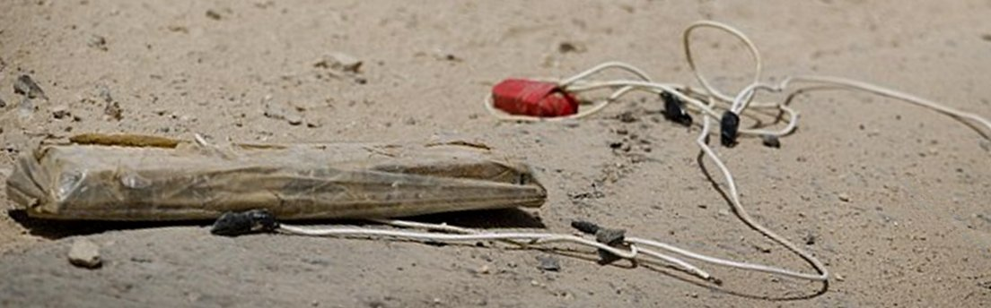
The picture above shows a pressure-plate with two electrical circuits attached.
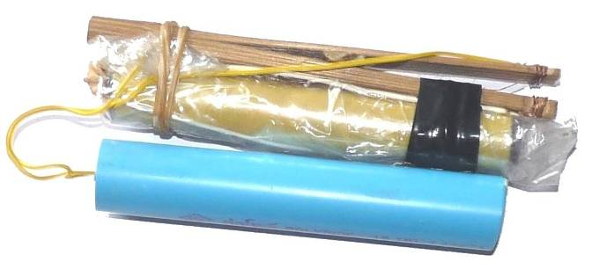
Using the same separate pressure-plate principle on a smaller scale, the picture on the right shows an improvised anti-personnel mine found in Myanmar. A main explosive charge of industrial gelignite is packed into a short length of (blue) plastic pipe and initiated with an electric detonator. Batteries are held inside the yellow pipe under the pressure-plate. The pressure-plate is made from a length of split bamboo with the electrical contacts held apart by a small bamboo wedge. The pressure-plate and batteries are generally placed under a path with the explosive charge to one side. The distance between the pressure-plate and the explosive charge is only limited by the length of the wires and some have been found with the pressure-plate several metres from the charge. Both pressure-plate and explosive charge are wrapped in plastic bags and sealed with adhesive tape. As with many improvised mines, wrapping nails, nuts and bolts or small pieces of metal around the main charge may be used to convert a blast device into a fragmentation device.
The explosives used in improvised mines may also be improvised or include improvised materials. Ammonium Nitrate and Aluminium powder (ANAL) has been commonly used. A detonator or knotted det-cord/Cortex inside a small ball of conventional plastic explosive is often positioned inside the main charge to provide the necessary shock wave to ensure detonation.
Improvised explosives are often unstable and sensitive to both heat and sunlight so mines filled with them are generally well concealed and may be entirely sealed in plastic bags, cling-film or plastic sheet.
Sometimes a non-metallic mechanical means of initiation are used in the firing train. An example is a length of water-filled hose that is sealed at one end with a plastic plunger in the other. When the hose is compressed, the plunger is pushed out to apply pressure and initiate the mine by making an electrical connection (often by pressing a simple electrical button switch). A length of hose can serve as an unusually long pressure-plate. To ensure that the hose is crushed, this initiation system is usually used when the hose can be placed over a hard surface and lightly covered with soil or rubbish and it may only be reliably effective when the weight of a heavy vehicle is applied. This type of initiation system cannot be located with a metal-detector because it has no metal parts. Search using a combination of area excavation to locate the lengths of hose and a metal-detector to locate the casing of the explosive charge may be necessary.
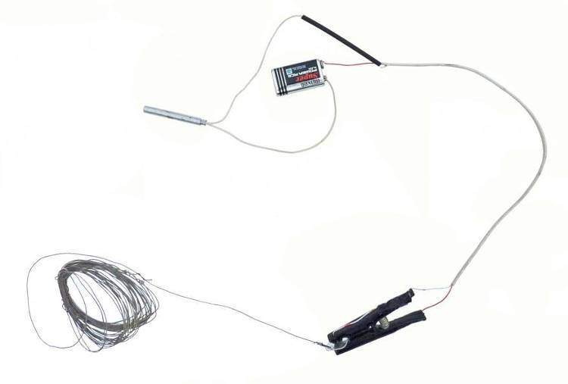
A simple and common means of electrically initiating
improvised fragmentation mines is made using a
wooden or plastic ‘clothes-peg’. Wires are attached
to the jaws of the peg and the contacts are kept
apart by a piece of plastic material between
the jaws that is attached to a tripwire. When
the plastic is pulled free, an electrical
connection is made and the detonator
is initiated.
Mines may also be made to look like
something else, such as a rock. At
least one kind of rock mine is made
in a conventional munitions factory
for a national army.
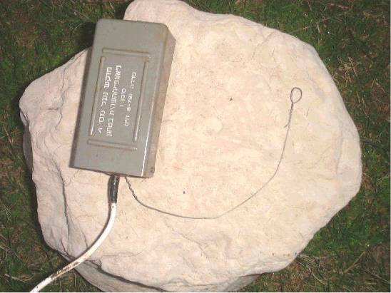
The rock mine on the left is factory made and is designed to be used with a conventional anti-personnel mine (which may be boosted with other explosive hazards).

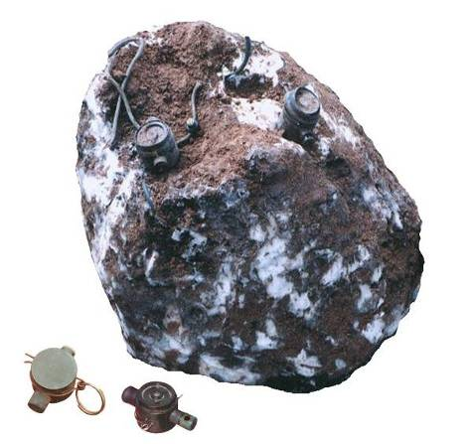
Improvised rock mines are shown below. The one on the left is from Syria and the one on the right was found twenty years ago in Angola.
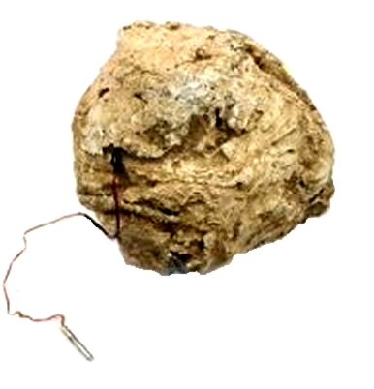
The ‘rock mine’ on the right has factory made booby trap switches (designed to initiate
det-cord) that are set into the surface.
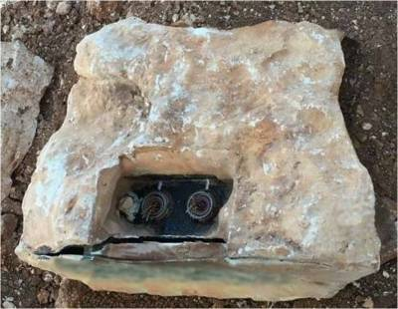
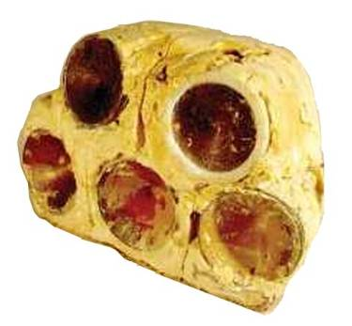
Rock mines found in Iraq, Syria and Afghanistan may be more sophisticated. The rock mine on the left has two separate electrical initiation systems.
The rock mine on the right has five shallow copper dishes set into the explosive charge in an attempt to fire shaped charge jets that are able to penetrate heavy armour.

- When to use a specialist HIEDC team
A specialist HIEDC team is a specialist Humanitarian IED search and Clearance team.
Subject to the Task Assessment and Task Risk Assessment, tasks at which Simple IEDs and conventional booby-traps are anticipated should be conducted by demining teams following the Search & Clearance procedures detailed in Chapter 6 of these SOPs. When an unanticipated suspected IED bomb is discovered during any Search & Clearance task, the area must be marked and a specialist HIEDC team asked to conduct an HIEDC Spot Task.
Wide-area tasks at which IED bombs are anticipated may only be conducted using the Search & Clearance requirements detailed in Chapter 6 when the position of the IED bombs is known and those areas can be left as specialist HIEDC team Spot Tasks. When IED bombs are anticipated but their location is unknown or uncertain, a specialist HIEDC team should conduct wide-area Search & Clearance at the task.
Wide-area tasks at which MF-IEDs are anticipated must be Searched & Cleared by a specialist HIEDC team whether of not the approximate location(s) of the MF-IED(s) is known. All MF-IED Spot Tasks shall be conducted by a specialist HIEDC team.
  - Specialist HIEDC teams
All members of a specialist HIEDC team must be selected to ensure that they have the following personal characteristics:
- a logical problem-solving approach;
- patience;
- the ability to work both independently and in a team;
- a non-competitive attitude; and
- supervisory experience.
The operations manager is responsible for ensuring that all staff are appropriately trained, experienced and competent to conduct the procedures they will be required to undertake. A provisional list of training headings is given in Annex C of this Chapter.
Every team member who may be required to enter the SHA should have the experience and qualifications necessary to safely locate and recognise the anticipated devices. HIEDC specialists who are only engaged in search may be trained deminers who have completed an HIEDC search training course approved by the operations manager. Specialist HIEDC search training should be conducted by a person qualified to HIEDC EOD Level 3+ C-IED who has appropriate training skills. HIEDC specialists who will be responsible for disarming, disruption or demolition of IED bombs and MF-IEDs must have appropriate EOD Level 3+ C-IED training. There is no IMAS approved authority able to approve IMAS EOD Level 3+ training and some training certificates are of dubious value. The operations manager must not accept an EOD Level 3+ C-IED certificate as evidence of competence unless it has been issue by a specialist HIEDC training organisation with an international reputation for achievement in training.
Specialist HIEDC teams can vary in size to suit the task. Generally, they should comprise:
- pairs of HIEDC specialist searchers (one partner working at a time);
- at least one suitably experienced HIEDC specialist trained to EOD Level 3+ C-IED , who may also work as a team leader or task supervisor;
- a team leader for each three pairs of HIEDC specialists;
- a task supervisor;
- a task liaison officer;
- a team medic; and
- an unspecified number of others that may be needed to control a safety cordon.
Generally, HIEDC searchers should be deployed in pairs with only one working at a time. This allows work to be continuous without the searcher being stressed or tired. It also allows the second searcher to QA check the first searcher’s work after a changeover.
When large or small remotely controlled unmanned machines are used, the machine operator must be experienced and be fully trained in the safe use of the machine.
On urban tasks with three (or fewer) two-person teams of HIEDC searchers deployed, the task supervisor can undertake the duties of the task liaison officer. On urban tasks with only one pair of HIEDC searchers deployed, the task supervisor may assume the role of team leader as long as there is also a task liaison officer present. At tasks where there is no community present and no civilians passing (as may predictably occur alongside unused roads or in abandoned settlements) the team supervisor may undertake the duties of the task liaison officer.
All specialist HIEDC team members should be aware of the security situation in the working area and refuse to work when the team is likely to be the deliberate target of any command detonated devices or other attack.
  - Working hours
Specialist HIEDC searchers are deployed to work on a 50/50 time basis. The extent of each work period must be flexible to allow for the circumstances at various tasks. For example, it may be undesirable or hazardous to stop part way through a search task that requires concentration.
Generally, no individual searcher should work more than six hours (excluding rest breaks) during any working day. A team rest period of at least 30 minutes during which all team members rest at the same time should occur at least once every four hours. The rest period is for physical rest and a break from the concentration required during search. It is not ‘off-duty’ time and the team leader should encourage discussion about the work and the sharing of experience.
  - Team member responsibilities
The responsibilities of specialist HIEDC team members are summarised below.

Task supervisor
The team supervisor is responsible for ensuring that all the requirements in this SOP are followed. These include ensuring that:
- appropriate written Task Risk Assessment and Task Release Plans are produced for all wide-area Search & Clearance tasks;
- appropriate Task Risk Assessments are produced for all Spot Tasks;
- all liaison with local authorities, security forces, police, fire and medical services is conducted before and during deployment;
- an appropriate control point, safe equipment store, rest areas and collection points for hazardous items are established and marked at each wide-area Search & Clearance task;
- all team members are appropriately trained and equipped;
- that any area marking or safety cordons is use are sufficient to prevent unauthorised entry to the working area;
- every member of the team receives a safety briefing at the start of each working day and is fully aware of their responsibilities during that day; and
- every member of the team is in a suitable physical and mental condition to conduct the work required of them.
The team supervisor may also be a suitably experienced HIEDC specialist trained to EOD Level 3+ C-IED with responsibility for destroying discovered devices appropriately.
The team supervisor may delegate some responsibilities but retains overall responsibility for ensuring that all requirements are met.

Team leader
Each team leader is responsible for ensuring that:
- at wide-area Search & Clearance tasks, the area is appropriately marked;
- the HIEDC searchers are deployed in accordance with the Task Release Plan;
- all required procedures are conducted correctly;
- the final identification of suspected hazardous devices is correct;
- appropriate methods of disposing of the hazard are chosen and conducted, and that full destruction is the ultimate result;
- the work of each team member during each work period is correctly recorded; and
- QC is conducted on the areas searched at the end of the day (or at closer intervals required in the Task Release Plan).
Other responsibilities may be added by the task supervisor.
The team leader may also be a suitably experienced HIEDC specialist trained to EOD Level 3+ C-IED with responsibility for destroying discovered devices appropriately.

Pairs of specialist HIEDC searchers
Each pair of HIEDC searchers must be deployed so that only one is searching at any one time. The 50/50 work rest period is intended to ensure that searchers are always alert and concentrating.
When working, they must:
- obey all safety requirements in this SOP;
- search thoroughly and make appropriate use of all the tools available to them;
- conduct QA on the work of their partner as required at the start of each work period; and
- report suspicious finds to the team supervisor and carry out appropriate responses as directed.
Other responsibilities may be added by the task supervisor. When remotely controlled machines are available, selected searchers should be trained to become specialists in their preparation, maintenance and use.

Team paramedic
The team paramedic must be available at or near the control point at all times when work is taking place. In the event of any injury, traumatic or otherwise, the paramedic must respond appropriately, commandeering other team members to serve as stretcher bearers when necessary. A dedicated ambulance vehicle must be within 10 minutes of the control point whenever work is being conducted.
At the discretion of the team manager and when the Task Risk Assessment permits, the paramedic may approach injured persons and provide initial treatment without moving the victim(s).

Task liaison officer
The task liaison officer’s responsibilities include ensuring that:
- all potential sources of information about the hazards in an area are consulted and the information that results is made available to the team manager;
- subject to any security agreements that may be in place with the NMMA and other relevant authorities, whenever wireless signal jammers are used the appropriate authorities are made aware of any disruption to their communication systems that may predictably result;
- whenever security permits, the appropriate authorities and civil stakeholders are kept informed about the task and its progress;
- whenever appropriate and available, a fire tender is in attendance;
- when necessary, a task safety cordon is in place and effective at all times;
- whenever appropriate, civil security forces are asked to assist with the maintenance of the task safety cordon; and
- persons laying claim to ownership of property in the task area understand that no liability for resulting loss or damage is accepted by the HIEDC team or its management.
Other responsibilities may be added by the task supervisor.
- Safety rules
Every HIEDC team deployment must be served by an on-site paramedic and have a dedicated ambulance vehicle not more than ten minutes drive away. Generally, the ambulance should be on site but the 10 minute rule is intended to promote efficiency by allowing one ambulance vehicle to serve two tasks that are close together. If the ambulance is ever withdrawn or unavailable, work at all tasks that it serves must stop. Each HIEDC task site (wide-area or Spot Task) shall have an on-site paramedic with the medical equipment that is required when conducting demining operations (see Chapter 13).
The following safety principles must be applied:
- Tasks should be conducted using remote procedures and equipment whenever possible.
- Minimum wait times should be applied, with variations that are longer permitted.
- A Task Risk Assessment and a Task Release plan must always be made when conducting area Search & Clearance tasks. When conducting Spot Tasks, a Task Risk Assessment should be made but a formal Task Release Plan is not necessary,
- Only one team member at a time should approach a suspected or confirmed improvised explosive hazard.
- Time spent close to an IED bomb or MF-IED should be as short as possible.
- Confirmed IED bombs and MF-IEDs (or their parts) must be destroyed without forensic examination. Simple IEDs may be separated for training purposes when it is safe to do so.
In addition, the safety rules applying to manual demining Search & Clearance operations must be applied, with the variations/additions described below.
  - Safety cordon
Whenever conducting HIEDC Spot Tasks in an area where they are people or livestock, a safety cordon of a size appropriate to the anticipated hazard must be put in place before approaching the suspected hazard. Except in an emergency, local authorities, police and/or security services should be informed before access to any area is restricted. When the police and/or security forces in the area are co-operative, they should be asked to help to move any people from the working area and to enforce the cordon.
  - Supervision from a distance
In demining operations, ‘working distances’ are used when no deliberate detonations will take place. ‘Safety distances’ are applied whenever items may be detonated by machines, whenever deliberately conducting explosive demolitions, and when disarming devices.
Whenever working in areas where IED bombs or MF-IEDs are anticipated, the safety distance should be applied as a working distance whenever practicable. No more than one team member should be inside the hazardous radius at any one time. Supervision should be conducted from a safe distance. A site specific communication system should be selected, tested and applied.
  - Electronic noise
Whenever fuze systems that can be triggered by a wireless signal are anticipated, full electronic silence must be maintained unless effective selective wireless signal jamming is in place. Whether or not a jammer is used, all computers, tablets, digital cameras, watches, radios and cellular or satellite telephones should be left outside the search area.
The use of remotely controlled machines inside the area is permitted when both the detonation of the hazard and damage to the machine would be ‘tolerable’ outcomes. When wireless signal jammers are available and it is possible to ‘unblock’ the specific bandwidth used by the remote control system, this should be done.
  - Jamming wireless signals
When approved by the NMAA, jamming equipment able to block wireless signals should be used in any areas where wirelessly activated initiation systems in IED bombs or MF-IEDs are anticipated.
Both limited-range and wide-range all-bands signal jammers may be used. Limited-range jammers (up to 40 metres range) can be carried by individual searchers. Wide-range high-powered jammers (up to several hundred metres range) may be used to cover a limited-area Search & Clearance task site from one place. When this is the case, every care must be taken not to obstruct the aerials attached to the jamming device and not to work beyond its effective range (taking into account signal obstructions such as buildings).
The power requirement of a wide-range jammer may require the use of a generator in areas where grid electricity is either unavailable or unreliable.
The effective range of any jamming system in use must be checked at the start of the day and at regular intervals throughout the working day. The international export/import of high quality jamming systems may be restricted and this can mean that only low-quality equipment is available. When the quality of a jamming system is not assured, the effective range of the system must be checked frequently during its use.
  - Locating wireless signals
An electronic device capable of locating the parts of an initiation system that may be emitting electromagnetic signals should only be used when fixed to a remotely controlled machine unless there is complete confidence that the use of the detector will not initiate the system it locates. Its use must not be permitted if it may compromise other safety measures.
  - Magnetic influence
If magnetic influence fuzes are anticipated, all magnetic (iron and iron-alloy) materials and electronic items should be left outside the search area. Personal wireless signal jamming systems must not be used by searchers. Because some fuzes may be sensitive to magnetic or electrical influence, some tools made using low-static plastics, resins, nylon or wood should be available to the HIEDC team.
  - Seismic disturbance
When seismic disturbance fuzes are anticipated, the only permitted initial approach is to use a remotely controlled machine. The machine should allow a camera survey without initiating the device and may also include a means of disrupting the hazard. SUAs and lightweight machines are preferred for making an initial assessment. If appropriate, a suitably armoured heavy machine may be deliberately used in an attempt to trigger the seismic fuze system. However, some seismic fuzes can discriminate between the passage of a person and a machine, so the passage of the machine without a detonation does not reliably indicate that seismic fuzes are absent.
  - Movement proximity fuzes
When fuzes sensitive to movement within a radial proximity are anticipated, the only permitted initial approach is to use a remotely controlled machine. The machine should either fly or be small enough to allow a camera survey without initiating the device. Depending on the position of the sensor, a small machine that moves very close to the ground may be the most appropriate machine to use, but any approach may initiate the device, so an exclusion zone at the anticipated safety distance for the device should be in place before any approach is made. If appropriate, a suitably armoured large machine may be deliberately used in an attempt to trigger the proximity fuze system.
  - PPE variations
All staff who enter the safety distance for any suspected IED bomb of MF-IED must be provided with PPE that meets the requirements listed in Chapter 2 (which are also the minimum requirements in IMAS 10.30).
Whenever the anticipated hazard is of a size that would predictably defeat the protective qualities of the IMAS compliant PPE, a bomb suit should be made available.
At the discretion of the task supervisor, HIEDC searchers and HIEDC EOD Level 3+ C-IED specialists may choose not to wear a bomb suit when approaching an IED bomb of MF-IED but must always wear the minimum IMAS protection. This is because a bomb suit may increase discomfort and limit movement in a way that makes an accident more likely to happen. Wearing the lighter IMAS compliant PPE provides some protection from a small or partial detonation.
A suitable respirator must be worn by any team member who is required to deal with the contents of IED bombs or MF-IEDs that may include harmful volatiles. This is not generally necessary during search but is necessary after disruption whether or not that disruption initiated a detonation.
Strong and impermeable protective gloves must be worn by any team member required to handle improvised explosive materials or parts if a disrupted device made using improvised explosive materials.
  - Blast trauma
Research into blast induced neurotrauma has shown that persons who experience the pressure wave from a large explosion can suffer internal injury, especially brain injury, without any obvious physical damage. This occurs with or without the protection of PPE. Brain injury can result even when the head is not struck by the pressure wave because it passes through body fluids.
The consequences of blast induced brain injury can take time to manifest but can be severely disabling, so must be avoided. It is not clear how best to protect against this. Until otherwise informed, the safety distance should be augmented by being protected behind solid walls or lying flat on the ground whenever the detonation of a large device is a predictable possibility or is deliberately conducted.
- Before deployment
When engaging in any task where IED bombs or MF-IEDs are anticipated, it is important to try to find out what was used to make the devices, how they were concealed, and why they were placed. Information must be gathered from all possible sources, including:
- any organisation that has conducted similar tasks in any area where the same combatants have been active;
- the police and security forces responsible for the area;
- local people who may have seen devices being placed or people acting suspiciously;
- anyone who has found an IED bomb or MF-IED; and
- the survivors of any IED attacks in the area.
In all HMA Task Assessments, the best information is gained from the people who placed the hazards and fought in the area. During HIEDC the most useful source of information may be the people who were present when the hazards were placed. When the conflict is over, it can be appropriate to seek their assistance as long as this does not put them at risk of reprisals. It should be remembered that the reliability of their information may be reduced by the fact that IED bombs and MF-IEDs were often used to promote ‘terror’ and so the informant may have been deliberately misinformed. A dummy device, for example, can terrorise the people as readily as a real device.
  - Pre-deployment Task Assessment
Before any area Search & Clearance tasks conducted by a specialist HIEDC team, a Task Assessment must be made. The Task Assessment will include a detailed Task Risk Assessment and lead to the writing of a provisional Task Release Plan that will be presented for approval by the operations manager and, when appropriate, the NMAA. The provisional Task Release Plan is a schedule of all demining activities that will take place to prepare the task area for release to end-users. It should include an estimate of the staff required, the equipment needed and all logistical and transport requirements.
A Task Assessment leading to a Task Release Plan is not necessary when conducting HIEDC Spot Tasks, but a Task Risk Assessment is still required.

Pre-deployment Task Risk Assessment (TRA)
The Task Risk Assessment (TRA) requirements in Chapter 14 of these SOPs must be applied when conducting any specialist HIEDC area Search & Clearance or Spot Task. All available evidence must be used as base-data when making the risk assessment. This includes accident data, information about the hazards, their fuzing system(s) and their condition, the context in which they have been placed and the tools and procedures available to use during the work.
Before starting an area Search & Clearance task, the TRA must be recorded in writing and approved by the operations manager. It may also have to be sent to the NMAA for approval. Before conducting an HIEDC Spot Task, a TRA must be conducted and recorded but it need not be approved before being acted upon. The purpose of recording it in writing is to provide evidence that it was conducted for QM purposes and to inform any subsequent investigation should the assessment prove inadequate. All risk assessment is a continuous cycle of analysis and correction that is informed by the evidence of past experience, so the evidence must be gathered and failings acknowledged and corrected.
The TRA should consider the following, as a minimum:
- the time that has passed since the device(s) are likely to have been placed;
- the possible continued presence of combatants in the area;
- the context in which the work will be conducted;
- the types of initiation systems that may have been used;
- whether and when any people, animals or vehicles have been close to the suspected hazard;
- the types of main explosive charge, incendiaries, additional secondary munitions or added fragmentation hazard, etc. that have been used in other devices placed by those who are suspected of having planted these devices;
- the possible consequences of a detonation (blast radius, fragmentation, shaped-charges, fire, launch of secondary munitions, etc);
- the availability of any remotely controlled machines; and
- the availability of any wireless signal jamming equipment.
The TRA should be used to determine:
- the probability of there being a command detonation hazard;
- the safety distance between searchers that is appropriate;
- the appropriate approach to the area;
- the appropriate close-in approach to any suspected device located;
- the equipment that the specialist HIEDC team will need;
- the number of HIEDC searchers that can search at the same time while maintaining safety distances;
- the number of people needed to police a safety cordon that effectively keeps civilians or livestock away from the working area; and
- any coordination that is needed with other public services such as the police, security and the fire service.
It is a principle of HMA that risk of human injury should always be minimised. Property is never of greater value than people. When a TRA identifies too many hazards to manage because of the condition of a damaged building or wrecked vehicles, it may be necessary that parts or all of the damaged building or obstructions be removed using machines before any manual search is conducted.
A TRA should allow for any additional hazards in the vicinity. Examples are damaged and unstable buildings or fuel tanks. Glass from windows overlooking a blast may be expected to fragment inwards. Glass from windows shielded from a large blast by being around a corner may be drawn outwards and cause a significant fragmentation hazard outside the building.

Risk of command detonation
Despite the fact that HMA should only be conducted after conflict has ended, it is sometimes conducted in areas where remnants of the defeated faction(s) remain active. When this is the case, the HMA staff may be seen as working on behalf of the victors, so as enemies.
Each TRA must determine whether there is a reason to anticipate a command-detonated threat to the team as they work. If a TRA determines that there is a risk of a command detonation targeting the team, the team should not enter the estimated safety distance until that risk of command detonation has been removed.
When the assessment indicates likely firing points from which a command detonated device may be initiated during the search, the team must not enter the hazardous radius until the relevant police or security forces have searched the possible firing points and declared them safe. When a firing point is believed to be ‘redundant’ and unmanned, specialist HIEDC team members may conduct that search.
Depending on the anticipated remote initiation method, it may be possible to reliably use wireless signal jammers or to otherwise disable a remote initiation capacity. Close liaison with local security forces and police may be essential.
 NOTE: infra-red signals are not blocked by conventional wireless signal jammers and may be long-range.
When the predictable risk of a command detonation cannot be removed, the specialist HIEDC team can only work with remotely controlled machines that allow the device to be located and disrupted/destroyed from a safe distance. There may be additional devices that will be used to target those who approach the remains of the first device, so a search for these must be conducted using remote machines before people enter the area.
Members of the HIEDC team should not photograph any observers. Photographs of the observers are sometimes taken by combatants in the hope of identifying their enemy, so taking photographs or filming observers may provoke reprisals. For their own safety, those working in HMA must be seen to be neutral whenever possible.
  - Provisional Task Release Plan
A provisional Task Release Plan based on the conclusions of the Task Risk Assessment should always be prepared before starting work at any area Search & Clearance task. When engaged in conventional demining, this usually includes a schedule of activities that are conducted in a sequence that includes timed breaks and fixed start and finish times. The same should apply when planning an HIEDC area Search & Clearance task unless the supporters of defeated faction(s) may still be active. In the past, those placing these devices have sometimes placed dummy or ‘easy’ devices in order to observe what the response is and then design or place the next device to target those responding. To limit the potential for this occurring, the specialist HIEDC task supervisor should ensure that routines are varied and that the public is kept out of sight of the team whenever possible if there is any risk that supporters of the defeated faction(s) may still be active in the area.
Although the information about a task may indicate that IED bombs are anticipated, all IED bombs should be presumed to be MF-IEDs with additional anti-disturbance initiation systems. When electrical initiation systems are believed to be non-functional (the battery life having been exceeded and there are no capacitors in the circuit) the presence of additional mechanical initiation systems should be presumed.
The Task Assessment and provisional Task Release Plan should take account of all types of initiation systems that may have been used and plan the work to first find out as much about the context as possible then to locate and inspect a potential hazard using a remote camera on a ground based machine or a UAV. The first approach to the device should also, whenever possible, be conducted by a remotely controlled machine. All demolition or disruption attempts should also be conducted using remotely controlled machines whenever possible.
Any risk that the search procedures used will initiate the device should be considered in the Task Risk Assessment and the appropriate safety distance enforced. Generally, searchers should recognise a potential hazard and not approach it.
The Task Release Plan should involve making as few approaches to a suspected IED bomb or MF-IED as possible so, whenever a manual approach is made, any person approaching should carry the equipment that may predictably be needed.
  - Deployment liaison
A deployment to search for IED bombs and MF-IEDs should only occur with authorisation from the National or regional Mine Action Authority (NMAA) and the approval of any police or security forces responsible for the search area.
When searching buildings, it can also be appropriate to liaise with the fire service to ensure that they are able to respond and ensure that any fires are promptly contained and controlled in a way that does not put those responding at risk from any remaining explosive hazard.
Whenever security permits, the task liaison officer should ensure that any plan to use a wireless jamming system is approved by the relevant authorities and that the approximate radius of the interference is made known to them.
The task liaison officer must ensure that anyone who claims ownership of the land or buildings being searched understands that the specialist HIEDC team cannot be held liable for any loss or damage incurred before, during or after the work is conducted.
As with all Search & Clearance work, it is necessary for the paramedic to plan a MEDEVAC route to the nearest medical facilities and, whenever possible, to notify the medical staff when work is being conducted so that they are aware that there may be explosive trauma casualties.
- Communications
Reliable communication between the task supervisor and the operations office must be in place.
Depending on the security status and/or the fuzing systems anticipated, on-site communication using HF or VHF radios and mobile telephones may not be safe. By transmitting signals on the appropriate frequencies, wireless signal jammers can make it impossible for a receiver located within their limited range to receive the signal that would initiate a device. However, they can also make it impossible to use mobile telephones and radios for task communication .When this is the case, the task supervisor should order the use of a simple flag, whistle and/or hand-signal system for communication and, when line of sight cannot be maintained, ensure that the searchers return to a position where they can be seen at regular intervals during their work period.
If approved by the NMAA and any other national authorities, limited-range wireless signal jammers (up to 50 metres) may be used without seeking the approval of local authorities. Whenever security permits, wider range jamming systems that can block wireless communication for an entire task may be used but generally only with the approval of both the national and the local authorities. If jammers are felt necessary but their use is not approved, the task should be suspended pending the receipt of approval.
The risk of the presence of fuzes that may be initiated by wireless signals should be weighed against the risks associated with poor task site communication. When an all-bands jammer has the facility to leave open a selected band and there is reason to believe that the use of that band would be safe, the selected unblocking of bands is permitted and those bands can be used for communication between team members at the task.
Whenever it is possible for telephones or radios to be used, all voice or text communications should be brief and avoid giving any information that may be of value to anyone monitoring the communications. Whatever communication system is used in areas where conflict may be ongoing, a simple code system should be adopted and regularly varied.
Unless tests have confirmed that a specific wireless signal jamming system in use does not interfere with any remotely-controlled machine that will be used at the task, jammers and remotely controlled machines may not be used at the same time as remotely controlled machines. It can be appropriate to turn off a wireless signal jammer while a remotely controlled machine is used and that machine is considered ‘expendable’.
- Approaches to IED bombs and MF-IEDs
The approach to a possible IED bomb or MF-IED may be constrained if possible command detonations (by wireless or physical links) are anticipated. Generally, if command detonations are anticipated that risk must be removed before the specialist HIEDC team is deployed. However, that may not be possible and the approach using remotely controlled assets is permitted as long as those assets are considered ‘expendable’.
When a command-detonated IED bomb or MF-IED is anticipated, a reliable all-bands signal jammer may be used to remove the risk of a wireless command detonation signal initiating the device whilst staff are in the vicinity. Any risk of remote initiation by other means, such as the remote manual completion of a wired circuit, should be managed by liaison with the police and security forces responsible for the area surrounding the task. Wired circuits may make use of existing electrical or telephone wiring, so the circuit may not be visible and may be wired for both remote and victim-initiation.
The first approaches to a suspected IED bomb of MF-IED must be made using a remotely controlled machine whenever remotely controlled machines are available.
Generally, when an approach with a machine is made, the suspected hazard should first be inspected using the camera. If it is not thought to be suspicious after all, it should be disrupted using appropriate tools and another camera inspection made to determine whether it was an explosive hazard. The absence of an obvious fuze system should not be enough on its own to give confidence that it is safe because there may be a significant distance between the fuze system and the main charge. When the inspection does not show that the suspected device is definitely safe, it should be treated as hazardous and further disrupted.
  - Manual approaches
When it is necessary for a person to examine a suspicious object that may be an IED bomb of MF-IED, the close examination should be made by the team’s EOD 3+ C-IED specialist. Only one team member should be permitted to approach a suspected the device at any one time. Other team members should not have line of sight to the device. All other team members must be at the appropriate safety distance or behind appropriate cover and must be wearing approved PPE.
Unless there is confidence that there are no pressure, tripwire or other proximity initiation systems placed on the approach to the device, their presence must be expected. No approach should be made without searching in a thorough and cautious manner to ensure that the approach is safe. When this is not possible, the initial approach must be made using a remotely controlled machine.
Unless the ground is clearly undisturbed concrete or tarmac, metal-detectors may be used to search the approach. However, in many areas there is so much metal in the ground that using a metal-detector is impractical. Also, some improvised fuzes are made using micro-wires and carbon rods in a plastic or wooden pressure-plate that is buried beneath the ground. Conventional metal-detectors will not signal on the wires or the carbon rods. If these are anticipated, a specialist detector may be used in the mode that makes carbon rod detection possible or an area excavation procedure can be conducted with appropriate caution.
When it is not possible to search the approach safely and fuzes or secondary devices are anticipated on the approach, the use of a remotely-controlled machine to traverse the approach before anyone walks over that ground must be the preferred option.
  - Approaches using a remotely controlled machine
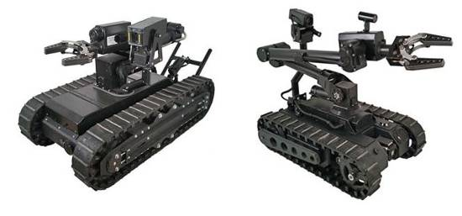
When it is anticipated that the approach to a suspected IED bomb of MF-IED may have concealed hazards or initiation systems linked to the suspected IED bomb of MF-IED, a first approach using a remotely controlled machine (sometimes called a ‘robot’) must be conducted. When a wireless jamming system is in use, a remotely controlled machine can only be used when there is no signal conflict. It can be appropriate to turn off the jamming system (or selected bands) while the remotely controlled machine is in use.

Small ground machines
Dedicated EOD robots (ground machines) are expensive to purchase, can have a very limited battery life and be difficult or impossible to deploy over broken ground, building rubble or inside buildings. Easily damaged and often prone to problems with dust ingress, they can rarely be treated as ‘disposable’ so there may be reluctance
to deploy them when a detonation is likely. In many cases the importation of dedicated EOD robots can also be complicated by licensing requirements or restrictions applied to their sale. However, they often combine a camera, manipulator arm and disruption capability in one device. When non destructive disruption of a device for forensic examination is a high priority, their use and risk of loss may be justified, but they are not designed for HIED.
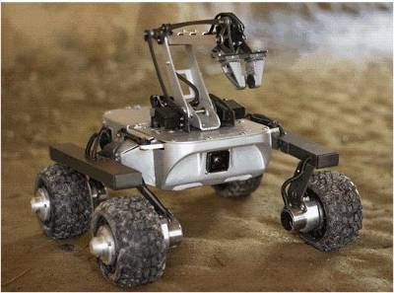
An ideal HIEDC robot would be capable of crossing rough ground and rubble (moving obstructions aside) and be able to carry out both delicate and robust manipulation tasks over a protracted period of time. It should be able to accurately place disruption devices and either be suitably armoured to survive a detonation or low-cost enough to be considered ‘disposable’.
Robust low-cost all-terrain machines that are not designed specifically for EOD work but are remarkably robust (like that shown on the left with a 200 metre range) are available at relatively low cost.
At present, no commercially available truly ‘disposable’ EOD robots are known but if they become available, their purchase must be considered.
Relatively inexpensive radio controlled toy cars have been converted to carry camera systems and disrupters for use in the first approach to suspected IED bombs or MF-IEDs. Their low cost is attractive, as is the fact the people who use them can be involved in manufacture and testing, so gaining knowledge of their limitations that is not influenced by any manufacturer’s sales pitch. The effective control range of some of these machine can be sufficient if the controller can be protected behind natural features or walls, or inside a suitably armoured vehicle. Extended the range of a ground machine by using it to place signal boosting devices along its route is an alternative that may be used.
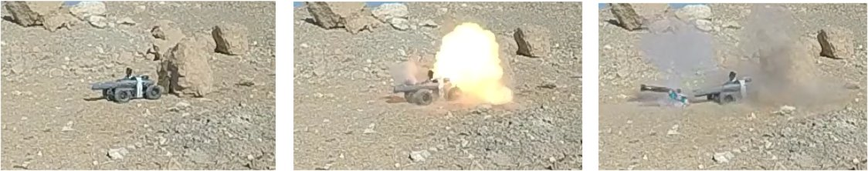
The photograph shows a radio-controlled toy with 12cm diameter wheels and robust independent suspension that is designed to traverse rough ground. Its body shell has been removed and it has been converted to carry a camera and an improvised disrupter that uses a large calibre bullet which is being used in the photographs to fire a metal slug at a suspected rock mine. To limit the recoil damaging the car, the disrupter is attached to the chassis with tape which breaks away so that the improvised barrel can recoil on its own. The rock in the pictures was not an improvised mine, but if it had been a mine the loss of the car would have been a ‘tolerable’ cost. Its most expensive component was the camera system which was omitted from later versions when the car was controlled using the camera of an SUA flying overhead.

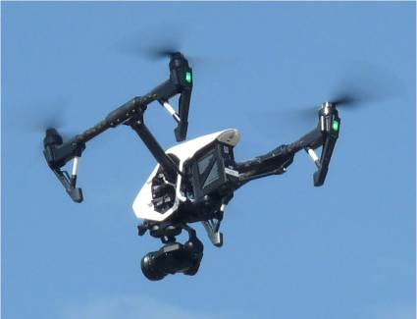
Small unmanned aircraft
Standard off-she-shelf SUA with quality cameras able to stream video footage to a remote controller are recommended for use during the first approach to any suspected IED bomb or MF-IED that is outside a building. Smaller SUA may be converted to allow the airborne camera inspection of suspected devices inside some buildings. The SUA may also be used to make wide-area over-flights to produce photographic maps than can help plan safe access routes during a Task Assessment. When reliably adapted, SUA may also be used to conduct other functions, such as placing disruption systems, as long as the procedures are approved by the operations manager and added to the SUA SOPs in Chapter 10.

Large ground machines
Depending on the level of protection offered by the armouring, some armoured machines may be used with an on-board operator. This is only permitted when the anticipated hazards are small enough for the risks associated with an unintended detonation to the operator to be tolerable. Machines with an on-board operator should not be used to deliberately disrupt or move IED bombs or MF-IEDs.
An armoured remotely controlled ground vehicle may be used to move obstructions aside or to traverse the area approaching a suspected device in order to initiate hidden fuzing systems designed to be initiated by a manual approach. The vehicle may be damaged or destroyed by a large IED bomb or MF-IED so this approach should only be used when the anticipated damage to the machine is ‘tolerable’.
Some manufacturers of demining machines have produced variants designed for use in HIED.
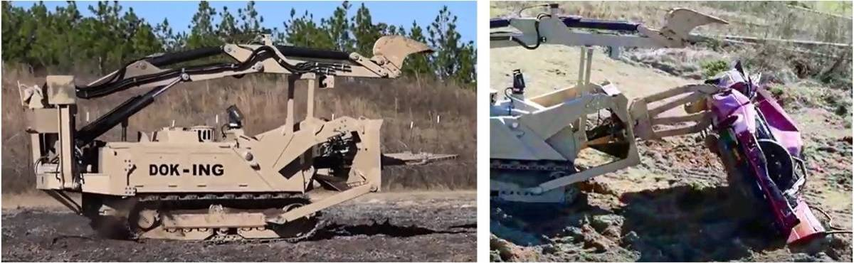
An example is shown above. This is the remotely controlled MV4 Skorpion which can be used to make an approach to a device for camera inspection, to move obstructions aside, to place a net and line system for remote pulling, or to aggressively disrupt a suspected IED bomb or MF-IED.

Constraints when using machines in HIED
All remotely controlled machines can only be operated by appropriately trained people who should be protected behind suitable armouring or other protection when the machine approaches any suspected hazard.
The operator of any remotely controlled ground machine should not maintain direct line of sight to the machine after it is within twenty metres of the anticipated hazard(s). A remotely controlled ground machine must carry an effective camera system unless its use is combined with a SUA that provides a camera overview which enables the ground machine to be controlled effectively.
The operator of a remotely controlled SUA may maintain line of sight to the SUA as long as that does not entail having line of sight to the suspected hazard. Chapter 10 in these Global SOPs covers the use of Small Unmanned Aircraft (SUA).
For any ground machine used as an HIEDC tool, detailed instructions for its maintenance and use must be added as an appendix to this SOP and appropriate training conducted before the machine is used.
- Spot-tasks in public places
A specialist HIEDC team may be called to deal with a single suspected IED bomb or MF-IED in a public place on a road, amongst buildings or inside a building. When this occurs, the following rules should be applied.
- Any device that has failed to detonate or may have failed to detonate completely must be approached as if it were fully functional.
- The team must liaise with all the appropriate authorities and make a Task Risk Assessment based on all available information.
- When appropriate, the use of a wireless signal jammer may be negotiated. A jammer should only be used when its use does not conflict with the use of remotely controlled machines.
- A safety cordon that keeps all members of the public out of sight of the device must be established. Although the details of the hazard are not yet known so a safety distance will only be a guess, the exclusion area should be as large as possible and should take account of the risk of secondary injuries caused by the effect of a detonation on any buildings or hazards close by.
- Unless it is reliably known that others have already approached the device, a remote inspection should be made using a camera on a remotely controlled machine.
- When the Task Risk Assessment permits, HIEDC searchers can search the approach to the device searching for secondary devices or fuze systems.
- An EOD Level 3+ C-IED specialist may approach the device to make an inspection of the suspected device without touching it.
- When there is no reason to believe that the device is actually a hazard, a net or a grapnel and line should be placed to allow the device to be pulled from a safe distance.
- When the device is or may be an explosive hazard, the task supervisor should consider the need to place damage-containment works, such as sand or water filled bags around it. Filled plastic water tanks can be particularly effective at stopping both blast and fragmentation. Any damage-containment works should be placed using a machine whenever possible, but cautious placement by hand is permitted.
- The task supervisor should decide whether a detonation is acceptable. If it is, a suitable machine may be used to place an energetic disrupter to disrupt or initiate the device. A team member trained in using the machine and conducting the selected procedure should control the machine from a safe position. The disrupter may also be placed by an EOD Level 3+ C-IED specialist if the specialist decides that it is safe to do so. When a detonation is not an acceptable outcome, the task supervisor should consider the placement of further damage containment works, extending the exclusion zone and/or sourcing other means of disruption that are less likely to cause an initiation.
- Placing a disruption device with the intent of separating the main charge from the initiation system(s) may reduce the risk of a detonation but it must be understood that a detonation is still a likely outcome. This procedure may involve the use of one of more of the following:
- an explosive charge;
- a net or a grapnel system designed to move or pull the device apart;
- a directed slug of steel, water or pellets;
- an explosively formed projectile; or
- a suitably weighted and wheeled nozzle attached to a hose through which a high pressure water jet can be fired (when a water supply is available and the nozzle can be anchored securely): the nozzle should not be directed by hand.
- The task supervisor must ensure that the safety cordon is in place before the disruption takes place. When a disruption separates a device and hazardous parts remain, a second disruption may be necessary. If there is any sign of continued combustion (smoke or flames), a pressure hose may be used to play water on the remains of the device.
- The results of the disruption should be inspected using an SUA or a ground machine carrying a camera. If further disruption is necessary, this should be conducted using a machine. After an apparently successful disruption, the EOD Level 3+ C-IED specialist should wait at least 15 minutes before approaching the site for further inspection. The wait time may be reduced when the results of a disruption are visible and the suspected device was clearly not an explosive hazard or when the successful separation of device components can be confirmed using a remotely controlled camera.
When working in any area where there is a possibility that members of the HIEDC team may be targeted, all routines should be varied. This also applies to the wait time before approaching the site for further inspection.
- Searching buildings
The instructions here only cover the search of buildings where there may be IED bombs of MF-IEDs. They do not cover the search of buildings in which improvised devices are not anticipated. Search of these buildings may be conducted using a disciplined search as part of the conventional demining procedures described in Chapter 6, part 14.5. At the discretion of the task supervisor, parts of this SOP may be used when booby-trap hazards are anticipated.
The HIEDC team must have been appropriately trained in building search before deployment (see Annex C for training headings). The training should stress the need for the search teams to avoid unnecessary damage to furnishings and private property that may be present.
A Task Assessment including a formal Task Risk Assessment should have led to the production of a Task Release Plan before a team is deployed, so ensuring that they are appropriately prepared and equipped. The Task Release Plan should detail any use of wireless signal blockers and the distances over which they can be reliably effective inside the building. Whenever fire is predictable outcome of a detonation, a fire tender should be available and stationed close to the control point.
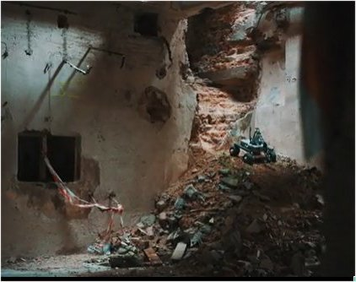
When working in damaged buildings the Task Risk Assessment and Task Release Plan must take all possible measures to reduce non-explosive related risk to tolerable levels. A remotely controlled machine should be used to make a visual survey to inform the Task Release Plan whenever one is available. When the machine is capable, it should be used to conduct a thorough primary search.
The picture on the right shows an all-terrain radio-controlled machine with lights and camera system inside a damaged building. Not designed for EOD
support, it is nevertheless a tool that can be used without requiring adaptation.
Things to be considered include:
- unstable walls and floors;
- twisted reinforcing bar causing obstructions;
- significant rubble that must be removed;
- unsafe or missing stairways; and
- the biological and psychological hazards that may be caused by the presence of human remains.
When civil machinery (such as fire tenders, back-hoes or bulldozers) are used as part of the work, their use must be closely controlled so that they do not present any increased risk to anyone present. No machine can be deployed on a specialist HIEDC Search & Clearance task unless that machine has a specific SOP for its use and the operator is trained to use the machine appropriately in accordance with that SOP.
  - Preparation
The Task Release Plan must include detailed team member instructions that ensure that appropriate safety distances are maintained throughout the work. The protection provided by walls or other structures should be taken into account when deciding appropriate and practical working/safety distances.
Before approaching the house/building the team supervisor should establish a control point in a safe area. The area must be searched whenever its safety is uncertain.
The Task Release Plan should indicate the approach path and place(s) of entry to the building(s).
If hazards are anticipated outside the building, the approach path and a working area around the place(s) of entry must be Searched & Cleared so that the team members can inspect the building through windows and doors without entering.
Additional equipment that may be needed includes:
- LED battery lights (hand-held or head-torches);
- tripod, pulleys, pulling wires, hooks and attachments;
- remote door-handle opening devices;
- remote lifting and turning devices;
- thick gloves (for safely moving broken glass and rubble);
- long and short ladders;
- insulated electrical screwdrivers to open the faces of light switches and electrical outlets;
- non-permanent spray paint for marking on floors or walls;
- chalk for marking searched furniture or on floor and walls;
- sand-bags and sand buckets; and
- a sharp utility knife to cut open soft furnishings when required.
  - Search team size and separation
Generally, the number of people searching inside a small building should not be more than two working separately. No other person should enter the building while they are searching.
In large buildings such as residential flats, offices or industrial premises, more IED searchers may be deployed to search simultaneously as long as they are appropriately protected by barriers and distance between each other. In a reinforced concrete building, there should be either two walls or two floors between each searcher. When a building is constructed using weaker materials or the anticipated threat is large, this distance must be increased.
Whenever more than one person is searching in a building simultaneously, the task supervisor must clearly define the places they will search and the order in which they will search before they are deployed. In order to achieve this, an internal map showing rooms, corridors and stairs will be necessary. If that cannot be produced, or until that can be produced, only one searcher at a time should be allowed to work inside the building.
  - Searching from outside
Looking through doors, windows or other openings without touching them, searchers should look for any indication of explosive hazards. These may include:
- unusual or attractive items left in the open;
- loose floor boards;
- new nails or screws;
- sawdust or masonry dust;
- unexplained piles of rubble or furniture;
- exposed electrical wires;
- obstructions that have been placed to oblige people to walk over a particular area or in a particular direction.
If any suspicious items are seen, their position should be noted and the team supervisor informed before any team member enters the building.
  - Entering the building
Those wanting to deny others use of the building will often have placed devices in or near the easy places of entry.

External doorways
Doorways should never be presumed safe unless the door is fully open and the entrance can be clearly seen. An undamaged concrete floor is unlikely to conceal a device but a rug or carpet could easily conceal an initiation system. The door itself may be attached to a device or a movement sensor may be positioned to be activated by anyone entering. When this is anticipated, the building can either be entered from another place, entered through the door using a small remotely controlled ground machine with a camera facility, or a small explosive charge can be used on the door. When using a small machine, the searchers should be aware that it may not be large enough to trigger a movement-sensor switch.

Windows
Ground floor windows should be considered suspicious, especially if broken or unfastened. Before approaching them, the ground outside should be searched. When looking through them, the searcher must pay particular attention to the floor inside where anyone stepping through could place their feet.
If it is decided to enter through a window:
- whenever possible, select a closed window with no sign of activity around it;
- when the window can be pulled open remotely, pull it open from a safe distance;
- when the window is closed, break the glass by throwing a heavy object through it, then attach a wire and pull away as much of the window frame as possible; and
- if the window has curtains or blinds, attach a line and pull them outside.
When entering through a window, searchers should use a broad plank of wood or a short ladder inside the building to avoid having to step on the floor close to the window.
When entering through a window, any broken glass should be removed so that it is safe to exit through that window if required.

Entry holes
When it is decided that entering the building through a door or window is too hazardous, a new entry hole may be made in a wall or the roof. Generally, the entry hole should be made using a small explosive charge (which may be a platter-charge) that is detonated from a distance. This will avoid any risks associated with making the entry manually.
Entry through the roof of a multi-floored building should generally be avoided because it is more difficult to search stairs going down than it is going up.
  - Searching corridors and opening doors
The search of corridors between rooms should be treated in the same way as a room search..
All doors should be opened remotely, then closed again before opening them to search. Check both sides of a door. When necessary, drill a hole through it and use a mirror-stick or flexible borescope camera to visually check the inside.
The threshold of each room must be searched before moving inside.
When necessary, doors can be opened using small explosive charges.
Some complex machines have the capacity to open doors and, if both available and able to access the working area, they may be used by suitably trained staff.
  - Searching visually
Visually search each room from the threshold, only moving inside when it appears safe to do so.
When a machine is available, use the machine to enter the room first and make a camera inspection of floor, walls and ceiling.
In dark places where light-sensitive initiation systems may have been used, use a machine to present a light remotely before searching. If infra-red switches are anticipated, consider fitting a lightweight (cardboard) figure to a small machine so that it presents an approximately human profile when turned around inside the room. When thermostat switches are anticipated, consider fitting a heated lightweight figure to a small machine so that it presents an approximately human profile when turned around inside the room. In all cases, the intent is to activate the switch so the procedure should be conducted from a safe distance.
Do not switch on lights or other electrical equipment.
When inside the room, do not open curtains or blinds without having inspected them thoroughly to ensure that it is safe to do so. Search every cupboard or alcove in a disciplined pattern that ensures no areas are left uninspected and mark each after search with spray paint or chalk.
Avoid stepping on any items such as rugs or rubble on the floor. If tripwires are anticipated, use a tripwire search drill from floor to above head height before advancing.
Before touching anything, in each room, visually search looking for signs of disturbance:
- floors and floor coverings;
- walls and wall hangings;
- doors;
- windows;
- fireplaces or recesses and shelves;
- the outside of cupboards and furnishings;
- light switches or electrical outlets;
- wall hangings and paintings;
- ceilings and light fittings.
  - Complete search
After the visual search, a complete search should be conducted.
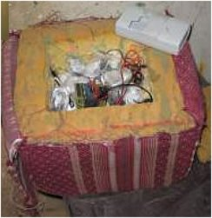
The search may involve carefully moving debris, opening drawers and cupboards, or moving furniture and small items in the room. Whenever possible, this should be done remotely using a line pulled from outside the room. When there is a risk of delay fuzes having been used, allow a suitable passage of time after remotely pulling an object.
Upholstered furniture and beds can be checked non-destructively by using a tripod and line system to remotely drop a heavy object onto them, then turn them over. Visually inspect every cushion or mattress and carefully cut it open when there is any reason to suspect that it may conceal a hazard. Do not feel for the hazard by pressing soft furnishings. The picture alongside shows a footstool containing an IED bomb booby-trap.
Plumbing should be checked by remotely turning on taps and allowing the water to run into baths and basins for at least one minute. Searchers should remotely check inside cisterns before flushing toilets. Setting up the means to turn a tap, lift a toilet seat or lift a cistern lid remotely can be time consuming but must be done. Searchers should avoid retaining a line-of-sight when remotely lifting or pulling because if they can see what is happening directly, any explosion will have a direct line to their eyes. Small UAVs with cameras, small mirrors on long sticks, borescope or tripod mounted cameras may all be used to see what is happening when required.
The faces of light fittings and electrical sockets should be unscrewed to ensure that there are no unexplained wires behind them. Replace the screws afterwards unless there is reason to be suspicious. Do not turn the switch on until there is complete confidence that doing so will not complete a circuit to initiate a device elsewhere.
Inspect any electrical items present to determine whether they have been fitted with devices that will be initiated when they are moved or turned on.
Leave open all windows, doors, cupboards and drawers that have been searched. Every item of furniture that has been searched should be marked with paint or chalk.
If a suspicious device is located, the searcher should mark the approach to it with a spray paint arrow and withdraw to inform the team supervisor.
When a room has been searched and no hazards are found, the entry should be marked with a line of white spray paint across the threshold to show that it has been searched and is ‘Presumed Clear’.
  - IED parts
During the search of any building, materials that suggest the premises have been for the construction of IEDs may be found. These may not present an explosive hazard until they have been assembled and armed. Unless the NMAA, the police, or those responsible for local security have given instructions to the contrary, the materials should be treated as hazardous and collected for destruction in a safe place. When they must be left where they are found, no police or security force investigation of the materials can take place while the specialist HIEDC team is present at the task site. Generally, the investigation should be delayed until the building has been searched for other hazards and the search team has left the task site. The Task Release Plan and Task Risk Assessment may need to be revised to reflect the risk that IEDs have been placed to prevent inspection/recovery of the IED making materials.
- IED bombs and MF-IEDs in vehicles
A Humanitarian Mine Action organisation should not be tasked to Search & Clear a recently placed vehicle that may be carrying an IED bomb. Typically, IED bombs in vehicles may be initiated by the driver in a suicide attack or abandoned by the driver for a later initiation. When left for later initiation, they may have a time-delay system, be designed for remote initiation, or may be MF-IEDs intended to be initiated by persons inspecting/entering the vehicle. In conflict areas, this is generally a task for the security forces. However, when searching for IED bombs and MF-IEDs, vehicles may be present at the task site and there may be reason to suspect that they could conceal improvised devices that have not yet functioned.
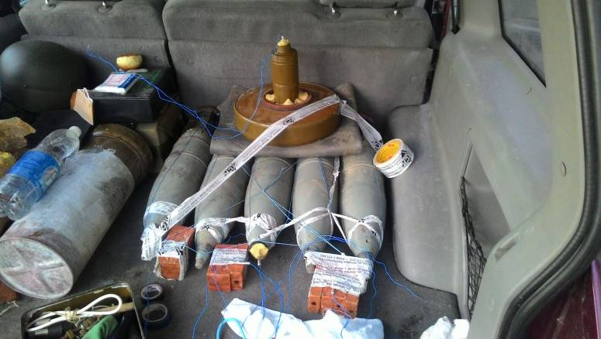
An IED bomb or MF-IED in a vehicle will generally have been designed to either cause damage to property and people or to target specific individuals who use the vehicle. IED bombs targeting an individual are usually concealed on, under or inside the vehicle so that the victim will enter it without suspicion. Other devices in vehicles may be hidden behind panels, beneath the vehicle or may be placed in their load carrying areas with innocent items on top. In some cases, the device is clearly visible and placed partly to make people keep away. The effects of the device may be augmented by deliberately parking the vehicle close to other hazardous materials, such as fuel tanks.
Whenever possible before a vehicle search, the task liaison officer should attempt to identify the vehicle owners and explain that the vehicle is likely to be damaged/destroyed. If the owner insists on moving or searching the vehicle, the search team should advise against this. However, it is not part of the HIEDC team’s role to enforce obedience. When appropriate, the police and security forces may restrain the vehicle owner. When the owner is determined to search or remove the vehicle and there are no authorities empowered or willing to restrain them, the HIEDC team should withdraw to a safe distance until the vehicle is no longer on the task site.
Unless larger hazards are anticipated, the following minimum safety cordon radius should be applied.
Anticipated size of IED | Cordon radius | Notes
Small under-vehicle IED | 200m | originally targeting an individual driver
Small in-vehicle IED | 300m | vehicle the size of a saloon car
Large in-vehicle IED | 400m | vehicle the size of a van or small truck
Hazardous Loads | Maximum practicable | When the load is not known, a worst-case should be presumed
As in all other HIEDC team search tasks, only one searcher is permitted to approach the vehicle during a search. All other team members must be at a safe distance or behind cover and should not have unprotected line-of-sight to the vehicle.
Unless it is known that people have already approached the vehicle and there is no risk of a command detonation, a ground machine or a UAV should be used to make a primary visual inspection. The primary inspection involves making a visual survey from all sides and, when possible, beneath.
When necessary, approaches to the vehicle should be searched for indications of secondary devices. After the search of the approach or when there is no reason to anticipate secondary initiation systems outside the vehicle, a searcher should first make a primary inspection without touching the vehicle. When nothing suspicious is seen, the searcher should inspect the underside and wheel arches of the vehicle using a battery-powered light and a search-mirror.
When there is no indication of an explosive hazard, the vehicle should be moved remotely by dragging it. This may initiate a victim-initiated device, start a delay fuze or re-start a choked timing device, so an appropriate wait time should elapse before continuing. When a vehicle is on a slope, obstructions should be placed to prevent it rolling downhill before moving it remotely. The ground where the vehicle originally stood should be searched for concealed hazards.
After moving the vehicle without incident, the HIEDC team should use remote pulling procedures to open the doors, then allow a suitable wait time to pass before making a visual inspection inside the vehicle without entering. Mirrors and lights should be used to check under seats and in concealed places before attaching lines to remotely pull the bonnet, boot, fuel-cap and remaining door catches. After the vehicle’s openings have all been released and the content inspected with no evidence of any hazard, a searcher can enter the vehicle to complete the search.
If at any time an indication of an explosive hazard is found, the search must stop and the team leader should be informed. The Task Risk Assessment and Task Release plan may need to be revised to allow for the fragmentation hazard from the vehicle or any other hazards associated with its possible content and context. The task safety cordon must be extended when necessary.
If a suspected IED is located it must be disrupted or detonated. A search of what remains should be conducted after an appropriate wait time. When that search is complete and no evidence of a hazard is found, the remains of the vehicle should be moved from the area.
- Destroying confirmed IED bombs and MF-IEDs
The device should not be approached until a thorough search for secondary fuze systems or separate devices has been conducted and there is full confidence that none are present. Whenever possible, this must be done remotely using a ground machine or UAV before any human approach is made. The decision over which methods to use to destroy the device should be made by an appropriately trained and experienced specialist HIEDC specialist with an EOD 3+ C-IED qualification. The same person should be the only person permitted to approach a confirmed IED bomb or MF-IED when an approach is necessary.
Unless there are compelling reasons not to detonate the device, all suspect IED bombs and MF-IEDs should be disrupted/destroyed where they are. The appropriate procedures to use will depend on the anticipated fuzing system and design of the device. Depending on the device, some methods will be more likely to lead to a full detonation of the device than others, and some will be more likely to be successful in disrupting the device than others. The task supervisor should consider the placement of protective works to contain possible damage whenever appropriate.
All attempts at disruption should be approached knowing that a detonation is a possible outcome. Disruption can be by non-explosive means designed to separate the initiation system(s) from the explosive charge or by firing something at high velocity at the device with the intent of separating components.
The first attempt at disruption may be by using a pulling procedure to try to separate components of the device, or by using a robust machine to attempt such a separation. High pressure water jets may also be used as long as the nozzle can be suitably anchored to allow remote use. All procedures should be conducted remotely, whenever possible.
Alternatively, a small explosive charge may be used to disrupt the device. Whenever a suitable remotely controlled machine is available, it should be used to place any demolition charges and disruption devices. SUA may be used to do this by appropriately trained operatives. Alternatively, when it is considered safe to do so, explosive charges and disruption devices can be placed by an EOD 3+ C-IED specialist taking great care not to disturb the device. The charge or disruptor should be placed to ensure that the suspicious item is either disrupted, initiated or compromised enough to allow a safe approach for further examination.
As a last resort, accurate, large calibre rifle fire may be used to attempt to disrupt a device from a distance that ensures safety. Rifle fire is the least reliable way of disrupting a device and should only be conducted with the approval of the local authorities and the knowledge of all those who might otherwise respond aggressively to the gunfire.
When appropriate, an attempt to detonate the device may be effected by placing an explosive charge close enough to the main explosive content to instigate a detonation by shock wave propagation, or by firing an energetic projectile such as an explosively formed projectile at the device.
After an attempted disruption/destruction, no approach by a person to the detonation site for at least fifteen minutes is permitted whether or not there is a major detonation. Any fire that results should be doused from a distance. A second visual inspection using a remote camera system may be conducted during the waiting period.
Generally, all IED bombs and MF-IEDs should be disrupted even when there is a high risk of that causing a major explosion. When there is complete confidence that the hazard is an IED bomb with an initiation system that cane be rendered safe so that the bomb can be moved to another place for destruction, that may be done. Whenever an IED bomb is rendered safe to move, all people other than the EOD 3+ C-IED specialist rendering the device safe must be at the appropriate distance wearing PPE and the safety cordon required for a deliberate demolition must be in place.
EOD 3+ C-IED specialists may only disarm/defuse IED bombs when they are entirely familiar with the initiation system. There is no tolerable level of risk that would justify an attempt to disarm a device that has an unfamiliar initiation system. While some fuzes can be safely disarmed, if there is anything unusual about an initiation system, it must be presumed that the device has been modified and is an MF-IED.
When a device includes munitions that a detonation may fire or throw a large distance, the possibility of munitions detonating in flight or on impact must be considered. The anticipated flight path and impact area(s) should be determined and the safety cordon revised to ensure that people will be safe if an initiation occurs. When munitions are spread, unexploded or damaged munitions should be located and destroyed following normal BAC procedures in a timely manner, which may require more searchers to be deployed.
When approaching any device after attempted disruption/destruction, a search must be conducted for secondary devices that may have become exposed. When approaching a disrupted device that has fired or thrown munitions away from the source, the point of origin may be an MF-IED that has been fitted with a self-destruct device or additional initiation devices intended to target the searchers.
After any attempt at disruption/demolition that does not lead to a detonation, the result must be surveyed remotely before any staff approach. A second disruption to ensure that all hazardous materials are completely separated should be conducted using a remotely controlled machine when there is any doubt about the safety of an approach.
  - General disarming safety guidelines
Because the range of possible improvised explosive devices is so great, it is not possible to specify detailed rules that must be applied. The only fixed rules are that the person tasked with deciding whether disarming is a responsible action must be experienced enough to make a well informed judgment and must never attempt to disarm or deactivate a device that they do not fully understand and have 100% confidence that they can safely conduct the task.
General safety guidelines are listed below.
- Never cut a slack wire without first having found where its starts and ends because it may be a “break-wire” which will initiate a fuze if cut.
- Do not cut a taut wire without first having found where its starts and ends. It may be attached to a pressure release fuze which will be activated when the wire is cut.
- When tracing a wire, look for other devices that may have been placed under or around the wire.
- Examine suspicious items from all angles to look for evidence of wires, detonation cord or trigger devices before moving them remotely.
- Generally, unless otherwise instructed, detonation cord may be cut and separated.
- Generally, do not cut electric wires in a suspected device unless there is complete confidence that the power-source is dead and any capacitors involved have discharged. When electrical wires that may have multiple cores must be cut, the use of a twin blade ceramic cutter can ensure that the cutter does not complete a circuit.
- Do not use excessive force when conducting any approved render-safe procedure.
Generally, disrupting a device from a safe distance must be preferred to disarming even when there is a high risk of initiating the device.
- Dealing with discovered UXO, AXO or explosives
During the search for IED bombs an MF-IEDs, unexploded or abandoned ordnance may be found. Any unexploded or abandoned ordnance that is found during the search should be assessed and categorised as being safe to move, save to move by hand only, or not safe to move.
- Safe to move: the device may be moved outside the building to a designated secure area and transported to another place for disposal later.
- Safe to move by hand only: the device may be moved outside the building to a designated secure area or demolition area but may not be moved by vehicle to another place.
- Not safe to move: the position of the UXO/AXO must be clearly marked until it can be destroyed without moving it. HIEDC team searchers should ask the team leader to assess the device and decide whether they should conduct the destruction before any further work can continue, or continue working away from the device and deal with it at a later time.
When any UXO/AXO with a white phosphorus content is discovered, the Task Risk Assessment should be updated to take note of the risks from phosphorus munitions that may have been damaged so that the phosphorus ignites when exposed to air as work is conducted. Buckets of sand should be available in all areas where this might occur.
Volatiles from nitrobenzine based explosives can seriously damage lungs, so persons required to approach them must be issued with a respirator.
Some improvised explosives (for example, acetone peroxide, aka TATP, TCAP, Peroxyacetone) are heat, friction and shock sensitive so especially hazardous to move, especially when old.
Some improvised explosive materials are sensitive to crushing and abrasion. If materials of this nature have been spread by disruption, the person making the next manual approach should be suitably protected against flash-fire. It may be considered appropriate to wear a bomb suit and closed helmet.
- Finding human remains
IED search is often conducted in battle areas where civilians and combatants may have died during the fighting. Because the areas are known to be dangerous, their remains may have been undisturbed since the fighting ended. When conflict remains are discovered, the appropriate authorities should confirm that the remains date from the conflict before it is presumed that no civil crime has been committed. The remains must not be disturbed until the appropriate authorities have decided whether an investigation of the circumstance surrounding the death is necessary.
The recovery, identification and storing of human remains is usually the responsibility of national police and health workers. Whenever possible, the HIEDC team should provide them with assistance by searching the approaches to the body, advising on safety, and moving the remains remotely to ensure that they are not linked to any explosive device.
The appropriate authorities should attend the site in a timely manner. When they are present, responsibility for safety at the task site remains with the HIEDC task supervisor and the visitors must obey the safety rules in place at the site. If they will not obey the required safety constraints, the task supervisor must refuse to allow any team members to enter the area until the investigators leave. When necessary, the NMAA should liaise with the authorities to gain their cooperation.
If human remains, or suspected human remains, are found during specialist HIEDC search, the procedures required by the NMAA must be followed. When the NMAA does not have published procedures, the procedures in this Chapter 6, part 15 should be followed.
- Quality Assurance (QA) and Quality Control (QC)
Conventional methods of conducting QA and QC during demining activities are not possible during specialist HIEDC area Search & Clearance and Spot Tasks for safety reasons. The methods to be used are described below.
  - Internal QA
Internal QA is provided by the second member in each pair of IED searchers conducting the search. All team members must be highly trained and have supervisory experience, so each can be the QA for the other. Every person in a search team must have been appropriately trained to conduct internal QA.
Whenever the second searcher in each pair starts work, the first few minutes of work will be to check that the last area searched is clearly and correctly marked as having been searched. The area searched during each work period must be recorded by the team leader. This means that the person responsible for any anomaly found during a QC check will be readily identified.
  - Internal QC
After each working day, the team supervisor should conduct a QC check of the entire area worked by the team under his/her control, randomly checking that every area has been appropriately searched and marked. If an anomaly is found, the entire area searched by that searcher during that work period must be searched again by another searcher. If no hazards are found, the searcher who failed to conduct an adequate search shall be subject to disciplinary proceedings which should include a suspension or redeployment and may include dismissal. If any hazards are found, the searcher who failed to conduct an adequate search must be dismissed.
  - External QA
Whenever searching in areas where IED bombs or MF-IEDs are anticipated, only one person at a time is allowed to be in the hazardous area during the search. This means that external QA staff must not be allowed closer than the control point or the safety cordon. The observation of activities from that distance is permitted.
External QA checks of the staff movement, equipment, documentation and command structure at the control point must be facilitated by all HIEDC team members.
  - External QC
QC checks conducted by an outside agency may be made immediately after an area has been declared Searched & Cleared. When the QC is conducted in a timely manner, the specialist HIEDC team supervisor should provide all possible assistance. When external QC is conducted after the team has moved to another site, this will not be possible.
External QC must be conducted immediately on completion of the work in order to avoid the possibility of new devices being placed between the completion of the search and the inspection.

Reporting
All work conducted by specialist HIEDC teams must be recorded and reported as required internally and as required by the NMAA and the donor. Reports must be submitted on time. Close liaison with any external QA/QC authority should be maintained throughout the work so that they can conduct their work appropriately.
As a minimum, a standard Completion Report must be prepared after any task conducted at the request of, or with the approval of, the NMAA.
Whenever IED bombs or MF-IEDs are found, a record of what is known about their type and composition should be included in an Annex to this SOP for future reference.

Annex A: Notes about improvised explosive hazards
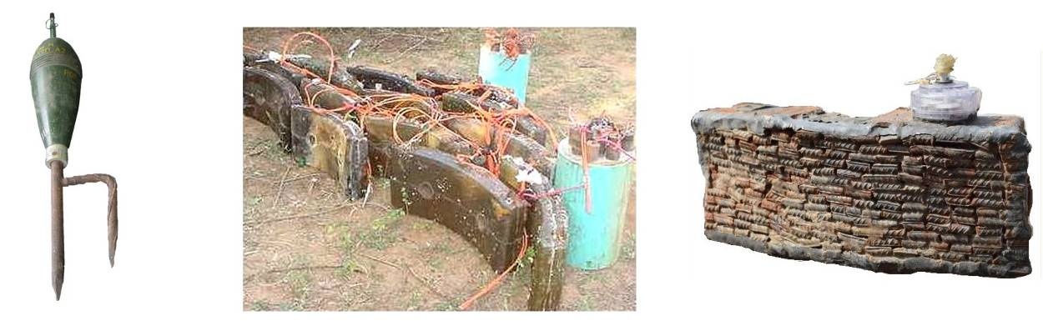
Improvised mines and munitions are often used in conflict.

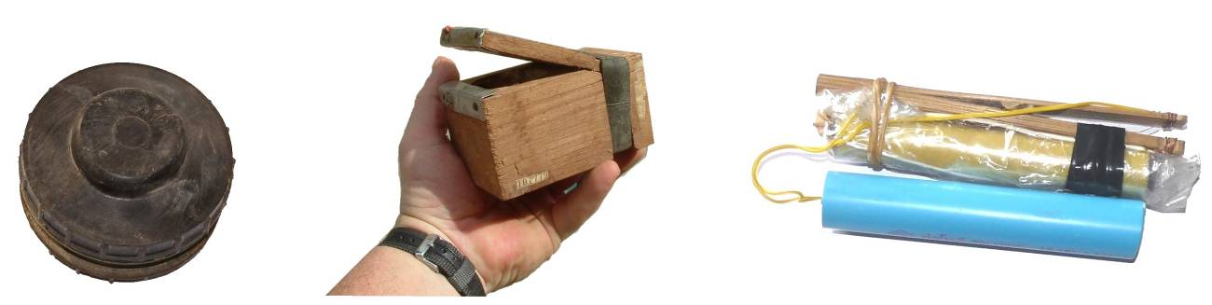
The pictures above show improvised fragmentation mines in Sri Lanka and Yemen.

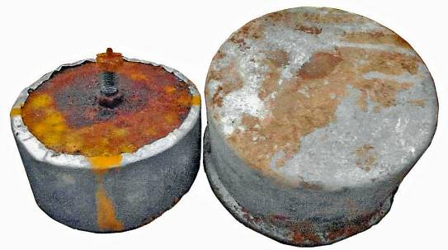
These pictures show improvised anti-personnel mines made in small workshops in Sri Lanka and Myanmar.

Cooking pots have been widely used to manufacture batches of improvised mines in Syria and Iraq, many of which have improvised pressure fuzes. However, additional fuze systems may make them MF-IEDs.

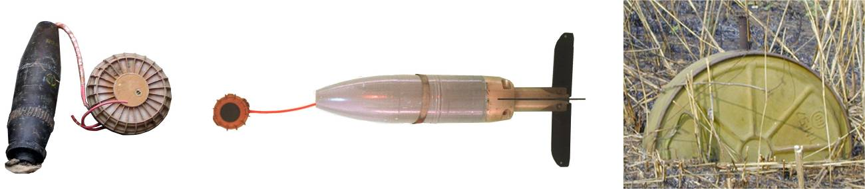

Factory produced mines can become simple IEDs by being boosted or having their initiation systems altered. The picture shows munitions used to boost the effects of an AT mine in Iraq, an AP mine in Afghanistan, and an AT mine adapted to be tripwire initiated in Angola. The use of mines as initiation devices or as boosters to IEDs is common in areas where there are many mines. IEDs that work in one country are often copied in another.

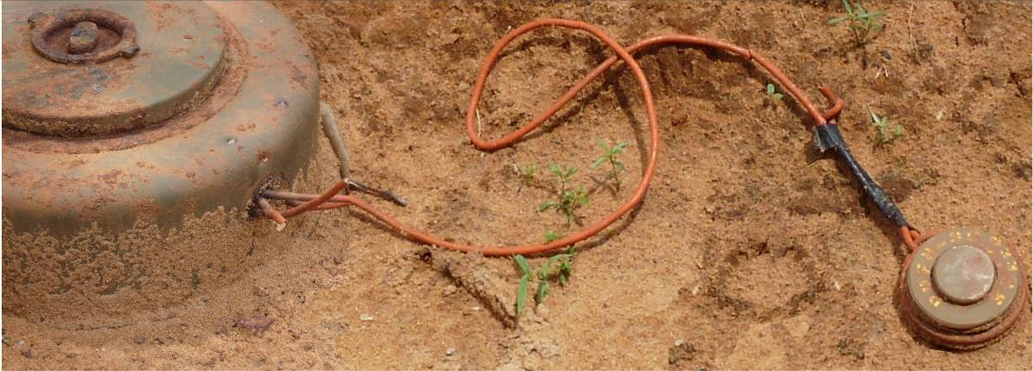
An AP mine linked by det-cord to an AT mine in Sri Lanka.
Improvised mines are not only made by non-state actors. Most armies teach their soldiers how to improvise mines in case of need.
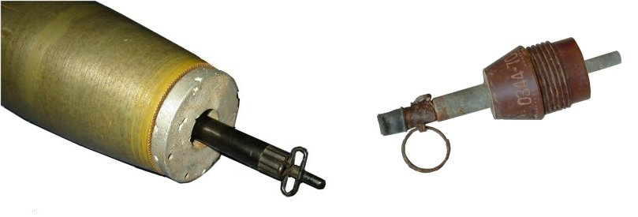
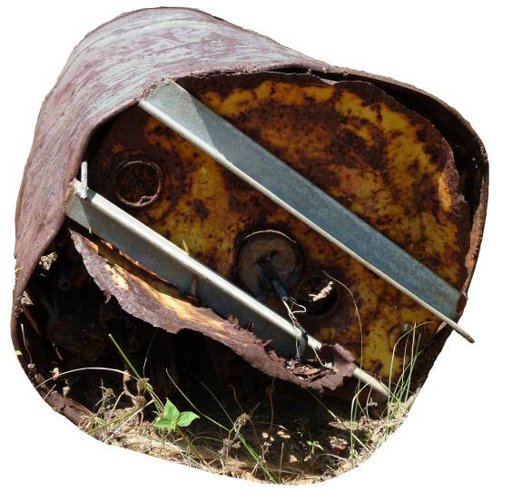
The pictures above show an improvised fuze attachment for a shell and an improvised fuze attachment for a mortar bomb, both of which adapt the munition to be used as a tripwire activated AP fragmentation mine.

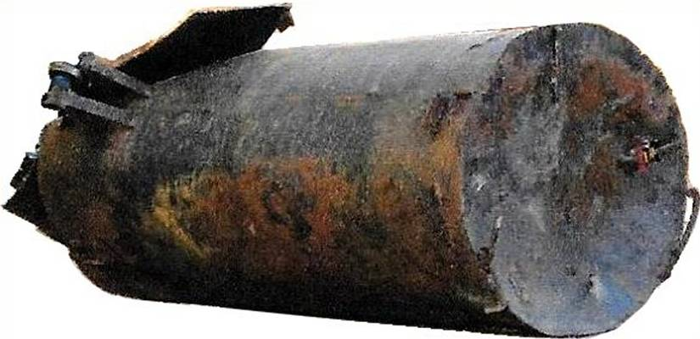

The photographs above show improvised barrel bombs. The barrel on the left was airdropped by government forces in Syria. It’s shaped end may be intended to form a penetrator and its payload may include toxic chemicals. The barrel on the right was a command detonated defensive weapon used in Sri Lanka by those opposing the government’s forces. It’s payload was captured small arms ammunition wrapped around a core of high explosives.

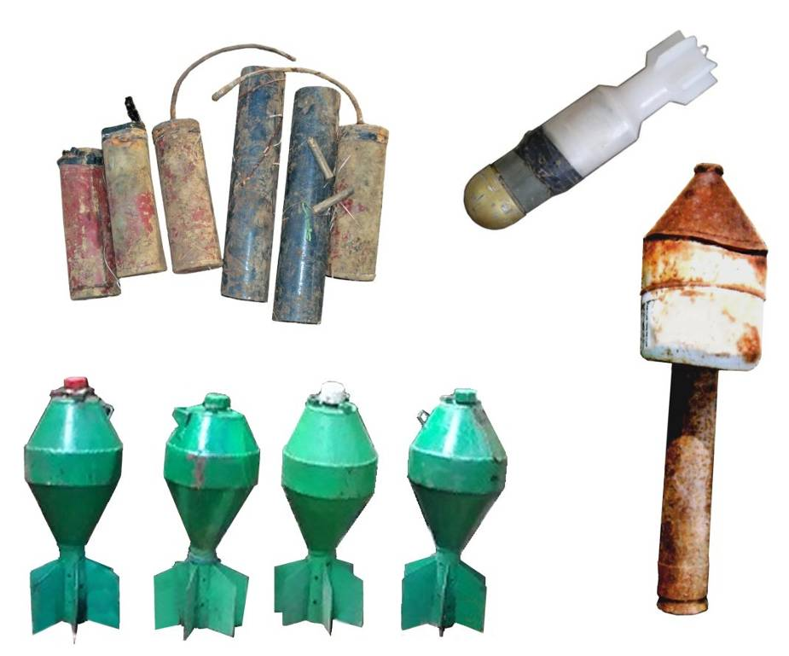

This picture shows improvised rockets, grenades and mortar bombs from Iraq, Syria, Colombia and Sri Lanka.
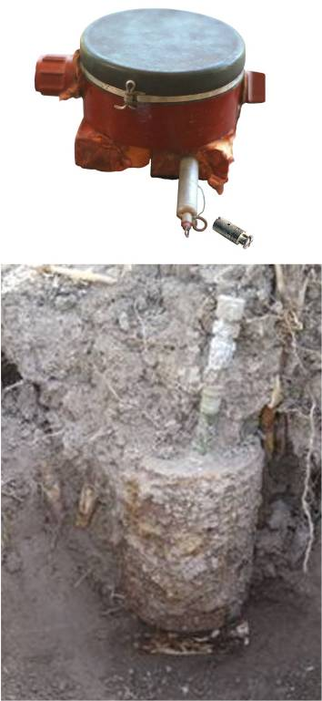
Improvised booby traps are also simple IEDs when they are intended to target any person who happens to come by. If they are also designed to target the person sent to clear them, they are MF-IEDs. All should be presumed to be MF-IEDs unless there is evidence that they are not.

The picture on the right shows a PMN AP mine Boosted with two 200g blocks of TNT with an MUV fuze and detonator attached so that lifting the mine would pull the tripwire. This is an improvised booby trap.

The picture on the right shows an OZM-72 mine with a factory made ML-7 anti-lift booby trap with saddle charges beneath it. This a booby trapped mine which is something all deminers should be trained how to deal with safely.
Because both parts of the device were made in conventional munitions factories and they are used in the way they were designed to be used, it is not an IED – but it is a booby trap that has injured several deminers in HMA.
The main difference between the improvised booby trap and the factory made booby trap is that those made in a factory are sealed and so can remain remained functional when underground for a much longer time than most improvised versions.

Improvised booby traps often make use of conventional munitions and may be attached to an item of interest that someone will pick up to initiate the device.
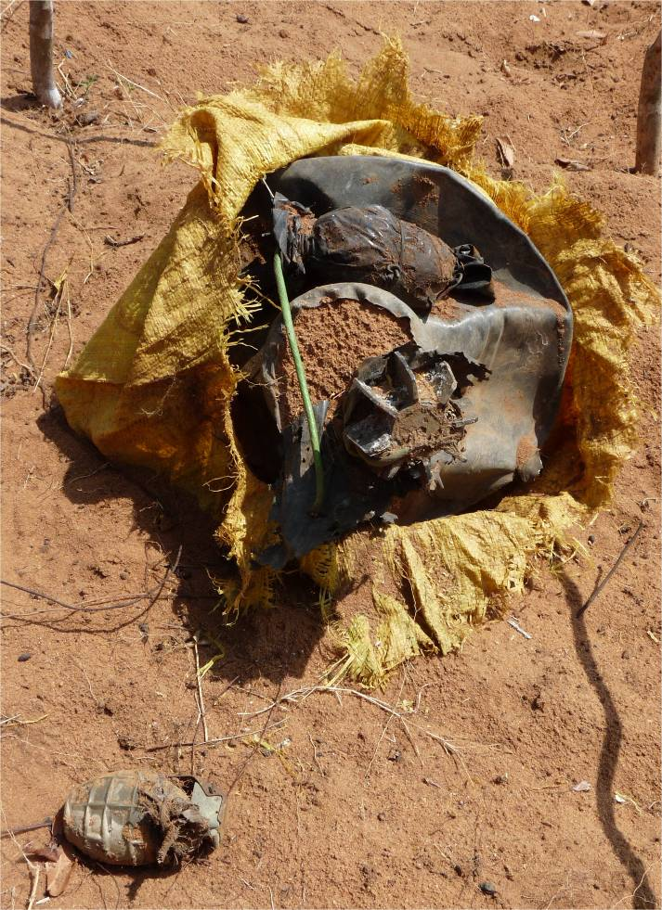
The yellow sack on the left contained some loose explosive, a mortar bomb and several grenades wrapped in black plastic. It was buried just beneath the ground surface.
The attractive item was a grenade left exposed on the surface above the bag. The grenade on the surface had its pin in place and appeared to have been dropped as combatants retreated. When it was picked up, a hidden wire would pull the pin on another grenade inside the sack.
There were no additional initiation systems so this was not an MF-IED. It was a simple IED booby trap found after the conflict has ended by which time the pins had corroded into the fuzes and could not be easily pulled.
Rapidly improvised booby traps like this often have a short life but still contain detonators and explosive and can be extremely hazardous if found by civilians.

The pictures below show a range of remotely initiated IEDs.
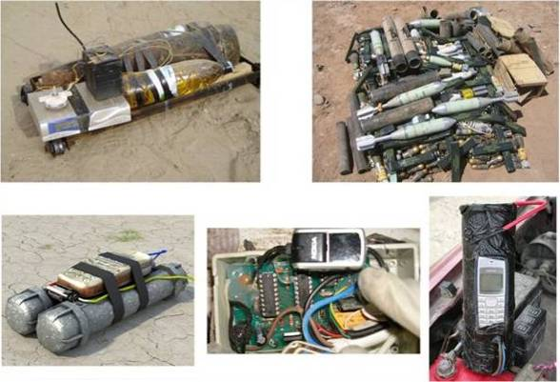
The use of mobile telephones or other wireless devices to command-detonate IEDs has been relatively common because it is so simple to attach a detonator to the speaker so that it is initiated when the telephone rings. When available (and its use is approved by the local authorities) wireless signal jamming equipment can be used to prevent remote initiation. Telephone batteries have a limited life so the telephone battery may be flat after a short time. Even when this is so, a charged capacitor or secondary initiation systems must be anticipated. The range of other wireless devices that could be used is extensive and grows longer each year.
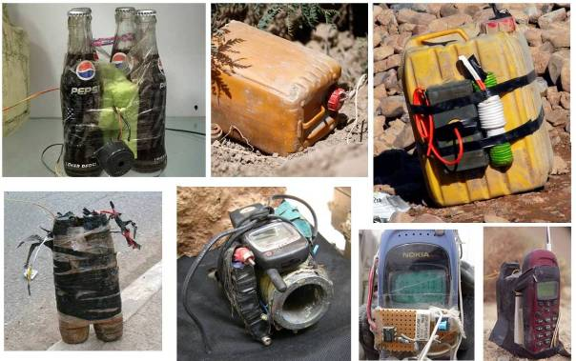
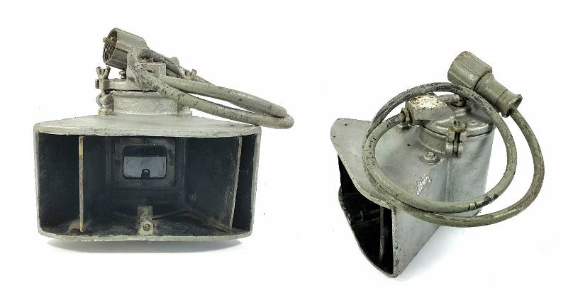
The ease with which the security forces can jam wireless signals has led to an increasing use of other ways to command detonate a device. Using existing telephone or electricity wiring to make a physical link is common. Also, infra red light signals can be broadcast over several kilometres with the right equipment and cannot be blocked by jammers.
The picture shows a long-range infrared signal transmitter designed for ‘secure’ military communications but readily converted as a means of remotely initiating IEDs.
Infra red receivers are commonly used in household devices that are remotely controlled (such as televisions), so are readily available for inclusion in the command detonation systems of IEDs. A direct line between the transmitter and receiver is not critical for reliable communication but approximate line of sight is preferred. This may limit the possible control points from which as initiation might be made.
Passive infra red switches (reacting to heat/movement) such as those used in security lighting or intruder alarms are rather different and have frequently been used as short-range switches in victim initiated IEDs and MF-IEDs.
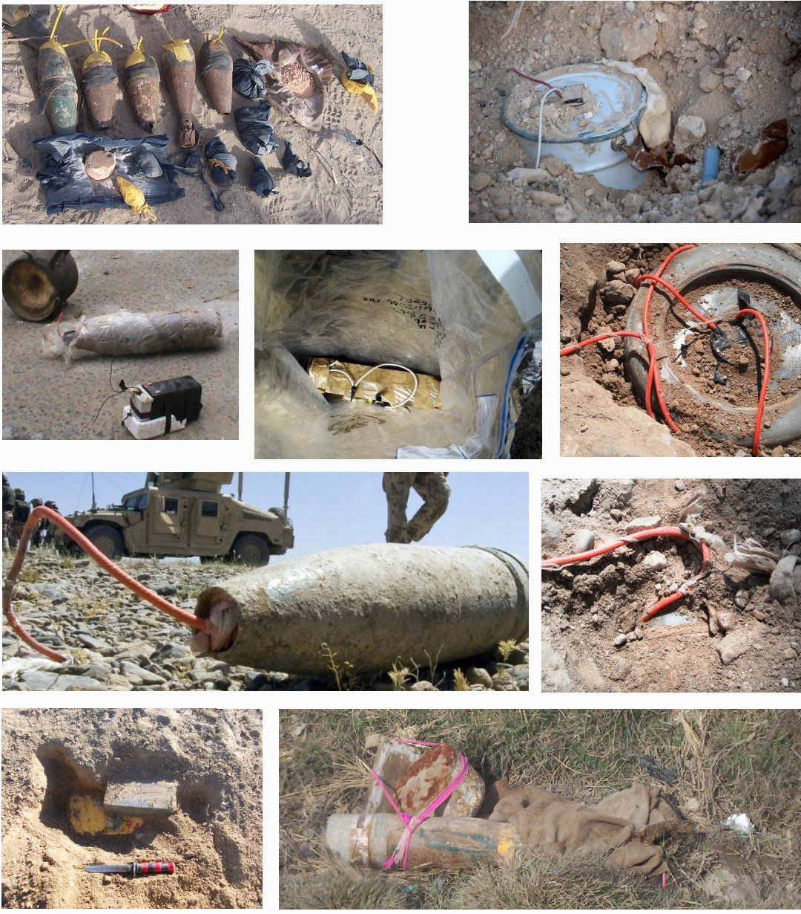
IED bombs may be concealed beneath ground, hidden amongst rubbish, or designed to be found. All may be designed to detonate when someone tries to take them apart, so MF-IEDs.
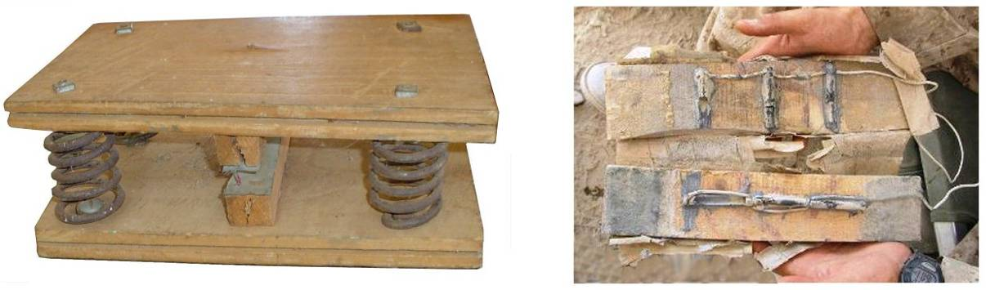
On the left is an improvised pressure switch that was designed to allow lightweight civilian vehicles to pass over it but be initiated by heavier military vehicles. The pressure switch on the right shows an opened electrical contact switch that uses carbon rods as contacts in order to make it harder to find with a metal-detector.

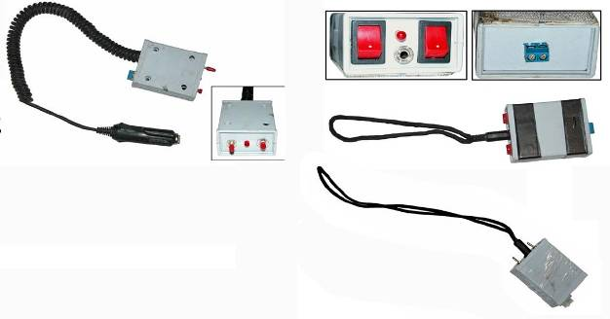

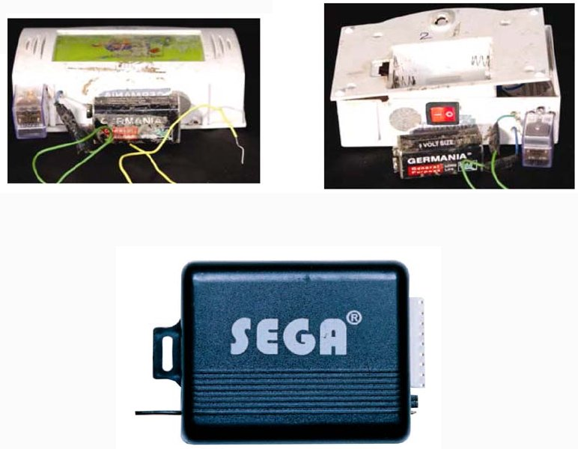
These pictures show improvised electrical trigger systems
recovered from intended suicide bombers (on foot and in a vehicle).

The pictures above show battery powered wireless doorbell systems that have been adapted to provide a remote initiation system for an IED.
This car alarm was also adapted to provide the
electrical impulse to initiate an IED.
The WOOKEE below is also a radio controlled firing device recovered from an IED.
Parts from any remotely controlled device could be incorporated into an IED initiation system, including radio-controlled toy cars and aeroplanes.
Command detonation has also been achieved by completing a circuit using micro-filament wires that are effectively undetectable with a metal-detector.
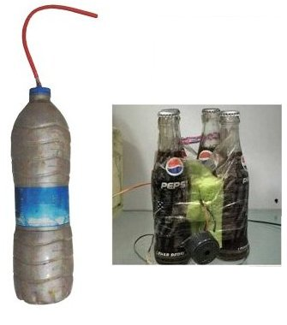
Mechanical means such as pulling a hidden wire (often fishing line that is hard to see) can also be used for initiation over short distances. A simple clothes-peg can make an effective electrical switch by holding the wired jaws open with a plastic slip that is pulled away with a tripwire to complete a circuit.
The picture on the right shows bottles filled with
Ammonium Nitrate and Aluminium (ANAL) improvised
explosive. This is sensitive to temperature and sunlight
and can become friction and impact sensitive. The glass
bottles combine glass fragmentations with a packet of
old nuts and bolts. Other commonly found improvised
explosives (all of which may be mixed with harvested
conventional explosives) include Ammonium Nitrate and
Potassium Phosphate or Ammonium Nitrate and Diesel Oil.
Acetone Peroxide is the only commonly used improvised high
explosive with no nitrate content (so undetectable to most explosive detection systems, if not to the human nose). Variants include Tri-Acetone Tri-Peroxide (TATP), Tri-Cyclic Acetone Peroxide (TCAP), Acetone Peroxide and Nitro-Cellulose (APNC). All the Acetone Peroxide variants sublimate and become unstable in a short time unless kept wet. Instability can lead to spontaneous ignition and detonation. A short “shelf-life” means that they are unlikely to be used in improvised or other devices intended to stay reliably functional for weeks and months, but may be favoured in suicide vests or in timed attacks.
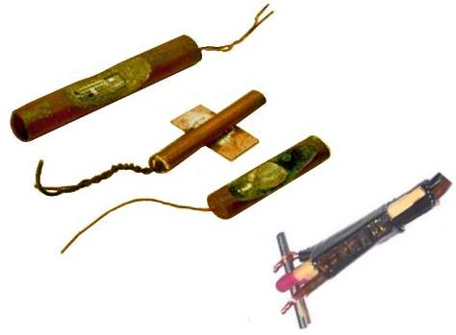

Even detonators can be improvised and may vary from simple electric matches to close copies of commercially available detonators (‘caps’).

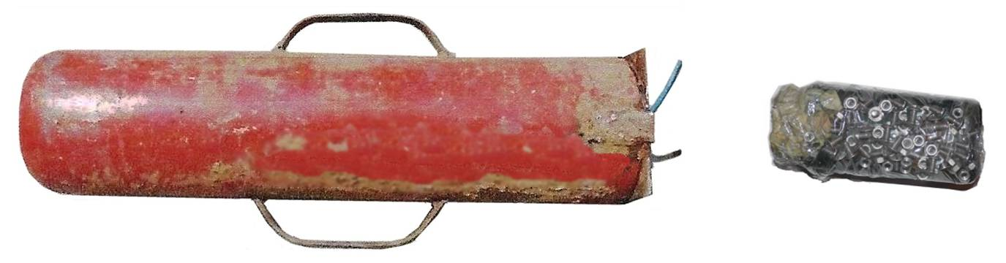

Fire extinguisher bodies, food jars (some wrapped with fragmentation) and other familiar items may be used as casings for IEDs. Many are initiated using knotted det-cord/Cortex inside a plastic explosive booster that is sealed inside the main charge and all may be initiated using any of a wide range of fuze systems.
Containers of fuel or bottled gas may be used to enhance the effects of the main explosive charge and, depending on the chemical mix in the explosive charge, this can produce a thermobaric effect. Bottled chlorine gas has been used to have effects that threaten the HIEDC team after a device has been disrupted or detonated/deflagrated. Any other toxic material could be added to an IED bomb and both survive the detonation and be widely spread: these include chemical, radiological or biological hazards.

Annex B: Sample fuzes
This annex should be extended as information about other initiation systems is gathered so that this part of the SOP can provide a field reference of increasing value to the search team.
In the English language:
A “fuze” is a mechanism by which an explosive device is initiated. It may be electrical, mechanical or both.
A “fuse” is a material which burns at a controlled rate, allowing those lighting it to withdraw. Smoke from a burning fuse may be visible.
Improvised fuze systems
Improvised fuze systems are often covered with a waterproof cover or placed inside a plastic container or bag. This conceals them and protects them against dust and rain.
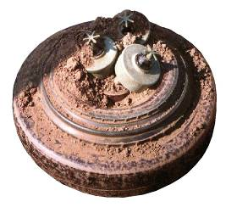
Improvised pressure fuzes are commonly used because they are relatively easy to make. They can be made using any material that will reliably compress when a weight is applied. For example, they have been made using plastic containers adapted to collapse easily and fitted with electrical contacts inside. They have also been made using split bamboo or plates of wood held apart with material or springs that collapse when sufficient weight is applied.
When they are available, pressure operated anti-personnel mines are commonly used as initiation systems in IEDs. Typically, they are placed on top of larger anti-tank mines or linked with detonating cord to other explosive charges/devices.
Improvised devices that are triggered by completing a circuit by calling a cellular telephone, radio or other wireless device sending commands on the electro-magnetic spectrum are also common. It is also common to use any timed alarm system as a backup timing device. For example, a telephone’s alarm will work as a timer switch even when signals are blocked or the device is in “sleep” mode. Wirelessly activated devices require an antennae which may be visible or may be improvised and so not look like an antennae (an example is a window heating element in a vehicle). Fuzes that are triggered using the electro-magnetic spectrum are often command detonated but may also be victim initiated when the fuze system is triggered by the presence/actions of a person, or by the proximity of the electronic equipment that they carry.
Mechanical delay timer devices (clockwork or chemical) may be purpose-made or improvised. Simple clocks and timers, clockwork or battery powered, can be used to give a delay of up to 24 hours. More complex clocks can allow longer delays to be set.
Factory made proximity fuzes designed for use in anti-tank mines may be used. Proximity fuzes may be improvised using the motion sensors used in security lighting and alarm systems. They may also be improvised using battery powered motion sensors used as camping alarms. To allow those placing IEDs to safely escape, the systems may be primed using a cellular telephone, pager, radio or other wireless device. In this case, the wireless device is not the trigger so the status of its battery or any signal jamming may be irrelevant.
Seismic fuzes that are triggered by the vibrations in the ground caused by the presence of people or vehicles may be purpose made or improvised.
Many commercially manufactured wire-pull fuzes can also operate when pressure is applied, or when pressure is released. Many wire-pull fuzes can be fitted with a winged pin that allows them to be also used as a pressure fuze, as in the PMD-6 mine.
Simple means of completing an electrical initiation circuit include the use of wired clothes pegs held open with a plastic disc, and the use of soldered loops of bare wire that are pulled into contact to complete a circuit.
Fuzes made in conventional munition factories
Many fuzes are produced in conventional munition factories for use in mines, booby-traps, as anti-disturbance devices or to be initiated by the presence of a target in the vicinity. A few of these are introduced in this Annex. No attempt has been made to be comprehensive. The fuzes from a great many other munitions have been incorporated into improvised fuze systems.
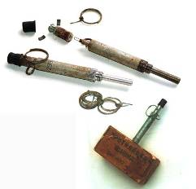
Every organisation should make a detailed study of all fuze systems that may be anticipated in their working area(s).
MUV Series wire-pull fuzes
The most common wire-pull fuzes are the MUV types
manufactured in the former Soviet Union. They are used
in some anti-personnel mines and in military explosive charges.
The striker pin inside an MUV fuze is under pressure and is
held away from the detonator with two pins. After the fuze is placed,
the arming pin is removed and the arming process starts. A small
piece of lead is cut by a wire on the end of the arming pin. The end
of the fuze may then fall away.
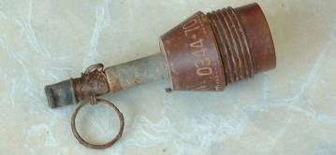
The picture alongside shows an MUV-4 fuze in a soviet TNT charge.

An MUV fuze adapted to attach to a munition.
UMP-1: wire-pull fuze
The firing pin is held under pressure by ball bearings near the end of the pin.
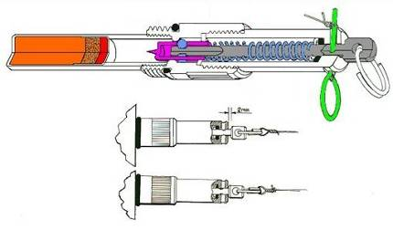
A tripwire or wires is attached to the ring at the end of the firing pin.
After the safety pin (shown green) has been removed, a sideways movement of the end of the pin allows the ball bearings to move into a recess and the pin to strike downwards into the stab-sensitive detonator.
The safety pin cannot be replaced after removal because the holes move out of alignment.
UMNP-1: wire-pull pressure fuze
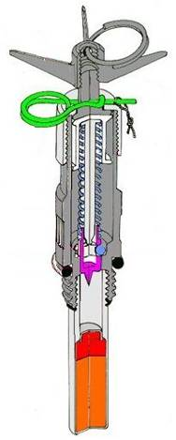
Made in the former Yugoslavia, the length is approximately 8cm. The detonator is bonded to the fuze body.
The top of the fuze has four wings radiating from the centre. These are sometimes made of plastic although the fuze body is usually a metal alloy. The firing pin is retained under pressure by ball bearings. The bearings move into a recess when the wire is pulled or approximately 5kg of pressure is applied.
After the fuze is placed and a pull-wire attached to the ring on top, the arming pin (shown green) is removed. When the wire is pulled or pressure applied to the top, the firing pin is released to strike the stab sensitive detonator.
By replacing the arming pin, the fuze is rendered safe.

UMOP-1: pressure-release or wire-pull fuze
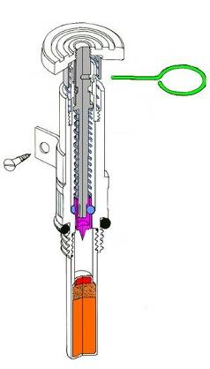
Made in the former Yugoslavia, this fuze is approximately 7.6cm long, including the detonator which is bonded to the fuze body. The single pin either serves as the safety pin or as the release pin.
Used in pressure-release mode, a weight of 4-15kg is placed on top before the pin is pulled out. When the weight is removed, the fuze functions.
If no weight is applied, a pull-wire can be attached to the pin and the fuze will function immediately when the pin is pulled out.
The pin hole is covered when the device is armed, so the pin cannot be replaced.
UDVK (or Time Pencil): time delay
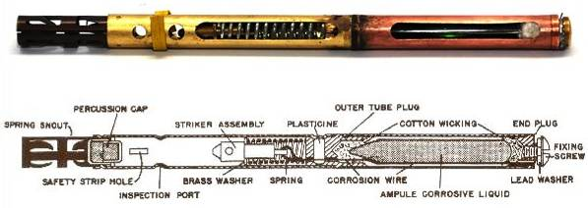
This is a delay fuze that may either include an integral percussion cap or be designed to have an M67 detonator attached. Length: 10.5cm; Diameter 0.8cm.
The firing pin is held under tension by a wire. When the safety bar is removed (shown in green), the top of the fuze is crushed which breaks an ampoule of acid. The acid then burns through the wire which retains the striker pin. The time it takes for the acid to burn through the wire depends on the ambient temperature.
If the body has been crushed or the safety bar removed, this device must be disrupted/initiated remotely.
UMP-2: wire-pull fuze
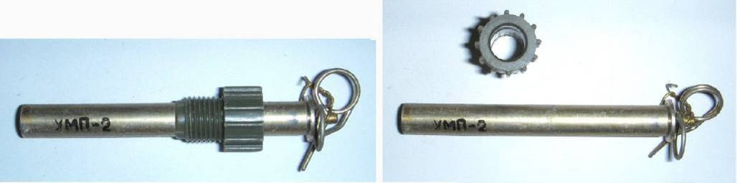
Made in the former Yugoslavia, the striker pin inside the UMP-2 is under pressure and is held away from the detonator with two pins. After the fuze is placed, the collar is tightened and the upper safety/arming pin is removed.
The length is approximately 6.6cm. The detonator is an integral part of the fuze.
The firing pin and its casing can easily rotate, so allowing several wires to be attached. When a wire is pulled, the fuze body rotates to allow the pin to be pulled out.
The top of the two pins is the arming/safety pin that is removed when the device has been set up. By replacing the arming pin, the fuze can be rendered safe.
MVE-72: break-wire
This a relatively large battery powered initiation system that is attached to an NM initiator by a wired plug. The NM initiator is then inserted in the main charge of the device.
Approximate size: Diameter: 6.4cm; Height 14.5cm
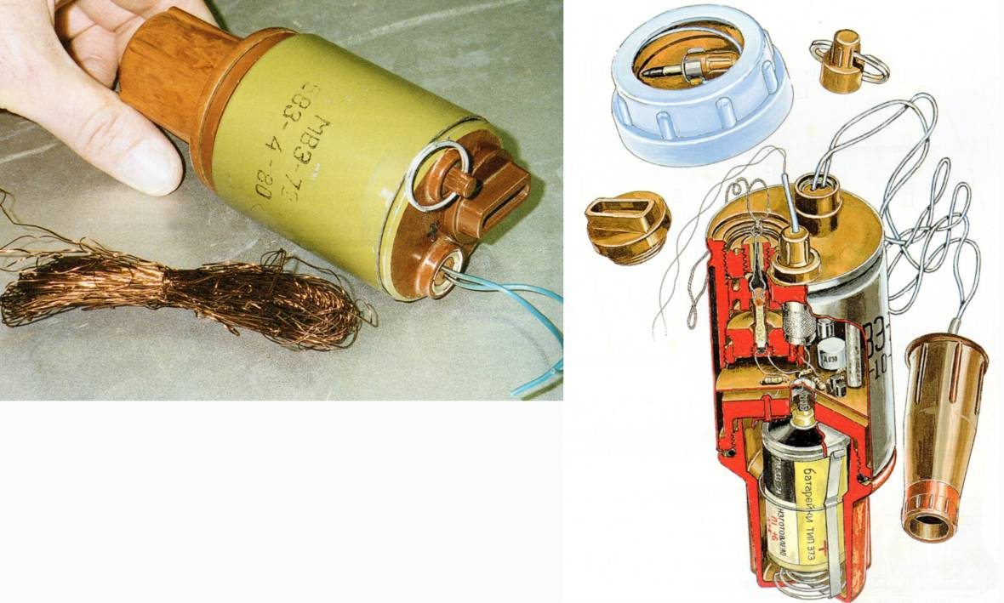

Breaking or applying pressure to the wire initiates the device.
Removing the wires connected to the initiator initiates the device.
The system is reported to self deactivate when the battery runs flat,
but there is no way of determining the battery condition.
This device should be remotely disrupted/initiated. (Pictures reproduced with permission.)

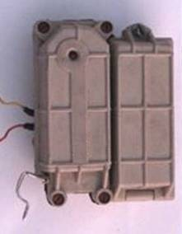
Yugoslav SEF or “superquick” fuze
A variety of Special Electronic Fuze (SEF) were produced.
All look similar and can be initiated by one of the following:
- vibration;
- temperature rise;
- light;
- inertia;
- delay;
- tilt;
- break-wire; or
- sound.
A two-part rectangle, its size is approximately 9.5 x 3.8 x 7.3cms.
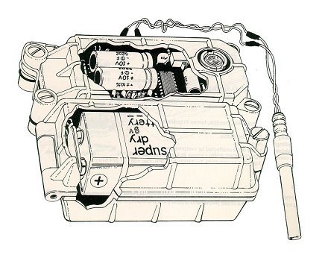
The arming pin is visible on the lower left of the picture.
The colour is usually pale cream or green and Markings
may be in Cyrillic or English.
The fuze is used with a remote electric detonator
attached by wires as shown.
The fuze is powered by a PP3 9V battery which
charges a capacitor. The fuze may be able to function
even after the battery has discharged.
This device must be remotely disrupted/initiated.
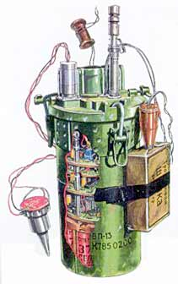
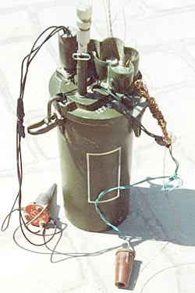
NVU-P (VP-13) or DDP-P:
"Hunting" seismic fuze
The DDP-P fuze is designed to be used
in conjunction with up to five fragmentation
mines (usually OZM-72 or MON-50 types).
Diameter:15.5cm.
Height: approximately 36cm.
A sensitive seismic sensor monitors
vibration nearby. It is programmed to
recognise a human presence and to
detonate the mine that is closest to
the victim. When someone approaches
to recover that victim, another mine
explodes. After the last mine has
been detonated, the fuze can be
configured to self-destruct.
The fuze controller is powered by batteries and linked with micro-wires to each mine. The micro-wires are undetectable with a standard metal-detector. The device is reported to be able to differentiate between the presence of people and of livestock.
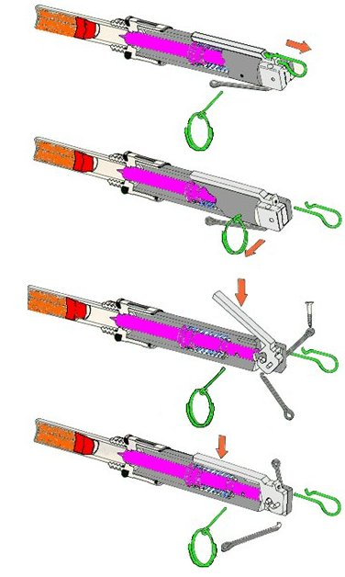
UMNOP-1: multi-function fuze
This is a multi-function fuze made in the former Yugoslavia.
The fuze can be configured to function with the application of pressure,
pressure release, or axial/radial wire-pull. This is achieved by using
different configurations of pin pull and lever positioning.
From top to bottom in the diagram alongside, the fuze is
shown configured for:
Axial pull;
Radial pull;
Pressure; or
Pressure-release.
The fuze length is approximately 8.5cm.
The detonator is bonded to the body of the fuze.
The missing pins can be replaced to disarm the fuze.
MS-3 pressure release Booby-trap
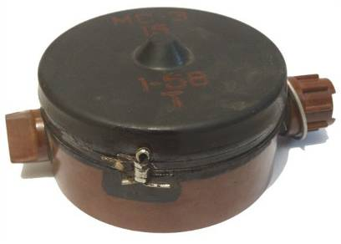
Manufactured in the former Soviet Union/Romania, this device is placed beneath a heavy weight and when the weight is lifted, the device functions.
Height: 6.5cm
Diameter: 11cm
Total weight: 630g
At least 4kg pressure must be applied on top before the arming pin is pulled. The mine detonates when the weight is removed.
The main charge is reported to be around 300g of TNT.
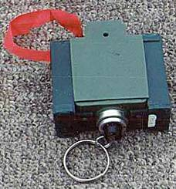
Former Soviet Union ML-7 anti-lift device
Length: 7.2cm
Width: 6.9cm
Height: 3cm
Any weight beyond 0.3kg is applied on top before the pin is pulled. When the weight is removed, the device detonates.
The device only contains 40g of explosive in the detonator (30g PВВ-5) boosted by 10g Tetryl/PETN but may be fitted with two small saddle charges to increase the detonation force. The picture shows an ML-7 with two 15g saddle charges attached The shock wave from this detonation is used to initiate other
explosives in close proximity.

Former Soviet UNOP-1 (or British No.6 Mk1 pressure release switch)
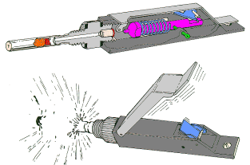
Made from pressed steel, the square end of the mechanism is threaded to accept an M67 detonator.
The colour is usually green.
The device is approximately 8cm long.
The mechanism can be used in pressure-release mode by placing a heavy weight on top (at least 3kg) and removing the pin. When the weight is removed the hinged lever will spring up and the firing pin will be released to strike the detonator.
It can be used in wire-pull mode by attaching a wire to the safety pin without placing any weight on the hinged lever. When the wire is pulled the pin is removed allowing the hinged lever to spring up and the firing pin to be released to strike the detonator.
The pin can be reinserted to disarm the device unless the holes have moved out of alignment.

Annex C: Subjects to be covered in specialist HIEDC training
All members of a specialist HIEDC team must be selected to ensure that they have the following personal characteristics:
- a logical problem-solving approach;
- patience;
- the ability to work independently;
- a non-competitive attitude; and
- supervisory experience.
Every team member who may be required to enter the Suspected Hazardous Area should have demining and supervisory experience and qualifications equivalent to IMAS EOD Level 3 or greater.
Further specialist training should cover the things listed below.
- General information about IEDs.
- Information about locally used IEDs.
- The identification of explosive materials and ancillaries (military and improvised).
- Awareness of the hazards associated with improvised explosive materials.
- How and why IEDs are used.
- Recognising IEDs and their initiation systems.
- Use and limitations of available wireless signal jammers (range, waveband and frequency limitations).
- Use of marking and warning signs during HIEDC search.
- All task communication systems and codes that may be used.
- Planning the search of suspected hazardous buildings.
- Establishing and maintaining safety cordons (including how to respond to a cordon breach).
- The approach and entry to suspected hazardous buildings.
- The use of small explosive charges to open doors.
- The use of a drill and mirror to inspect inside closed doors.
- The sequence of search inside a room or building.
- The use of remote pulling cables, grapples and clamps.
- The use of remote weight-dropping equipment.
- The approved procedures for vehicle search.
- Disruption by remote pulling.
- The use of high pressure water hoses for disruption from a distance.
- The use of all other specialist tools and equipment that are available.
- What any remotely controlled machines available can be used to do.
- Demolition/disruption by energetic means.
- Conducting QA/QA during specialist HIEDC search.
- Reporting requirements for specialist HIEDC tasks.
- Full awareness of the content of this and other relevant SOPs.
All specialist HIEDC team members must be aware of the security situation in the working area and refuse to work where the team is likely to be the target of any command detonated devices or armed attack.
Equipment that can be reliably used to recognise and identify Chemical, Biological, Radiological (CBR) hazards should be available whenever there is a risk that these hazards are present. If a possible CBR hazard is identified, the team must be withdrawn from the task and an appropriate response arranged with a suitably experienced specialist organisation.

Recommended skills for IMAS EOD 3 operatives are listed in Annex B of T&EP 09.30/01/2014. Training to achieve all of the 450+ competencies suggested for Level 3 would take many years, so EOD 3 training is selective and no two people with EOD 3 training can be guaranteed to have the same skills.
For example, the Minelab F3Ci detector.
As guidance, it is recommended that 30g should be sufficient, although it may be necessary to use an explosively formed projectile with the manufacturer’s recommended charge weight.

