HMA Global SOPs 2018
CHAPTER 6: SEARCH & CLEARANCE

Release date: July 2018

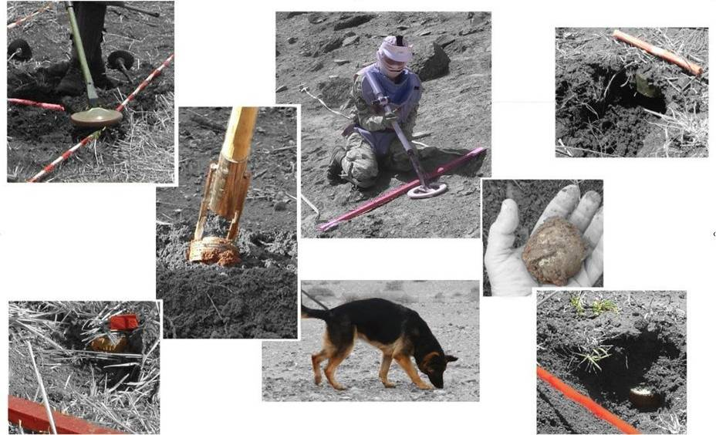

Although mechanical and MDD assets can assist, Search & Clearance is always ‘manual demining’ and so its quality is dependant on the professionalism of the demining staff involved. To have full confidence that land is safe to be released to its end-users, reliable staff must conduct and/or oversee every stage of the Search & Clearance procedures that are used.
Whatever the search procedure, staff must determine where to search, then ensure that the search is properly conducted, then expose and remove or destroy the explosive hazards that are found. Area marking and overlaps between search lanes ensure full ground coverage. Pre-search tests and frequent QA checks ensure that the required search depth is reliably achieved.

CHAPTER 6: SEARCH & CLEARANCE
These generic and global SOPs have been available since 2007. This Chapter has been updated and significantly changed for this 2018 release. Definitions that are necessary to understand this SOP are included at the start of the Chapter.
Contents
1. Glossary 4
1.1 Should, Must & Shall 7
2. Introduction 8
2.1 Manual demining team 8
3. Demining team deployment 9
3.1 Daily briefing 9
4. Approved manual search patterns 10
4.1 Search lanes 10
4.1.1 Cutting vegetation from beside a search lane 11
4.2 Lateral lanes 12
4.3 Spot Tasks 13
4.3.1 UXO/AXO Spot Tasks 13
4.3.2 MDD Spot Tasks 14
5. Task site preparation 15
6. Working distances between staff 15
6.1 Supervisor working distances 15
6.2 MEDEVAC procedures during manual demining 16
6.2.1 Preliminary accident investigation 17
7. Manual demining procedures 18
7.1 Prohibited detection method 18
7.2 Detection by eye 18
8. Lane search using metal-detectors 19
8.1 Safety and metal-detectors 19
8.2 General principles 20
8.2.1 Metal-detector care 20
8.2.2 Metal-detector calibration area 21
8.2.3 Metal-detector test area 21
8.2.4 Using the metal-detector calibration and test areas 22
8.2.5 Search-head movement 22
8.2.6 Search-head advance 22
8.3 Using the MineLab F3 metal-detector 24
8.3.1 Switching ‘mode’ with the MineLab F3 25
8.3.2 Turning on and checking the MineLab F3 25
8.3.3 MineLab F3 search patterns 27
8.3.4 Pinpointing with the MineLab F3 27
8.3.5 Edge pinpointing 28
8.4 Metal-detector search procedure 28
8.4.1 Pinpointing a metal-detector reading 31
8.4.2 Metal-detector signal markers 31
8.5 Investigating a metal-detector signal using hand tools 31
8.5.1 Magnets 32
8.5.2 Special tools for hard ground 33
8.5.3 Slicing tools 33
8.5.4 Signal investigation procedure 34
8.6 Investigating a metal-detector signal using rakes 36
8.6.1 Procedure 37
9. Area-excavation using hand tools 38
9.1 Procedure 39
10. Area-excavation using REDS 41
10.1 Conducting Rake Excavation and Detection 42
11. Using water to soften ground 44
11.1 Waterlogged ground 44
12. Action on locating an explosive hazard 45
12.1 Pulling procedure 46
13. Removal of vegetation 47
13.1 Approved vegetation cutting tools 47
13.1.1 General rules for the use vegetation cutting tools 47
13.2 Manual cutting of vegetation 48
13.3 Using a powered strimmer 49
13.4 Burning-off vegetation 50
14. Obstacles in the search area 51
14.1 Rocks 51
14.2 Fences and wire 52
14.3 Vehicle wrecks 52
14.4 Ditches/trenches 53
14.5 Abandoned or battle damaged buildings 54
14.6 Fallen trees 55
15. Finding human remains 56
15.1 Reporting finding human remains 56
15.2 Ancient human remains 57
15.3 Human remains from conflict 57
15.4 Recent human remains 58
15.5 Human remains found outside the task area 58
15.6 Health hazards 58
15.6.1 Psychological considerations 59
16. Tripwire location 59
16.1 Action on locating a tripwire 59
17. Collection of explosive hazards 60
18. Conducting Battle Area Clearance (BAC) 60
19. Conducting Battle Area Clearance Subsurface (BACS) 62
19.1 Why a single BACS search may not be enough 62
19.2 Metal-detectors used in BACS 62
19.3 BACS search test targets 63
19.4 Probability of detection and false alarm rate 64
19.5 Requirements during all BACS searches 64
19.5.1 Excavating BACS metal-detector signals 65
19.6 Using a large-loop detector 66
19.6.1 Large-loop search patterns 66

Glossary
The terms defined below are listed in alphabetical order. Terms not used in this SOP may be included for clarity. A full Glossary of terms used throughout the Global SOPs is included in the introductory Chapter.
Accident (Demining accident): following ordinary use of the term, an HMA ‘accident’ is any damaging or injurious event that occurs during working hours. This includes road traffic accidents and other events that give rise to injury which do not involve explosive hazards. Whenever an accident involving explosive hazards occurs (whether injurious or not), a detailed and objective accident report must be compiled and shared. Demining accident reports must be appended to the Field Risk Register and the appropriate risk mitigation strategies recorded. See also the entry for ‘Incident (demining incident)’.
Area Cleared: the area ‘Cleared’ is a defined area (or areas) that has been subjected to one or more demining Search & Clearance procedure(s) which guarantee(s) that a thorough search to the required depth has been conducted over the entire area(s). In all areas released as ‘Cleared’, the task supervisors must have full confidence that no explosive hazards remain to the specified search depth and must be prepared to demonstrate their confidence by walking or driving over the area. When no explosive hazards are located during Search & Clearance of an area, the area may still be released as ‘Cleared’ even though there were no explosive hazards to ‘Clear’.
Area preparation: ‘area preparation’ involves the passage of a tool over a wide area to remove vegetation and/or prepare the ground surface before other demining procedures are conducted. The processing tool is generally attached to a machine that is suitably protected so that it can be safely driven over the area (often by remote control). Depending on need, the reliable depth of any ground processing may be important but is not critical because a ground engaging machine must always be followed by thorough Search & Clearance procedures if the land is to be released as ‘Cleared’.
BAC - Battle-Area-Clearance: ‘BAC’ is a visual search process that raises confidence that an area is free from explosive hazards on the ground surface without applying any subsurface search procedures. BAC cannot be used where the Task Assessment determines that there may be any buried explosive hazards that are pressure or movement sensitive. When there may be any other buried explosive hazards (such as common UXO), BAC must be followed with a reliable sub-surface Search & Clearance procedure. Areas subjected to BAC may be recorded as ‘Surface Cleared’.
BACS – Battle-Area-Clearance Subsurface: ‘BACS’ is a search process involving the use of metal-detectors that raises confidence that an area is free from explosive hazards without applying procedures that would locate hazards with a small metal content. BACS cannot be used where the Task Assessment determines that there may be any anti-personnel mines, pressure or movement sensitive devices, or buried minimum-metal explosive hazards. The metal-detectors used must be able to reliably locate all of the anticipated hazards in the area. When used as described, areas subjected to formal BACS procedures may be recorded as having been ‘Cleared of hazards with a large metal content to a specified depth’.
Booby-traps: in common with the definition of anti-personnel mines in the Ottawa Convention, ‘booby-traps’ are victim-initiated devices that are not triggered remotely by command detonation. Designed to target anyone who disturbs them, they are manufactured in volume production and sold to armed forces as part of their arsenal. An example is the MS3 which looks similar to a PMN anti-personnel mine but functions when a weight is removed from on top of the device. The ML-7 has a similar function and is frequently placed beneath anti-personnel mines to target anyone lifting the mine.
Clear (Presumed Clear): when applied to land, the word ‘Clear’ is used to describe land where there is no evidence of there being any explosive hazards (No Threat Evidence, NTE). When this is a result of the explosive hazards having been removed/destroyed during Search & Clearance, the area must be described as having been ‘Cleared’. When land has been released by area Reduction, Verification or Cancellation, it has not been ‘Cleared’ but can be ‘Presumed Clear’ because there is no evidence of it being likely to be contaminated with explosive hazards (No Threat Evidence, NTE). The distinction between the use of ‘Presumed Clear’ and ‘Cleared’ is important because it can be critical in cases of litigation.
Clearance: ‘clearance’ is the removal or destruction of explosive hazards. Most in the industry describe what they do as ‘clearance’. In fact what most field people are doing most of the time is preparing ground and searching. If there are no explosive hazards there, there is nothing to be ‘cleared’ so clearance cannot be happening. In these SOPs, the activity of searching for and removing or destroying explosive hazards is referred to as Search & Clearance despite the fact that, at some times, no hazards will be found and no ‘clearance’ will be required.
Cleared (land): ‘cleared land’ is a defined and mapped area that has been formally searched to a required depth and on which all explosive hazards have been removed or destroyed. An area can only be declared ‘Cleared’ after it has been subjected to disciplined Search & Clearance procedures that ensure the discovery and removal of all explosive hazards to a specified depth over the entire area. That depth must be determined during the Task Assessment and should be varied if devices are discovered at greater depths as work at the task progresses. If the depth that can be reliably searched using any one demining procedure is less than the requirement, additional search procedures must be used to gain confidence that thorough Search & Clearance to the required depth has been achieved before the area can be declared ‘Cleared’. Following Quality Management principles in pursuit of efficient Land Release, if no explosive hazards are found, an investigation should be made into why the task documentation indicated that the area was contaminated with explosive hazards when it was not.
Deminer (Searcher): a ‘deminer’ is a person engaged in Search & Clearance tasks in areas that may be contaminated with explosive hazards. A deminer must always be trained and qualified to carry our procedures related to searching. A deminer may also have EOD training, but does not have to be trained to appraise and manage the explosive hazards that are found. Persons with EOD training are called ‘EOD specialists’ and must also be trained as deminers/searchers.
Demining procedure(s): see the entry for ‘procedure’.
Explosive hazard: the term ‘explosive hazard’ is used to describe mines and ordnance whether fuzed, fired or otherwise, and all explosive devices whether mass-produced or improvised. It also covers hazardous parts of these devices, including detonators, propellants and pyrotechnics. Following the usage in international treaties and conventions, the IMAS distinguish between ‘mines’, ‘submunitions’ and ‘Explosive Remnants of War’ (ERW) and treats them separately. This is confusing because, in normal language, ‘mines’ and ‘submunitions’ are also ‘ERW’. Rather than trying to reclaim the commonsense meaning of ERW, the term ‘explosive hazard’ is used in these SOPs.
HIEDC: The acronym ‘HIEDC’ (Humanitarian Improvised Explosive Device Clearance) is used to describe those IED search & Clearance activities that are conducted in HMA. HIEDC differs from the counter IED work that is conducted by active combatants or security services because it prioritises the safe destruction of the hazard without adopting a forensic approach that is intended to assist in the identification of those who made or placed it.
High Probability Area (HPA): a ‘High Probability Area’ is a part of a task where there is a high probability that explosive hazards are present. This may be called a Confirmed Hazardous Area or CHA by other agencies. The threat in a High Probability Area is the same as that in a Low Probability Area when the same explosive hazards may be present. Typical HPA include mapped and marked minefields, areas where mines are visible, defensive positions, areas where there have been multiple explosive accidents, and areas where the presence of hazards has been reliably reported.
IED (simple IED): in these SOPs, a simple ‘IED’ is an ‘improvised explosive device’ which is an improvised munition, such as a mortar bomb, rocket, grenade, or a mine. The defining feature of a simple ‘IED’ is that it is designed to function in a way that parallels the conventional munition it is intended to emulate. See also the entries for ‘IED bombs’, ‘MF-IEDs’ and ‘booby-traps’.
IED bombs: ‘IED bombs’ are improvised explosive hazards that are placed for timed or command detonation. Although placed during the conflict which should have ended before HMA activity began, improvised bombs may be encountered as legacy hazards. They may be unstable and may have MF-IED features. See also the entries for ‘IEDs’, ‘MF-IEDs’ and ‘booby-traps’.
Incident (Demining incident): avoiding the confusion between ‘accident’ and ‘incident’ apparent in the IMAS, in these SOPs a ‘demining incident’ is the discovery of one or more explosive hazard(s) on land that has been declared ‘Cleared’ or ‘Presumed Clear’ and released to the end-users as part of Land Release. The rigorous and honest investigation of demining incidents is necessary to ensure that errors are identified and corrected in pursuit of the primary goal of HMA. Demining incident reports must be appended to the Field Risk Register and the appropriate risk mitigation strategies recorded. See also the entry for ‘Accident (demining accident)’.
Indication: an ‘indication’ is the action of a Mine Detection Dog (MDD) when it detects the presence of a target which it has been trained to locate. An MDD indication may be at some distance from the target. See also the entry for ‘signal’.
Low Probability Area (LPA): a ‘Low Probability Area’ is a part or parts of the task where it is possible that there are explosive hazards but there is not enough evidence of their presence to make it probable. Typically, land bordering a High Probability Area is a Low Probability Area. The threat in a Low Probability Area is the same as that in a High Probability Area when the same explosive hazards may be present.
Malign fuzed IEDs (MF-IEDs): an ‘MF-IED’ is an IED that has one or more initiation systems that is deliberately designed to be triggered by any attempt to approach, disarm, separate, disrupt or move all of part of the device. Any explosive hazard can be turned into an MF-IED by the addition of an initiation system designed to target those sent to find and destroy it. MF-IEDs may have several initiation systems, any one of which may be followed by a delay to give the impression that the hazard is safe, so maximising injury. See also the entries for ‘IEDs’, ‘IED bombs’ and ‘booby-traps’.
Procedure(s), demining procedure(s): ‘demining procedures’ are activities conducted on land that may be contaminated with explosive hazards as part of preparing it for Land Release. Searching with metal-detectors or MDDs are demining procedures. Cutting undergrowth or ground processing with a demining machine are also demining procedures. One or more procedure can be applied to process the same ground to give confidence that the area can be released. Not all procedures, or combinations of procedures, constitute full Search & Clearance and so guarantee that no explosive hazards remain to the required depth in the area. This is not important when there is found to be No Threat Evidence in an area and it can be reliably ‘Presumed Clear’.
REDS – Rake Excavation and Detection System: REDS uses two specialist long-handled rakes to either excavate the ground where a metal-detector or MDD has signalled, or to conduct area-excavation in search lanes. Used correctly in the search for anti-personnel pressure mines and anti-tank mines, the system has been as fast as other area-excavation or signal investigation method. The rakes effectively sift the ground and any explosive hazards are exposed without risk of initiation. The length of the rakes reduces the risk of severe injury in the event of an anti-personnel blast mine accident by keeping the deminer at a greater distance from the hazard.
Safety distance: the ‘safety distance’ is the distance at which all staff must be from a deliberate detonation in order to avoid injury. This is also the distance at which staff must be from a demining procedure that may predictably detonate some devices (such as processing the ground surface using a machine). See also the entry for ‘working distances’.
Search & Clearance (Searched & Cleared): ‘Search & Clearance’ refers to the disciplined use of demining procedures that are reliably able to locate all anticipated explosive hazards to a specified depth beneath the ground surface and the removal/destruction of those hazards over an entire recorded area. Only areas that have been Searched & Cleared can be released as ‘Cleared’.
Search depth: the ‘search depth’ is the depth beneath the ground surface to which reliable search for explosive hazards must be conducted. Unless otherwise directed by the NMAA or client, the search depth should be agreed during task planning and must be increased as soon as any evidence suggests that the hazards may be at a greater depth than was originally believed.
Signal: a ‘signal’ is the sound and/or visual alert made by a metal-detector when the presence of metal is detected beneath or around the search-head. The position of the signal may be pinpointed with varied precision depending on the metal-detector and its settings. See also the entry for ‘indication’.
Suspected Hazardous Area (SHA): at the start of a demining task, the entire task area is often referred to as a ‘Suspected Hazardous Area (SHA)’. After a Technical Survey has been conducted and more becomes known as the task progresses, parts of the SHA should be designated Low Probability Areas (LPA) and High Probability Areas (HPA) where the ‘probability’ refers to the probable presence of explosive hazards. HPA and LPA designations and the Task Release Plan should be reviewed and revised as soon as more evidence about the contamination in the SHA is gathered. As areas with No Threat Evidence are identified, they may be Reduced, Verified or Cancelled, as appropriate.
Task (demining task): a ‘task’ is a specified area of land on which a demining organisation must conduct activities detailed in a Task Release Plan in order to declare the area ‘Cleared’ or ‘Presumed Clear’ in preparation for land release.
Task Release Plan: the ‘Task Release Plan’ is the schedule of all demining activities that will take place in a demining task area. It includes maps of HPA and LPA showing all areas that will be released as ‘Cleared’, Reduced, Verified or Cancelled. All Task Release Plans should be revised regularly as work progresses and more becomes known about the task area. This is essential to allow the work to be conducted efficiently, so protecting the donor/client from unnecessary costs. When the Task Release Plan must be approved by the NMAA, a provisional Task Release Plan sent to them before work starts should cover as many of the variations that may be required as can be reasonably predicted. When further revisions are required, the NMAA should appraise revised Task Release Plans without delay. When the revision is necessary to keep risk within tolerable limits, the NMAA should approve its immediate implementation pending the results of their formal appraisal.
Technical Survey: a ‘Technical Survey’ involves using demining Search & Clearance procedures over parts of a task area in order to try to determine parts that are High Probability Areas (HPA), parts that are Low Probability Areas (LPA), and parts where there is No Threat Evidence (NTE). A Technical Survey should precede wide-area Search & Clearance at all tasks where a Technical Survey has not already been conducted. When staff walk over the ground during the survey, the ground on which they walk must have been declared ‘Cleared’ or ‘Presumed Clear’.
Wide-area: In these SOPs, the term ‘wide-area’ is used to describe large land areas over which Search & Clearance will be conducted. The breach lanes that are ‘Cleared’ during a Technical Survey are not conducted over wide-areas, but parallel breaches can be combined to provide wide-area Search & Clearance.
Working distance: the ‘working distance’ should make it unlikely that more than one person will be injured in a demining accident. Working distances can generally be shorter than safety distances because there are no deliberate detonations occurring and the risk of an accidental detonation occurring should be very low. Working distances that are shorter than ‘safety distances’ can increase safety during Search & Clearance by improving the ease of supervision which ensures that procedures are conducted correctly and risks are appropriately managed. See also the entry for ‘safety distances’.
  - Should, Must & Shall
Throughout this document the distinction between the terms ‘should’ and ‘shall’ that is used by the International Standards Organisation (ISO) and in the International Mine Action Standards (IMAS) is adopted.
When ‘shall’ or ‘must’ is used, everyone working to this SOP must comply with the requirements as they are written. No variation is permitted.
When ‘should’ is used, everyone working to this SOP must follow the requirements unless they have a reason to vary them that has been approved by the senior staff with operational responsibility. Variations must be recorded in writing in the Task Release Plan and the person(s) making the variation must be identified.

Introduction
Before any demining task is undertaken, the operations manager must ensure that the task area has been visited and a Task Assessment has been conducted. The Task Assessment will include a detailed Task Risk Assessment and lead to the writing of a provisional Task Release Plan that will be presented for approval by the operations manager and, when appropriate, the NMAA. Making a Task Risk Assessment in described Chapter 14 of these SOPs. The provisional Task Release Plan is a schedule of all demining activities that will take place to prepare the task area for release to end-users. When possible, it should include maps of probable HPA, LPA, and areas with NTE that will be used to inform the way that Technical Survey is conducted. The plan is ‘provisional’ because all Task Release Plans should be revised regularly as work progresses and more becomes known about the task area. The maps in the provisional Task Release Plan must include a map of the task site layout and the positions of safe areas.
The person who will supervise the task should be involved in the Task Assessment and in writing the provisional Task release Plan. The Task Release Plan should be included in a Task Folder that contains all available information about the task. A copy of the Task Folder must remain with the task supervisor until the task is completed.
This Chapter gives details of manual Search & Clearance operations. Demining work often involves the co-ordinated application of mixed manual, mechanical and MDD assets. The Task Release Plan must take integrated asset management into account. As long as safety is not compromised, some details of the demining procedures may be varied when integrated processes are used at a task. For example, elements of site layout, marking and control can be varied according to the assets deployed at any one time. MEDEVAC requirements will be common across assets and must be managed to avoid duplication.
The provisional Task Release Plan must include an estimate of the manual demining that is required and the other demining assets that are needed. The plan should include details of the staff, equipment and all logistical and transport requirements.
  - Manual demining team
The diagram below shows the various staff in a typical manual demining team and the hierarchy of command and responsibility above them.
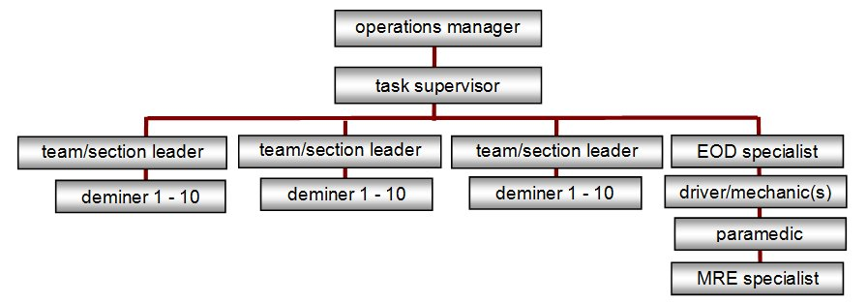
The demining team structure may be varied as numbers of staff change or to meet the needs at a task. Generally, a team comprises three sections of up to ten deminers who work under a ‘task supervisor’. The team is supported by an EOD specialist deminer (when others are not suitably qualified/experienced), by an MRE and community liaison specialist, a paramedic and drivers. A cook and security guards should be added when required.
When appropriate, a demining team may be divided to work on two tasks. When this occurs, the operations manager should appoint a suitably experienced temporary ‘task supervisor’ to control work at the second task. Appropriate medical provision should be made to ensure that a paramedic is never more than five minutes away from any working deminer. The driver of a well equipped ambulance must have reliable communications with the task supervisor(s) and be no more than ten minutes away from the site(s) it serves.
Each task supervisor may control three or more section leaders. Each section leader normally controls eight to ten deminers. When accidents have occurred in demining, field supervision has very often been unsatisfactory, so there is evidence that good field supervision is essential to ensure the correct application of SOPs and procedures. Field supervisors must be able to establish and maintain discipline. Deminers who do not obey instructions must be removed from the field and, when appropriate, dismissed.
Deminers are expected to take responsibility for remembering their training and applying it sensibly without always having a supervisor looking at them. When deminers are known to be experienced and reliable, the number of deminers in a section may be increased to twelve at the discretion of the operations manager.
To promote efficiency, if absences or vacancies reduce the ratio of deminers to supervisors below 5:1, the task supervisor should ensure that section leaders work as deminers until more deminers become available. A well designed Task Release Plan should ensure that deminers never stand idle and that supervisors are always busy.

Demining team deployment
The demining team will be deployed under the direction of the task supervisor appointed by the operations manager. The task supervisor is responsible for ensuring that all the equipment and consumables necessary for the deployment are available on time and in the right place.
Demining teams may deploy for one of the main purposes listed below.
- Combined Technical Survey and wide-area demining tasks.
- Separate Technical Survey tasks.
- Separate wide-area demining tasks.
- In support of MDD or mechanical assets.
Demining teams should not be deployed to any wide-area task until a Task Assessment has been conducted. Technical Survey may be conducted as part of the Task Assessment.
On deployment to any wide-area or Technical Survey task, the task supervisor should ensure that the safe areas as described in Chapter 4 of these SOPs are established.
  - Daily briefing
A team briefing must be given every day before starting any work at a task. The task supervisor should brief all the sections under his/her management on the following:
- the layout of the task (using a map drawn on a whiteboard or on paper);
- The Task Release Plan and any changes that have been made as work has progressed;
- the Task Risk Assessment and any changes that have been made as work progresses;
- explosive hazards anticipated in the area and the risks they present;
- procedures and tools to be used;
- field communication methods to be used;
- working shift timings and any meal breaks;
- the MEDEVAC procedure;
- each section’s area of responsibility; and
- each deminer’s responsibility for his/her own safety and the safety of those around him.
Time should be taken to encourage questions from the section leaders and the deminers.
The paramedic should attend the briefing and be satisfied that all staff members are fit to work.
After the briefing, the task supervisor should oversee each section leader briefing his/her section about each deminer’s start position. The task supervisor should use this opportunity to check that the deployment matches the reports of progress at the task and update the Task Release Plan and Task Risk Assessment when necessary.
At the end of the daily briefing, the section leaders must check that their deminers have their PPE and necessary equipment/tools before their section is deployed.

Approved manual search patterns
Deminers generally search using one of the following patterns.
- Search lanes that are one metre wide and start from a safe baseline and breach into the SHA (search lanes are extended with adjacent search lanes to cover a wide-area).
- Spot Task search over a small area, such as when investigating an MDD indication.
- Lateral search lanes up to 10 metres wide that can be efficient when searching the verges of roads or waterways, etc.
The use of varied search patterns should be integrated at any task in order to keep all staff busy.
Frequently, the full wide-area Search & Clearance of an entire task is not necessary because some of the area is not hazardous (see Chapter 3). Most Task Release Plans start by using search lanes to make breaches in a Technical Survey that is designed to locate or confirm those parts of the task that are High Probability Areas (HPA), Low Probability Areas (LPA) and No Threat Evidence (NTE) areas. The HPA are then scheduled for wide-area Search & Clearance. Technical Survey is described in Chapter 3 of these SOPs.
Work at the task should be designed to test whether the HPA, LPA and NTE designations in the Task assessment were correct and if not, to re-designate parts or all of the areas (see Chapter 3 of these SOPs).
Although wide area Search & Clearance should not be conducted where there is no reason to believe that there are explosive hazards present, when a contract requiring wide-area Search & Clearance of an entire task area has been agreed, the terms of the contract must be honoured.
  - Search lanes
Most manual demining is conducted in search lanes. Demining search lanes start from a baseline in a safe area and cut into the SHA in what are known as ‘breaches’. Search lanes are combined with adjacent lanes to join up and provide Search & Clearance over a wide-area.
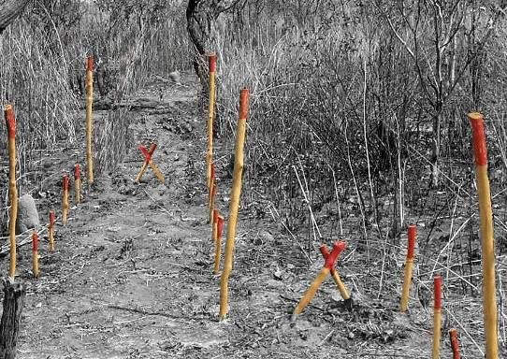
Each search lane is marked as being one metre wide. An overlap of 10 cm on each side means that the area searched is actually 1.2 metres wide. This ensures that adjacent lanes overlap without any possibility of missing narrow areas between them.
No one metre wide search lane into a HPA should be more than five metres long. When the lane reaches five metres long, it should be closed and an adjacent lane searched so that the lane becomes two metres wide. The second lane can then be extended a further five metres before it is also closed and the first lane extended. Ensuring that search lanes that are more than five metres long are always at least two metres wide allows efficient supervision and safe emergency access.
When appropriate, one metre search lanes made into Low Probability Area (LPA) or areas with No Threat Evidence (NTE) may be extended to 20 metres in length before being widened with an adjacent lane. Although it saves time to search a narrow lane across LPA and NTE areas, a narrow search lane may pass through a patterned area of hazards without locating it which would introduce an intolerable risk of leaving hazards behind. Breaches across these areas must eventually be broader than two metres (as described in Chapter 3) so widening a breach into LPA and NTE areas when it reaches five metres in length is preferred.
Search lane marking is described in Chapter 5 of these SOPs.

Cutting vegetation from beside a search lane
When a search lane into a HPA has reached five metres long, a lane must be made alongside it and that part of the adjacent lane which is accessible can be prepared from the side. Undergrowth, rocks and other obstructions can be removed and, when approved, the vegetation strimmer described in Part 13.3 of this Chapter can be used. It has been found that this allows deminers to work more quickly because they are not constantly changing tools. The procedure is shown in the diagram below.
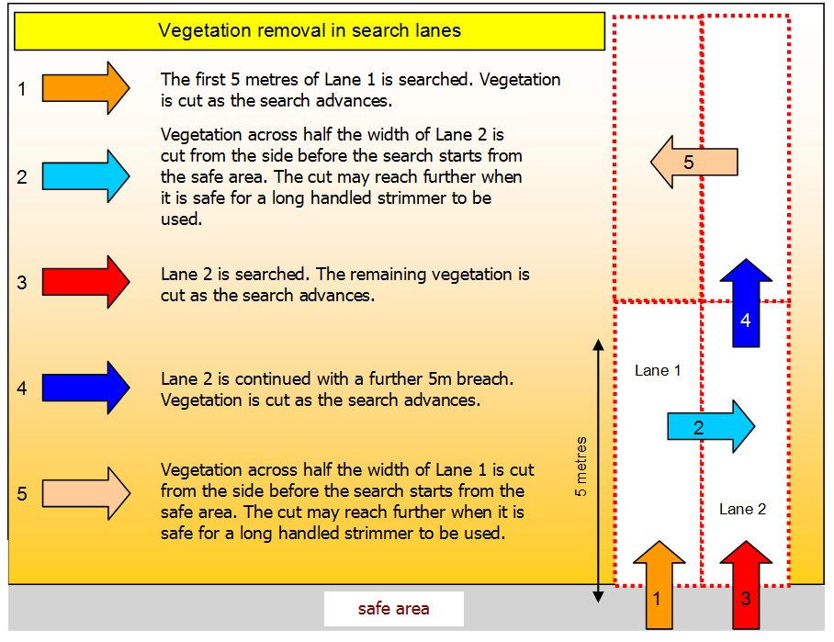
This procedure may be used whether searching with metal-detectors or using area-excavation procedures.
Using hand tools, deminers cannot safely cut vegetation across the entire width of the adjacent lane, but cutting some of the vegetation will often speed up the Search & Clearance of the adjacent lane without adding risk.
  - Lateral lanes
Step 3
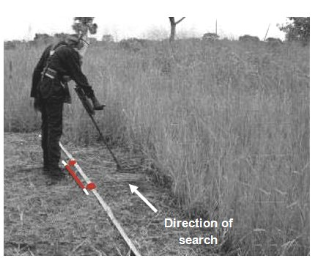
Lateral lanes are lanes that search slices from the
front of the SHA instead of searching directly into
it. This approach can be especially useful when
searching road-verges, alongside railway lines or
up to buildings.
The photograph alongside shows a deminer
searching a lateral lane. There is a road behind
the deminer. Lateral lanes do not extend to a
metre in front of the deminer. They should be as
wide as the deminer can safely reach to cut
vegetation and prepare the area for search.
This is usually around 50cm unless the Task Risk
Assessment has determined that it would be safe to use a long handled strimmer.
Lateral lanes are prepared from a start line at which a baseline is placed inside the safe area. This may be a road. The length of a lateral lane may be varied to suit the task but is usually not more than ten metres.
Because lateral lanes involve the deminer moving sideways along the baseline, it is sometimes called a ‘Crab’ search approach.
Procedures for using a lateral lane search pattern vary and the method described below is the simplest.
- On a start line, the deminer places markers ten metres apart. The markers are linked with tape that must be pulled tight to ensure a straight line and make a baseline. The deminer should always start on the right of the area and move left as the search progresses.
- When necessary, a search for tripwires must be conducted before cutting vegetation.
- At the right hand end of the baseline, the deminer kneels and cuts the undergrowth in front of the baseline as far as can be safely reached. If a long handled vegetation strimmer has been approved for use, the deminer stands and moves along the baseline using the strimmer.
- Undergrowth should be cut in two or more stages to ground level while looking through it for visible hazards. Any visible hazard must be marked with a hazard marker at the baseline and the vegetation in the area around it gently removed by hand.
- The deminer removes all cut vegetation, and small obstructions such as rocks and rubbish, then moves to the left to repeat the area preparation. Cut undergrowth may be removed with a leaf rake (from the REDS rake system) when the Task Risk Assessment permits this.
- Moving sideways to the left, the deminer removes all of the undergrowth in front of the baseline to a distance of around half a metre. Generally, a base-stick is not used during the cutting of undergrowth because the baseline tape is in place.
- When the vegetation has been removed across the entire ten metres, the deminer returns to the right hand end of the baseline and places a base-stick on top of the first metre of the baseline. The base-stick provides a guide when using the metal-detector and ensures a search overlap.
- A temporary marker is placed at the other end of the base-stick, on top of the baseline. This is usually a red painted stone because it will not be in place for long.
- The deminer searches the area in front of the base-stick using the metal-detector and signal investigation procedures described in Part 8.4 of this Chapter.

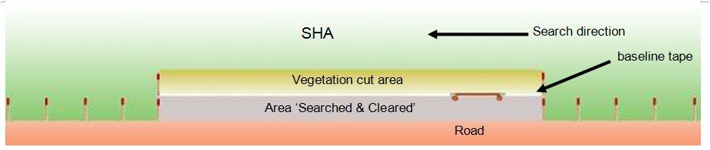
- When the first area in front of the base-stick has been searched and any metal-detector signals investigated, the deminer moves the base-stick to the left, then moves the temporary marker to the left before searching the next area. Depending on the types of explosive hazard located, hazards may be exposed, marked and left while the search continues. All explosive hazards must be removed or destroyed before the baseline tape is moved forward and another swathe of undergrowth is removed.
- Step nine and ten are repeated until the prepared 10 metre wide area has been Searched & Cleared .
- After the removal or destruction of any explosive hazards located, the baseline is moved forward to 10cm inside the area where the vegetation has been cut. If uncut vegetation prevents the tape being straight, the deminer should move the markers back until the tape can be straight.
- The deminer searches along the baseline tape with the metal-detector and investigates any signals.
- The lateral search process begins again at Step 2 and is repeated until the required area has been Searched & Cleared to the required distance from the start line.
 NOTE: A long handled vegetation strimmer can increase speed but must not be used if the Task Risk Assessment indicates the possible presence of tripwire mines, submunitions, tilt-sensitive fuzes, or any other hazard that may be initiated by the strimmer.
  - Spot Tasks
Spot Tasks involve the removal of explosive hazards from small areas. Typically these may be single items of UXO or AXO. The investigation of an MDD indication is also a Spot Task. When a reported or discovered hazard at a Spot Task may be an improvised bomb, MF-IED, or booby-trap the approach and procedures described in Chapter 7 of these SOPs should be used.

UXO/AXO Spot Tasks
UXO/AXO Spot Tasks should be conducted by a Spot Task team.
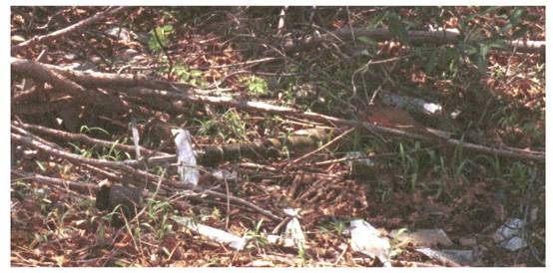
The team leader must assess each task and approach the area where the hazard is reported with appropriate caution. Many UXO/AXO Spot Tasks are made in response to a report of an explosive hazard made by the local community or local authorities. In many cases a device is in an area that is frequently used. In some cases, several explosive hazards have been collected in one place. This type of Spot Task can generally be approached presuming that the area is safe.
The picture alongside shows an RPG lying in rubbish at a roadside.
If there is any uncertainty about approaching a Spot Task, the area must be approached by searching a breach lane from a known safe area.
When the reported device is a mine or submunition, or when an explosive incident has occurred, an assessment must be made of the extent of the area that must be searched. If the area is greater than 100 m², the EOD Spot Task Team must record all details of the area and consult the operations manager about whether to continue or to make a SHA report so that the area can be treated as a wide-area Search & Clearance task that will be conducted by a larger team. The operations manager may need to liaise with the NMAA to reach a decision.
When a search must be made over an area greater than 100 m², a bench-mark must be established and the entire area accurately mapped. All the management and reporting procedures appropriate to searching a wide-area task is required.

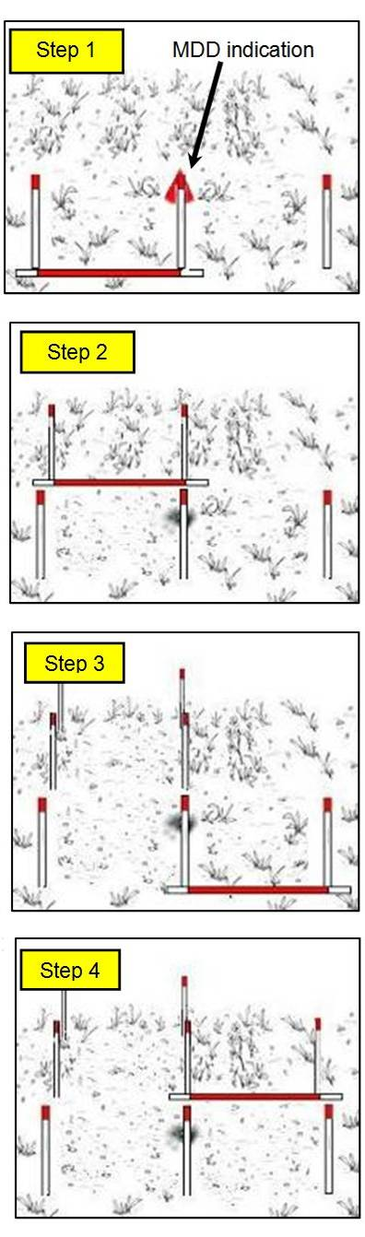
MDD Spot Tasks
Typical MDD Spot Tasks involve the search of small areas surrounding an MDD indication. The MDD marker is placed and the baseline starts at least 50cm back from the marker. The area is Searched & Cleared using the following procedure.
Step 1: the deminer marks the closest side of the two
metre area with three hazardous area markers placed at
metre intervals.
Step 1
If at any stage during the search an explosive hazard is
found, the deminer stops work, closes the lane and
informs the section leader.
Step 2: When one metre has been searched, the deminer
places hazardous area pickets on both sides and starts on
the second metre. He/she does this whether or not any
explosive hazards have been found. A 4 m² area must be
searched even when something is found in the first metre.
Step 3: When two metres have been searched, the
deminer places hazardous area markers at the extent of
the search and moves the base-stick to the adjacent lane.
Step 4: The deminer searches the first metre in the
adjacent lane and places a hazardous area marker on
the outside edge.
Step 5: The deminer searches the second metre in the
adjacent lane and places a hazardous area marker in the
last corner of the four metre square box.
Step 6: The deminer removes the centre marker.
If one or more explosive hazards has been found, the Spot Task has been completed. If no hazards are found, the deminer should extend the start-line with a marker on both sides and search another metre on both sides and beyond the original indication (so searching 12 m² in all).
Whether or not anything is found, the MDD Spot Task has been completed and an MDD set should search the area again. If the MDD signals outside the area searched, that is
another Spot Task that must be Searched & Cleared.

Task site preparation
Site preparation must always be designed to optimise safety for those working at the task.
When the deployment of mechanical assets requires the removal of marking, the marking must be replaced before manual demining is restarted.
The detailed requirements for task site preparation and safe area marking are given in Chapter 4 of these SOPs.

Working distances between staff
A ‘working distance’ is not the same as a ‘safety distance’. The ‘working distance’ is the minimum distance between all staff working inside a demining task area with the exception of supervisors. The working distance is intended to make it unlikely that more than one person will be injured in a demining accident.
The ‘safety distance’ is the distance at which all staff (including supervisors) must be from a deliberate detonation in order to avoid injury. This is also the distance at which staff must be from a demining procedure that may predictably detonate some devices, such as the pulling procedure described in Part 12.1 of this Chapter or the use of a ground processing machine.
Working distances can generally be shorter than safety distances because demining accidents are rare and injuries to a second worker are even rarer. Short working distances can increase safety by improving the ease of supervision which ensures that procedures are conducted correctly and risks are appropriately managed.
To reduce the risk of secondary injury at a task to a tolerable level, working distances should be established based on a written Task Risk Assessment (TRA). The TRA (see Chapter 14) should take into account the anticipated explosive hazards at the task, the demining procedures being used, the ground and vegetation at the site, and the PPE provided to staff.
Instructions for determining task working distances, are given in Chapter 2 of these SOPs. The principles used to determine working distances appropriate for manual demining should also be used when determining appropriate minimum distances between MDD.
NOTE: Working distances do not guarantee safety. The minimum working distances provide a practical means of reducing risk of secondary injury without introducing new risks or compromising the efficiency of the work.
  - Supervisor working distances
During manual demining, authorised supervisors and QA staff are allowed to approach as close as two metres to working deminers as part of their work. EOD specialists dealing with discovered hazards may approach the deminer showing an explosive hazard as long as the deminer is standing and not working. Supervisors and EOD specialists should not stand closer than two metres to a deminer who is showing the position of a discovered device. The deminer should withdraw to the working distance before the device is approached by a single appropriately trained person.
Supervisors, QA staff and EOD specialists should be aware the accident records shows that they are more likely to be involved in an accident than a deminer. Whenever they enter any area where demining work is being conducted they must always wear PPE that complies with the requirements in Chapter 2 of these SOPs.

  - MEDEVAC procedures during manual demining
If the detonation of an explosive hazard causes a casualty, the following procedure should be followed.
- All deminers must stop work, step back from their baseline area and wait for instructions whenever they hear an unscheduled detonation. They must keep calm and quiet while they wait for instructions from their section leader. If there has been an accident, they should stand still until more information is known.
- The section leader in charge of the casualty must order all work to stop and inform the task supervisor that there has been an accident. If the section leader is the casualty, a deminer should inform the closest section leader or the task supervisor who will then take charge of the MEDEVAC.
- When the casualty is inside a safe area, the section leader should instruct the nearest two deminers to carefully approach the casualty, walking on known safe areas, and offer first aid and psychological support in accordance with their training. All other members of the section must stand still and await instructions.
NOTE: If there is more than one casualty, no more than two deminers should be allowed into the area to offer first aid and psychological support.
- The task supervisor should call the paramedic and instruct the ambulance driver to move the ambulance closer to the accident site when that is practical. The paramedic and ambulance may already have responded.
- The task supervisor must notify the Programme Office and the NMAA that there has been an accident and that more details will follow.
- If the casualty is inside a SHA, the section leader should order a deminer to make a search lane giving access to the casualty. If the casualty is mobile, he/she should be guided back to the safe area. When the casualty is not mobile, the access lane must be widened to at least two metres so that a stretcher can be carried along it safely.
- When the casualty is inside a safe area and on a stretcher, the section leader should ensure that the casualty is carried to the safe place where the paramedic is waiting. Generally, the section leader should go to the casualty and ensure that all deminers are acting in a calm and controlled manner. All accidents are shocking events, and deminers who cannot cope must be ordered to stand back and replaced by deminers who are less shocked.
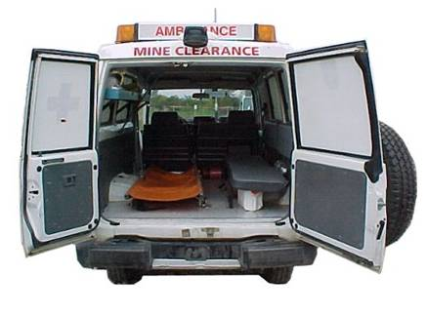
- The paramedic should have arrived by the time that the stretcher is carried to the safe place. The section leader must support the paramedic, instructing deminers to carry the casualty to the waiting ambulance when appropriate.
- The paramedic will stabilize the casualty, then ask for him/her to be moved to the waiting ambulance. Generally, the task supervisor should have arrived and taken charge by this time.
- The task supervisor should stay in contact with the operations manager and keep him/her informed of all developments.
- The task supervisor will liaise with the ambulance driver and confirm the MEDEVAC route to the nearest hospital. The task supervisor may also arrange for an escort vehicle to accompany the ambulance with two staff who have a blood group compatible with that of the casualty. Compatible blood groups are listed in Chapter 13 of these SOPs.
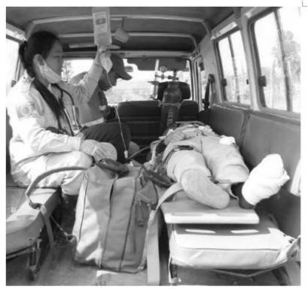
- As soon as the casualty is inside the ambulance, the task
supervisor or operations manager must notify the hospital
that a casualty is en-route, giving his/her name,
blood-group and an initial assessment of the injuries.
The task supervisor or operations manager should stay in
contact with the ambulance and its escort vehicle
throughout their journey to hospital. When appropriate,
he/she should telephone ahead to arrange fast transit
through any traffic bottlenecks.
- When the casualty has been evacuated, the accident site
must be left undisturbed. All staff must close their search-lanes, collect their equipment and withdraw to the Control Points or the administration area in an orderly manner. When equipment has been left at the accident site, the task supervisor should order a guard to be placed when there is a risk that it may be disturbed.
- No work should be conducted at the task site until an accident investigation has been completed. Generally, staff should be kept busy with maintenance tasks and kept informed about the condition of the casualty as it becomes known.
- When all staff have left the task, the task supervisor should carry out an initial investigation of the circumstances surrounding the accident, then notify the operations manager and request a formal accident investigation to be conducted. Generally the task supervisor will be a member of the accident investigation team.

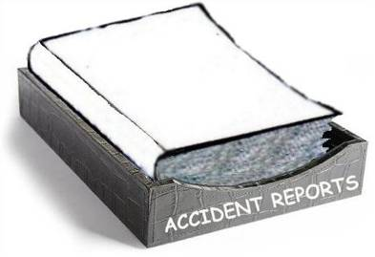
Preliminary accident investigation
The honest and rational investigation of events surrounding demining accidents provides the best data the industry has about what is safe and what is not. It is an essential part of risk management, so every stage of the investigation must be conducted with professional integrity and recorded for future use. Conclusions have to be based on evidence rather than conjecture, so it is essential to preserve the evidence and share the responsibility for drawing conclusions from it.
During the preliminary investigation that the task supervisor must conduct immediately after the accident, the accident site should be photographed but left undisturbed. The names of all staff present at the time or involved in the MEDEVAC must be noted and a brief description of events surrounding the accident compiled. The paramedic’s record of the apparent injuries and the treatment(s) administered should be appended as soon as possible.
Generally, formal interviews of witnesses should not be conducted until the full accident investigation is conducted. The requirements for a full accident investigation and its report are given in Chapter 13, Medical Support.
The task supervisor should compile the information into a brief provisional report and submit it to the operations manager on the same day that the accident occurred. The Programme Manager should notify the victim’s family, the insurance company and the NMAA.
In case of a fatal accident, the Programme Manager must ensure that the police or local authorities are informed and that any police investigation is assisted.

Manual demining procedures
The following manual demining procedures are designed to be used by a deminer working alone in a search lane. If deminers work in pairs to share equipment, the tasks allocated to each deminer should alternate at each rest period.
A demining section is led by a section leader and each section generally comprises up to ten deminers. The following are general rules that the section leader must ensure are followed.
- All working deminers must wear approved PPE at the task site except when in designated rest or administration areas. PPE should be worn before leaving a rest area and removed when arriving back in a rest area.
- No deminer should work for more than 40 minutes without a ten minute rest break.
- Deminers must always have sufficient drinking water available to prevent dehydration.
- When using metal-detectors, metal-detector test and calibration areas must be prepared close to the working deminers.
- When using REDS rakes, the deminer must always work in a standing position when using a rake.
  - Prohibited detection method
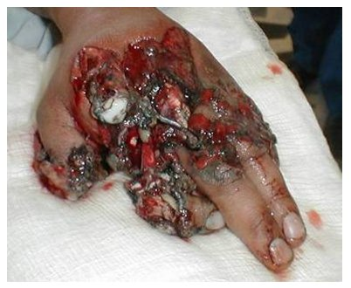
In independent studies its has been found that using a prodder to detect buried hazards is intolerably hazardous for two reasons. First, there is a very high risk of pressing onto the pressure plate of any mine that might be present. Second, a prodder cannot be reliably pushed to a search depth greater than a few centimetres, so there is a very high risk of leaving explosive hazards behind.
Despite the fact that military training often includes prodding with a bayonet to make a passage through a minefield, the GICHD study and the accident record in the Database of Demining Accidents (DDAS) proves that prodding to detect explosive hazards puts the deminers hands at intolerable risk and also puts the end-users of the land at intolerable risk.
Prodding tools are used while excavating a metal-detector signal but must not be used to try to detect where to excavate.
  - Detection by eye
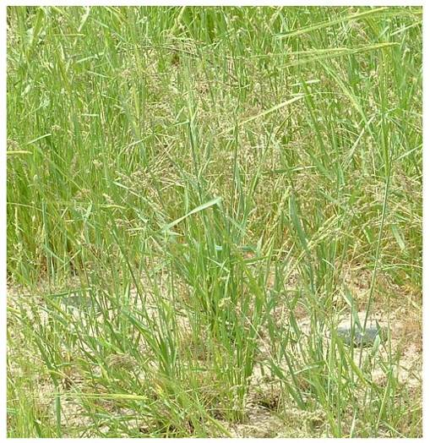
During all manual demining procedures, the most common means of detecting an explosive hazard is often by seeing it. Tripwire hazards generally have their fuze mechanisms above ground and mines that were originally buried are often partly exposed. Many hazards are partly visible after undergrowth has been removed. Parts of the pressure plates of two PMN anti-personnel mines are visible in the foreground of the picture on the right. Most mines intended to be stepped on are not buried deeply.
All deminers and supervisors must be constantly vigilant, especially during vegetation cutting procedures when it is essential to avoid pulling tripwires or touching tilt-sensitive fuzes and/or armed submunitions.

Lane search using metal-detectors
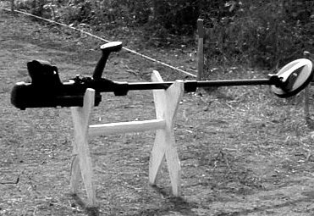
A metal-detector may be used in either a one-person-one-lane search procedure or a two-person-one-lane search procedure in which roles alternate at rest periods. The deminer using the metal-detector is issued with a detector and a tool-kit and works independently in a search lane.
To allow the metal-detector to be set aside safely, a wooden detector stand should be provided. The frame may be a simple arrangement of support sticks or a structure that is designed to be moved from task to task. An example of a purpose-made metal-detector stand is shown alongside. When a detector stand is used, there is no chance of the deminer accidentally stepping on the metal-detector.
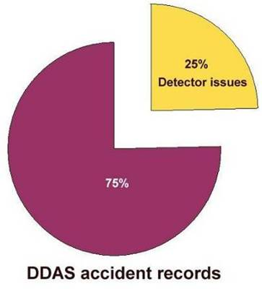
  - Safety and metal-detectors
The incorrect use of a metal-detector is recorded as having been involved in 25% of the demining accidents in the accident record in the Database of Demining Accidents (DDAS).
The metal-detector was rarely being used when the accident occurred, but its inappropriate use led to hazards being missed and accidents happening while the metal-detector signals were being investigated.
The causes of these accidents include poor pinpointing, incomplete ground coverage during the search, inappropriate metal-detector set-up, and the use of the wrong kind of metal-detector.
 NOTE: A ferrous locator must not be used to search for plastic cased mines.
It is essential that all supervisory staff understand the limitations of the metal-detectors available and the need to use the metal-detector in the approved way. When possible, the metal-detector manufacturer should be asked to provide preliminary training for any new model. Supervisors and trainers should then test the model to discover its limitations.
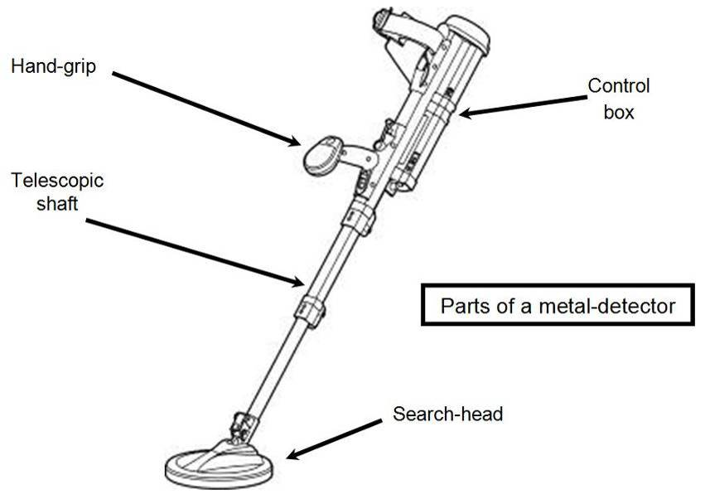
  - General principles
Only deminers internally trained and tested in the use of the specific model of metal-detector can be used to perform metal-detector search procedures with that metal-detector.
There must always be absolute confidence in the metal-detector’s ability to locate the target device at the required depth before metal-detector search procedures are used. Because equipment and deminers can both be at fault, it is essential to confirm that the metal-detector and its operator can locate all of the anticipated targets at the required depth beneath the ground surface. To determine whether the metal-detectors can be used, metal-detector Test and Calibration areas must be established. Metal-detector Test and Calibration areas are also described in Chapter 4 of these SOPs.
At the start of the working period, or after any period when the metal-detector has been turned off, the metal-detector must be switched on and set-up. The deminers should follow metal-detector start up procedures as described in the manufacturer’s instructions.
NOTE: The manufacturer's instructions determine whether the metal-detector is working as designed, not whether it can locate the explosive hazards at a particular task. Deminers shall not follow the manufacturer's instructions for using the metal-detector unless those instructions coincide with the content of the procedures described in this Chapter.

Metal-detector care
Metal-detectors are sensitive electronic devices that must be treated carefully. Moving parts, such as clips and the search-head hinges will wear over time and may need to be replaced. The underside of the search-head may also wear away as it brushed lightly over the ground and some manufacturers offer a disposable cover for the search-head to prevent the coils inside the search-head becoming exposed.
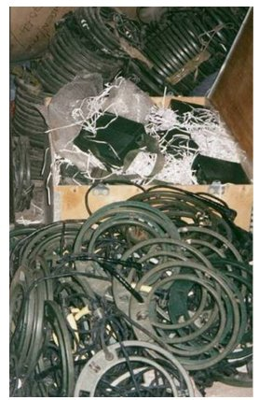
All metal-detectors should be cleaned and carefully packed inside hard protective casings with their batteries removed whenever they are not in use.
When sourcing metal-detectors, the availability of spare parts and service should be considered. Models of metal-detector with exposed cables should be avoided because cable and socket damage is common.
The picture alongside shows dozens of old metal-detectors that could not be economically repaired.
The most common cause of careless physical damage is a deminer stepping onto a metal-detector that has been put aside. The provision of a metal-detector stand and the enforcement of strict rules about metal-detector placement can avoid this.
Another common cause of damage is the deminer adjusting the angle of the search-head by stepping on it. The search-head angle should always be adjusted by hand. If the model of metal-detector
has a hinge clamp, it must be slackened during the adjustment.
Physical damage is often caused by careless treatment. Dust and humidity may also cause damage, as can the presence of insects inside the casings and/or the use of incorrect batteries.
The working life of a metal-detector varies but most can be expected to perform reliably for five years unless they are physically damaged. If they are damaged, many models cannot be economically repaired.

Metal-detector calibration area
Metal-detector calibration areas are needed for carrying out ‘ground compensation’. This is the same thing as the ‘ground learning function’ or the ‘ground balance’ referred to in some metal-detector manuals. Ground compensation must be used whenever searching in areas where the properties of the ground causes electro-magnetic disturbance. Ground compensation should not be used unless it is needed because it generally reduces the effective depth of search.
Ground compensation must be set up as described in the manufacturers' documentation. To do this, metal-free calibration areas of at least one metre square should be prepared close to where the deminers will work because the properties of the ground can vary over distance. There may be a need for many calibration areas at a single task. The areas should be moved forward as work progresses so that there is always a calibration area within 100 metres of the place where the deminer will work. Usually a calibration area will be close to a metal-detector test area. Both areas can be inside access lanes as long as those lanes are at least two metres wide and the areas are marked by white painted stones. This is permitted because the test and calibration areas can be walked over in an emergency.
It is the section leader's responsibility to ensure that all calibration areas are metal-free and that calibration and ground compensation procedures are followed whenever necessary. When a metal-detector cannot compensate for the electromagnetic properties of the ground and continues to signal or signal erratically where there is no metal, it must not be used at that task (or that part of the task).

Metal-detector test area
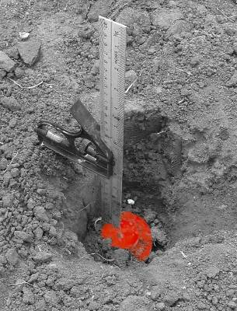
The metal-detector test area is used to ensure that the metal-detector can reliably signal on a target at the required depth. The target should accurately represent the explosive hazard that is most difficult to detect at that task. This is often a minimum-metal mine and the target is often a real mine that has been rendered safe by removing the high explosive content and ‘gagging’ the mechanism to prevent pressure initiating the detonator. Examples of how to make some common mines into target mines are given in Chapter 12 of these SOPs. After each metal-detector has been set-up with appropriate ground compensation, each metal-detector's ability to signal the presence of the target at the required depth must be confirmed.
The photograph on the right shows the depth of a target mine being measured. It does not matter that the deminer knows where the target is, so a cord attached to the target may be left on the surface to allow its easy recovery.
 NOTE: The deminer must not use a metal-detector manufacturer's test piece as a reliable simulation of a real target.
 NOTE: A mine that has been rendered safe for use as a metal-detector target is usually not Free From Explosive (FFE) because the detonator is generally present. They must not be marked as FFE but as ‘Detector Targets’. They should be transported and stored as ‘detonators’ and clearly marked (painted red) to avoid any confusion.
A suitably qualified/experienced EOD operative should be made responsible for providing and controlling all metal-detector targets, ensuring that they are recovered when they are no longer required and that they are stored in the explosives storage area.
Metal-detector targets must be buried in metal free detector test areas close to where the deminers will work (usually within 100 metres). Each target should be buried in a marked area measuring at least one square metre. The target must be buried so that its top is at the required search depth at the task. The section leader must ensure that there is no detectable metal in the metal-detector test areas before the targets are placed at the required depth.
Metal-detector test areas are often positioned alongside detector calibration areas but need not be. Both areas must be clearly marked.

Using the metal-detector calibration and test areas
The deminer should switch on the metal-detector, set up its ground compensation capacity in the calibration area when necessary, and then use the detector test area to check that it signals on the target. If the metal-detector signals erratically or does not give a distinct signal over the target, it should be switched off and section leader should attempt to set up the metal-detector again. If there is any ambiguity about the signal, the section leader must repeat the test with other metal-detectors. If the problem is repeated, the section leader must report that searching the area with the available model of metal-detector is not appropriate and the task supervisor should ensure that the Task Release Plan is adjusted appropriately.
If the section leader can reliably detect the target but the deminer cannot, the deminer must not be allowed to use a metal-detector until he/she has been trained to use the metal-detector effectively.
If the section leader cannot detect the target but can detect it with other metal-detectors of the same type, the faulty metal-detector must be withdrawn from service immediately.
If the metal-detector has an erratic fault and does not work reliably all of the time, it must be withdrawn from service immediately .
Every time that a deminer leaves the working area (for rest breaks, etc) the ability of the metal-detector to signal on the buried target in the test area should be confirmed because metal-detector performance can change while it is being used. This may happen as a result of temperature variations, battery condition, or an electrical malfunction. If the metal-detector does not signal on the target concealed in the test area when the deminer leaves the working area, the area searched since the last check must be searched again. The second search can be conducted using a metal-detector that does signal reliably in the test area, or by using other search procedures.

Search-head movement
The sideways movement of the metal-detector’s search-head depends on its operating principle (‘static’ or ‘dynamic’). The search-head of a dynamic metal-detector must be constantly moved over a target in order to signal. The search-head of a static metal-detector will continue to signal when held over a target without movement. Some models of metal-detector can be switched between static and dynamic operation.
Whichever model of metal-detector is used, the required rate of advance is one third (or less) of the search-head width when searching for minimum-metal mines or one half of a search-head width when looking for hazards with more metal inside. The search procedure is described in Part 8.4 of this Chapter.

Search-head advance
The distance by which the search-head is advanced during each metal-detector sweep is important because of the way that metal-detectors work. Expressed simply, metal-detectors emit electro-magnetic waves and receive (then analyse) those waves that reflect. When the waves hit metal they return and the metal-detector signals. The waves of energy emitted get weaker as they spread, so a metal-detector that signals on a small target that is just below the surface, may not receive sufficient reflection from the same target to signal when it is deeper in the ground.
The area beneath the search-head that the waves can both reach and usefully reflect depends on what they are reflecting from. A large target will reflect more waves so may be detected even before the search-head passes over them. A small target will reflect most waves when it is directly beneath the centre of the search-head so the metal-detector may only signal when directly over it.
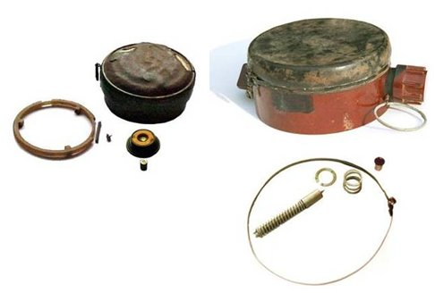
The difference between ease of detection can be shown using the PMN and the Type 72a anti-personnel blast mines. The PMN has a large metal signature and the Type 72a has a small one.
The metal inside them is shown on the right.
The large ring of metal around the top of
a PMN makes a metal-detector signal
strongly. If the ring corrodes and breaks,
the signal is much weaker
Many metal-detectors will only signal on
the small detonator inside the Type-72a.
Curved cardboard shapes have been taped to
the search-head of the metal-detector shown below.
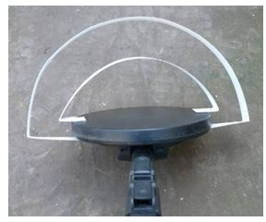
The outer white curve shows the area beneath a search-head where this metal-detector will signal on a PMN in good condition. The inner white curve shows the area where it will signal on a Type-72a.
The same metal-detector at the same settings was used.
Every metal-detector may have a slightly different search area for these targets.
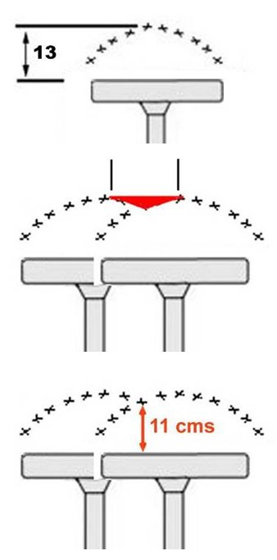
In the drawing alongside, the 13cm depth at which a
Type-72a will be located is shown.
When sweeping the search-head, it must be overlapped by
enough to ensure that the required search depth for the
target is always maintained.
When the search-head is advanced too much, parts of the search area will not be searched to the required depth. In
this example, the search-head is advanced by half of its width, which many people might think gave an adequate search-head overlap but it is not because a Type 72a mine at 13cm depth in the red area would be missed.
The reliable search depth using that metal-detector to find that target and advancing the search-head by half its width on each sweep is actually 11cm.
This is only important when the target is at the detection limits of the metal-detector but it is essential that the required search depth be maintained, so deminers must understand the need to advance the search-head an appropriate distance between sweeps.

To discover a metal-detector's limits in the ground where the work will be conducted, first set up the metal-detector with any ground compensation necessary, then bury half of the search-head in the ground as shown.
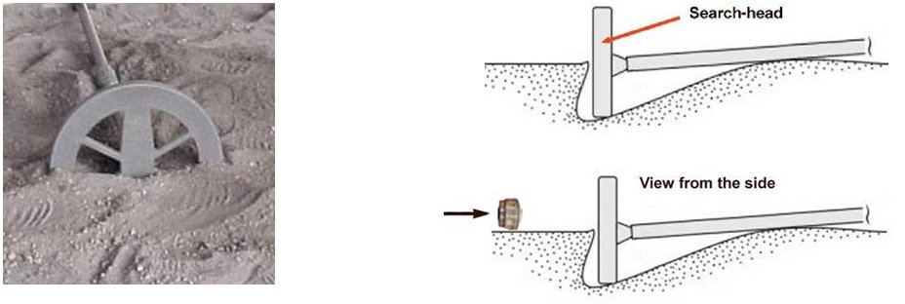
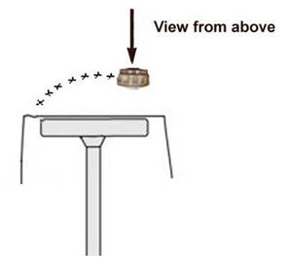
Now move a target towards the search-head,
marking the ground as soon as the metal-detector
signals.

Repeat this to get a marked shape on the ground
showing that metal-detector's search area for that
particular target in that ground.

  - Using the MineLab F3 metal-detector
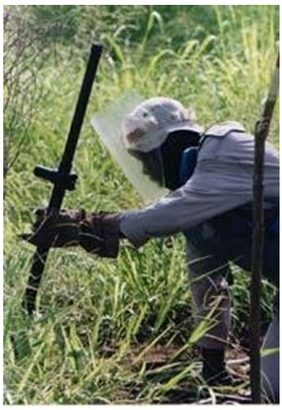
A detailed description of the use of one particular model of metal-detector, the MineLab F3, is provided here. When a different model of metal-detector is used, instructions for its detailed use must be documented and appended to this Chapter. The MineLab F3 is a good ‘all-rounder’ that is able to be used anywhere in the world. It is probably the best metal-detector for locating minimum-metal mines at depth in electromagnetic soils, but it is not the simplest metal-detector available. When simpler metal-detectors are capable of finding the explosive hazards reliably in the ground conditions at a task, they may be preferred.
The preferred secondary metal-detector is one of the Ebinger (EBEX) 420 series. This series of metal-detector are generally very simple to set up and their lightness makes them easy to use with one hand when kneeling, as shown in the photograph alongside.
Whichever model of metal-detector is used, it will be necessary to pass the search-head over the position of the original signal frequently during the signal investigation process. If the position of the signal moves while it is being exposed, the deminer then knows that the signal was caused by a small fragment of something metallic in the soil that has been moved aside.

Switching ‘mode’ with the MineLab F3
The control-box of the F3 has a coloured plastic end-cap that is changed to select different ‘modes’. By changing mode, users can reduce the sensitivity of the metal-detector and allow it to be used without it signalling on every small fragment of metal that may be present.
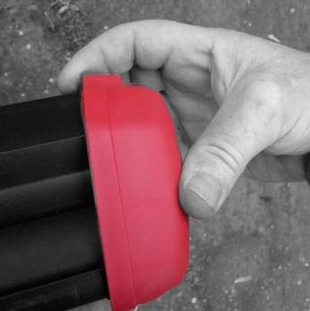
While searching for explosive hazards with a small metal content, the black end-cap must always be used. When searching for large metal devices, the red end-cap may be used.
The end cap is removed by pressing in the centre at the same time as pulling the lower edge away – as shown in the photograph alongside.
Electronics inside the end-cap change the configuration of the metal-detector. If no end-cap is fitted, the machine is designed to operate with the same sensitivity as it does with the black end-cap.
If other coloured end-caps are sourced, their use should be fully documented in an amendment to this Chapter before they are issued.

Turning on and checking the MineLab F3
The MineLab F3 metal-detector is prepared for use in the following stages.
- Hold the F3 upside down and unlock the battery pack lid by twisting the battery pack locking lever anti-clockwise a quarter of a turn, then pull the lid away from the battery pack. The lid should remain attached to the battery pack with a plastic tie.
- Using the battery maps on the side of the battery pack and on the inside of the lid to orientate the batteries, insert four D cell batteries.
Replace the battery pack lid and turn the battery pack locking lever clockwise a quarter of a turn. If the batteries are not inserted correctly, the F3 will not work.
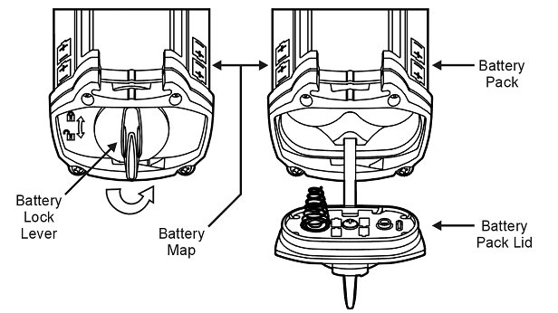
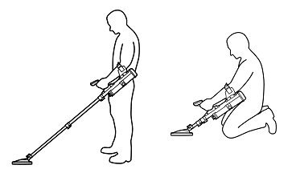
NOTE: Use NiCad or NiMh D cell rechargeable batteries with a capacity of at least 4000 mAH.
- Unclip the search-head lock and position the search-head
in line with the handle.
- Extend the telescopic shaft to the length that will be used.
Extend the lowest part of the metal-detector by at
least 10cm because the metal-detector may not
work properly unless it is extended by at least
this amount.

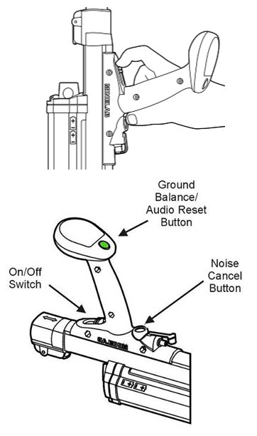
- Adjust the arm rest and tighten the arm strap as required.
- Hold the metal-detector with the search-head high in the air and slide on the on/off-switch towards the handgrip. Keep the search- head in the air while the F3 runs through a series of internal self-tests that take 12 seconds. While this is happening, the metal-detector makes four start-up tones that rise in pitch.
- When the start-up checks are completed, the metal-detector makes a steady low tone called the ‘normal’ tone.
The ‘normal’ tone will get louder if the search-head is
left over electromagnetic ground for a long time, or if
the search-head is twisted around in relation to the telescopic handle. If the ‘normal’ tone ever gets louder during use, press the green ‘Audio Reset’ button to return it to normal.
Interference from electrical motors, lights, power lines and other metal-detectors may make the ‘normal’ tone vary in pitch and volume. When this happens, press the ‘Noise Cancel’ button to make the metal-detector search for an operating frequency that will minimise the interference.
- Wait half a minute after the ‘normal’ tone has started, then move to the metal-detector calibration area to ‘ground balance’ the
metal-detector when required. ‘Ground balance’ is what MineLab call ‘ground compensation’. Start by holding the search-head 15cm above the ground over the calibration area.
- Press and hold down the green ground balance button on the metal-detector handle. Holding the button down, slowly lower the search-head to the ground, then slowly raise it again.
- Slowly lower and raise the search-head until the metal-detector makes a short, high-pitched beep-beep noise. Then stop pressing the green ground balance button.
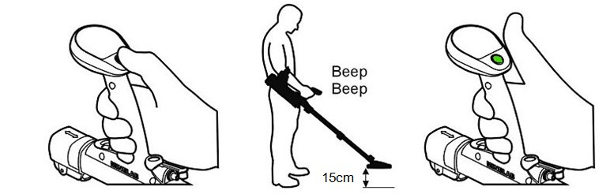
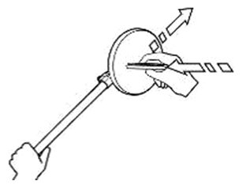
- Test the metal-detector using the metal-detector test piece. Hold the test piece so that the metal part is away from the search-head. Slowly move the test piece towards the centre of the head until it lightly touches the surface then move it sideways off the search-head. A faint but clear change in volume and pitch should be heard.
- The metal-detector is ready to use in the detector test area.
In the detector test area, the search-head must be used over the
concealed target to confirm that the metal-detector gives a distinct signal.
This proves that the metal-detector is able to find the required target at the required search depth. It also gives the deminer confidence in the metal-detector while familiarising the deminer with the sound that the metal-detector makes when the type of explosive hazard that was used to make the target is located at that depth. The signal that a metal-detector makes over a particular target will usually vary in volume or tone depending on the target’s depth.

MineLab F3 search patterns
The standard MineLab F3 metal-detector works in ‘static’ mode so the search-head does not have to be kept moving in order for it to signal when there is metal under it. Some models are switchable between static and dynamic modes.

Pinpointing with the MineLab F3
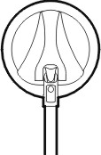
Having detected metal and gained a rough idea about its size and location using the sweeping search procedure, a more precise location of the metal can be found using the F3’s ‘Edge Detection’ technique.
To detect the edge of concealed metal, the search-head should be brought towards the metal from all angles as shown on the right.
As the search-head approaches metal, the normal tone will change,
indicating that there is metal close by. When the normal tone
changes, the deminer should note the position on the ground,
move the search-head away, and approach the metal from another angle.
This should be repeated until the deminer has a mental picture of the position.
NOTE: After an initial detection, if the search-head is repeatedly swept over a small
piece of metal the signal may get quieter. If this happens, move the search-head away from the target and quickly press and release the green ground balance button. This will reset the tone and the metal-detector should signal over the metal again.
The signal marker should be placed at the nearest part of the signal to the base-stick.
When pinpointing using the edge-detection technique reveals an irregular shape, it may be that several pieces of metal are close together as shown in the drawing below.

The variation in pitch of the signal as the search-head is passed over the top of the metal may allow an experienced operator to discriminate between the separate pieces. This is because the detection signal for the 3 varies with different metals.
 NOTE: In all cases where an irregular perimeter is found, the deminer should presume that more than one potential hazard is present.

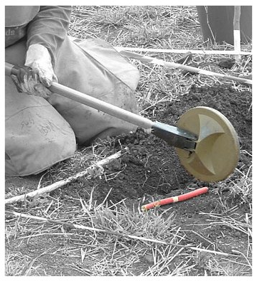
Edge pinpointing
In some cases, pinpointing using the search-head on its side makes it easier to see exactly where a signal begins.
The edge of the search-head cannot be used to pinpoint weak signals from small or deep targets because it will not signal on them.
When the signal is strong enough, edge pinpointing is often preferred because the deminer can see the ground clearly instead of it being covered by the search-head.
Whatever pinpointing method is used, the deminers must know it well and place a signal marker on the closest part.
  - Metal-detector search procedure
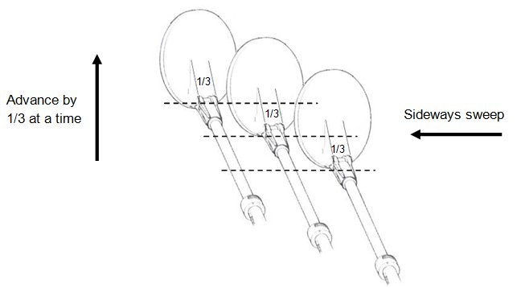
The following procedure achieves a one third overlap of a metal-detector search-head.
The metal-detector search-head should
always be kept as close to the ground
surface as possible.

 NOTE: The metal-detector search-head may be brushed
lightly over ground that has been visually inspected
but must not be used to ‘pat’ the ground with an
up-and-down movement.
The ground in front of the deminer should be prepared using vegetation cutting techniques and any surface rocks or obstructions removed and placed behind the deminer. Generally, all vegetation, rocks and other obstructions should be placed behind the last QA marker to ensure that they are in a safe area.
The deminer works forward from a base-stick. After cutting the vegetation, a 50cm long flat wooden ‘guide-stick’ may be laid so that is extends forward of the base-stick. The guide-stick should have marks along its length that are a measured percentage of the search-head diameter, so providing a guide to the appropriate search-head overlap. The use of a guide-stick is optional.
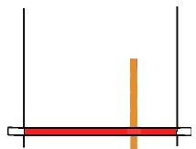
guide-stick

The preferred base-stick has tapes five metres long attached to each end (as shown below). The tapes are rolled out as work progresses. They are marked at every metre, providing a reminder to the deminer about placing side-marking. See Chapter 5 of these SOPs.
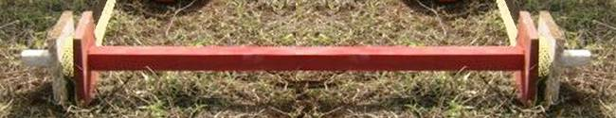

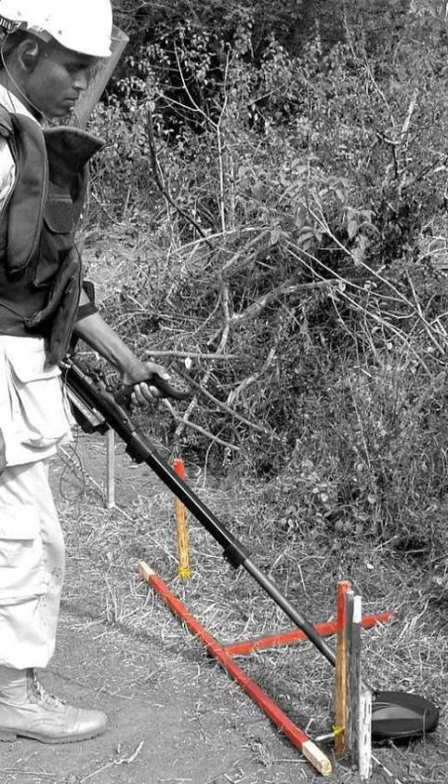
The same search pattern must be used whether the deminer is standing or kneeling. The telescopic shaft should be adjusted to an appropriate length before the metal-detector is used in the detector calibration and test areas because changing the length of the shaft can change the metal-detector’s sensitivity.
The picture on the left shows a standing deminer with the shaft of the MineLab F3 extended. This deminer is using a guide-stick to ensure the correct search-head overlap.
The picture below shows a kneeling deminer with a short Ebinger 420 metal-detector.
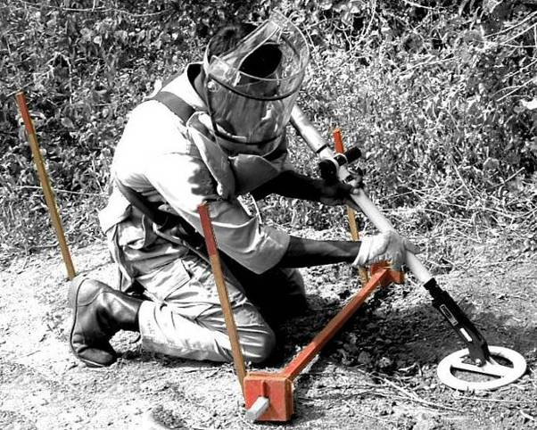

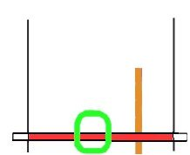
- The search-head is placed in the middle of the base-stick, with at
least one third of the search-head behind the base-stick. When
using a raised base-stick, the search-head is placed under the
base-stick.

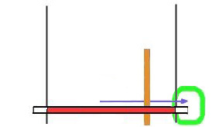
- The search-head is moved to the right and beyond the end of the base-stick. The overlap outside the lane must be at least 10cm. The search-head is constantly kept as close to the ground as possible without applying pressure to the ground.
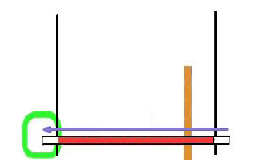

- The search-head is moved all the way to the left without advancing it and beyond the end of the base-stick. The overlap outside the lane must be at least 10cm.

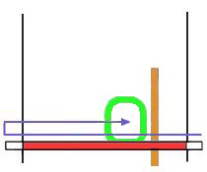
- The search-head is moved forward by a third of the search-head length or less, and swept to the right. If the metal-detector signals, the sweeps are not interrupted.

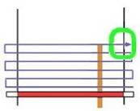
- Advancing by one third of a search-head length or less, the head is moved forward until it is at least one-third over the end of the guide-stick (or 40cm in front of the deminer) and over the side of the search area (overlap). If the metal-detector signals, the deminer must remember the approximate position and keep searching.

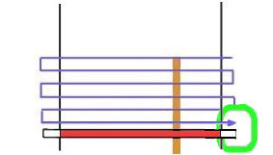
- The search-head is moved back over the search area in a reverse action. If the metal-detector signals, the sweeps are not interrupted, but a mental map of the search area is made.
The deminer now knows how many signals are in the area and their approximate position. If two signals are close together, or are in a linear pattern (as is common with lengths of wire), the deminer knows this and so can pinpoint the closest signal (or the part of a signal that is closest).
- If there are no signals in an area, the base-stick is moved forward to 10cm closer than the extent of the search. The deminer then removes the vegetation and rocks in front of the base-stick and starts the search process again.
If there are signals in the area, the deminer should first inspect the ground visually for surface metal and carefully remove any obvious metal by hand. Exposed wire or other items must not be pulled if parts are under the ground. After a visual inspection, the deminer should use a magnetic tool to try to remove metal that cannot be easily seen. The magnet should be brushed lightly over the ground surface to attract magnetic material on the surface.
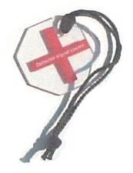
After using the magnet, the area must be searched with the metal-detector again as described in Steps 1-6 above.
- After the area has been searched with the metal-detector, surface fragments removed and the search repeated, the deminer must pinpoint the closest signal to the base-stick and place a signal marker (a simple plastic marker is shown alongside).
Side of lane markers should be positioned every metre. When a base-stick with marking tape attached is used, the deminer looks at the tapes to see whether any of the one metre marks on the tape are showing. When the base-stick has no marking tape attached, the base-stick can be used as a means of measuring one metre.

Pinpointing a metal-detector reading
The method of pinpointing varies with the metal-detector but will either involve using the search-head to approach the signal from all sides (‘a’ below) or moving the search-head across the signal in ‘cross-hairs’" (‘b’ below).
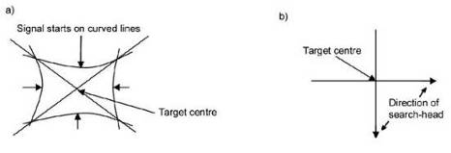
The marker should be placed at the nearest part of the signal to the deminer's base-stick. When a small target is deeply buried it may not be possible to pinpoint accurately, so the deminer should be cautious and place the marker slightly closer to the base-stick than the signal.
NOTE: When marking plastic, bakelite or wooden cased mines, the marker often indicates the fuze and detonator in the centre of the mine. When marking large metal-cased hazards, the marker indicates the side of the hazard that is closest to the base-stick.
Edge-pinpointing described in Part 8.3.5 above may be used when the signal is strong.
When the nearest signal has been pinpointed, the signal investigation procedure must be started.

Metal-detector signal markers
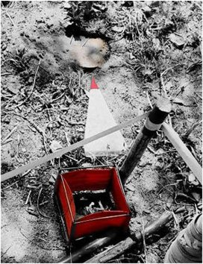
Metal-detector signal markers must be easily seen. Thin plastic markers are preferred because the search-head can be passed over them to confirm the position.
In the picture shown alongside, the top of a mine is clearly visible and the red pointer on the preferred marker points directly at it. This is a GYATA-64 anti-personnel blast mine.
Thin plastic pointer triangles that are 20cm long can show the deminer the minimum distance from the signal at which an excavation can begin, so reducing the risk of a deminer starting to excavate too close to the source of a signal that cannot be seen.
  - Investigating a metal-detector signal using hand tools
After a metal-detector signal has been pinpointed and a signal marker placed at the nearest part of the reading, the deminer can begin a signal investigation procedure.
If at any point during the procedure metal is found and it is not an explosive hazard, the deminer should stop the investigation and use the metal-detector search procedure to check the area where the metal was found to find out whether there are other signals.
If an explosive hazard is located, the deminer should expose the side of the device closest to the base-stick and follow the actions detailed in Part 12 of this Chapter.
Hand tools approved for use during signal excavation should be blast resistant and meet the design requirements given in Chapter 2 of these SOPs.
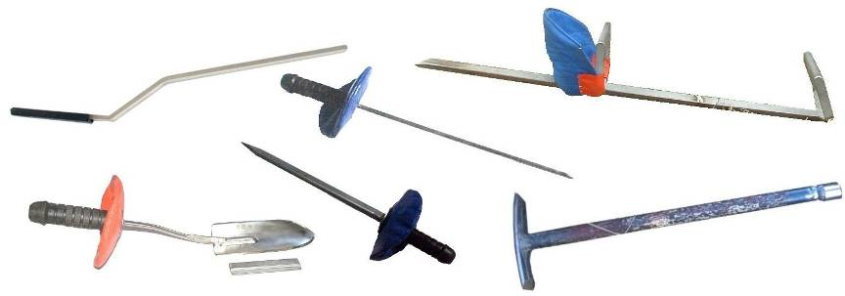
The picture above shows some of the approved blast resistant hand tools. Any tool that is used in the ground during signal excavation should be blast resistant.
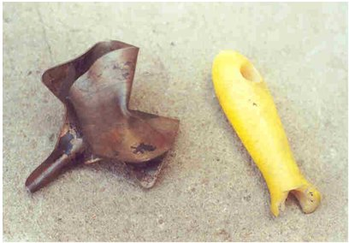
Tools designed for gardeners may only be used for vegetation cutting. Tool designed for use in the building industry, such as cement trowels, must not be used.
The picture alongside shows the pressed steel head of a gardening trowel after it was recovered from inside a deminer’s thigh. The deminer had used the tool with too much force when investigating a metal-detector signal.
Short tools that separate in a blast event are known to have increased injury in many accidents and must not be used. Tools made using very hard materials can
shatter in a blast event, so must also be avoided.

Magnets
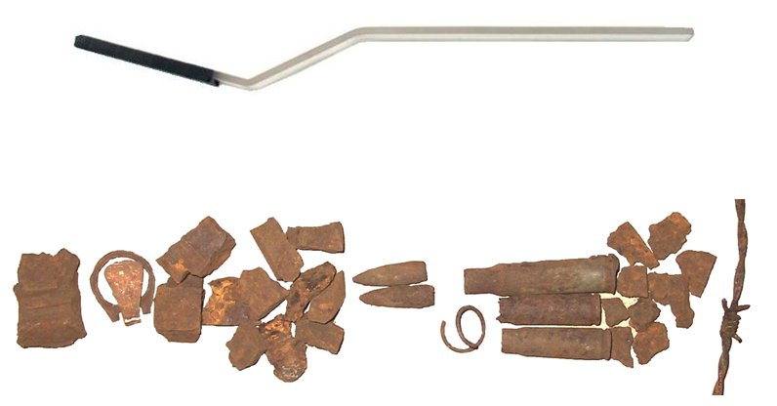
Strong (rare-earth) magnets can be very useful in areas where metal-detector search is used and there is a lot of metal contamination in the ground. The magnets may be attached to tools such as the light rake or trowel, or can be held in the hand. They should be brushed over the ground surface without downward pressure. The picture below shows a thin strip of polycarbonate with thin neodymium magnets taped to one end. This tool is light and keeps the user’s hand at least 30cm away from the magnets.

The photograph below shows typical minefield scrap metal. Most of the metal has a ferrous content, so it is magnetic. The only item that is not magnetic is the ring-pull from a drink can.

Locating small pieces of ferrous metal with a powerful magnet can speed up the signal investigation process very dramatically and so make it efficient to use metal-detectors in areas that are heavily contaminated with metal fragments. However, when an area is contaminated with many fragments that are beneath the ground surface, it may still be quicker to search the area using an area-excavation procedure.
NOTE: Never put a powerful magnet near the controls of a metal-detector because it could alter the settings or damage sensitive components.
 NOTE: Although there are no recorded demining accidents where this has occurred, both magnets and metal-detectors could trigger electromagnetic fuzes or battery powered fuzes. If explosive hazards with these features are anticipated, magnets and metal-detectors should not be used without first checking whether they may trigger the hazards.

Special tools for hard ground
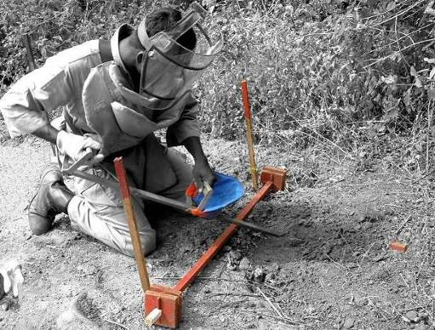
When ground is exceptionally hard, a signal investigation may be started using a two-handed digging tool to break up the ground surface at least 20cm from the nearest part of the signal (the distance from the signal must be more than half the diameter of the largest anticipated target at the task). Digging down to the search depth in a safe place gives the deminer a point from which to work forward towards the signal using one-handed tools with less force.
The deminer in the photograph on the right is using a two-handled tool to start the excavation well away from the metal-detector signal marker.
The tool is made using blast-resistant material and its design includes a guard for the hand that would be closest to any blast.

Slicing tools
When investigating a metal-detector signal or conducting area-excavation, there are times when the use of a tool that slices away the face of the excavation can be efficient and safe.
Excavation must be conducted using the procedures described in Part 8.5.4 below unless none of the anticipated targets are movement sensitive and none have pressure plates extending to the edge of the mine.
 NOTE: Movement sensitive hazards include some armed submunitions and that must be excavated with the greatest caution.
Anti-personnel blast mines have pressure plates of various sizes. Pressure plates that are small make the mine less likely to be stepped on but they are used because they make the mine less likely to be detonated by the pressure wave associated with an air-blast nearby.
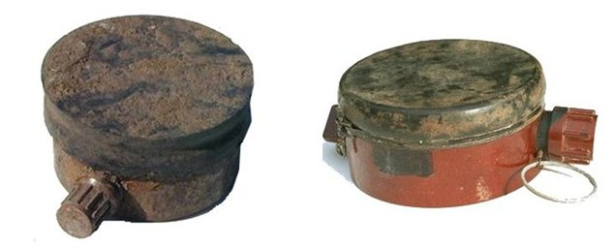
The GYATA-64 and PMN mines shown above have large pressure plates extending to the edge of the top of the mine. When these mines are anticipated in a SHA, slicing away the face of an excavation should not be conducted. The face of the excavation should be crumbled away from the bottom upward.
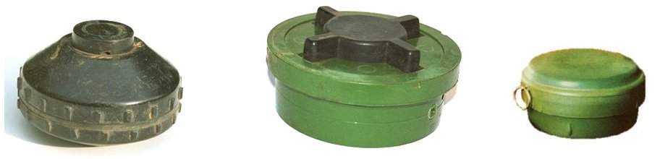
The anti-personnel blast mines shown here are the MAI-75, PMN-2 and Type-72a. In each case the pressure plate is smaller than the top of the mine and excavation using a cautious slicing procedure may be permitted.

Signal investigation procedure
Metal-detector signals should be investigated using the procedure described below.
- The deminer must begin by looking closely at the ground surface for sources of the metal-detector signal. If any metal is found, the deminer should remove the metal and check the signal position with the metal-detector. Throughout the investigation, the deminer should be constantly looking for the source of the metal-detector signal.
- When magnets are available, the deminer should pass a magnet over the ground surface where the metal-detector signalled. The signal marker may be temporarily removed for this. When approved, the REDS ‘Light rake’ with a magnet may also be used for this. After a magnet is used, the deminer should check the area with the metal-detector again.
- An investigation should be started by prodding into the ground at least 20cm back from the signal marker. In most ground, the prod will not penetrate more than a few centimetres. The deminer must not apply excessive pressure to make the prodder go more deeply into the ground. If the prodder will not penetrate 3cm, the deminer should use an approved two-handed tool to break the ground surface. Sometimes the ground has a crust with softer spoil underneath. Frequently the ground becomes harder as the investigation gets deeper, and the use of other two-handed tools may be required.
- The ground should be prodded or broken-up over a width of excavation equal to the width of the anticipated explosive hazards at the site. If anti-personnel mines are expected, a width of 15cm is required. If anti-tank mines are expected, a width of at least 30cm is required.
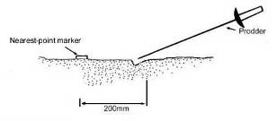
- The ground that has been loosened with the prodder should then be removed with a trowel.
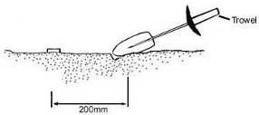
Whenever metal is found during the excavation, with the magnet or by eye, the deminer should check the position of the original signal with the metal-detector.
- Steps 3 and 4 should be repeated as many times as necessary to create a sloping hole at least 15cm wide advancing towards the signal-marker. The depth of the hole should reach the required search depth at the site before the marker is reached.
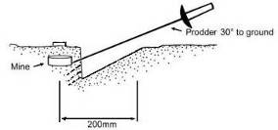
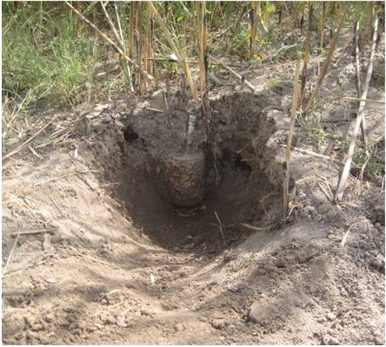
The side of the excavation closest to the marker is approximately vertical. This should be prodded from the bottom upward at a spacing of 2cm. The prodded earth can then be removed with the trowel. When the prodder meets an obstruction, the prodder should be used to feel for the sides of the obstruction and so estimate its size. The trowel should then be used with extreme caution to expose the side of the obstruction.
Although lightly tapping an obstruction with the prodder can sometimes provide feedback to confirm that the object is likely to be a mine. The deminer must expose any obstruction with extreme caution, regardless of the ‘feedback’ from the prodder.
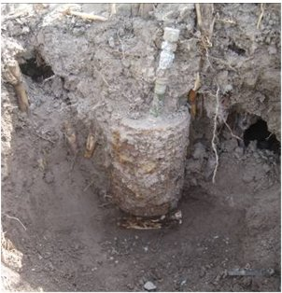
The fuze of the OZM-72 bounding fragmentation mine shown here had become buried by silt deposited by floodwater. The excavation approach shows a gentle slope getting deeper as the signal is approached. The deminer increased the depth of the excavation while maintaining a gently sloping approach as soon as the top of the mine had been exposed.
There was an ML-7 anti-lift booby trap beneath the mine, so the excavation had to be deep enough to show the bottom of the mine before both devices could be safely destroyed.
- If no obstruction is found at the signal-marker, the deminer should check the position of the signal with the metal-detector. When the metal-detector continues to signal over the area, it may be appropriate to excavate more deeply. The section leader should decide this based on the Task Risk Assessment and any pattern of mines that may be known. The section leader should consult the task supervisor when there is any uncertainty. Generally, when a mine is missing from an anticipated pattern and there is a metal-detector signal near where the mine was expected, the depth of excavation should always be increased up to a depth of twice the required search depth at the task. When hazards other than mines are being sought, the excavation should continue at least 10cm beneath the search depth for the task.
When searching more deeply, the deminer should start excavating again, beginning further away from the signal and extending the slope of the hole so that any hidden device will still be approached from the side.
When an explosive hazard has been found and the parts facing the deminer have been gently exposed, the deminer should follow the actions detailed in Part 12 of this Chapter.
  - Investigating a metal-detector signal using rakes
The REDS rakes can be used for metal-detector signal investigation. The other hand tools approved for signal investigation must also be available, along with a plastic bucket in which to place contaminated ground. The use of the REDS rakes for area-excavation is covered in Part 10 of this Chapter.
The light rake can be fitted with a magnet to help remove metal-clutter.
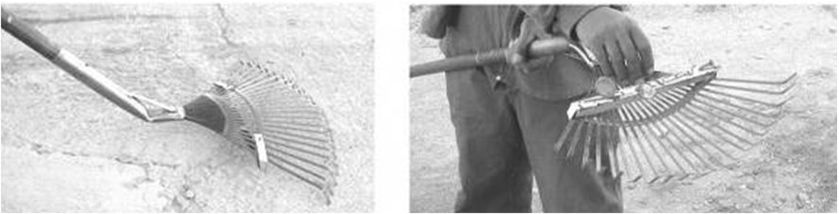
The photograph on the left shows a light rake with a magnet attached. The photograph on the right shows a deminer removing magnetic pieces from the magnet after raking the ground. The scratching action of the rake loosens fragments in the soil surface and often means that the deminer finds the metal that made the metal-detector signal.
The light rake must be tested against the pressure-sensitive hazards that may be present. This involves using the rake to expose a hazard that has been rendered safe. The initiation mechanism of the test hazard must be intact and the high explosive removed. If the use of the light rake initiates the fuze mechanism, the rake fails the test and cannot be used at tasks where that hazard is anticipated. Anti-personnel mines that have passed previous tests include the PkMk2/4, Type 72, PMN, PMA-3 and PRB M35.
The use of REDS rakes to investigate metal-detector signals can be very fast when mines are relatively close to the surface or when the source of a metal-detector reading was a ferrous fragment close to the surface. In soft ground, the time saving over using other hand tools to make the investigation can be significant.
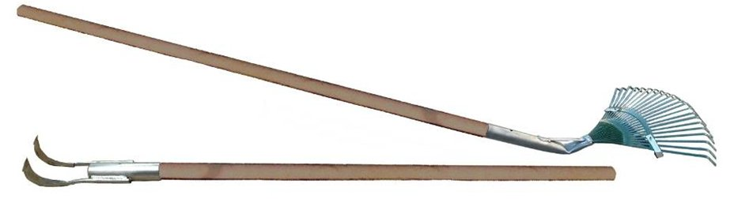

Variations in REDS rake design should be tested. Heavy rake heads should be made using E304 stainless steel. Light rake heads may be made from plastic or sprung steel.
Before starting the REDS metal-detector investigation procedure, an area behind the deminer must be prepared to place the rakes and the metal-detector so that the deminer can change tool quickly and will not step on them.

Procedure
When a metal-detector signal has been pinpointed, the deminer can conduct a signal investigation procedure with REDS rakes in the sequence described below.
- Remove the signal marker and make a mental note of its position.
- In a standing position, and holding the handle well away from the rake-head, use the light rake over the area where the metal-detector signalled. The rake tines scratch the ground surface and can help to loosen fragments just below the ground surface. Soil collected by the brushing of the rake should be moved back to the base-stick. The area raked will usually extend from 20cm beyond the metal-detector reading to the base-stick and be the width of the light rake head.
- Look closely for exposed metal. When the magnetic light rake is used, it may have picked up the metal. Use a hand-held magnet over the loosened ground if necessary. If metal is found, the deminer should use the metal-detector to check the position of the signal. If the signal has gone, the investigation has been completed and the deminer should return to the metal-detector search procedure.
- The area must be searched with the metal-detector again. This must be done whether or not metal fragments have been found because the action of the rake may have moved the signals around. Non-magnetic metal may have been moved by the rake.
- Use the light rake to move soil from the area of the signal back to the base-stick. Continue until the light rake becomes ineffective. When roots are uncovered, they should be cut with secateurs.
- Check with the metal-detector to find out whether the signal has moved and is now amongst the loosened earth.
- If the signal has moved, move the loosened earth into the plastic bucket and check with the metal-detector again.
- If the metal-detector signal has not moved, use the heavy rake. Hold the rake handle as far as possible from the rake head. Place the heavy rake on the ground surface beyond the metal-detector reading and draw it back towards the base-stick.
NOTE: The metal-detector search procedure usually means that an area beyond a signal position has been searched with the metal-detector. When it has not, the deminer should ensure that the area closest has no signals, then advance the base-stick so that he/she can safely sweep the search-head beyond the area under investigation before using the heavy rake.
- Drag the heavy rake towards the base-stick without downward pressure. Repeat this across the area where the metal-detector signalled until the soil is loose, then place the heavy rake in the safe area.
- Use the light rake to move the loosened soil back to the base-stick.
- Return to Step 3 and check with the metal-detector to find out whether the metal has moved. Repeat Steps 3 to 10 until the detection depth has been reached or until the reason for the metal-detector signal has been found.

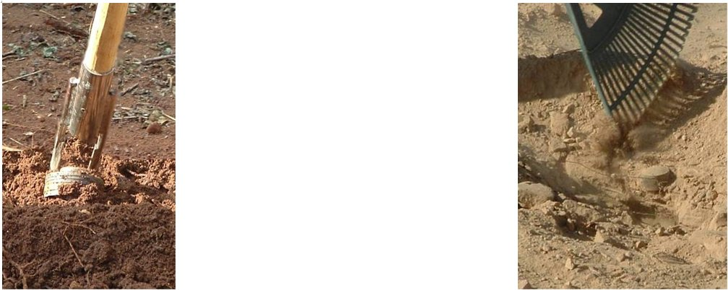

The heavy rake may lift a device to the
surface, as shown on the left.
When a device is close to the surface or
in loose soil, the light rake will expose
the top of it. When this happens, the
movement of the rake tines over the
device often makes a sound which
alerts the deminer.

When a mine or explosive hazard is found, the deminer should expose the parts facing the base-stick using approved hand tools when necessary, then follow the instructions in Part 12 of this Chapter.
NOTE: When using the heavy rake, it should be placed beyond the metal-detector signal and drawn back towards the base-stick, raking over the position of the signal.
If the ground becomes very hard as the depth increases, the deminer should be permitted to use the metal-detector to reposition the signal-marker and start an alternative investigation procedure using approved hand tools.

Area-excavation using hand tools
During area-excavation, the whole ground surface is searched while moving it, so the procedure both detects and excavates any hazards that are present. Correctly executed, area-excavation gives total confidence that the area searched contains no explosive hazards to the excavation depth. A base-trench is used and the base-trench moves forward as work progresses in the same way that a base-stick moves forward during search with a metal-detector. The method is slow and hard work, but the search is absolutely thorough.
Area-excavation is performed using a one-person one-lane procedure. When an explosive hazard is found, the deminer withdraws, informs his/her section leader and either waits until an EOD specialist has dealt with the device or starts a new lane. When an EOD specialist is not immediately available, the section leader should always instruct the deminer to start a new lane.
The area-excavation procedure is hard work, so, depending on weather and ground conditions, deminers should work in their lanes for a maximum of 30 minutes between rest breaks.
The deminer must start by making a ‘base-trench’ within the safe-lane at the start of a search lane. The first base-trench is always inside the safe area, 120cm from side to side, and 10 - 20 cm from front to back. Its depth must be the required search depth at the task. As the base-trench is advanced, the sides of the lane are marked using hazardous-area sticks or stones on both sides at every metre.
Tools issued may include a tripwire feeler; grass cutting tools; secateurs; a handsaw; a hammer (for placing marking pickets); wire-cutters; blast resistant ground engaging tools (see Part 8.5 above); and a spade or mattock to dig the first base-trench inside the safe area.
NOTE: Mattocks must never be used inside the SHA because their two-handed use is imprecise and has resulted in many accidents.
As a deminer progresses, all tools that are not being used should be kept behind the deminer and on one side of the working lane.
  - Procedure
Follow the four steps shown below. They illustrate Search and Clearance by excavation in a lane and the same principle applies when starting the lane at a baseline.
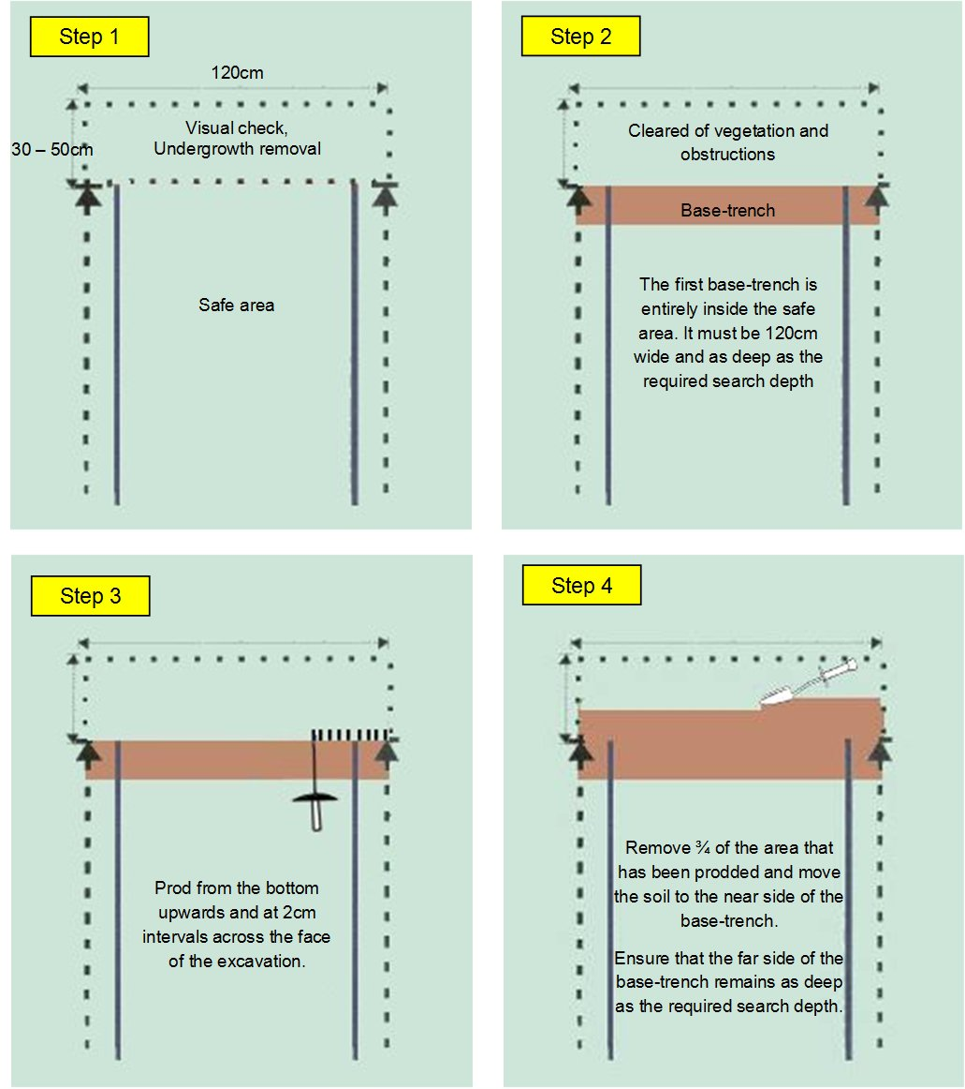
When steps three and four have been completed across the entire face of the base-trench, the prodding in Step 3 starts again.
Tools may only be used to slice away the ground when the anticipated hazards identified in the Task Assessment do not include anti-personnel mines with pressure plates extending to the side of the mine, armed submunitions or other potentially touch sensitive hazards. When these hazards may be present, the face of the excavation must be crumbled away from the bottom upward.
Prodding should begin at the bottom of the face of the base-trench which is then prodded at 2cm intervals from the bottom upwards and laterally.

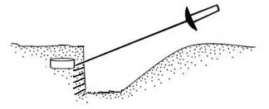
Face of the base-trench
Base-trench

If an obstruction is encountered, the deminer should prod to both sides of the obstruction. If the obstruction continues, the soil must be cautiously removed up the obstruction to check whether it is a mine or other explosive hazard.
In soft ground, it may occasionally be possible to insert the prodder a considerable length into the ground. The prodded ground can then be cut away in complete confidence that there is nothing concealed within it. The ground cut away must never be more than the ground searched with the prod. For safety and to ensure an overlap, the deminer must never cut away more away than 75% of the soil that has been prodded because the length prodded is not the distance ahead of the excavation face that can be safely removed.
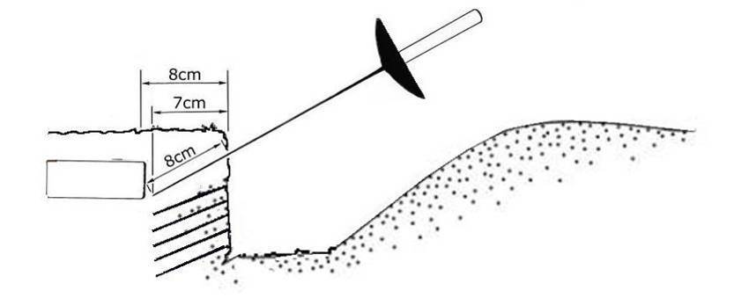
75%

The picture above shows a prodder inserted 8cms into the face of the excavation. Because of the angle of the prodder, the prodder has only reached 7cms forward into the unknown ground. In this example, if a deminer were to cut 8cm of soil away he/she would cut onto a mine while doing so.
PMN mine
After prodding (bottom upwards) the face of the base-trench, the deminer should insert the prod a final time and grip the blade to record the depth before withdrawing it. He/she should then estimate three-quarters of the length and mark the ground ahead lightly with the prodder tip. The ground up to that mark can then be safely cut away.
If any explosive hazard is discovered, the deminer must tell the section leader and withdraw from the lane until an EOD specialist has assessed the situation and dealt with the device. Work in the lane must not continue until the hazard has been removed or destroyed. Generally the deminer should start another lane and continue working.
The picture on the right shows a base-trench with a base-stick marking the progress of the area-excavation. A base-tick is used to maintain the width of the lane but is put behind the deminer while he/she is excavating.

Area-excavation using REDS
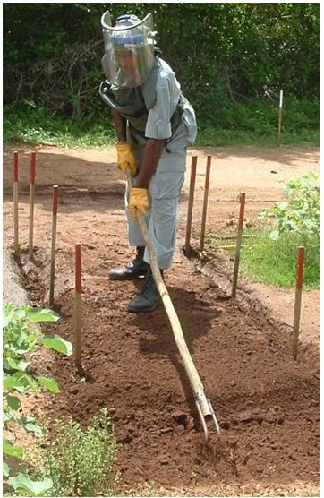
The Rake Excavation and Detection System (REDS) can be used when the Task Risk Assessment has not identified a threat from especially sensitive devices, tripwires or vertical fuzes (as are commonly used with fragmentation or ‘anti-group’ mines). REDS is commonly used in areas where anti-personnel blast mines, anti-tank mines, or UXO and AXO that is not movement sensitive are anticipated. The size of the pressure plate on an anti-personnel blast mine is not relevant when using the REDS system.
Because the rakes are used in a standing position, area-excavation using the REDS system has proven to be safer for the deminers than other area-excavation methods.
The REDS can be especially useful after mechanical ground processing has reduced any threat from tripwires, vertical fuzes and especially sensitive hazards at the same time as removing undergrowth and loosening the ground surface.
REDS is performed using either a one-person-one-lane procedure or a two-person-one-lane procedure in which one person rests while the other works. The raking procedure is hard work so, depending on weather and ground conditions, deminers should work in their lanes for a maximum of 30 minutes between rest breaks or between alternating with a resting partner.
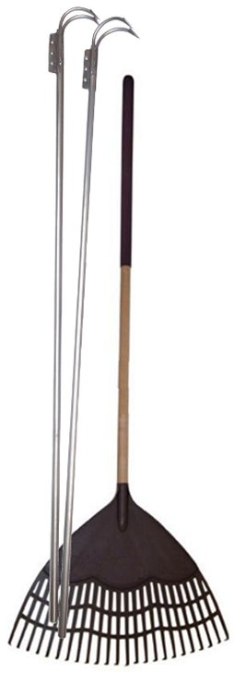
When an explosive hazard is found, the raking deminer must close the lane and inform the section leader. The deminer should then either wait until an EOD specialist has dealt with the device or start a new search lane.
All working deminers must wear frontal blast protection. As a further safety feature to ensure the deminer’s distance from any initiation, all deminers must work in a standing position when using the rakes, but they may kneel or squat when using other tools.
The vegetation in the search lane must always be cut before rakes are used.
The raking deminer must start by making a base-trench within the safe area at the start of a search lane. The base-trench moves forward into the suspect area in the same way as a base-stick does in metal-detector search procedures. As the base-trench is advanced, the sides of the lane are marked by leaving narrow trenches.
A hazardous area picket or painted stone should be placed in the side trenches on both sides at every metre.
Heavy and light rakes similar to those shown alongside are used. Other tools issued may include: a tripwire feeler; grass cutting tools; root cutting tools (secateurs); a handsaw; a hammer (for placing marking pickets); wire-cutters; and a trowel.
As the deminer progresses, all tools that are not being used should be kept behind the deminer and on one side of the search lane.
  - Conducting Rake Excavation and Detection
To start a REDS search lane, a base-trench is dug to the required search depth, 120cm wide and at least 20cm from front to back in a known safe area at the start of the lane. The distance front to back of the base-trench may be varied according to ground conditions but should never exceed 50cm. When the first base-trench is made, it should always be entirely inside the safe area. Because it is inside a safe area, it can be dug with a spade, mattock or other suitable tool.
The soil from the initial excavation should be moved out of the base-trench and to the rear.
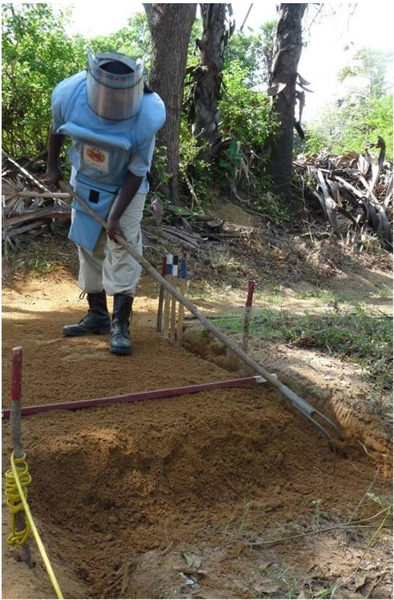
The area (up to) 50cm forward of the base-trench is visually checked and cleared of vegetation and loose stones or debris. The light rake is then used over the ground in the 20-50cm by 120cm area to the front. When the light rake is ineffective, the heavy rake should be used to break up the surface, then the light rake used to rake the loosened material to the back of the base-trench. Generally, the light rake should be used as the main excavation tool, exposing any explosive hazards as the ground is raked to the back of the base-trench. When the rake comes into contact with a hazard, the sound of it scratching the casing can alert the deminer to the presence of the hazard before it is visible.
The heavy rake should be used only when the light rake becomes ineffective. The heavy rake scratches the ground, loosening it so that the light rake can be effective again. The head of the heavy rake is placed to the front of the search area and pulled back towards the deminer. The rake tines then plough back through the soil in the base-trench. The deminer must not hack at the ground with the heavy rake.
The heavy rake’s ploughing action must be repeated across the width of the search lane. The deminer may change between using the light and heavy rake several times until he/she is able to excavate to the required depth and move all of the soil to the back of the base-trench with the light rake.
Water may be used to soften the ground or damp-down dust if required.
When an explosive hazard is discovered, it should be exposed using an approved hand tool. When the device can be clearly seen, the deminer must close the lane and alert the section leader who will inform an EOD specialist. Work in the lane must not continue until the hazard has been removed or destroyed. Generally the deminer should start another search lane and continue working.
The photograph shows a deminer using the heavy rake during REDS area-excavation. The first part of the search lane has been excavated and then filled with the loosened ground at the base-trench was advanced. The ground that has been raked back is higher than the surrounding land and narrow side-of-lane trenches are left unfilled so that the excavation depth can be seen during QA.

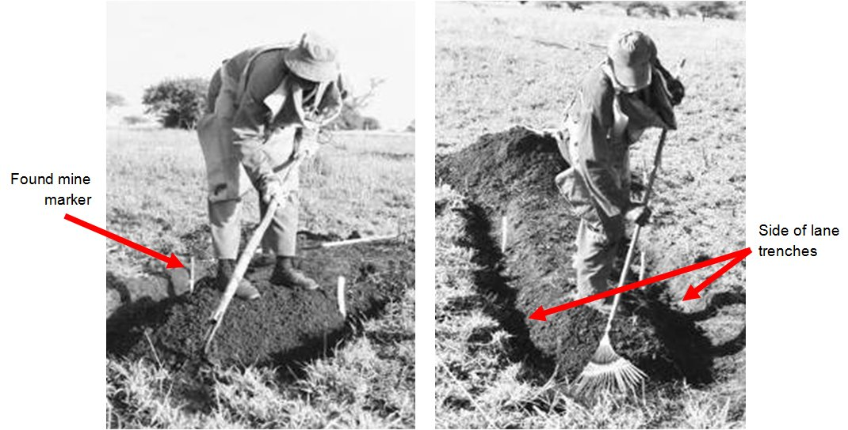

The photographs above show a deminer using the REDS system in heavy soil. The deminer is wearing blast goggles and frontal body armour, which is the minimum permissible PPE requirement while raking. The deminer’s heads is approximately two metres from the rake head and any accidental detonation that may occur. The accident record while using REDS confirms that the risk of the deminer suffering severe injury from an anti-personnel blast mine is very low as long as the minimum PPE is worn.
The REDS raking sequence is shown in the four steps below.
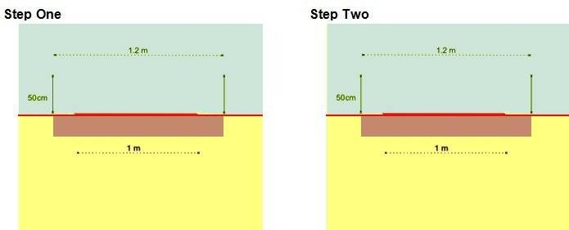
Visual search of the ground and removal of rocks
Base-trench
Cut and remove the vegetation
Base-trench
Safe area
Safe area
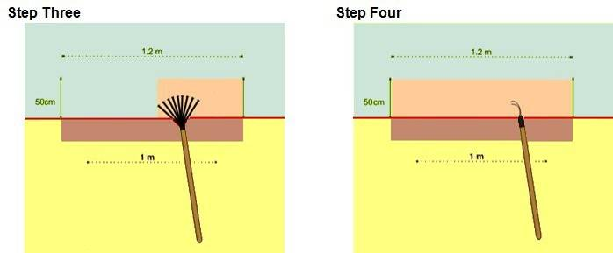
Rake over the entire area to 5cm depth
Rake over the entire area to 10 cm depth
Safe area
Safe area
When steps 1 to 4 have been completed once, steps 3 and 4 are repeated until the base-trench reaches the required search depth for the task. Then the entire procedure is repeated to extend the processed lane forward.
As the base-trench at the front of the lane moves forward, side trenches to the full excavation depth are left at the sides of the lane in the area marked as ‘overlap’. These side-trenches mean that internal Quality Assurance (QA) can be confident that the required depth has been consistently maintained.
Each deminer's section leader must use QA markers to show the extent of the lane to which the depth of the side trenches has been checked, and the side trenches must be maintained until this has occurred. The task supervisor should periodically QA the work of the section leaders, checking that they are measuring the depth of all lanes regularly and that the required excavation depth has genuinely been maintained.
Internal QA is part of the system. External QA must be made while the area-excavation using REDS is being conducted if it is to be made in the same way. Because the REDS system does not leave metal free ground, the use of metal-detectors for QC would not be effective. QC checks can be conducted by an external QC team using REDS when required.
When conducting REDS the same constraints over search lane width and length that apply during metal-detector search must be used.

Using water to soften ground
Water may be used to soften the ground or damp-down dust when necessary. A bucket or hose delivery system may be used to transport the water to the end of the lane where the water should be sprayed or splashed over the required area. All safety requirements at the task should be observed during the watering process with working distances maintained and PPE worn.
The deminer must close the lane and work in another lane while the water is allowed to soak into the ground. No signal investigation or excavation should be conducted until the surface water has gone.
When a bowser is available, water should be applied the day before the area is scheduled to be searched.
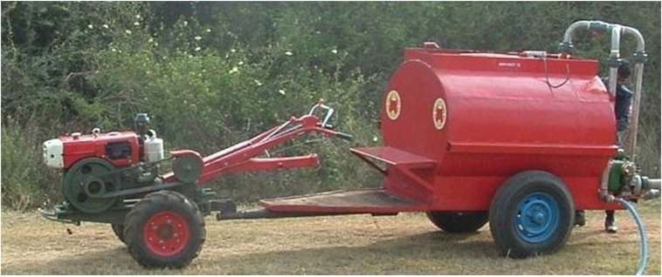
A dedicated water bowser that is narrow enough to be driven along two metre wide safe lanes is ideal. The example shown in the photograph is narrow, low-cost and versatile.
  - Waterlogged ground
When the groundwater level is so high that water pools in an excavation, deminers will usually be unable to see the face of the excavation clearly. If this occurs, excavation will have to be conducted largely by touch and additional training to cover this must be conducted.

Action on locating an explosive hazard
When the EOD specialist determines that it is safe to do so, explosive hazards may be moved for destruction outside the task area. Damaged or unstable explosive hazards should be destroyed without moving them whenever possible.
Except during BAC, on locating an explosive hazard, the deminer should expose enough of the device to be sure that it is an explosive hazard and then close the search lane. Unless the deminer is EOD trained, he/she must inform his/her section leader will arrange for an EOD specialist to deal with the device. If there is a delay dealing with the discovered device, the section leader should instruct the deminer to start work in another area. The deminer should not return to the search lane until the explosive hazard has been removed or destroyed.
During BAC, when a hazard discovered on the surface has been appraised by an EOD specialist and declared not to be touch sensitive, it may be marked and the search can continue beyond it. The same condition applies to hazards located on the surface when BAC and BACS are combined.
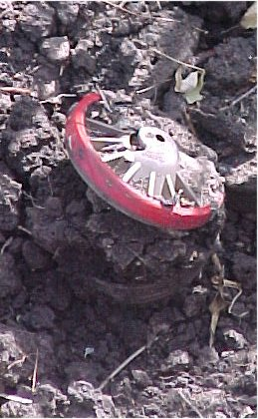
The EOD specialist may render safe some devices before they are moved. The approved render safe procedures for some mines are documented in Chapter 12 of these SOPs. In many cases, conducting a render safe procedure involves greater risk than simply moving the hazard.
The picture alongside shoes an R2M2 anti-personnel blast mine that has been exposed to the weather for decades. The plastic has been bleached white by the sun and split, allowing the top of the mine to spring up. It is not certain that the mine can be safely moved and it is also possible that the mine would be initiated by placing a demolition charge in close contact with it.
Mines in this condition should be pulled using a hook and line system (see part 12.1 below) to determine whether they are movement sensitive, then either destroyed where they are or moved for demolition in a designated demolition area.
When there are still concerns about the safety of moving anti-personnel blast mines after they have been moved with a hook and line but it is undesirable to destroy them where they are, a long-reach gripper like that shown below should be used so that the mine is held at a distance from the person moving it.
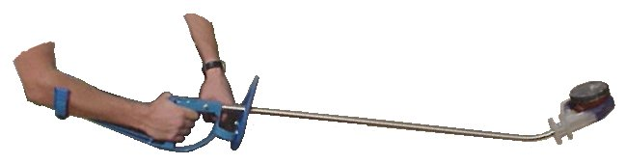
Wearing full frontal PPE and being more than a metre from an anti-personnel blast mine can make the risk of severe injury very remote. The protection offered by distance will not be effective if the hazard is a fragmentation device, so if they are considered unsafe to move by hand, they must always be destroyed where they are. When the spread of fragmentation is undesirable, they should be surrounded by sandbags or earthworks.
  - Pulling procedure
The pulling procedure must be conducted by an EOD specialist who must approach the work presuming that a detonation may occur. The pictures below show a set of pulling tools and the way that they are used.
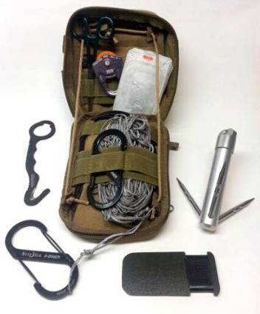
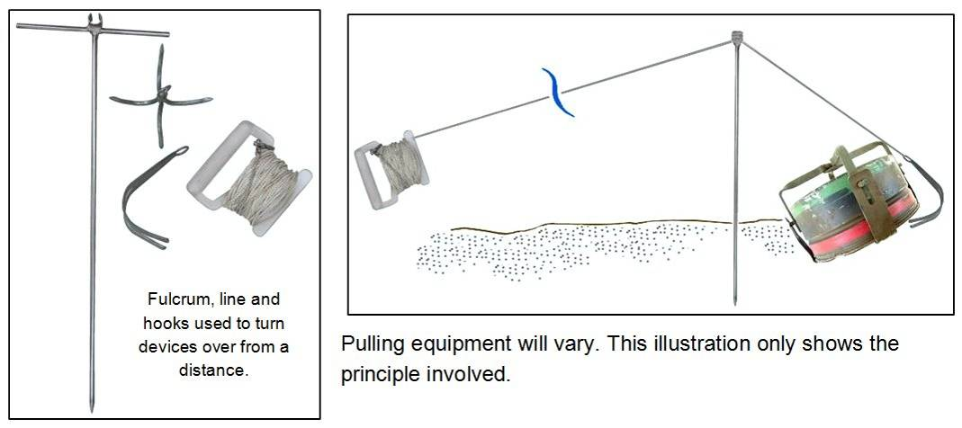
Pulling is conducted using the following procedure.
- All people not involved in the pulling operation should be withdrawn to a safe area.
- When necessary, sentries should be posted to prevent people/livestock entering the area.
- A pulling line should be rolled out from a safe point to the hazard. The line must be in place before the hook is put under the hazard. Ideally, the length of the line should equal the safety distance for the explosive hazard but this is often impractical. The EOD specialist should arrange to be protected behind adequate cover at a closer distance.
- One of more fulcrum devices may be used to make it easier to turn the hazard over.
- With the line in place, the EOD specialist should position it, usually by pushing a hook under the far-side slightly away from it. A clamp, net, noose or other means of gripping the device can be used to attach the line when it is safe to do so.
- The EOD specialist must then confirm that the area is clear of people before returning to the safe point from which he/she will pull. Before pulling he/she should inform the task supervisor that he/she is about to pull.
- The line should then be pulled in a slow, continuous movement until the hazard has turned over or moved a minimum of two metres.
- When the hazard does not detonate and there is no sign of smoke from it, the EOD specialist should wait a few minutes before approaching it. The wait time should be extended if there is any concern about the condition of the device being pulled.
- The EOD specialist should inspect the hazard and remove any pulling equipment that may still be attached. Unless turning the device has revealed something new about its condition, the EOD specialist should then move the device to a designation collection point (using a long-reach gripper if appropriate) and place an appropriate marker where it was found. The pulling equipment should be collected after the hazard has been moved.
- The task supervisor must ensure that the original position of the explosive hazard is searched for any other hazards that may have been beneath it before it was pulled.
NOTE: The pulling procedure is not routinely necessary for recognised mine types that have no anti-disturbance feature. Exceptions occur when any mine is in a condition that causes concern and when there is any reason to believe that mines may have been booby-trapped. Improvised mines must always be pulled. Other explosive hazards should be assessed on a case-by-case basis.

Removal of vegetation
Whenever there is significant vegetation, the use of mechanical assets to cut the vegetation in front of manual demining should be considered. Whenever the Task Assessment indicates both the presence of vegetation and active tripwire activated devices, an armoured machine should be used to remove the vegetation whenever possible.
When an armoured machine is used to cut vegetation, the ground surface should not be disturbed. As long as there is no reason to anticipate surface fuzes, intact tripwires, or touch-sensitive devices in the area, the cut vegetation that is lying on the ground may be removed using a REDS light rake as the follow-up work progresses.
  - Approved vegetation cutting tools
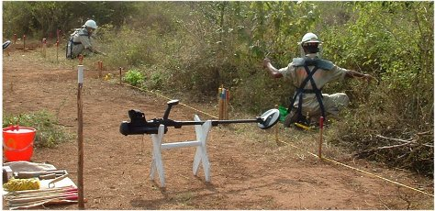
A range of approved hand tools can be used for the manual removal of vegetation. A hand held petrol driven ‘strimmer’ may also be used. There are restrictions on the way in which each tool can be used and the places in which their use is appropriate.
The tools generally approved for use during vegetation removal include a tripwire feeler; shears; sickle; secateurs; a handsaw; a hammer (for placing marking pickets); and wire-cutters. A REDS light rake and a powered strimmer (long-handled) may also be approved depending on the anticipated hazards in the area.
All tools can be used in a dangerous way, but some are hard to use in a safe way at any time. The following vegetation cutting tools may not be used in any area that has not yet been declared ‘Cleared’ or ‘Presumed Clear’: machete; scythe; chainsaw; axe/hatchet. This is because the user cannot reliably control the tool (or the vegetation it cuts). These tools may be used in safe areas, but should never be inside the search area during demining.
It is the responsibility of the task supervisor to ensure that deminers are always issued with appropriate tools for the task and have access to strong ‘gardening’ gloves. Deminers do not have to wear gardening gloves but they must be available whenever vegetation includes thorns, is sharp, or has stinging or skin-irritant properties. The gloves protect against the cuts and scratches that can occur during vegetation cutting.
All tools should be in good condition with appropriately sharp blades. It is the responsibility of the task supervisor to ensure that sharpening stones and files are available in the rest area and for use during tool maintenance sessions.

General rules for the use vegetation cutting tools
- The powered strimmer and REDS light rake may not be used in an area where the Task Assessment indicates the possible presence of surface fuzes, intact tripwires, or touch-sensitive devices.
- When using shears, sickle or a saw, the blade(s) must not be pushed into the vegetation beyond the area that has been visually checked, or through which fingers have not passed feeling for obstructions.
- When using a saw, the vegetation being cut must be controlled to prevent it falling into any area that may be hazardous.
- When using a sickle, the stem(s) to be cut should be gripped in one hand and cut carefully using the tool with the other hand. The tool must not be swung at the vegetation in a scything action.
- When using a powered strimmer the operator should wear PPE and frontal leg protection unless the design of the strimmer removes all chance of a broken blade being thrown back towards the operator. The operator must always ensure that the cutting blade does not touch the ground. The operator must always ensure that his/her feet never leave the safe area.
- When using a REDS light rake to collect vegetation cuttings or leaves, the user must always work in a standing position and hold the handle so that he/she is as far as possible from the head of the rake.
  - Manual cutting of vegetation
Vegetation must be cut during all kinds of manual search procedures and in front of MDD. Because the vegetation will vary and may not cover the whole area in front, the process is described in terms of principles that must always be followed rather than as a step by step process.
The manual removal of vegetation must be conducted in a controlled and deliberate manner, avoiding any disturbance of vegetation outside the width of the search lane and its safety overlap.
The following rules should be applied.
- Before and during the cutting, the deminer must make repeated visual checks for any item that has become visible.
- Generally, trees or bushes with a trunk diameter smaller than 10cm should be removed unless otherwise indicated in the task documentation.
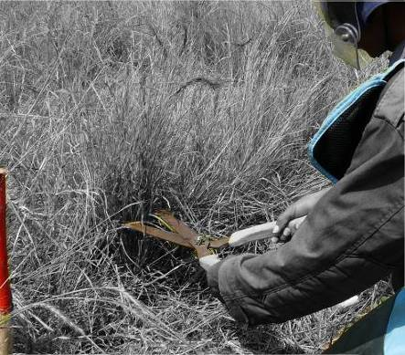
- To ensure that surface devices would be seen before ground level is reached with the cutting tool, vegetation should first be cut to 15cm above ground level (as shown alongside). The height of the first cut should be increased if the Task Assessment suggests that large items may be on or above the ground surface.
- When the deminer is confident that the tool will not strike any devices, the deminer should cut the vegetation close to the ground surface. When stem thickness increases near the ground, the deminer should change tools as necessary.
- When metal-detector search will be conducted, the vegetation should be cut very close to the ground. This allows the search-head to be moved close to the ground, so maximising the depth of search.
- Undergrowth must always be cut. It must not be torn or broken.
- The deminer’s feet must never leave the safe area while cutting and removing vegetation. This usually limits the area in front of a deminer that can be cut to between 30 and 50cm in front of the base-stick.
- When vegetation is so tall that it might fall outside the lane when cut, it should be cut in lengths that allow the deminer to hold it and easily remove the cuttings to the safe area.
- When vegetation is not likely to fall outside the working area, the deminer should kneel or squat to work.
- When using a one-handed cutting tool, the deminer should use one hand to hold the vegetation while the other uses the tool to cut it. When using shears, the deminer should move the cuttings to the safe area as the work progresses so that it does not obstruct what they can see.
- While cutting vegetation, the deminer should continuously look for any evidence of devices.
- Any cut vegetation in the search area should be removed by hand or by using a REDS light rake. The use of the REDS light rake will depend on the hazards identified in the Task Assessment and its use must be approved by the task supervisor.
- Cuttings should be stacked outside the lane for later disposal. Cuttings must always be stacked so that they do not obstruct emergency access to the working areas. The section leader should allocate an area for the deminer to place cuttings and ensure that the cuttings are later moved and destroyed.
- The controlled burning of cut vegetation should only be conducted when no work is being conducted in the SHA. When burning is not appropriate, cut vegetation should be stacked in a safe area where it causes no obstruction.
Explosive hazards that are located during vegetation removal should be marked and left where they are until the ground up to them has been searched. The deminer must notify the section leader when a device is found, and when unexpected obstructions such as barbed wire, ditches or large rocks, become visible as a result of vegetation removal.
  - Using a powered strimmer
Vegetation strimmers (also called ‘Brush Cutters’ or ‘Weed Whackers’) are commercial machines developed for use in agriculture and municipal maintenance tasks. Proven in HMA in many countries, the tool provides a rapid and effective means of cutting grasses and thin-stemmed vegetation in areas where there is no possible presence of tilt-sensitive fuzes, intact tripwires, or touch-sensitive devices. Variations may be made to the tool to improve efficiency.
A strimmer may only be used by a deminer who has been appropriately trained in its use. Usually the same person is responsible for its maintenance and for the correct storage of its spare parts and consumables.
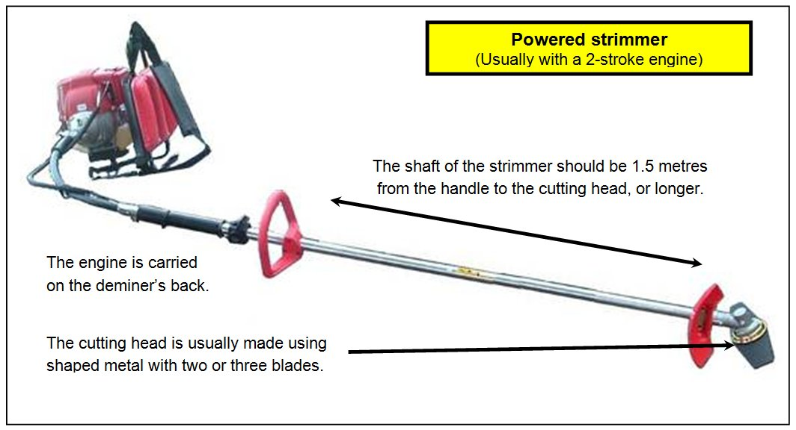
The strimmer may be used to cut inside the SHA while the user is standing in a safe area. The width of the cut is usually around a metre, depending on obstructions. This can be especially useful when preparing lateral lanes for manual or MDD search procedures.
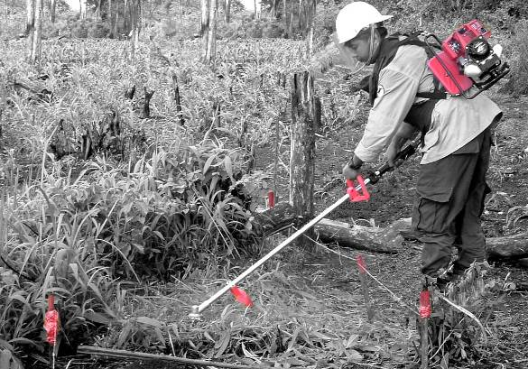
The photograph shows a strimmer being used to prepare the next area to be searched with a metal-detector.
Before strimmer use, the task supervisor must ensure that an appropriate means of communication is in place. The noise of the machine prevents voice communication being adequate, so the strimmer operator will usually have a VHF radio and may have an ear-piece. When necessary, a simple flag-system can be used and the section leader controlling the
strimmer operator must carry the relevant flag(s).
Detailed control of the strimmer varies with each design. However, the following constraints apply with all types of strimmer.
- The strimmer operator should not put the moving cutting head in or over the uncleared area until all other staff are at the approved working distance.
- The strimmer operator must wear frontal PPE, and should also wear frontal leg protection.
- The strimmer operator must take all care to keep his/her feet inside the safe area at all times.
- The strimmer operator must not allow the cutting head of the tool to strike the ground at any time.
- The strimmer operator must not move around in the safe area with the cutting head spinning.
- No other person should approach closer than the working distance while the strimmer is cutting vegetation.
Because a strimmer must not be used in areas where surface fuzes, intact tripwires, or touch-sensitive devices are anticipated, the vegetation cut with a strimmer can usually be raked into a safe area using REDS light rakes.
  - Burning-off vegetation
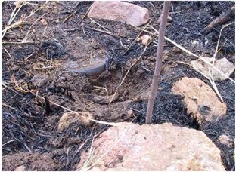
Burning-off vegetation is permitted in the following circumstances.
- The Task Release Plan does not include the use of MDD for at least seven days after the burning.
- The Task Assessment has not identified plastic cased explosive hazards on the ground surface because a burned casing (like that of the PMN shown alongside) can make the hazard more sensitive to movement.
- A broad (usually at least 3 metres wide) fire-break can be made on all sides of the area to be burned. This is often easiest to achieve by cutting vegetation using a machine (which need not be armoured when the firebreak is outside the SHA) and, whenever possible, spraying water onto the ground in the firebreak.
- The height of the vegetation must be low and it must be dry enough for most of it to burn. Green vegetation should not be burned off because it will burn slowly and may make a lot of smoke.
- Essential area marking must be resistant to fire (painted stones and metal pickets may be used).
- There is no expectation of wind strong enough to spread the fire beyond the firebreaks.

Controlled burnings are subject to the following additional constraints.
- No work should be conducted within the working distance for the area to be burned or in any area where smoke drifts.
- Whenever it is possible that people or livestock might enter the area during a controlled burning, sentries should be posted to prevent entry.

Obstacles in the search area
Common obstacles include: large rocks; wire (coiled or in strands); fences; vehicle wrecks; ditches/trenches; abandoned or destroyed buildings; and fallen trees. Requirements for dealing with each are given below.
  - Rocks
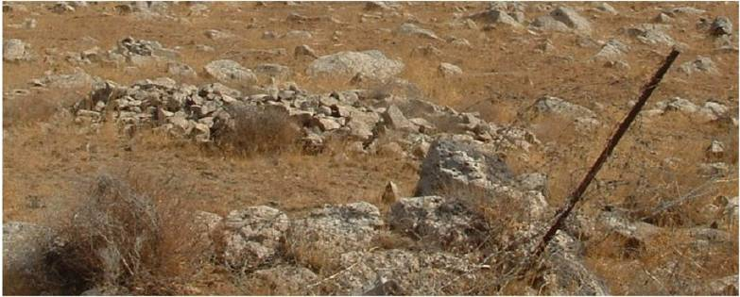
Areas may be littered with rocks of various sizes or there may be piles of rocks and low-walls of rocks all of which can influence the choice of procedures and tools to be used. If there are many rocks, the use of any mechanical demining machine that processes the ground should be avoided because the rocks will cause a high level of wear to the machine and will prevent the machine processing the ground to a constant depth.
When using manual demining procedures, surface rocks that are small enough to be easily lifted should be removed. The deminer may reach in front by 30-50cm to lift the rocks. Rocks that are too large to be removed, or that are partly buried and resist lifting, should be left in place until searched around and any hazards moved or destroyed. Removed rocks should be transferred to an area behind the deminer that has been subjected to internal QA. They should be moved out of the search lane before continuing to search so that they never obstruct emergency access.
When larger rocks have been searched around so that the deminer can stand beside the rock, the deminer may try to move it again. This is because the rock may impede easy access in the lane and should be removed when possible. If the rock is moved, the area beneath it must be searched to ensure that no explosive hazards are present. If the rock cannot be easily moved, it should be left in place unless there is reason to believe that explosive hazards may have been placed beneath large rocks in that area. When necessary, large rocks may be roped and pulled from a distance using a suitable machine.
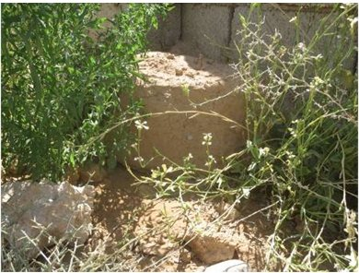
Factory manufactured fibreglass mines that look like rocks have been used by some countries. Improvised mines, bombs or MF-IEDs that look like rocks or building rubble are also common and each may be unique in appearance. In the photograph alongside, the rock in the centre is an MF-IED cast in a barrel using a soil/cement mixture around the explosive charge with metal added for fragmentation. When demining in any area where IED bombs or MF-IEDs are anticipated, the procedures described in Chapter 7 should be followed.
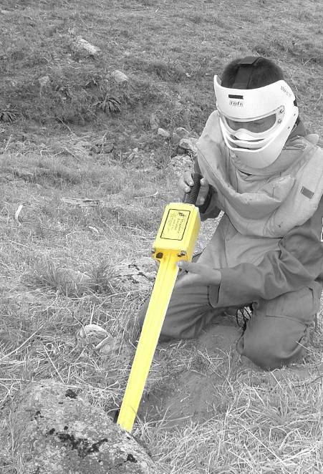
When piles or walls of loose rock are encountered, the Task Release Plan should allow for the search lanes to be diverted around the obstruction. When the area around the obstruction(s) has been Searched & Cleared , the task supervisor must re-evaluate the Task Assessment and decide whether piled rocks must be moved for the area to be adequately searched to depth. If the piles or walls of loose rock have been made since the conflict began, the entire pile or wall may need to be carefully moved. When the obstruction dates from before the time when the area was contaminated it may still be necessary to move some of the rocks because the large search-head of a standard metal-detector cannot be easily manoeuvred between rocks.
Stick detectors (such as the common ferrous locator shown alongside) can be used to search among and between rocks, but ferrous locators should never be used when any one of the anticipated hazards does not have a high ferrous metal content.
When suitably prepared MDD assets are available, they should be used to search the piles or walls of loose rock.
When the rock obstruction must be moved, appropriate mechanical assets may be used to assist.
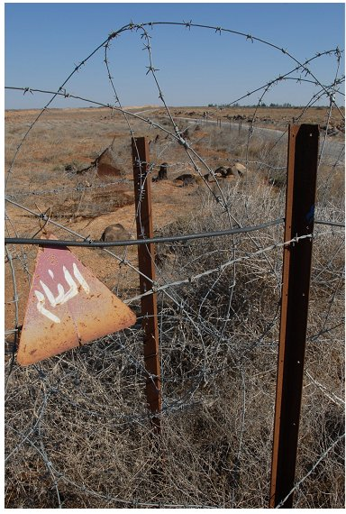
  - Fences and wire
Some minefields and defended areas were originally fenced with strands or coils of barbed or razor wire. In other areas, security and agricultural fences may be inside the SHA. All broken fences should be removed and the area beneath them searched. Intact fences should be left unless their presence restricts the use of mechanical assets or prevents necessary access. When the area around an intact fence must be searched, a metal-detector search should be used to search until the presence of the fence interferes with the reliability of the metal-detector. The remaining area beside the fence should be excavated using area-excavation techniques. When reliable and appropriately trained MDD are available, they may be used to conduct the search.
Wire obstructions must not be pulled by hand. They may be cut into short lengths using efficient wire-cutters, then
the short lengths removed and placed in a dedicated
metal-collection area.
The task supervisor may order that entanglements or buried wires are pulled from a distance using a suitable machine. Generally, the area surrounding the wire should have been searched first because moving the wire may spread any explosive hazards entangled in it.
  - Vehicle wrecks
When wrecked or abandoned vehicles are found in the SHA, it must not be presumed that there are no explosive hazards beneath the vehicle. The remains of wrecked civilian vehicles should be visually searched for hazards after being approached over land that has been searched. The vehicle can then be pulled into a known safe area using mechanical assets so that the land where it was can be searched. When a vehicle has a value to the end-users of the land, care should be taken not to damage it unnecessarily.
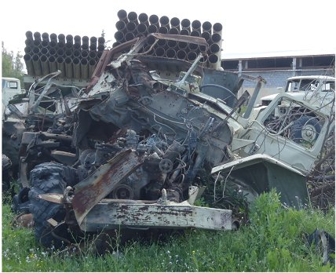
Wrecked or abandoned military vehicles should only be approached over ground that has been searched. They must be individually assessed by an
EOD specialist who must presume that there may be:
- booby traps in and around the wreck;
- UXO or AXO in and around the wreck;
- mines surrounding the wreck;
- human remains in or around the wreck; and
- mines between the wreck and any nearby route.
Sometimes the combat damage that a military vehicle
has sustained can give evidence of the weapons that
were used against it, so providing evidence of UXO
hazards that may be present. After a military vehicle has been searched, it should be pulled into a known safe area using mechanical assets so that the land where it was can be searched.
  - Ditches/trenches
If a ditch with collapsed sides is suspected of having been mined, it is possible that the mines will have become deeply buried. In these places, mechanical assets may be used to dig out the ditch and sift or spread the spoil removed. The need for this will be determined on a case-by-case basis by the task supervisor. The use of a mechanical excavator is covered in Chapter 8.
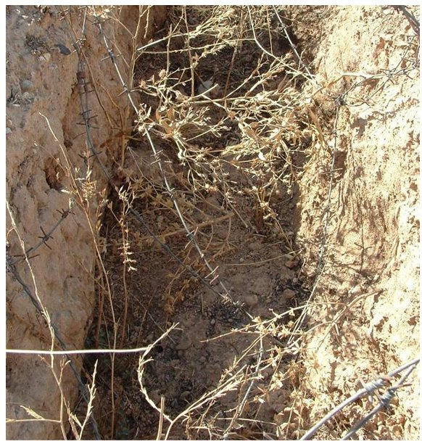
In the photograph alongside, the trench has not collapsed but local people have moved barbed wire and mines into the trench so that they can safely move their livestock.
There were corpses in the trench so the local villagers thought that it would be disrespectful to dig the trench out with an excavator.
Most of the barbed wire was pulled from the trench using a machine.
The trench was Searched & Cleared using a combination of excavation and metal-detector procedures by deminers working at distances that varied but always ensured that one deminer could not see the next because the hazards included bounding fragmentation mines.
The task supervisor must decide the best method to use on a case-by-case basis and should always listen to the desires of local people.
  - Abandoned or battle damaged buildings
When the presence of IED bombs, MF-IEDS or booby-traps is anticipated in a building, the procedures given in Chapter 7 should be followed. When the anticipated hazards inside a building are limited to UXO, AXO or anti-personnel mines, the procedures described here may be followed.
 NOTE: Buildings that still have window and door frames, roofing and plumbing fittings, or furniture inside should be approached with great caution. In many countries, useful parts of buildings are scavenged so when useful parts are left in place, there may be a reason for that. The task liaison officer should consult the local population about why the building has not been emptied.
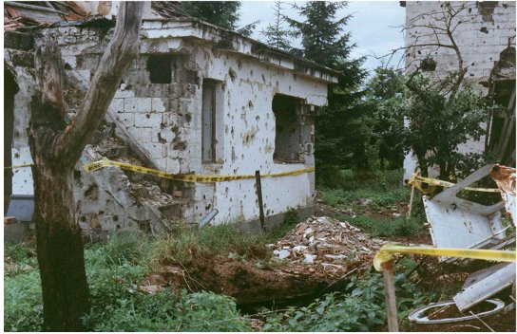
The following general constraints must be applied when searching a building.
- The building must be approached over land that is either known to be safe or that has a safe access route at least two metres wide leading to it.
- Search lanes inside a building can be marked using paint, painted stones or tape and may be restricted to one metre wide because of the need to search corridors, through door openings and up stairs. Search lane marking must always ensure that there is no confusion between area that have been searched and those that have not.
- Intact walls may provide protection and allow a reduction in working distances between deminers, depending on the anticipated hazards.
- When there is rubble inside the building, the deminers must be issued with strong buckets to move the rubble outside. Material on the floor must be removed until the search has reached the original floor level.
- Metal-detectors can be used in some areas but there is often a lot of metal among the debris so excavation using hand tools is often more appropriate.
- When an abandoned building is in a dangerous condition, some parts of it may be carefully dismantled using mechanical assets or by hand. Parts should be lifted into a marked safe area and searched as work progresses. As with all mechanical processes, safety distances must be enforced while a demining machine is working and approved area marking must be used.
The fastest method of searching any building is to use appropriately trained MDD. When MDD are not available and there is no reason to anticipate the presence of IED bombs, MF-IEDs or booby-traps, a search complying with the following rules can be conducted.
A two metre wide safe lane should be made all around the building. Standing in the safe lane to look through windows doors or broken walls, the ground floor should be inspected from the outside, looking for visible explosive hazards and obstructions. Whenever the building has more than one room, the section leader should make a detailed sketch map of the rooms inside the building.
When there is concern that the entrances to the building may have been mined, gaining safe entry through windows should be considered when making a Task Release Plan.
Generally, all interior corridors should be Searched & Cleared before any rooms are entered. The search is started from a base-stick placed in a safe area. Then the deminer should follow the search procedure described below. The section leader must supervise the deminers and always be aware of their progress. When visual contact is not possible, the deminers must report progress regularly.
- The deminer should check the area in front of the base-stick visually and feel for tripwires when appropriate. When inside the building, a strong flashlight/head-torch should be issued for use whenever visibility is poor.
- The deminer should carefully remove any rubble, vegetation, broken furniture or rubbish from the area in front of the base-stick, using a hook and line to pull heavy items from a safe distance.
- Working forward from the base-stick, the deminer should then search the area using area-excavation procedures unless a metal-detector search is reliable (which can be the case when the only anticipated hazards are UXO/AXO with a large metal content).
- All building rubble and debris should be carried outside the building to a designated collection point ensuring that access lanes are never obstructed (because they are already narrow in the doorways).
- When the original floor is visible across the width of the base-stick, the deminer should then advance the base-stick and start at Step 1 again. When the floor is packed earth, it should be searched with a metal-detector.
- A one-metre search lane should be made from the door to the far wall in each room. This lane allows a visual search of the room to be conducted in safety and, when necessary, it can be used as a baseline from which search lanes are made.
Only one deminer should work in a room unless the floor area is large enough to allow working distances to be applied. When the rooms are small, the deminers should work with two walls between them whenever possible. Generally, one floor of building should be completed before moving to the next floor.
While working, the deminers must not touch anything outside their search lane. No switches, taps, cupboards, furniture, or consumer items should be moved. When doors need to be opened, a specialist HIED deminer should assess the situation and use remote means when appropriate. When rugs or floor coverings are in the way, they should be remotely pulled.
After access has been made to all rooms on the ground floor, the deminers should be withdrawn and a specialist HIED deminer should check the rooms without moving outside the safe access lanes. The specialist HIED deminer will ask for search lanes to be made to allow safe access to features that are often booby trapped, such as toilets, taps, furniture and consumer goods.
The specialist HIED deminer should notify the task supervisor if he/she finds or suspects the presence of IED bombs. MF-IEDs or booby-traps. When this occurs, the task must be suspended and a dedicated HIED Search & Clearance team called in (see Chapter 7).
  - Fallen trees
Fallen trees and branches in the SHA must be moved so that the area underneath them can be searched. The area leading to the obstruction must be ’Cleared’ along the entire length of the fallen tree or branch.
If the tree is to be moved manually, a rope can be securely attached around it. This may mean that the area on both sides of the tree must be Searched & Cleared to allow safe access. Sometimes it is appropriate to cut away smaller branches with a handsaw and move them out of the way. A chainsaw must not be used to cut a tree unless the entire area around and under it have been searched and any hazards removed. The area around the tree can then be declared ‘Cleared’ and a chainsaw may be used.
If the tree is to be moved using a mechanical asset to lift or pull it, the area leading up to the tree must be searched and marked in a lane that is at least two metres wider than the machine.
The tree or branch must be moved into a safe area. When it is moved by machine, mechanical safety-distances should be applied while the machine is being used. When it is moved by manual pulling, the distance from the tree to the nearest man should be the working distance at the task site. Several deminers can stand behind each other pulling the rope. All deminers involved must wear PPE and be supervised by a section leader. Other staff at the task should be withdrawn to the safety distance.
When the obstruction has been removed, the place from which it was removed must be Searched & Cleared .

Finding human remains
If human remains, or suspected human remains, are found during operations, the procedures required by the NMAA must be followed. When the NMAA does not have published procedures for this eventuality, those given here should be followed.
Work in the area immediately surrounding the remains must stop. Mechanical demining must not be conducted within a 25 metre radius of any suspected human remains.
Although the anticipated human remains that may be located during mine action activities often date from the time of known conflict, human remains that are much older may be found. It is also possible that human remains that are more recent will be located. Whatever the origin of human remains, they must always be treated with respect and dignity by everyone involved in their recovery.
  - Reporting finding human remains
Every discovery of human remains must be reported to the NMAA and the police immediately by radio or telephone. After making a verbal report, a written report must be made.
When the remains of more than one person are found together, the task supervisor should make one report describing the finding of multiple human remains. When the remains are formally investigated with a police presence, a separate record should be prepared for each set of remains.
As a minimum, the following details must be recorded.
- The time, date, and place where the human remains were found. This should include a detailed description of the location and a GPS grid reference.
- The name and contact details of the person(s) doing the recording.
- A unique identification number that is assigned to the human remains. When parts of more than one person may be present, a single identification number should be assigned pending investigation by specialists. Any files, bags or boxes used for artefacts associated with a set of human remains should be clearly marked with the same reference number.
- A description of the scene, including the position of the remains in relation to any features and landmarks. The description should include any obvious disturbance to the human remains. Photographs should be included whenever possible.
NOTE: When photographing human remains, a paper showing the identification number assigned to the remains should be shown in the photograph.
- The task identification number/code for the task that was being conducted when the remains were found.
- Whether the human remains can be safely approached without further Search & Clearance being conducted.
- Record whether the remains appear to be complete. If they are not complete, the report should give a degree of confidence over whether they are human. For example, if a human skull is visible, the confidence may be given as ‘certain’. If there are only scattered bones, the level of confidence may be ‘possible’ or ‘uncertain’.
NOTE: When it is uncertain whether the remains are human, they should be referred to as “possibly human” in the report.
- State whether the remains appear to be ancient, dating from known conflict, or recent. Clothing or associated artefacts may inform this judgment. The way in which the remains are investigated and removed will depend on their age so include a detailed description and photographs whenever possible.
- When possible, state whether the remains appear to be those of an adult or a child, and a male or a female.
Investigation of the remains and associated artefacts with a view to determining the identity of the deceased is the responsibility of the police or other authorities.
The report should be signed, dated and delivered to the NMAA and the local police as soon as possible.
  - Ancient human remains
When it is suspected that human remains may be ancient it should be presumed that the place they were found may be a burial ground or of archaeological interest. The find must be reported to the NMAA and the written report required in Part 15.1 above submitted. The discovery will often mean that the remains have been approached on one side. The area extending five metres in all other directions from the discovered remains should be left undisturbed until authorisation is granted for the removal of the remains by the appropriate authorities. The area surrounding the remains must be marked with hazardous area marking and, if necessary, guarded to ensue that they remain undisturbed.
The police and a representative of an appropriate archaeological or historical institute should be present when the area immediately around the remains is Searched & Cleared and the remains are collected. Any artefacts found within a five metre radius of the remains must be bagged and given an identification number that is the same as that of the human remains. The NMAA should arrange collection to occur with the minimum possible disruption to demining activity.
If ancient human remains are part of an ancient burial site, all staff must respect the relevant religious and cultural sensitivities associated with the find. Everything reasonable must be done to assist in the management or the remains in a timely manner.
  - Human remains from conflict
Demining is often conducted in battle areas where combatants may have died in action. In some cases, bombardment may have buried the remains at the time of death. Because the areas are known to be dangerous, the remains may have been undisturbed since the fighting ended.
When the remains of combatants are discovered and the artefacts found with them (clothing and other items) confirm their status as former combatants, the find must be reported to the NMAA and the written report required in Part 15.1 above submitted. The human remains must not be disturbed more than is necessary to confirm that they were former combatants. The area around the remains should be marked with hazardous area marking and, if necessary, guarded to ensure that they are not disturbed by animals, birds or people.
The police should visit the site to confirm the identification of the human remains as being that of former combatants. The police should then arrange for the remains to be collected and removed, and may ask for assistance in doing so.
Unless the NMAA indicates otherwise, Search & Clearance procedures may continue around the remains of former combatants. Any portable artefacts found within a five metre radius of the remains must be photographed and placed in a bag with the same Identification number as that assigned to the remains. All artefacts must be collected in case they have a significance that may help to identify the deceased later.
  - Recent human remains
If there is any suspicion that human remains discovered during mine action activities are too recent to date from the time of conflict, demining in a radius of at least 10 metres around the area must stop immediately. The police and the NMAA must be informed immediately.
A written report of the discovery must be made and the human remains must be photographed and assigned one or more unique identification numbers. The area surrounding the remains must be marked and, if necessary, guarded to ensue that they remain undisturbed.
The police should attend the site urgently. The task supervisor must assist the police in their investigation of the remains, arranging for deminers to search up to and around the remains while the police are present. While this occurs, responsibility for safety at the task site remains with the task supervisor and any police that are inside the safety distance for the site must wear the appropriate PPE and obey the safety constraints required in these SOPs.
NOTE: If the police do not wear the appropriate PPE or obey safety constraints, the task supervisor must refuse to carry out any demining work in the SHA. The NMAA should liaise with the police to gain their cooperation.
Any artefacts found within a ten metre radius of the human remains must be collected and recorded as required under police procedures.
Generally, the actual recovery of a recent corpse must be conducted by specialist police and medical staff. Until the cause of death is known, demining staff must not touch the remains unless wearing suitable protection against disease. When the remains may have been booby trapped, they must be moved using a pulling procedure before recovery. This should be achieved without damaging the remains more than strictly necessary.
  - Human remains found outside the task area
The management of human remains found outside the task area falls outside any HMA remit for which the NMAA may have granted operational accreditation. Nonetheless, human remains found outside the task area should be reported to the NMAA and the police by telephone or radio.
  - Health hazards
The health hazards (biohazards) associated with handling human remains from an armed conflict that occurred some time ago are very low. When the human remains are recent and have not desiccated or decomposed, a risk of infection may occur from direct contact. All blood and some body fluids are considered potential vectors of the hepatitis B and C virus, human immunodeficiency virus (HIV), and other blood-borne pathogens. To avoid these risks, staff must never handle fresh or decomposing bodies unless qualified and equipped to do so.

Psychological considerations
The psychological burden for staff dealing with human remains can be considerable. Persons unwilling to be involved in the activity must not be ordered to do so. Any staff member who is traumatised by the discovery of human remains must be treated with respect and offered professional counselling in order to facilitate a full recovery.

Tripwire location
When the Task Risk Assessment indicates a possible threat from tripwire operated mines with functional fuzes and intact tripwires, the Task Release Plan for the affected area may include the use of machines for mechanical preparation of the area. Flails and vegetation cutters can be used in a manner designed to ensure that no intact tripwires remain before manual deminers are deployed. The machine should remove vegetation but not process the ground unless ground preparation is also required.
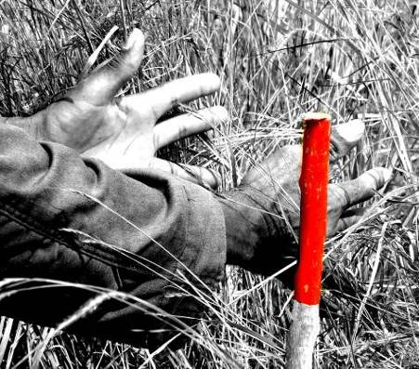
When it is necessary to use a manual demining tripwire detection procedure, the search should be made using the eyes and hands. A tripwire ‘feeler’ that is a length of stiff-wire may also be used but hands are preferred because they provide the greatest tactile feedback. After a thorough visual check of the area, the deminer searches the area in front by gently parting any thick vegetation that may conceal tripwires, unexploded ordnance, surface-laid mines, protruding fuses or other hazardous items. The vegetation should be parted by pressing the palms of the hands together and pushing gently into the vegetation, then spreading the fingers and slowly parting the hands as shown in the photograph on the right. This should be repeated across the width of the deminer’s lane, including the overlap.
When vegetation is high, the tripwire search should be repeated from the top to the bottom, ensuring that all vegetation is separated and any tripwire would be seen or felt.
After conducting the tripwire location procedure, the deminer must take great care not to cut vegetation ahead of the area that has been searched for tripwires.
  - Action on locating a tripwire
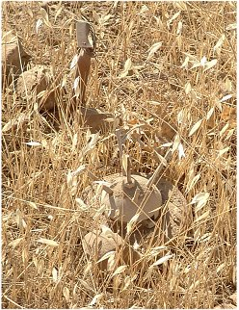
When a tripwire is found, the deminer must stop work and notify the section leader. The section leader should determine the direction of the wire. Generally, the wire should be marked and the search lane closed. When it is not clear where the tripwire runs, the search lane should be widened up to the place where the tripwire was found so that more of the tripwire is located and a direction can be determined. When a direction has been determined, another search lane should be started running alongside and following the tripwire. The tripwire will run between an anchor (usually a metal or wooden stake but sometimes a tree or other ‘anchor’) and a mine, so Search & Clearance in both directions will need to be conducted. The tripwire must be followed in both directions because there may be another mine close to the stake or anchor as shown in the picture alongside.
 NOTE: In some places, anti-personnel blast mines are placed along tripwires. They may also be placed around the mine at one end of the wire and the ‘anchor’ at the other.
When a tripwire is taut, the tripwire must not be moved or disturbed until the ends are exposed and the mine identified. When a tripwire is slack, it may be cut at the discretion of the section leader in the interests of safety.
When the type of mine is not known and its condition is uncertain, a working distance of 30 metres should be enforced until the ends of the tripwire have been located and the device identified. Working distances for mine threats are given in Chapter 2 of these SOPs.
When a tripwire operated mine is located, the section leader should instruct an EOD operative to either move it or destroy it where it is. If tripwire operated mines were not anticipated in the Task Assessment, the task supervisor must ensure that the Task Risk Assessment and Task Release Plan are reviewed and revised immediately.

Collection of explosive hazards
Deminers may not handle or move explosive hazards unless they have been trained to do so. When explosive hazards have been declared safe to move by an appropriately trained EOD specialist, they should be moved and taken to clearly marked and separated collection areas.
Under the direction of a suitably trained EOD specialist, the explosive hazards should be destroyed using one of the procedures described in Chapter 10 of these SOPs.

Conducting Battle Area Clearance (BAC)
Battle Area Clearance is a visual search of the entire ground surface of a defined area.
The task conditions required before BAC is conducted are described in Chapter 3, Part 3.1.1. When those conditions are met, visual BAC search can be included in the Task Release Plan.
BAC can be conducted in areas with sparse vegetation or from which vegetation has been removed. The vegetation may be cut by a suitably armoured machine before the BAC but the machine must not disrupt the ground surface because disrupting the ground may bury the explosive hazards that BAC is intended to locate.
BAC should lead to the removal of all explosive hazards and battle debris that is on the ground surface so that the land can be released as ‘Surface Cleared’.
 NOTE: BAC may not be used in any area where there is evidence suggesting the presence of mines or any other movement or pressure sensitive hazards that may be initiated during BAC. If evidence of any of these hazards is found during BAC, work at the task must be immediately suspended and the Task Release Plan revised so that appropriate Search & Clearance is conducted.
When conducting BAC, the area to be searched is considered safe to walk on. The area should be divided into clearly marked ‘search boxes’ which may vary in size depending on the task and the number of deminers available to search.
The following procedure can be used to search each box.
- The width of the area to be searched depends on the number of searchers. Six deminers can generally search an area approximately ten metres wide.
- Wearing approved PPE and carrying a bag for scrap metal, the deminers form a rank approximately one metre apart at the baseline.
- On command from the section leader they advance slowly across the area looking closely at the ground. The section leader walks a few metres behind the deminers ensuring that they maintain a straight line and placing side markers every ten metres.

- At the end of the marked area, the deminers form a rank in the adjacent area, then walk back over the adjacent area.
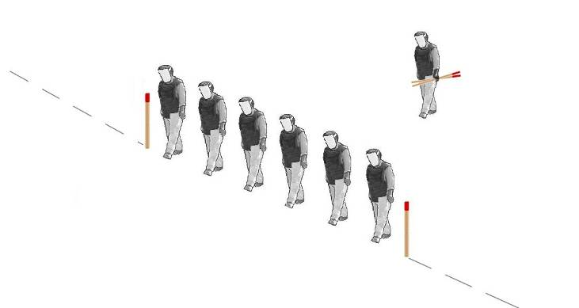
- As the deminers advance on the return pass, the section leader moves the side of lane markers so that they always mark the side of the area visually searched.

The Section Leader removes sticks on the searched side as the line of deminers moves forward.
1st search
2nd search
3rd search

- The deminers move in ranks up and down the area as shown in the diagram above.
- When a deminer sees something suspicious he must raise a hand and call out. The line of deminers should stand still while the suspicious item is inspected. An EOD specialist should inspect the item and if it is found to be a hazard that is safe to touch, the hazard is marked and the search can continue beyond it.
The position of each device must be recorded using GPS by the section leader. An EOD specialist should deal with discovered devices after the deminers have moved beyond the working distance.
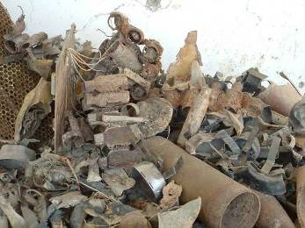
 NOTE: If the discovered device is a mine or any other movement or pressure sensitive hazard that may be initiated during BAC, all deminers must be withdrawn immediately.
- All battle debris such as mortar fins or abandoned equipment should be removed during the search. This will prevent people who use the land being concerned in future. When small-arms are found, they must be photographed, collected, and destroyed.
The photograph shows a pile of scrap collected during BAC.
BAC allows wide areas that are not mined to be released to the community quickly.

Conducting Battle Area Clearance Subsurface (BACS)
The task conditions that must apply before BACS is conducted are described in Chapter 3, Part 3.1.2. When those conditions are met, BACS subsurface search can be considered for inclusion in the Task release Plan.
BACS should lead to the removal of all UXO and large battle debris to a known depth (at least 30cm) beneath the ground surface. BACS may be recorded as ‘Clearance’ as long as the only hazards anticipated in the area would be reliably found by the metal-detectors used and the search procedures ensure full search of the entire area to the required depth. Areas processed by BACS may be released as ‘Cleared of hazards with a large metal content to a specified depth’.
A BACS search can only be conducted on areas with sparse vegetation or from which vegetation has been removed.
 NOTE: If any evidence of mines or any other movement or pressure sensitive hazards that may be initiated during BACS procedures is found, the BACS search must stop immediately.
  - Why a single BACS search may not be enough
Many metal-detectors (digital or analogue) that are optimised to search at a particular depth will not reliably signal on targets buried at other depths, so a metal-detector that will signal on a target buried at 30cm may not signal on the same target buried at 20cm or 40cm. This means that repeated searches over the area using different metal-detectors (or metal-detectors at varied settings) are necessary when reliable search to depths below 30cm are required.
In some battle area minefields, a two or three stage search is required, depending on the reliable search depth that is required.
- First search with a hand-held metal-detector that is able to find any minimum-metal hazards present to a depth of 13cm or more. After this search it should be safe to walk over the ground during subsequent searches.
- Second search with a large search-head on a conventional metal-detector that is able to locate large metal targets to depths of 30cm or more.
- Third search with a large-loop detector designed for deep search that has been adjusted to detect large metal targets at a depth greater than 30cm.
In areas with no anticipated mine hazards, search 1 above may be BAC.
  - Metal-detectors used in BACS
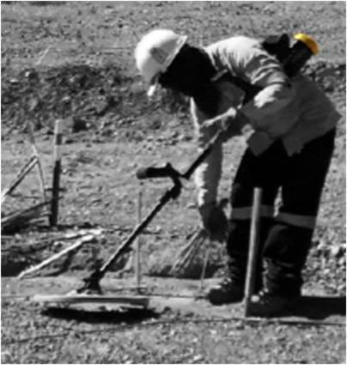
Some of the metal-detector models that are conventionally used to search for mines can reliably signal on large metal objects at 30cm but this must not be presumed without confirming that the metal-detector will give a clear and unambiguous signal on representative targets buried at 10, 20 and 30cm. Unless the target is round, it should be placed in different orientations because the real hazards could be an any angle under the ground.
Generally, fitting a larger search-head to the standard metal-detectors used to search for mines increases the depth of search while reducing the metal-detector’s ability to signal on small pieces of metal. The MineLab F3 can combine a yellow coloured end-cap to adjust the metal-detector’s settings with a larger search-head to reliably increase depth (it is shown alongside).
The Ebinger PIDD UXO locator and the Vallon VMXC1 with large search-head and UXO optimisation (shown below) are other variants on standard metal-detectors that can be reliably used to search at depths between 0 and 30cm. Whichever metal-detector is used for BACS search, an extension describing its use must be added to this SOP.
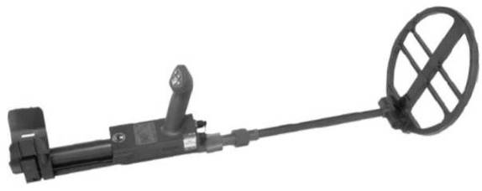

All metal-detectors optimised for deep search have an increased power requirement, so standard metal-detectors with large search-heads will need to have their batteries replaced more frequently than those with smaller search-heads.
 NOTE: A standard metal-detector that has been optimised for deep search can only be used when searching for large metal-cased explosive hazards. They must never be used to search for plastic cased hazards. Metal-detectors which only find ferrous items (such as magnetometers) must not be used when searching for explosive hazards that do not have a high ferrous content.
While some standard metal-detectors may find the hazards anticipated at a task at greater depths,
generally the search for large metal targets deeper than 30cm should be conducted using ‘large-loop’ BACS metal-detectors that have been designed for deep search.
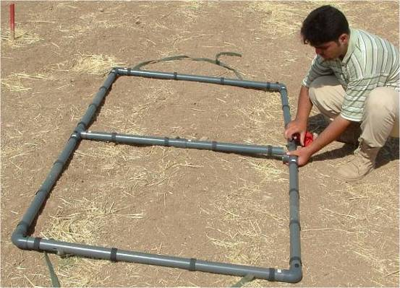
In these SOPs, a standard metal-detector fitted
with a large search-head and adapted for BACS
is called a ‘large search-head detector’. A
dedicated deep search metal-detector with a
search-head so big that it cannot be used by a
single deminer is called a ‘large-loop detector’.
The picture alongside shows the search-head of
a large-loop metal-detector being assembled.
The large-loop is the search-head and it is carried
between two deminers. Some models of large-loop
detector have the loop resting on wheels.
  - BACS search test targets
To ensure that the BACS search will reliably locate the anticipated targets at the required search depth, each metal-detector must be tested in a dedicated test area that is clearly marked and set up close to the search area.
The ability to reliably signal on the most difficult to detect anticipated hazard at the task must be confirmed every time that the metal-detector is switched off and on. When no other UXO or AXO target is indicated in the Task Assessment, the targets used for the test should be inert rifle or hand grenades placed under the ground at 10, 20, and 30cm depth and the holes filled with earth. Strings can be attached to the targets to facilitate easy recovery.
NOTE: The ground above the targets must be replaced because the detection depth through earth is not the same as the detection distance through air.
The test must be repeated over targets placed upright and lying flat at each search depth so that there is confidence that the targets will be found whatever their orientation under the ground. The metal-detector must signal clearly and unambiguously when passed over all the buried targets.
When appropriate, the setting of the metal-detector may then be adjusted so that it does not signal on pieces of metal that are significantly smaller than the targets as long as it still signals reliably on the targets.
  - Probability of detection and false alarm rate
In some comparative studies, various models of metal-detector have been appraised in terms of the probability of them detecting a particular target in certain conditions and the false alarm rate associated with their use. There has been a fundamental error in the approach to these studies.
Using the procedures described in these SOPs correctly, the probability of a metal-detector detecting a specified target at a task will always be 100%. If it is not possible to detect all the anticipated hazards at the required depth, the metal-detector will not be used.
If the metal-detector were to signal when there is no metal present that would be a ‘false alarm’ and would indicate a problem with the machine or its design. When a metal-detector signals on the presence of metal but that metal is not an explosive hazard that is not a ‘false alarm’, it is a limitation of the technology. The number of positive signals that are associated with harmless metal will depend on the number of pieces of metal in the ground.
When the ground itself contains metallic compounds, the metal-detector’s ground compensating feature should allow it to recognise that this signal is ‘constant’ and not to signal its presence. Metal-detector manufacturers are developing discriminating metal-detectors that give a different signal for different metal types or when the metal is at different depths but these innovations are not yet proven and must not be used without extensive testing to determine their strengths and limitations.
The sensitivity of the metal-detector can be adjusted so that it does not signal on pieces of metal that are significantly smaller than the target hazards because this can significantly increase the speed with which the search is completed. However, increased speed must never be allowed to compromise safety. The metal-detectors used during BACS may be appropriately adjusted to ignore small metal pieces but any attempt to reduce the number of times that a metal-detector signals on harmless metal must not lead to a reduction in the probability of detection. To reduce the probability of detection would be unprofessional because it would put the end-users of the land at unnecessary risk and so contradict the primary goal of Humanitarian Mine Action.
  - Requirements during all BACS searches
The following rules must be used when conducting BACS.
- Each BACS metal-detector must be tested before and after use each day (as described in Part 19.3 above). If a metal-detector cannot find the targets reliably at the end of any search period, the area searched using that metal-detector since it last found the targets must be searched again.
- All significant vegetation in the search area must be removed before or during the search.
- Working distances during BACS should be increased if the metal-detectors in use have an electronic influence on other metal-detectors close by. Generally, large-loop detectors need to be separated by a greater distance than large search-head detectors.
- When BACS is conducted using large search-head detectors, all search lane marking and start and finish lines must be used in the same way as that required when searching for mines, except that the marking at the sides of the lane can be placed at two metre intervals.
- When BACS is conducted using large-loop detectors, the centre of the search lane should be marked with tape and the centre of the large-loop kept in line with the tape as the large-loop is advanced. Those carrying the large-loop can walk outside the search lane because land must be safe to walk over before BACS is conducted.
- Unless otherwise recorded in the Task release Plan, all BACS should be conducted in a manner that guarantees that no anticipated explosive hazards are left in the search area to a depth of 30cm. The search depth may be varied by the NMAA or according to the needs at the task.
- To allow a rapid advance over areas where there are no signals, a base-stick need not be used during BACS.
- Large-loop detectors should be moved forward with the centre of the large-loop following a line of tape laid out on the ground. The large-loop should be overlapped by 50% for the next search, so tapes should be placed at distances equal to half of the large-loop diameter as the search progresses. When the same tape is moved to mark the next centre, it must be replaced with markers two metres apart along its length. The markers allow supervisors and QA staff to check that ground coverage has been thorough.
- Large search-head detectors should be used in conventional one metre wide search lanes. The large search-head should be swept across the face of the lane with each sweep overlapped by 33% of the search-head diameter, extending the search outside the sides of the lane by at least 20cm.
- Pinpointing of signals should follow the manufacturer’s instructions for the relevant metal-detector unless otherwise indicated in an appendix to this SOP.
- Each time that the metal-detector signals during BACS, the position of the signal should be pinpointed as far as possible and a suitable marker placed (often a painted stone). The search should continue without pausing for excavation. This allows the search to be conducted quickly, but all search lane marking must be left in place until after all signals in the area have been investigated by excavating the metal source.

Excavating BACS metal-detector signals
When the search of the area has been completed, an excavation team should uncover the source of each signal. They should work in the original search lanes at the required working distance. Those excavating should be equipped with standard metal-detectors with small search-heads so that they can check the position of each signal as they get close to it.
The method used to excavate deeply will depend on the targets and their condition. When a target may be sensitive to movement, a 50cm long sloping trench that is at least 30cm side and advances towards the signal marker should be made. This will allow the source to be seen as the approach is made and, when appropriate, will allow a demolition charge to be placed without moving it. When insensitive UXO is anticipated, the excavation trench can be shorter.
When the metal discovered is not associated with an explosive hazard, it should still be removed so that a QC check that the search has been successfully conducted to the detection depth can be made.
The Task Release Plan should detail what must be done when the search depth for the task is reached and the source of the signal has not been reached. Generally, the excavation should continue a further 10cm before being abandoned. When a deep signal is left in the ground, the excavation must be left open and marked with a stick until after the QC has been conducted. After the QC check, all excavations must be filled in.
  - Using a large-loop detector
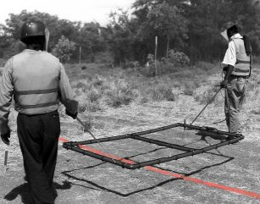
When a large-loop detector can be adjusted to reliably detect targets at depth, it can be the fastest way of searching wide areas for deeply buried UXO or AXO.
The large-loop is carried by two men as shown in the photograph alongside. Large-loop BACS detectors like this are used for searching areas where hazards may be deep under the ground and the predicted end-use of the land will involve digging deeply. In some cases
When there may be UXO, AXO or metal debris on the ground surface, the area should be BAC searched and the visible hazards and debris removed before the BACS is conducted.
The following additional rules should be used when using any large-loop detector.
- The large-loop detector can only be used by staff who have been appropriately trained and tested. The large-loop must be assembled in accordance with the manufacturer’s recommendations. Variations that allow more efficient batteries to be used are permitted.
- The sensitivity of the large-loop detector must be calibrated for the anticipated targets following the instructions in the manufacturer’s handbook. After calibration, the large-loop must be passed over targets as described in Part 19.3 above.
- Large-loop detectors should be re-calibrated after every hour of use, or every time they are switched off. They should also be calibrated if the readings become erratic.

Large-loop search patterns
Large-loop search can be conducted by making a search across marked boxes as shown below.
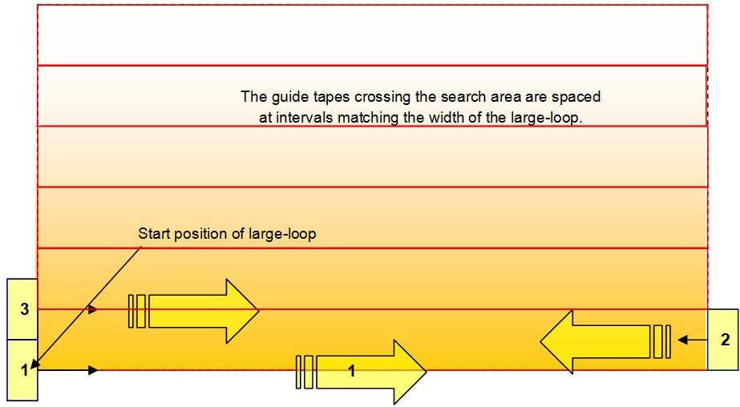
The baseline marking should be replaced by a tape (or rope) that can be stretched tightly along the ground. More tape must be stretched to make a line crossing the box between every side marker at intervals matching the width of the large-loop.
When the box has been prepared, the search is conducted in this way:
- The deminers move the large-loop so that it is centrally over the stretched tape that marks the baseline. The deminers walk slowly along the tape holding the large-loop centrally over the tape. The large-loop should always be held at the same height above the ground surface and held as level as possible.
- When they reach the other end of the search area, the deminers turn around and position the large-loop so that its sides are each directly above a tape. They walk back across the search area keeping the sides of the large-loop over the tapes.
- At the start side of the search area, the deminers turn and position the large loop so that it is centrally over the second stretched tape, then walk back across the search area keeping the centre of the large-loop over the tape.
This is continued over the entire search area. The method means that the large-loop is always overlapped by 50% to ensure complete ground coverage. Where the ground rises and falls, the deminers should ensure that the large-loop follows the ground contours.
- When there are signals, a deminer should place a marker to show the position of the signal. The stone should be placed on the centre of the signal. The signal can be crudely pinpointed by moving the large-loop back and forward and side to side.
When the large-loop has been used over the entire search area, the deminers should move to search another area while other deminers investigate the markers they have placed.
NOTE: If there are several small pieces of metal beneath a large-loop it may signal as if one large piece of metal were present. After some of the metal has been removed, the large-loop may not signal at all when held over the same area.
After all signals have been investigated in the area, the large-loop should be used to search over the excavated areas again to confirm that the signals have gone. When a signal is still there, further excavation should take place to the maximum depth indicated in the Task Release Plan or 40cm, whichever is greater.
A QC search over parts of the area using a large-loop metal-detector with the same setting must be conducted before the land can be declared ‘Cleared of hazards with a large metal content to a specified depth’.

